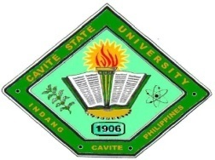Republic of the Philippines

**CAVITE STATE UNIVERSITY**

**Imus Campus**

Cavite Civic Center Palico IV, Imus, Cavite

*(046) 471-66-07 / (046) 471-67-70/ (046) 686-2349*

[www.cvsu.edu.ph](http://www.cvsu.edu.ph)

**TITLE APPROVAL SHEET**

Name : **ARATEA, ANGELICA J. Type of study: DEVELOPMENTAL**

**DELOS ANGELES, HAROLD**

**GICALE, JOHN ANDRE C.**

**MARBIBI, JANELLE T.**

Degree : **BACHELOR OF SCIENCE IN**  **Major : NONE**

**INFORMATION TECHNOLOGY**

Title:

**WEB PORTAL FOR THE DEPARTMENT OF COMPUTER STUDIES WITH**

**SMS NOTIFICATION AND TWO FACTOR AUTHENTICATION**

APPROVED:

**CARLO P. MALABANAN, MIT** ______   **GIZELLE A. RODERO**  **______**

Adviser Date Technical Critic Date

NOTED:

**JOSE LERIO V. BATULA, MIT** ______ **CROMWELL R. CABALU, MBA, MHM** ______

Department Chairperson Date Campus Research Coordinator Date