Lab Report
Use this template to document your work as you complete your assignment.

Your Information
Your Name: Christopher Lyles
Assignment Title: 3.4 Performance Assessment - Supervised Learning Algorithms
Instructor: Thomas Clinger
Class: SDC485 - AI/ML and Data Analytics Methods and Modeling

Screenshots
As you complete the procedure, add the screenshots for the required step(s) below.
Step 1 – Set up Assignment Markdown Cell
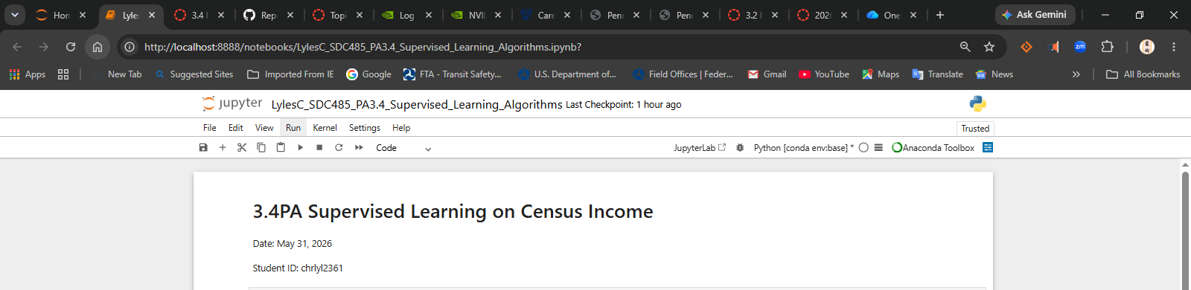
Step 2 - Import Libraries
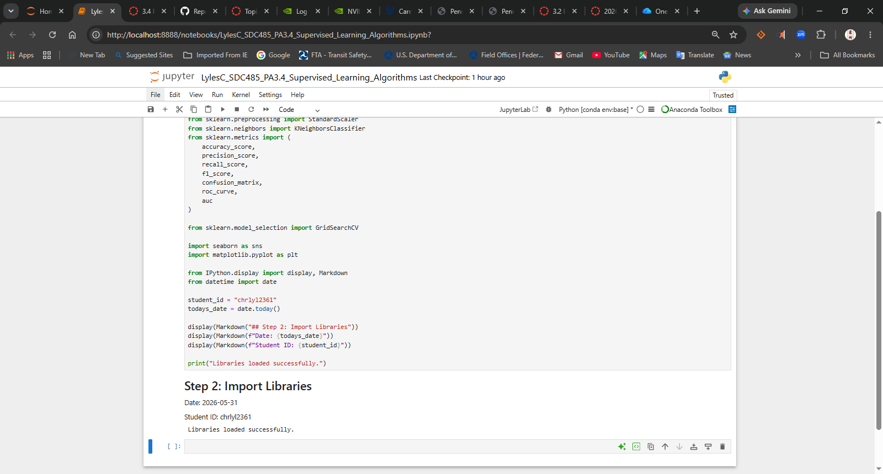
Step 3 - Load Dataset
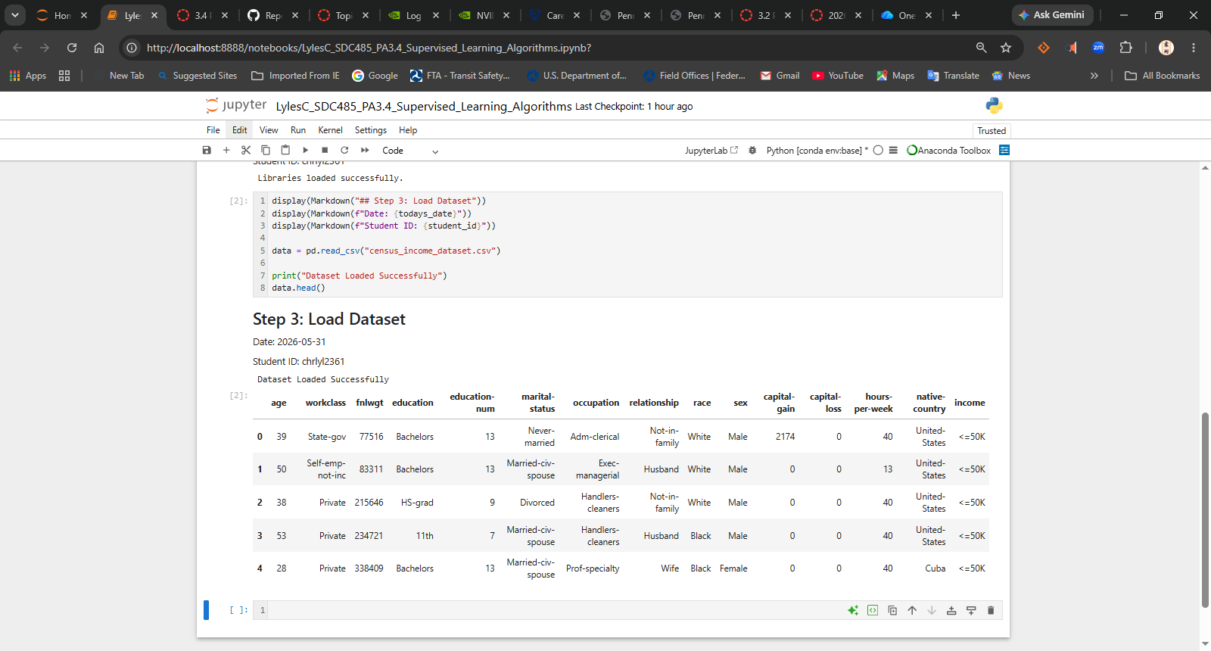
Step 4 - Explore Dataset
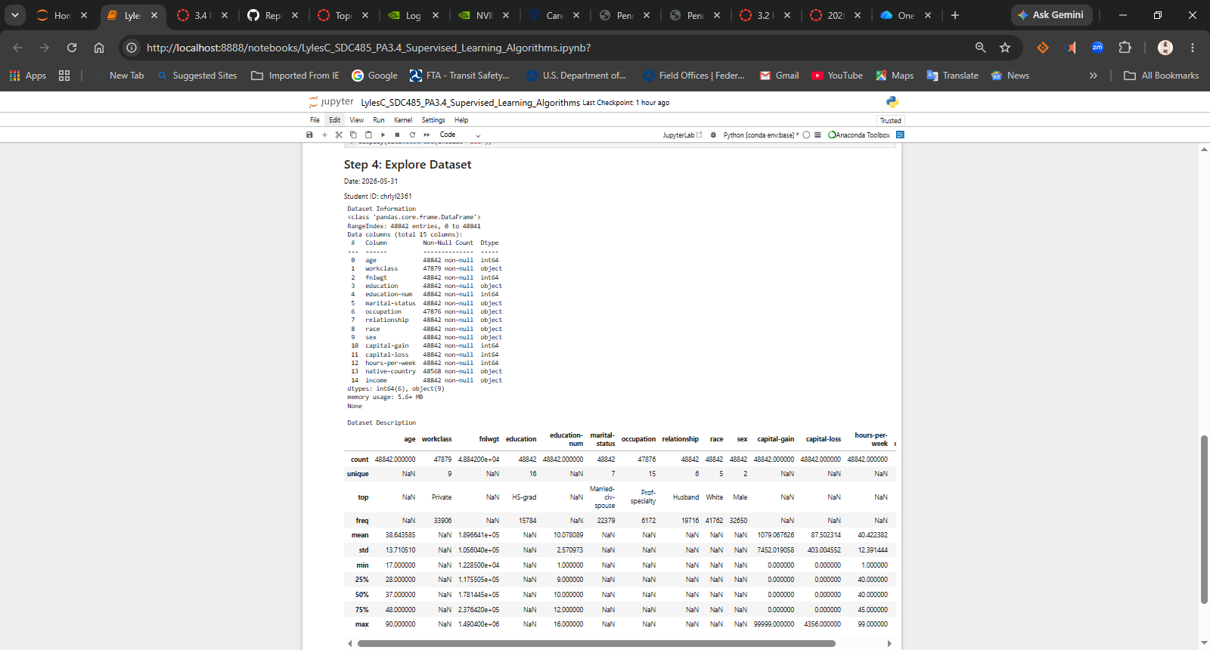
Step 5 - Check Missing Values
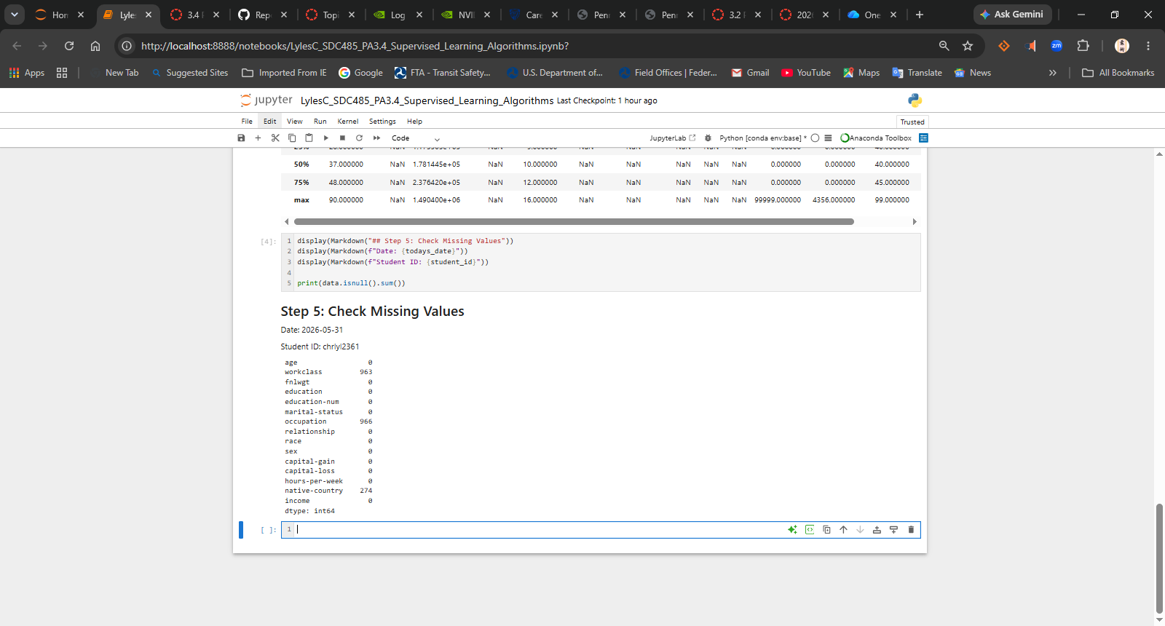
Step 6 - Handle Missing Values
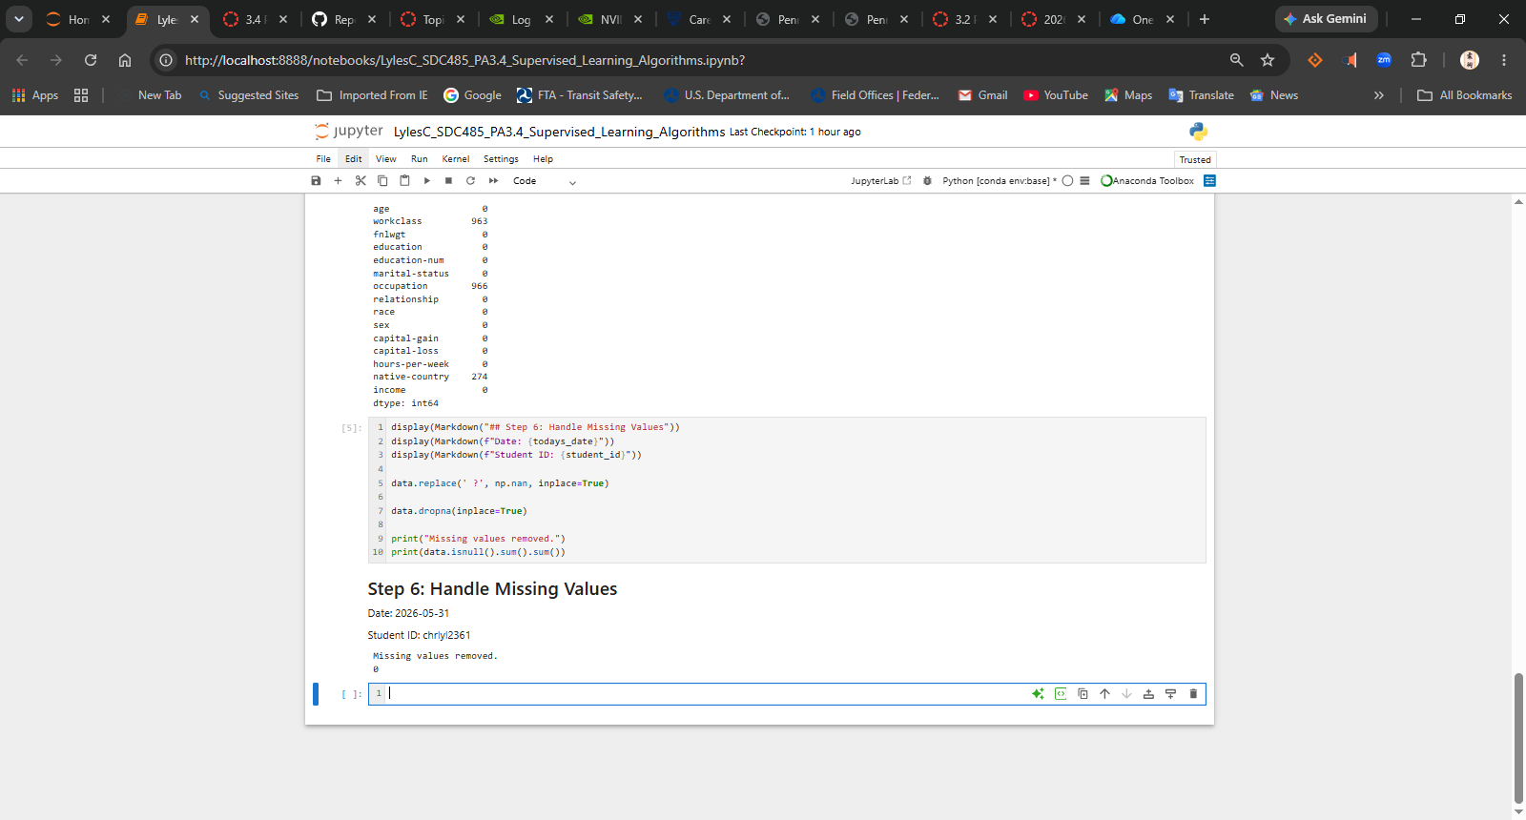
Step 7 - Remove Duplicates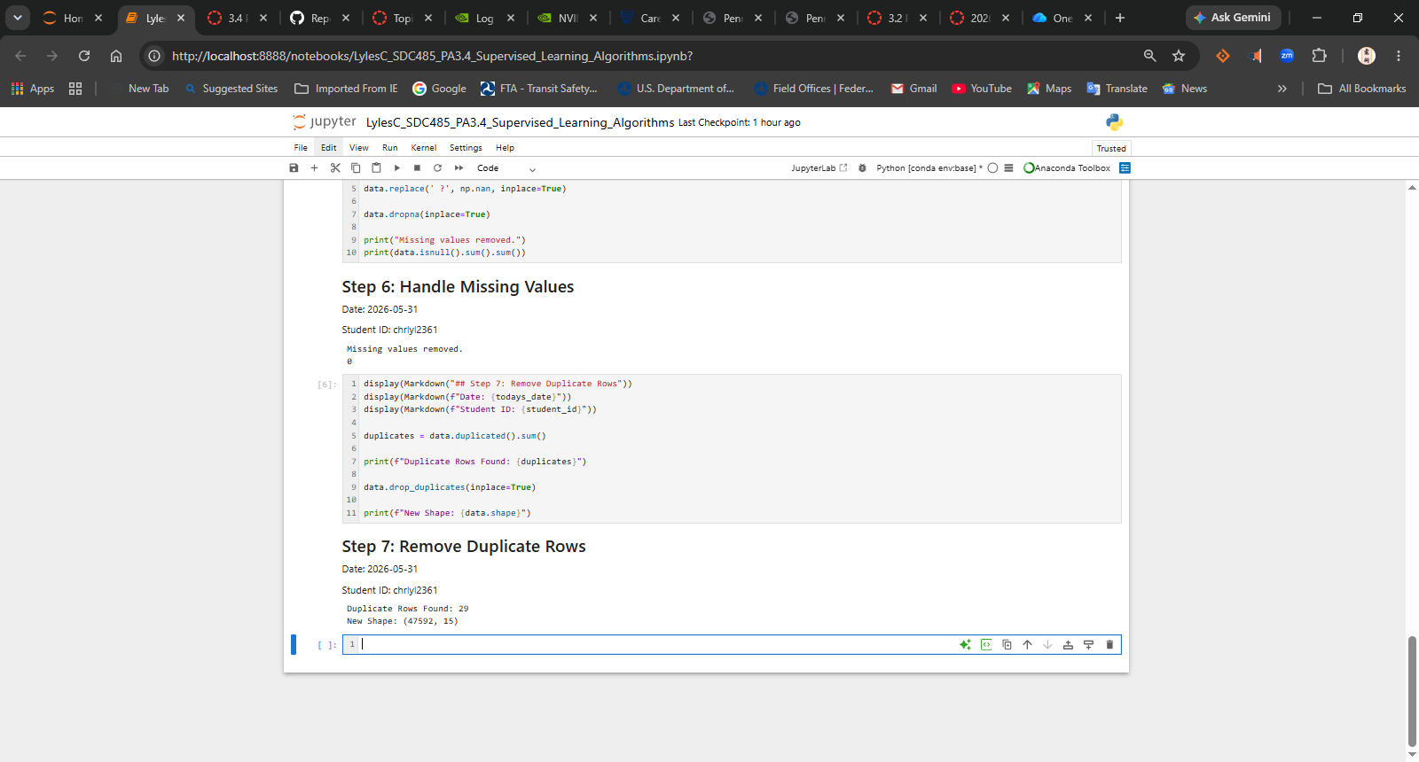
Step 8 - Convert Income to Binary
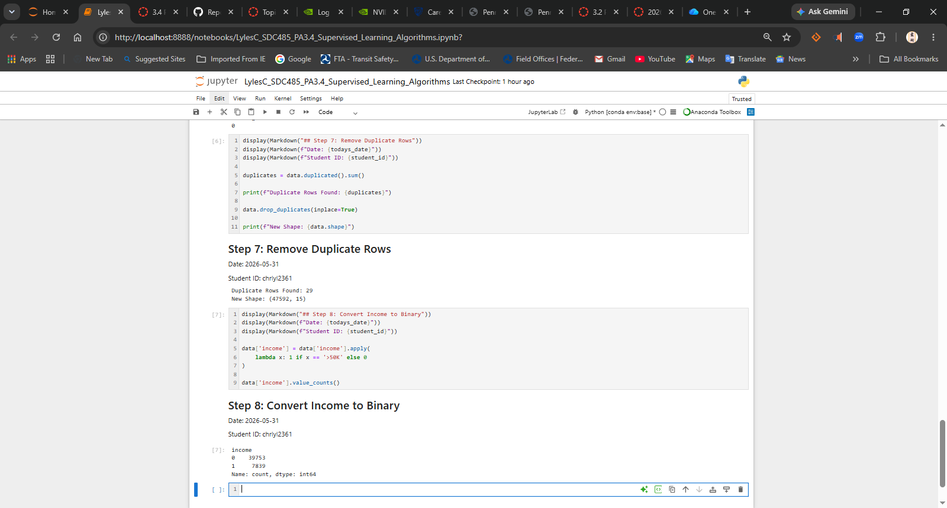
Step 9 - One-Hot Encoding
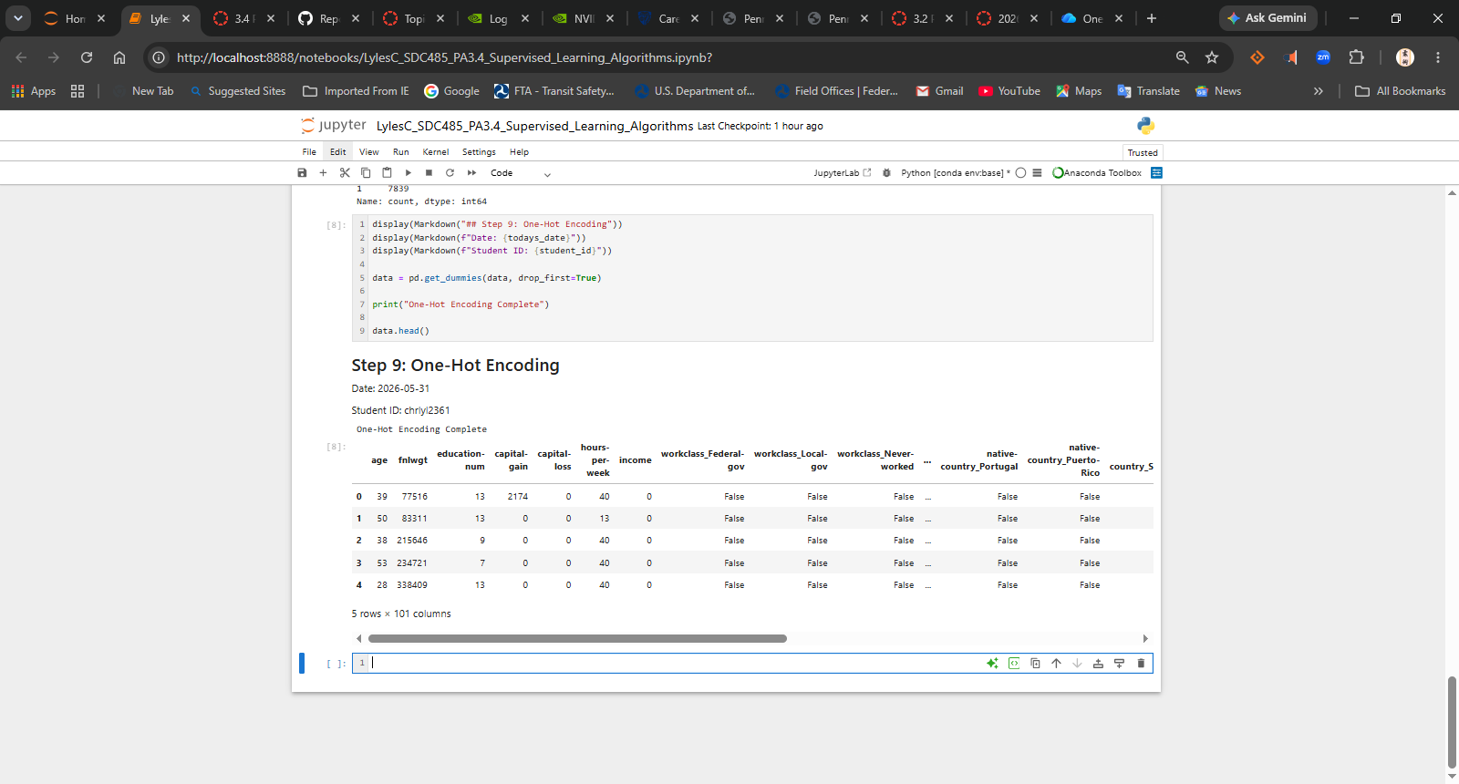
Step 10 - Define Features and Target
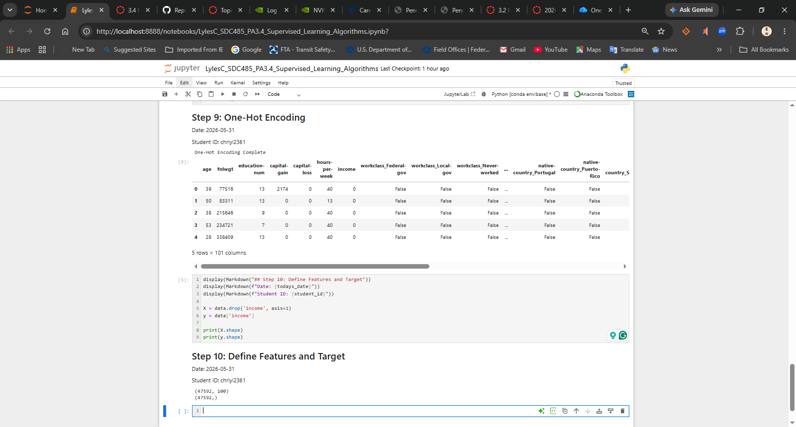
Step 11 - Split Dataset
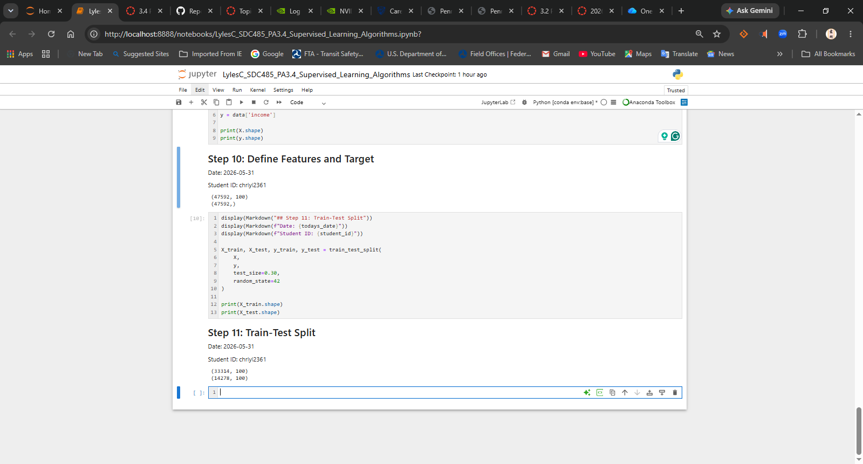
Step 12 - Scale Features
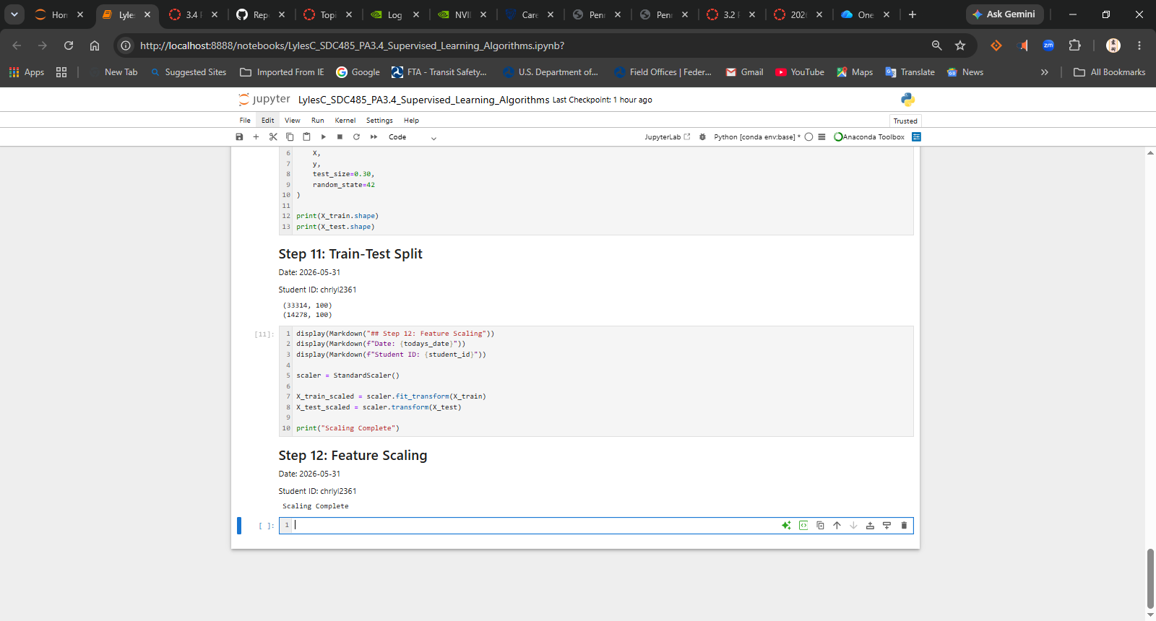
Step 13 - Train KNN Model
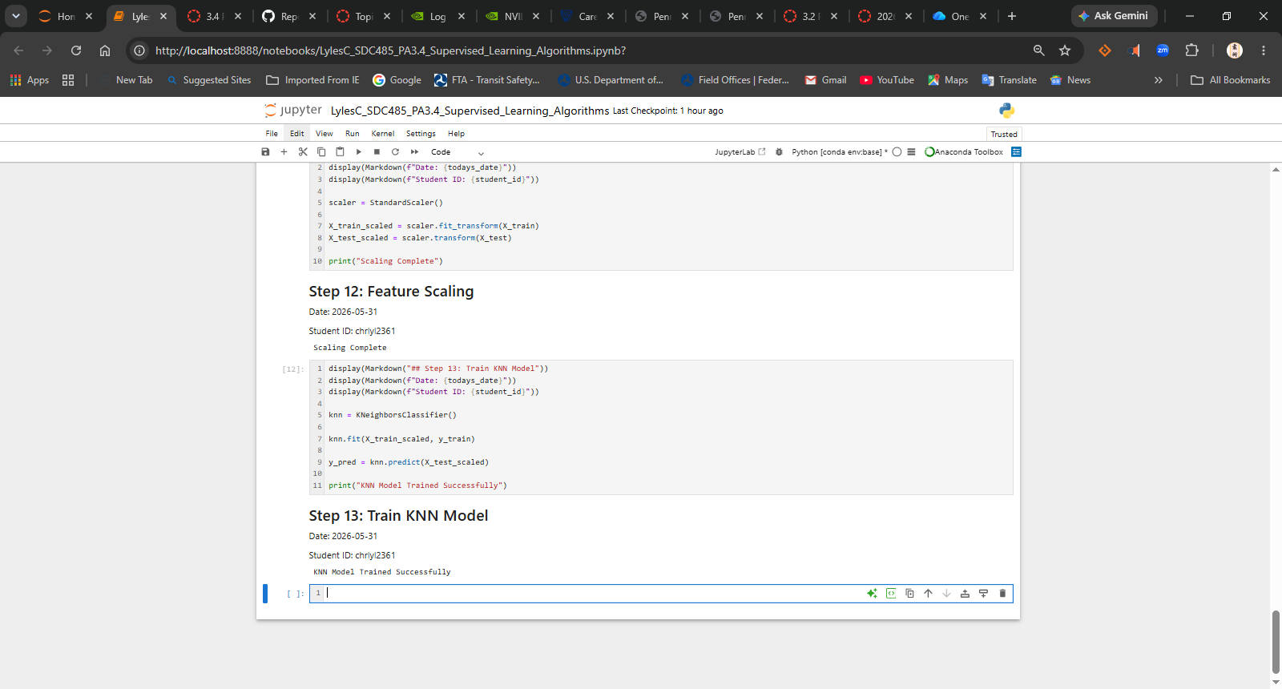
Step 14 - Initial Predictions
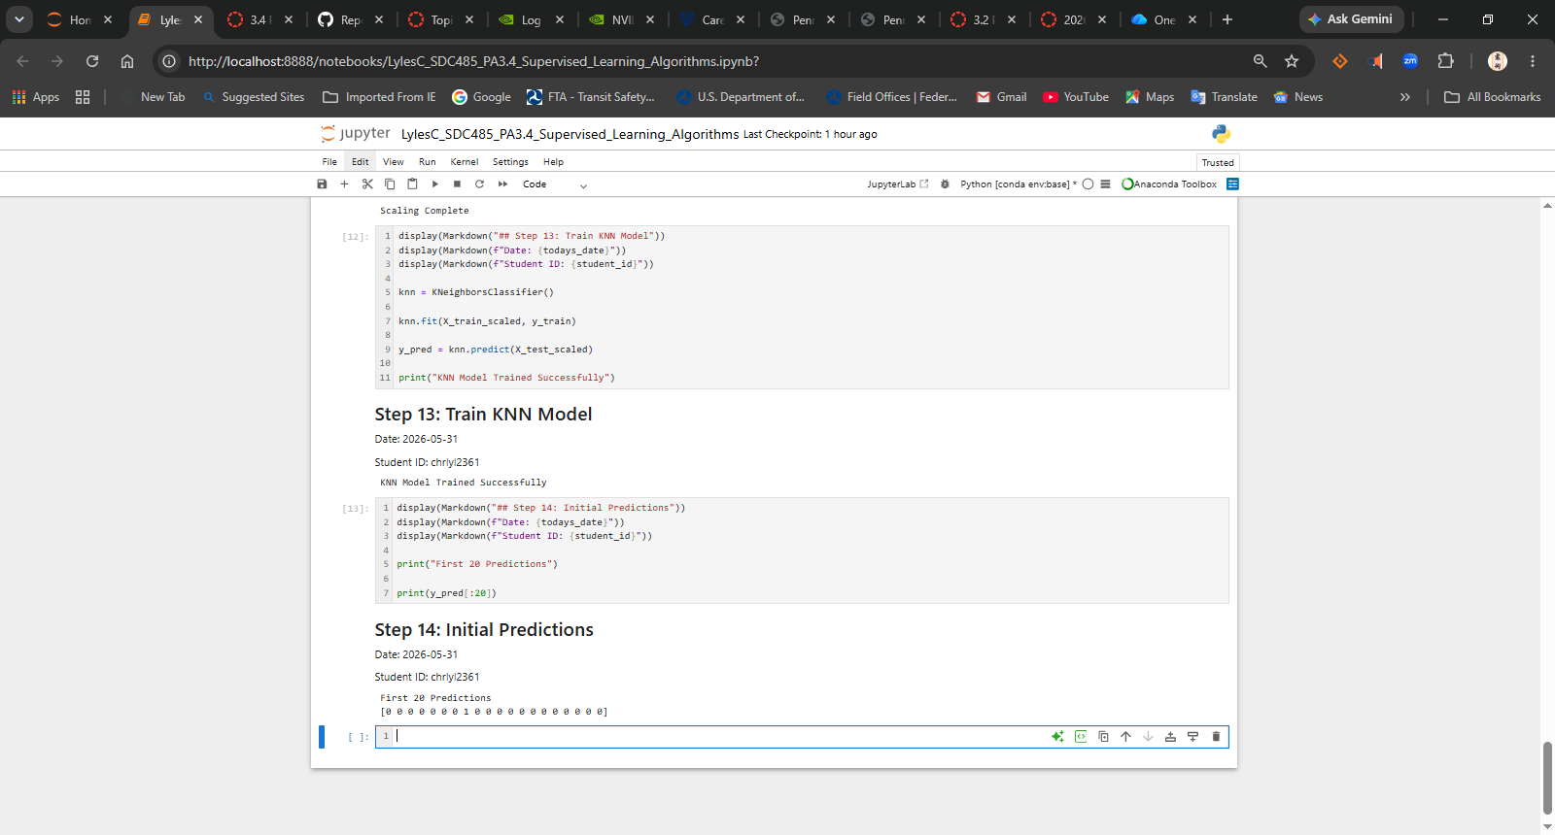
Step 15 - Evaluate Original Model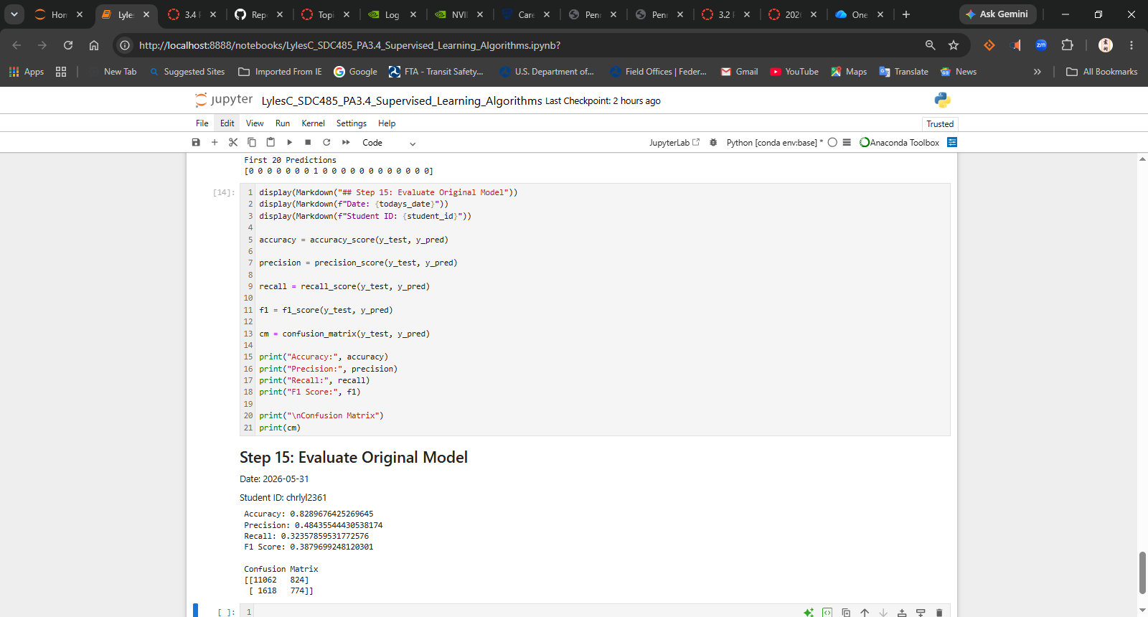
Step 16 – GridSearchCV
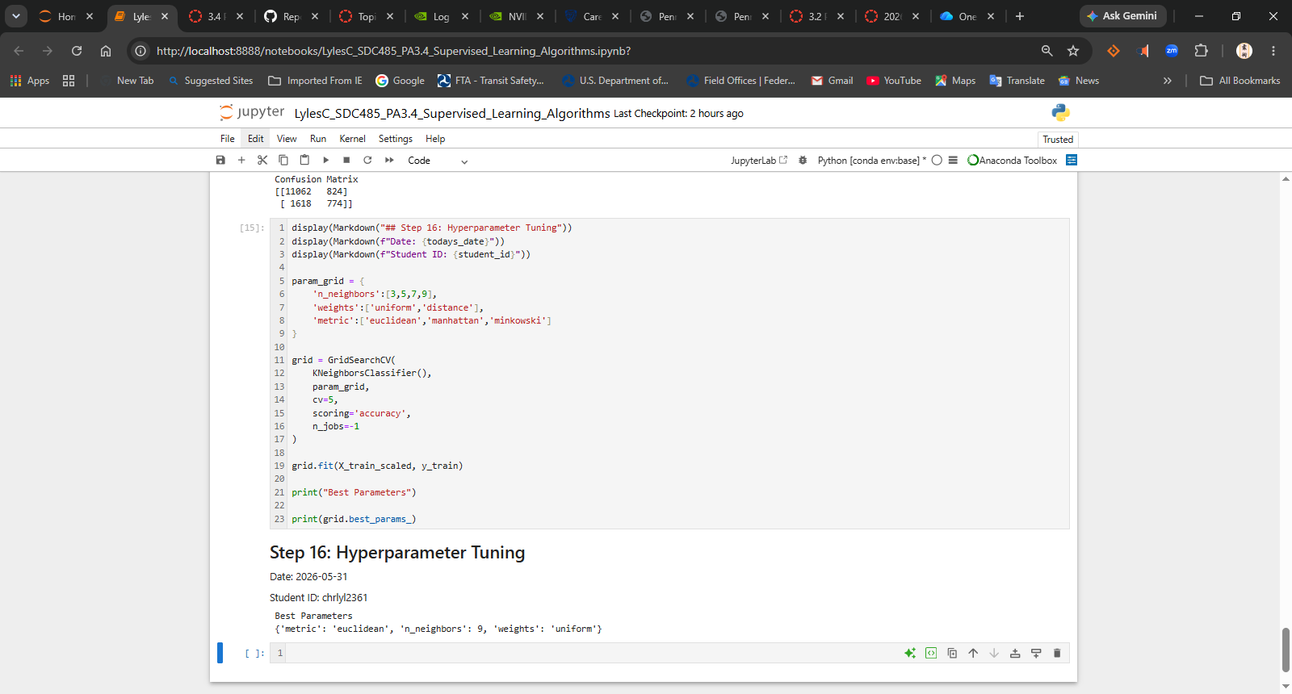
Step 17 - Refit Tuned Model
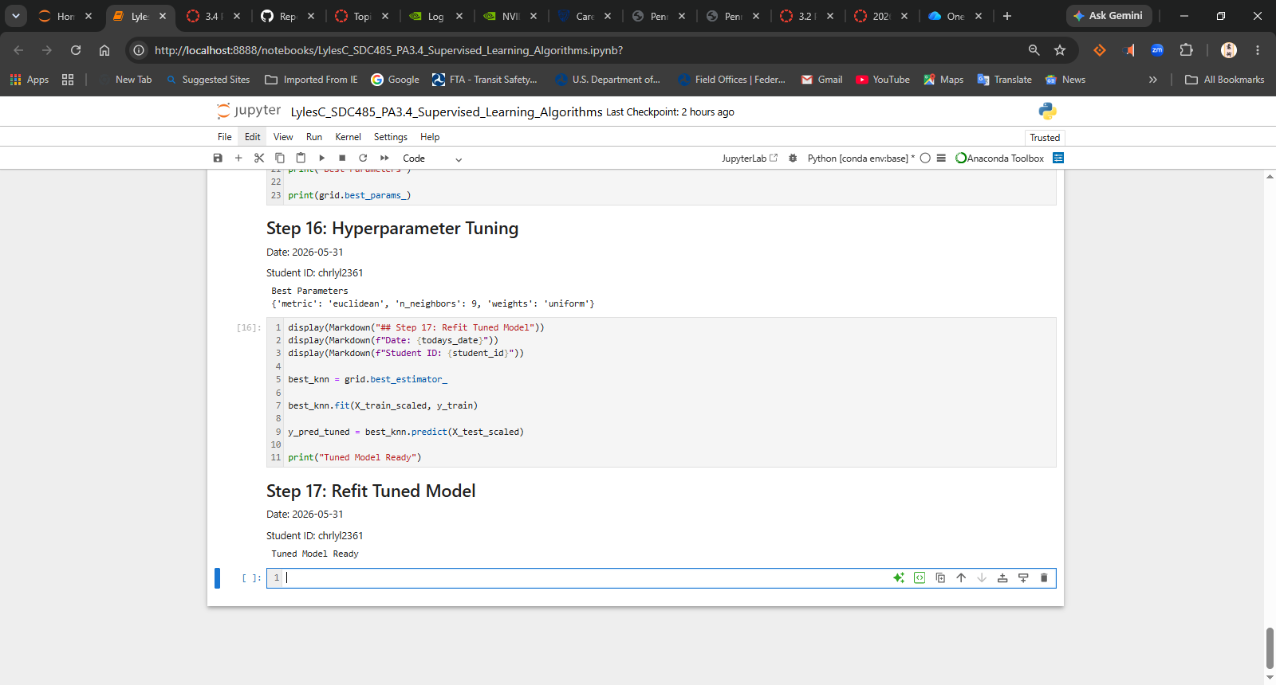
Step 18 - Evaluate Tuned Model
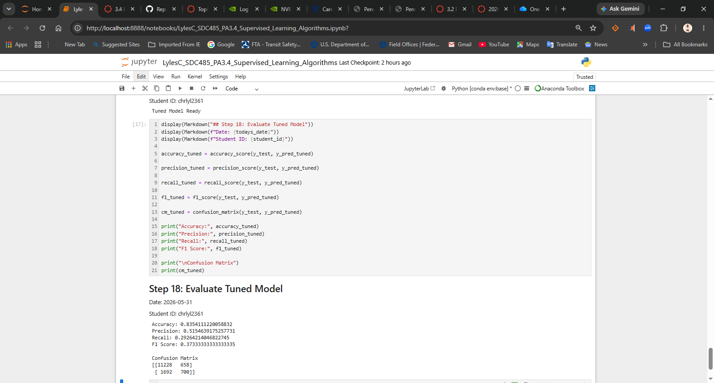
Step 19 - Confusion Matrix Heatmap
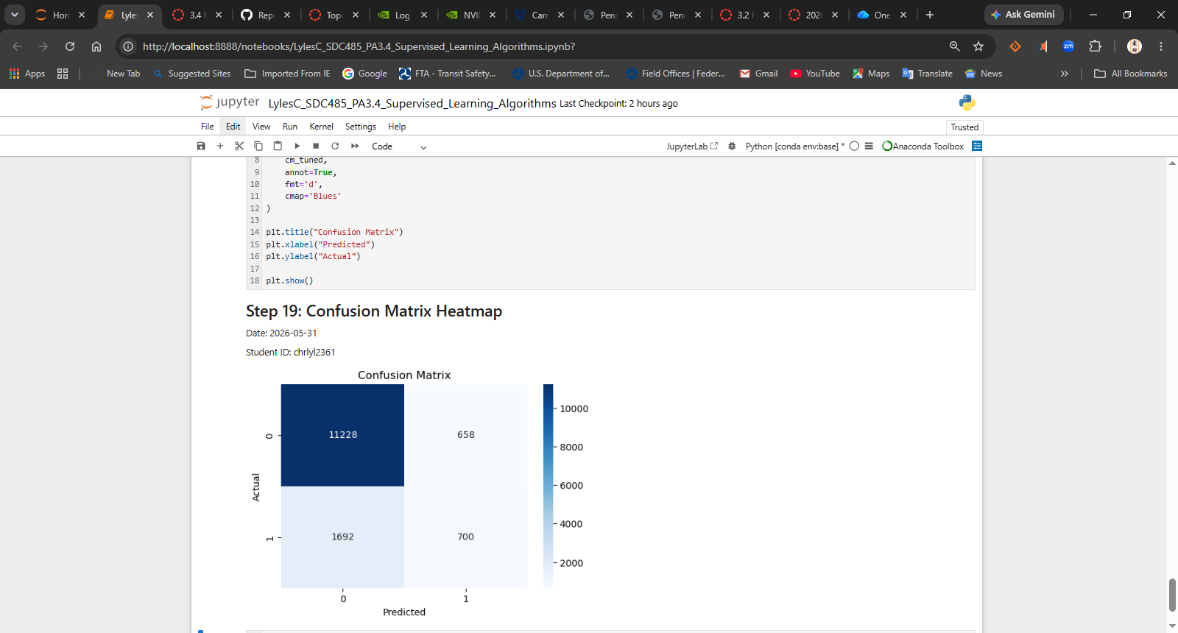
Step 20 - ROC Curve and AUC
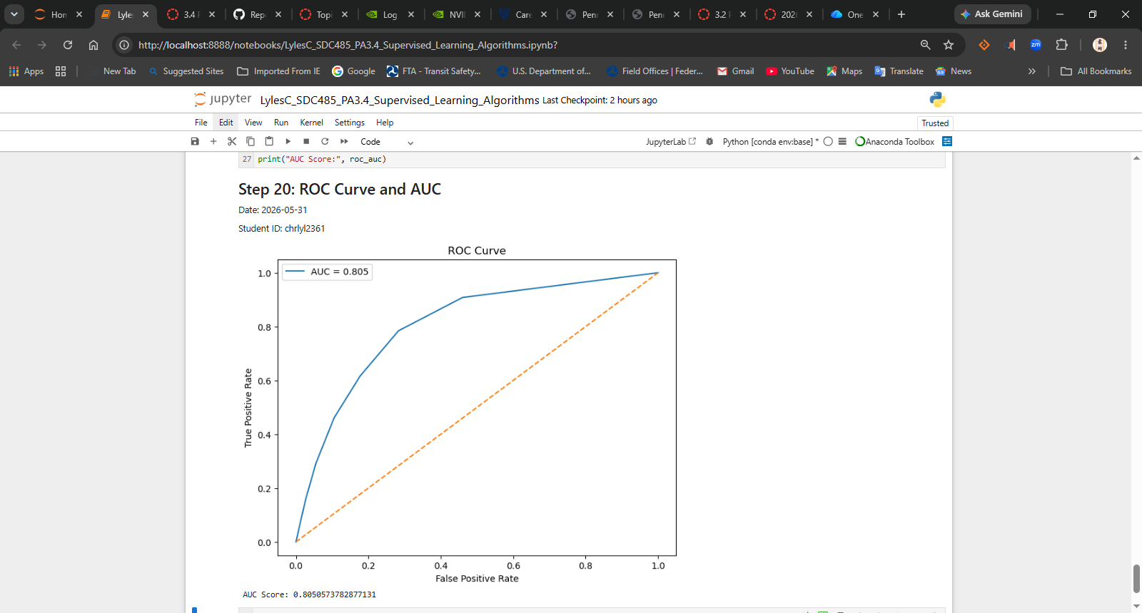
Step 21 – Question and Answer Markdown Cell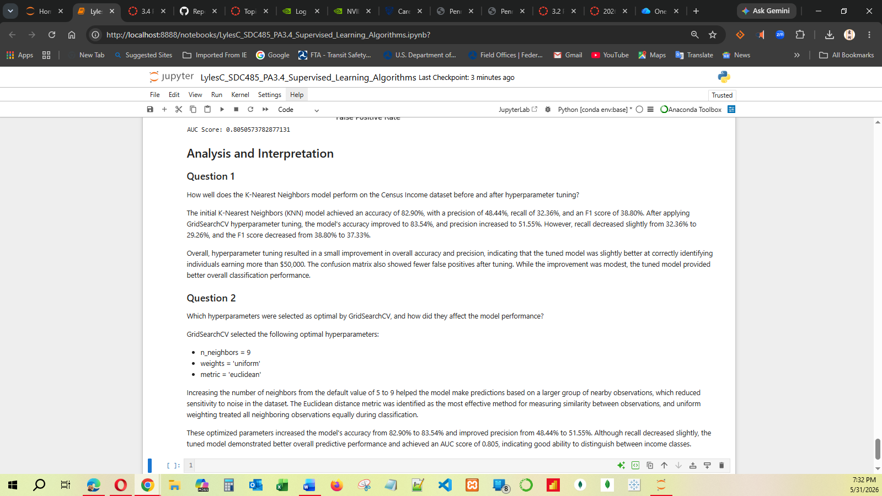

Questions
Answer the required questions in the space below.
- How well does the K-Nearest Neighbors model perform on the Census Income dataset before and after hyperparameter tuning?
  - The initial K-Nearest Neighbors (KNN) model achieved an accuracy of 82.90%, with a precision of 48.44%, recall of 32.36%, and an F1 score of 38.80%. After applying GridSearchCV hyperparameter tuning, the model's accuracy improved to 83.54%, and precision increased to 51.55%. However, recall decreased slightly from 32.36% to 29.26%, and the F1 score decreased from 38.80% to 37.33%.
  - Overall, hyperparameter tuning resulted in a small improvement in overall accuracy and precision, indicating that the tuned model was slightly better at correctly identifying individuals earning more than $50,000. The confusion matrix also showed fewer false positives after tuning. While the improvement was modest, the tuned model provided better overall classification performance.
- Which hyperparameters were selected as optimal by GridSearchCV, and how did they affect the model performance?
  - GridSearchCV selected the following optimal hyperparameters:
- n_neighbors = 9
- weights = 'uniform'
- metric = 'euclidean'
  - Increasing the number of neighbors from the default value of 5 to 9 helped the model make predictions based on a larger group of nearby observations, which reduced sensitivity to noise in the dataset. The Euclidean distance metric was identified as the most effective method for measuring similarity between observations, and uniform weighting treated all neighboring observations equally during classification.
  - These optimized parameters increased the model's accuracy from 82.90% to 83.54% and improved precision from 48.44% to 51.55%. Although recall decreased slightly, the tuned model demonstrated better overall predictive performance and achieved an AUC score of 0.805, indicating good ability to distinguish between income classes.

