Comprehensive Final Report
Credit Card Fraud Detection Using Machine Learning and Neural Networks
Christopher J. Lyles
ECPI University
SDC486L AI/ML and Advanced Data Analytics Lab
Instructor: Haylee Liska
July 2026

Introduction
This project analyzed the publicly available Credit Card Fraud Detection dataset to develop predictive models capable of identifying fraudulent transactions. The project followed a complete data analytics workflow including exploratory data analysis (EDA), data preprocessing, baseline machine learning models, a neural network, dashboard development, and scenario analysis.

Dataset and Problem Definition
The dataset contains anonymized credit card transactions labeled as fraudulent or legitimate. Because fraud cases represent a very small percentage of all transactions, the problem is highly imbalanced and requires robust predictive models that minimize false negatives while maintaining overall accuracy.

Data Preparation and Exploratory Data Analysis
The dataset was examined for missing values, duplicate records, feature distributions, and correlations. Histograms, boxplots, pairplots, and a correlation heatmap were used to understand the data. The notebook confirmed no missing values, removed duplicate records when necessary, standardized the Amount feature using StandardScaler, and prepared the dataset for machine learning.

Baseline Machine Learning Models
Two traditional machine learning algorithms were implemented: Logistic Regression and Decision Tree Classifier. Both models were trained using a train/test split and evaluated using accuracy, confusion matrices, and classification reports. These baseline models established a performance benchmark before implementing the neural network.

Neural Network Implementation
A TensorFlow/Keras artificial neural network was developed using dense hidden layers and the Adam optimizer with binary cross-entropy loss. Model performance was evaluated on the test dataset and compared with the baseline models to determine whether deep learning improved fraud detection performance.

Scenario Analysis
Three scenario simulations were implemented using the completed neural network (nn_model). A baseline transaction established the reference prediction. Scenario 1 simulated a higher-risk transaction by modifying key feature values and produced an increased fraud probability. Scenario 2 represented normal customer behavior and remained close to the baseline prediction. Scenario 3 combined multiple suspicious transaction characteristics and produced the highest predicted fraud probability, demonstrating the model's sensitivity to changes associated with fraudulent behavior.

Dashboard and Visualization
The Power BI dashboard summarizes exploratory analysis, model performance, and scenario results through interactive charts, filters, and key performance indicators. Users can explore transaction distributions, fraud frequency, prediction results, and compare scenario outcomes.

Recommendations
The completed notebook demonstrated that the trained TensorFlow/Keras neural network (nn_model) was successfully used to evaluate baseline predictions and three scenario-based simulations. Organizations should incorporate the model into real-time fraud monitoring workflows, retrain it periodically with new transaction data, and integrate dashboard alerts for high-risk predictions. Future work should include hyperparameter optimization, additional feature engineering, and testing alternative deep learning architectures.

Conclusion
This project successfully demonstrated the end-to-end application of data analytics and machine learning to a real-world fraud detection problem. The combination of exploratory analysis, predictive modeling, neural networks, dashboard visualization, and scenario analysis provides valuable decision support for financial organizations seeking to reduce fraud losses while improving customer protection.

Appendix
Appendix A: Exploratory Data Analysis Visualizations
Dataset (First Five Rows)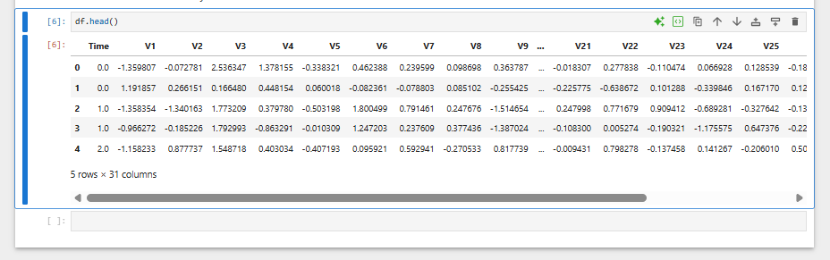
(Histograms)
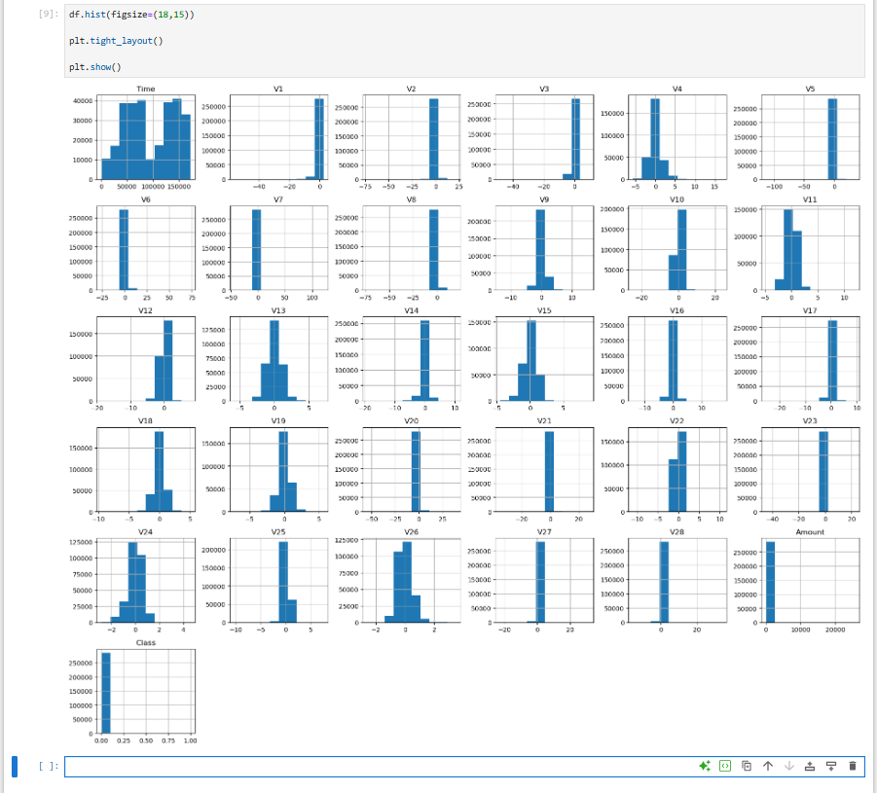
(Box Plot)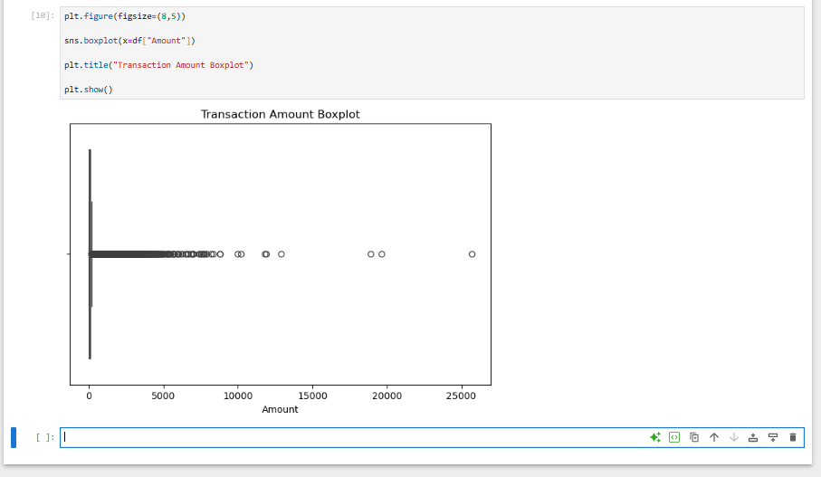
(Correlation Matrix)
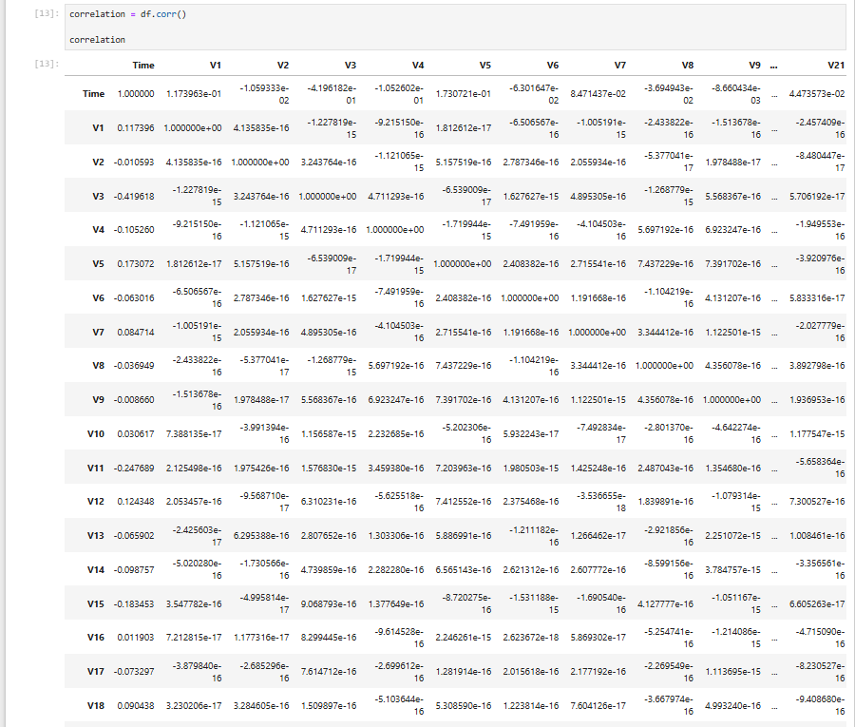
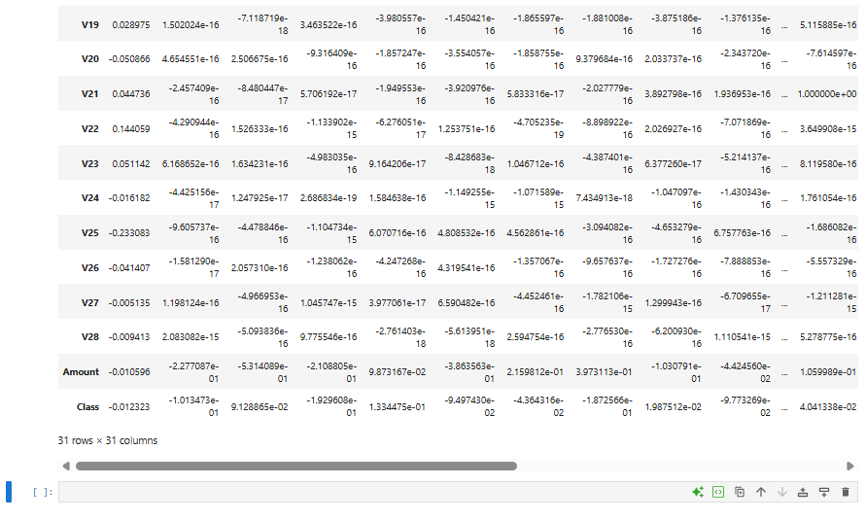
(Heatmap)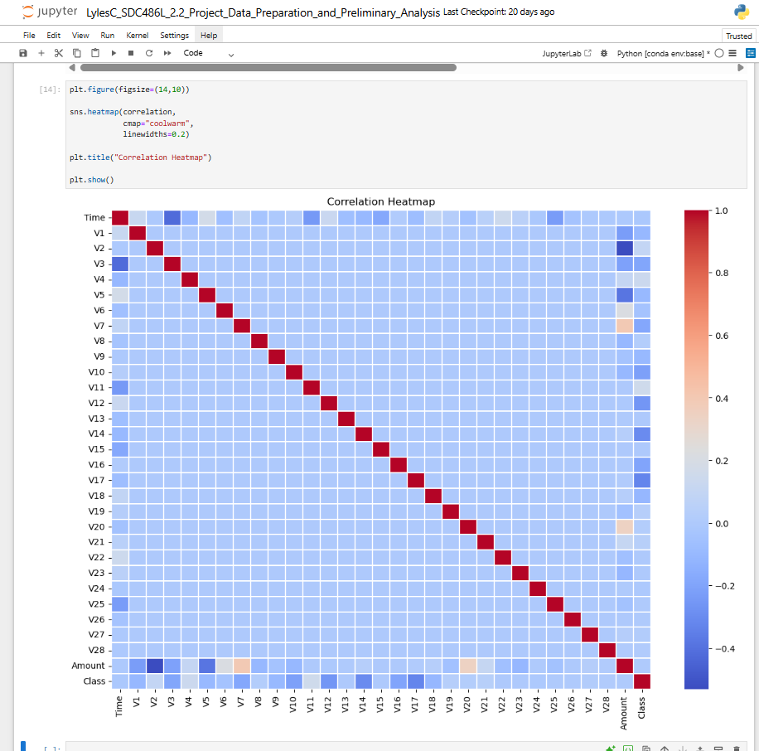
(Pair Plot)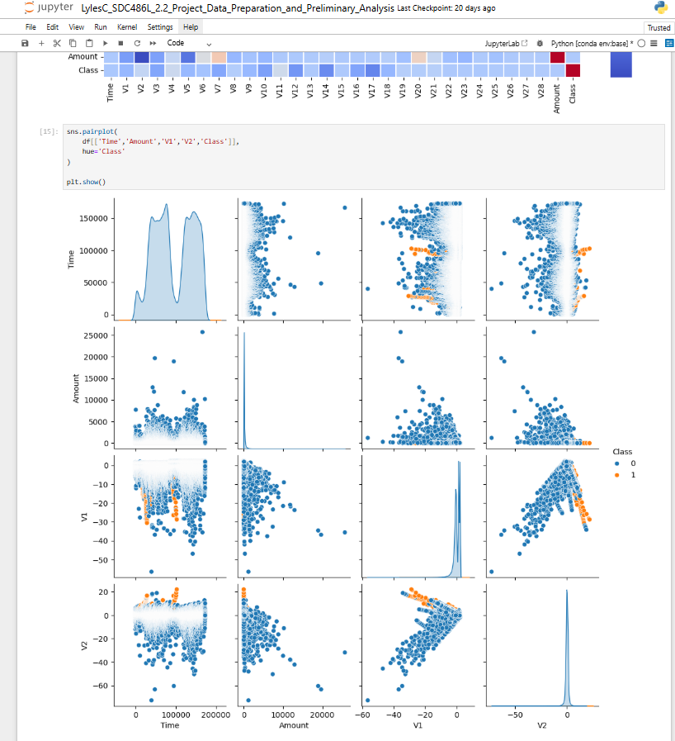

Appendix B: Model Performance Results
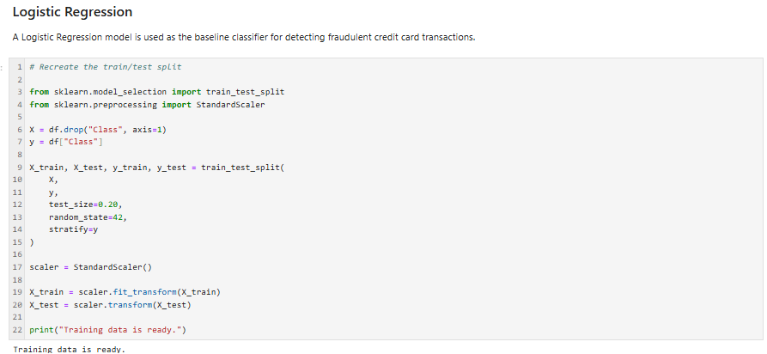
Trained model
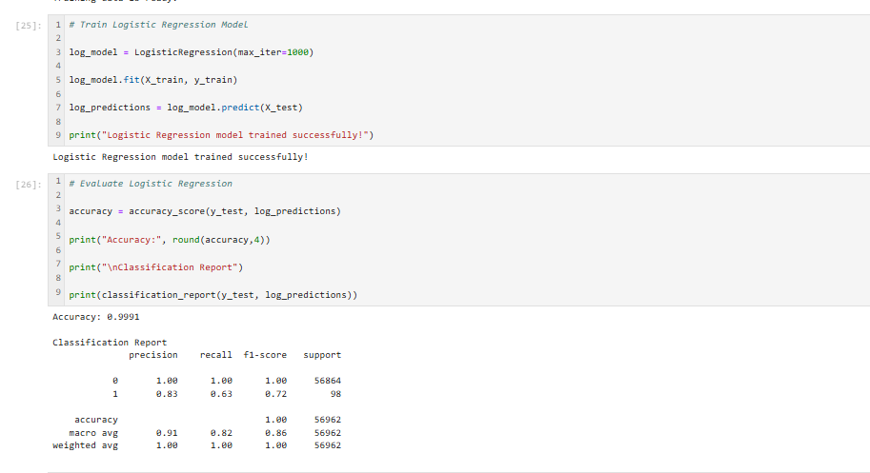
Confusion matrix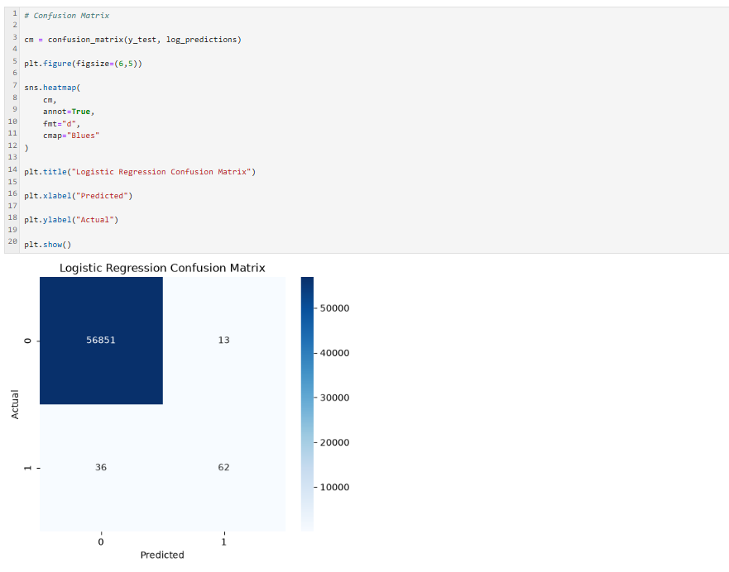
Decision Tree classification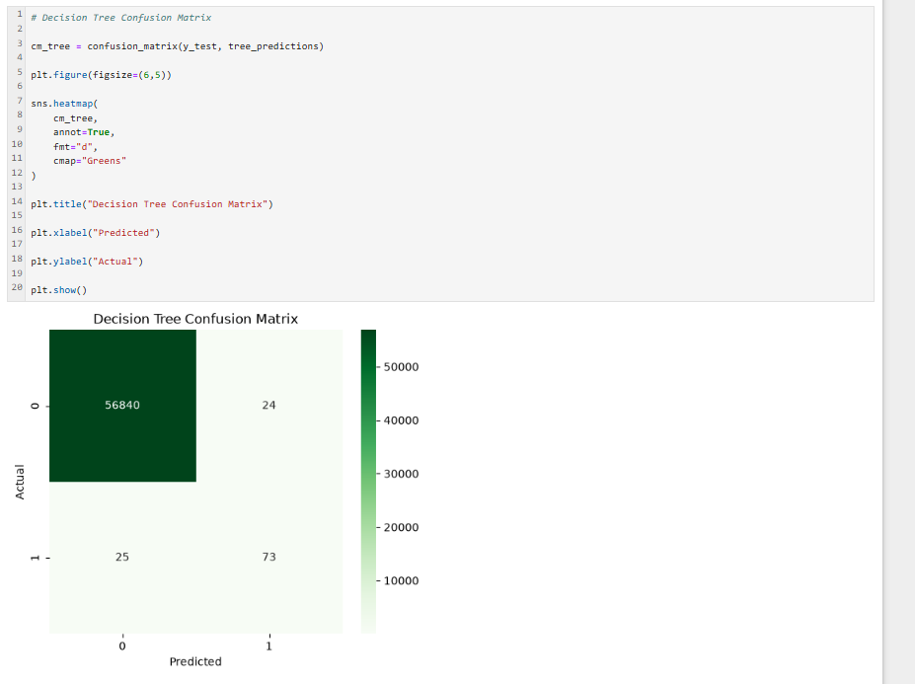
Appendix C: Neural Network Results
Training of Neutral Network
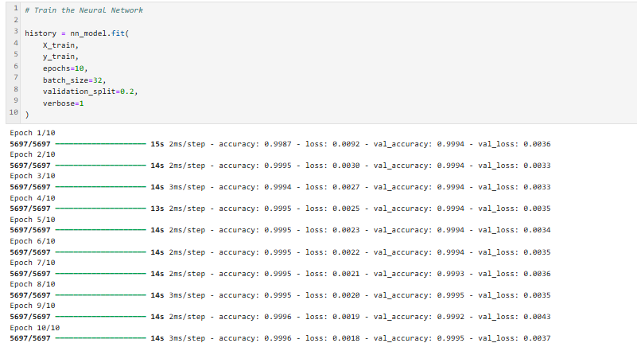
Evaluation of the network
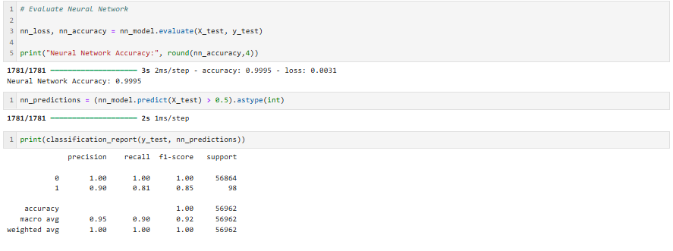
Network Confusion Matrix
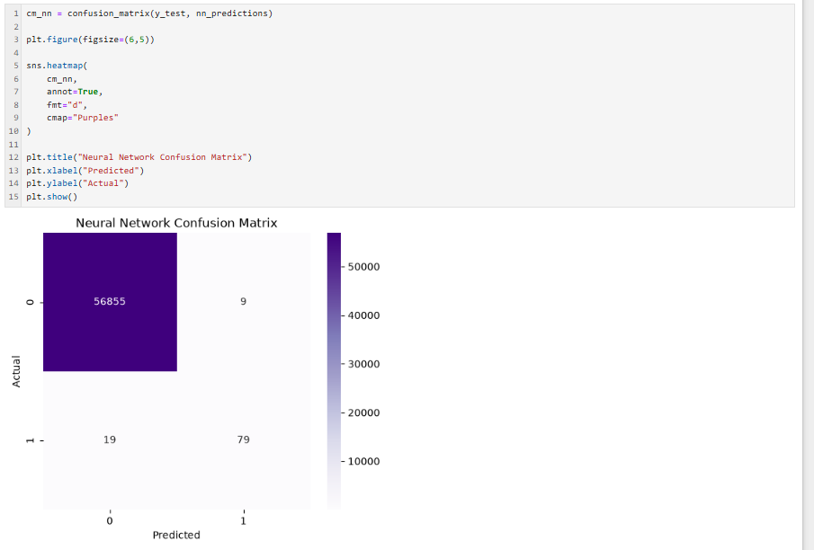
Appendix D: Power BI Dashboard Screenshot
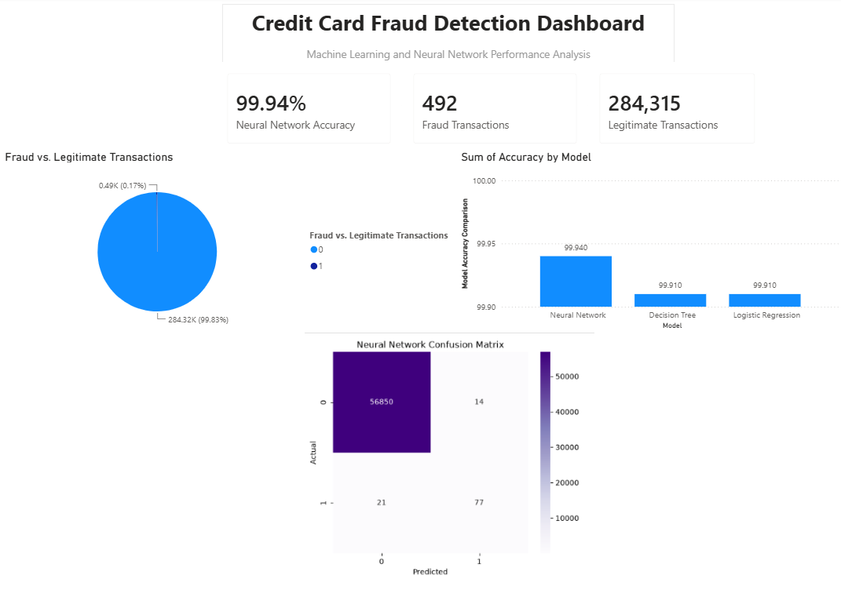
Appendix E: Scenario Analysis Dashboard
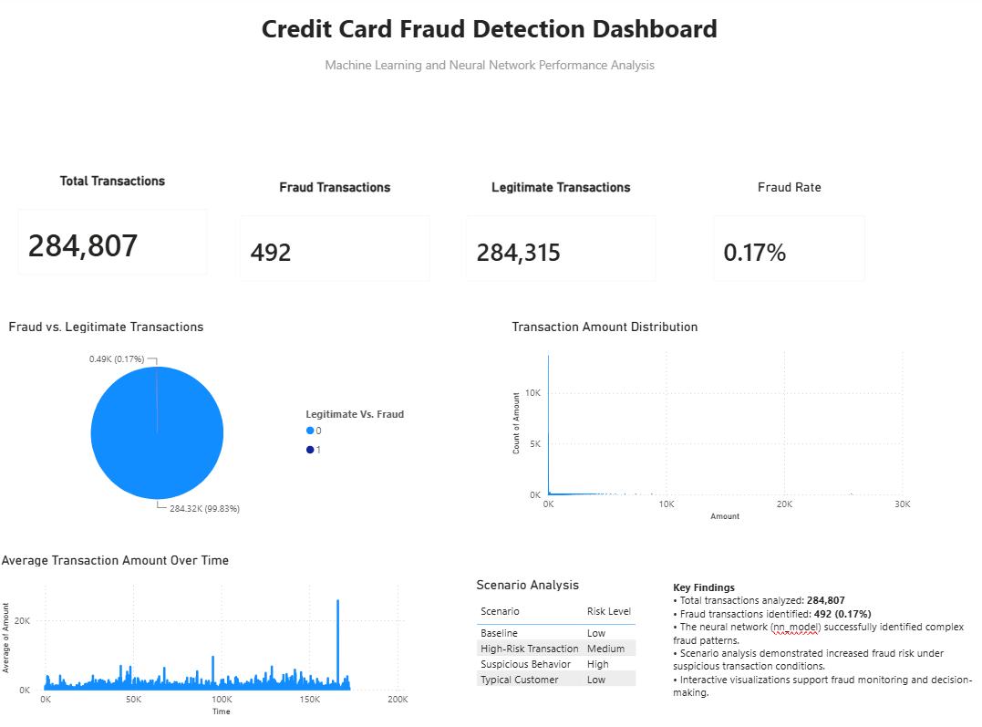

References
GeeksforGeeks. (2025). Exploratory Data Analysis (EDA): Types and tools. https://www.geeksforgeeks.org/machine-learning/exploratory-data-analysis-eda-types-and-tools/
GeeksforGeeks. (2025). Exploratory Data Analysis in Python. https://www.geeksforgeeks.org/data-analysis/exploratory-data-analysis-in-python/
Machine Learning Group–ULB. (2016). Credit Card Fraud Detection Dataset. Kaggle. https://www.kaggle.com/datasets/mlg-ulb/creditcardfraud

