Lab Report
Use this template to document your work as you complete your assignment.

Your Information
Your Name: Christopher Lyles
Assignment Title: 4.5 Performance Assessment - Model Tuning and Feature Engineering
Instructor: Thomas Clinger
Class: SDC485 - AI/ML and Data Analytics Methods and Modeling
GitHub Link:

Screenshots
As you complete the procedure, add the screenshots for the required step(s) below.
Create notebook and Markdown cell

Step 1 - Import Libraries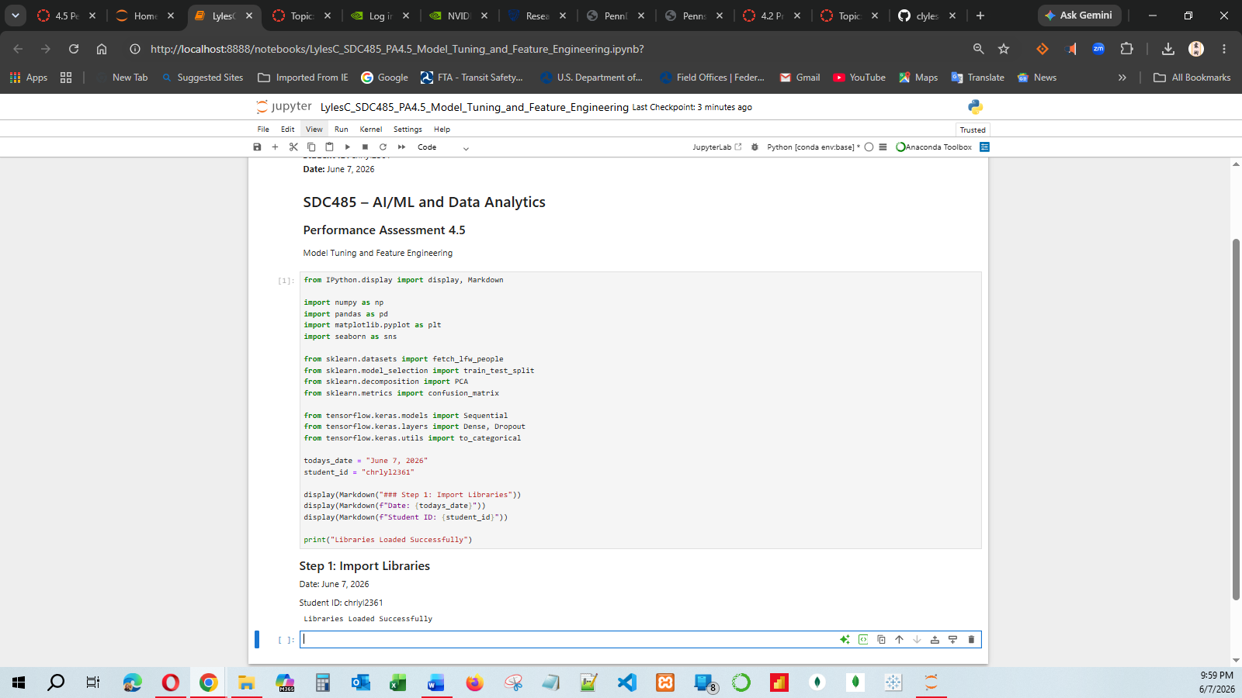
Step 2 - Load Dataset
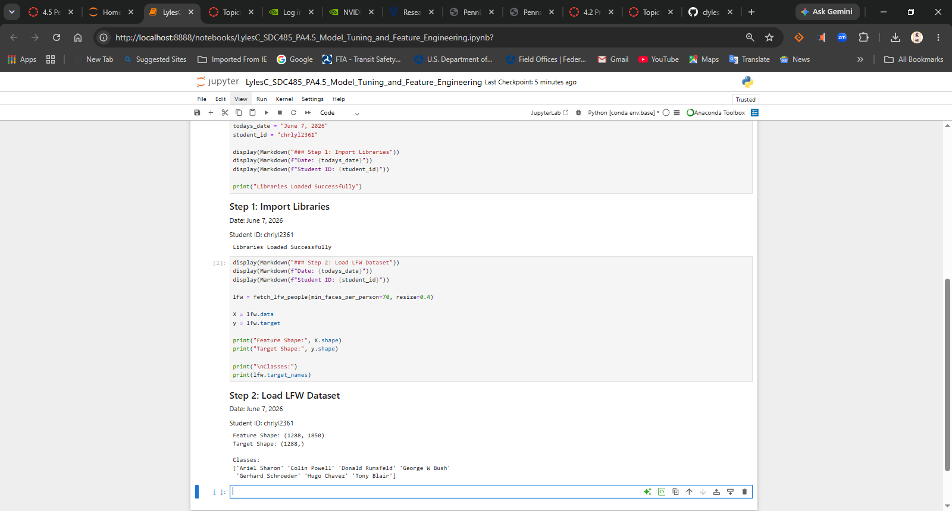
Step 3 - Display Sample Images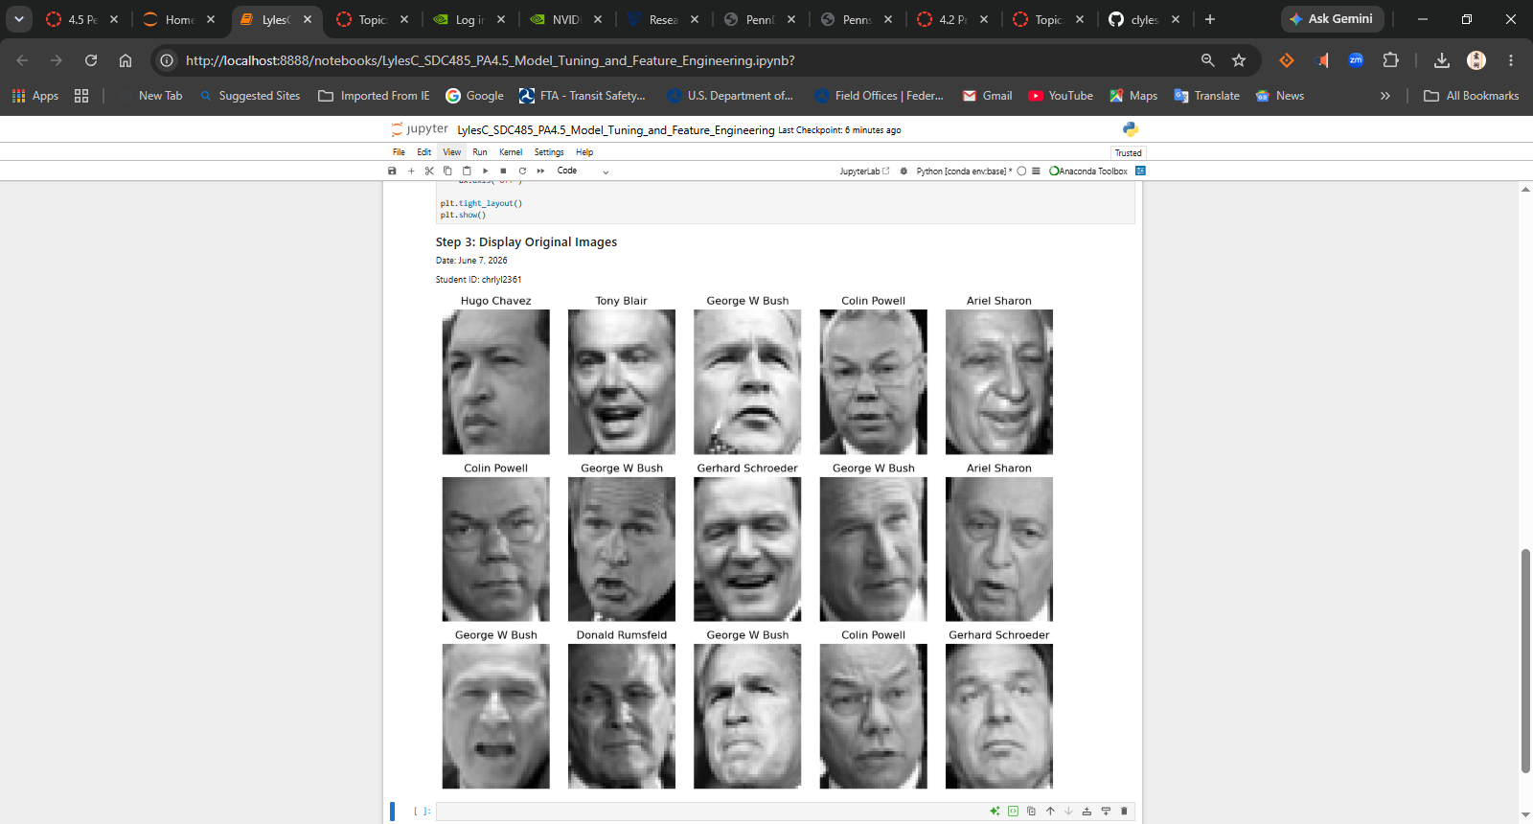
Step 4 - Normalize Data
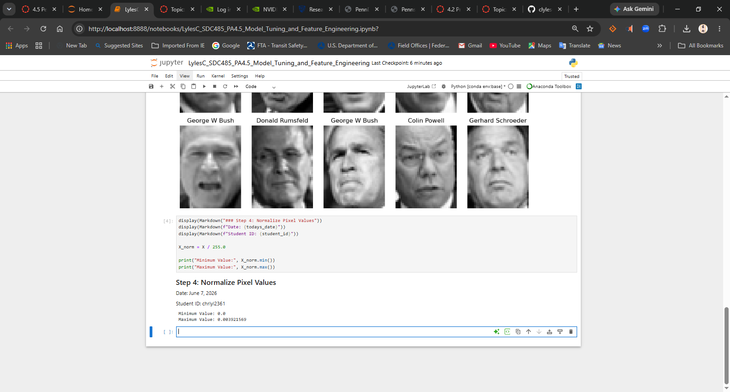
Step 5 - Create Min/Max Features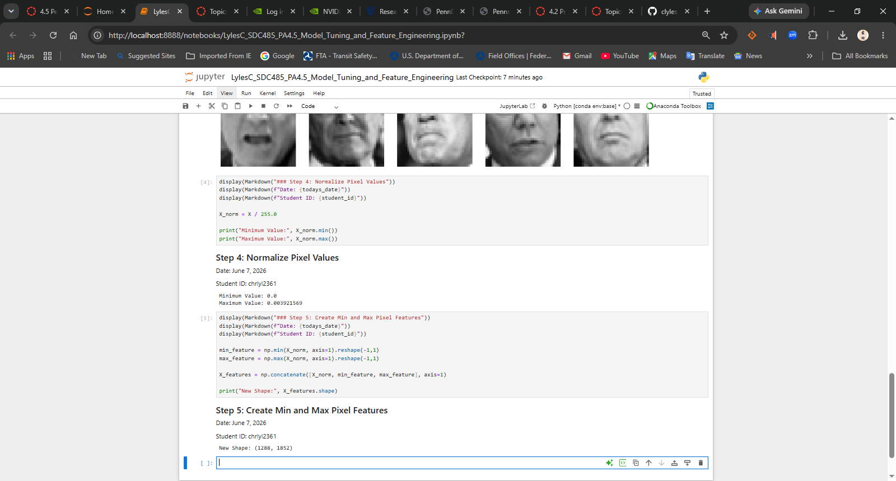
Step 6 - Train/Test Split
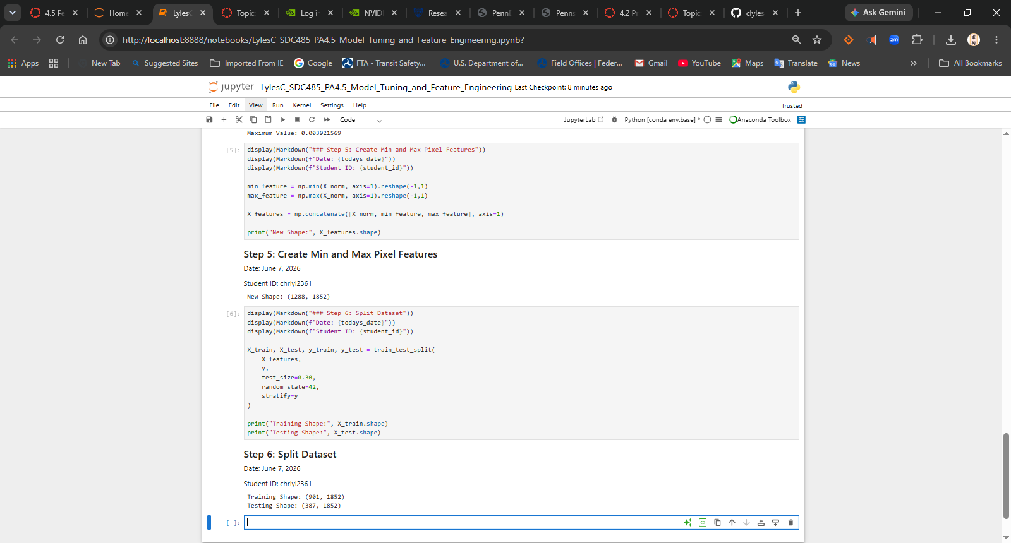
Step 7 - Convert Target to Categorical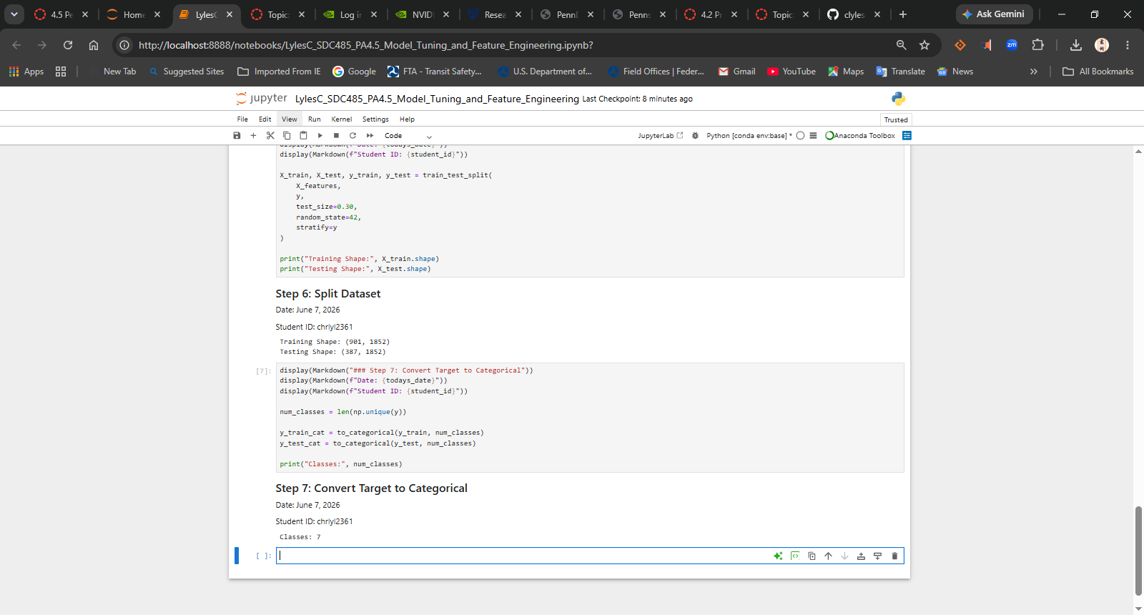
Step 8 - Display Shapes
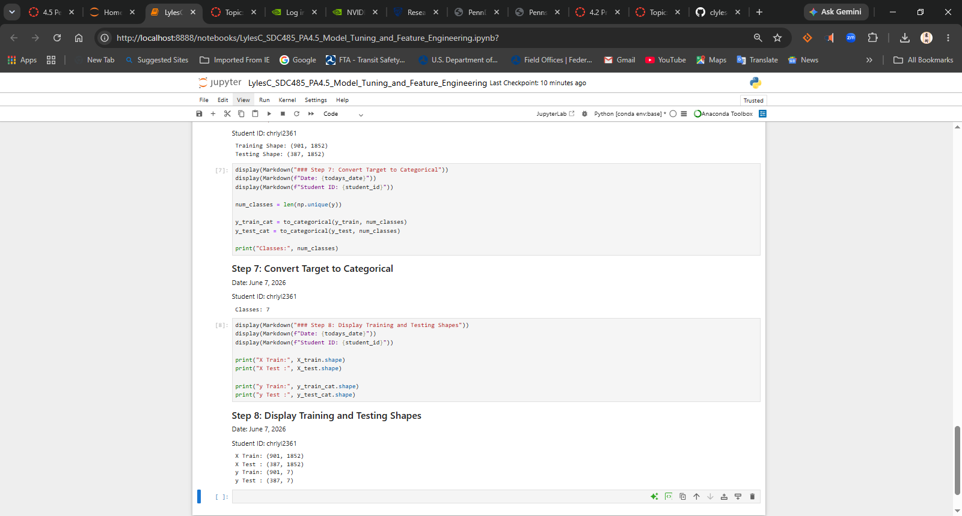
Step 9 - Build CNN Model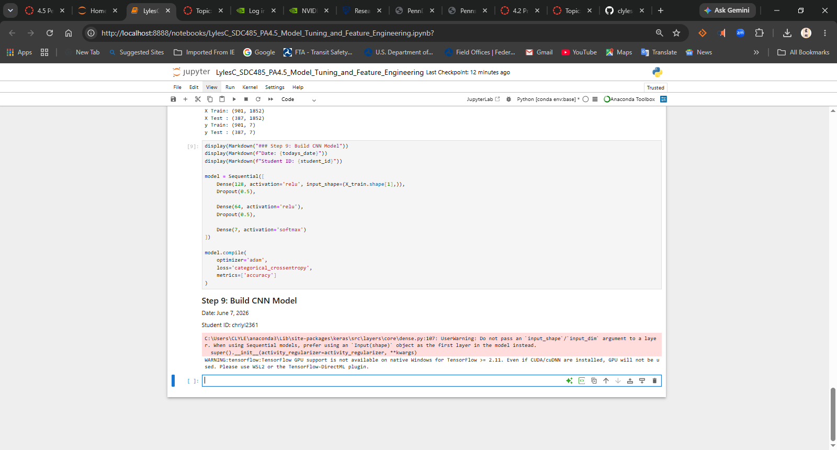
Step 10 - Model Summary
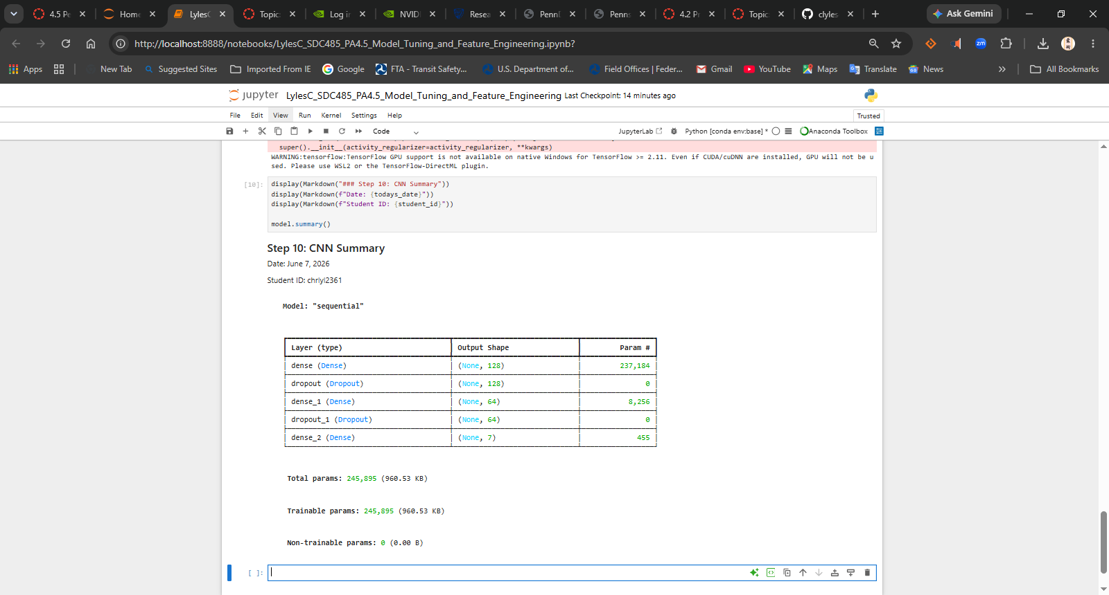
Step 11 - Train CNN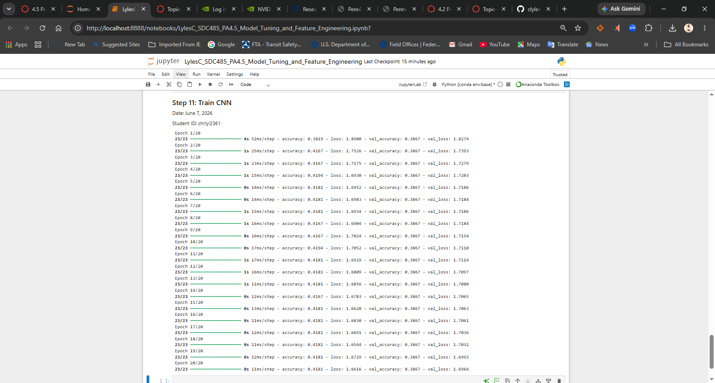
Step 12 - Display History
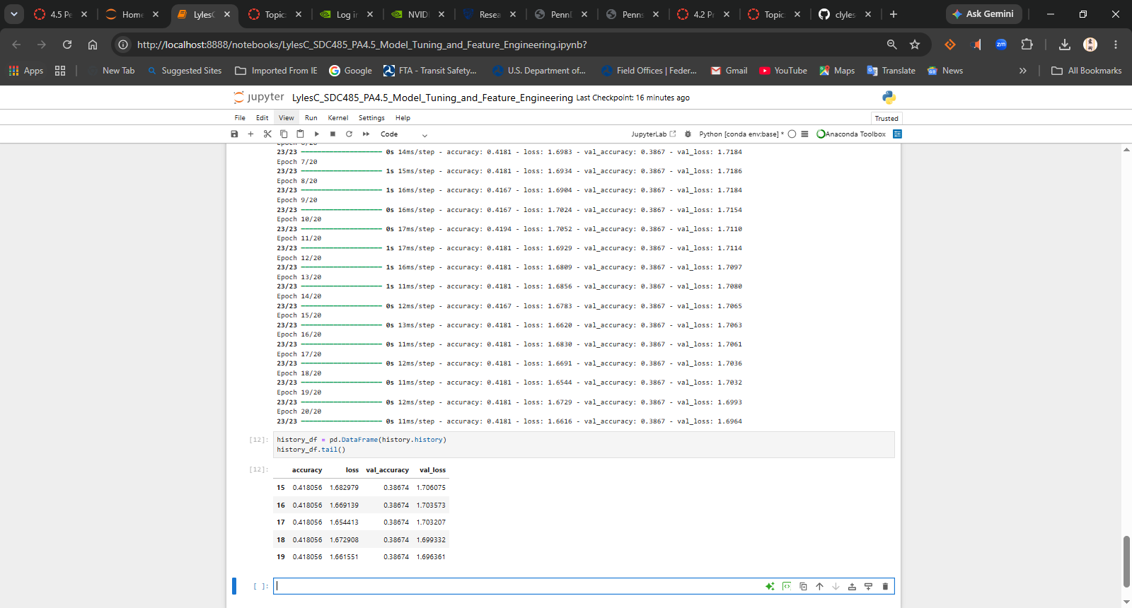
Step 13 - Evaluate CNN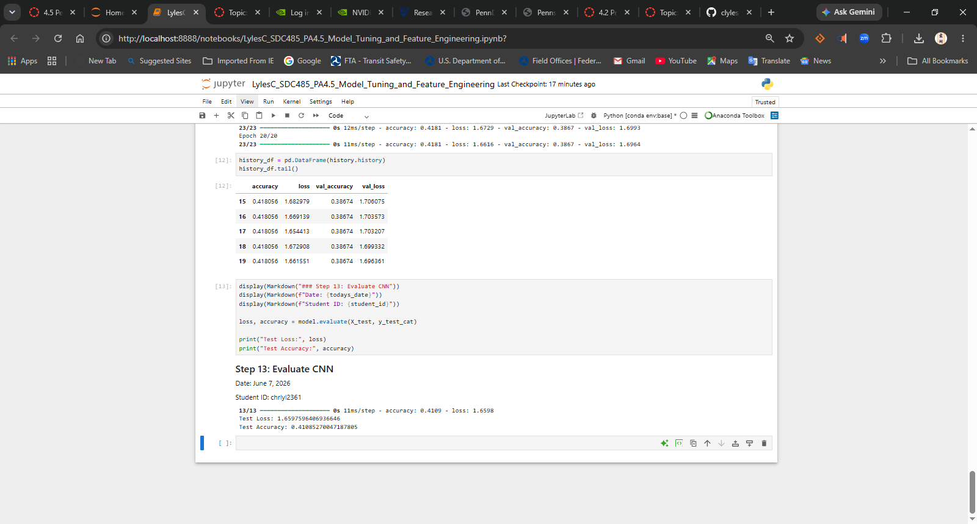
Step 14 – Predictions
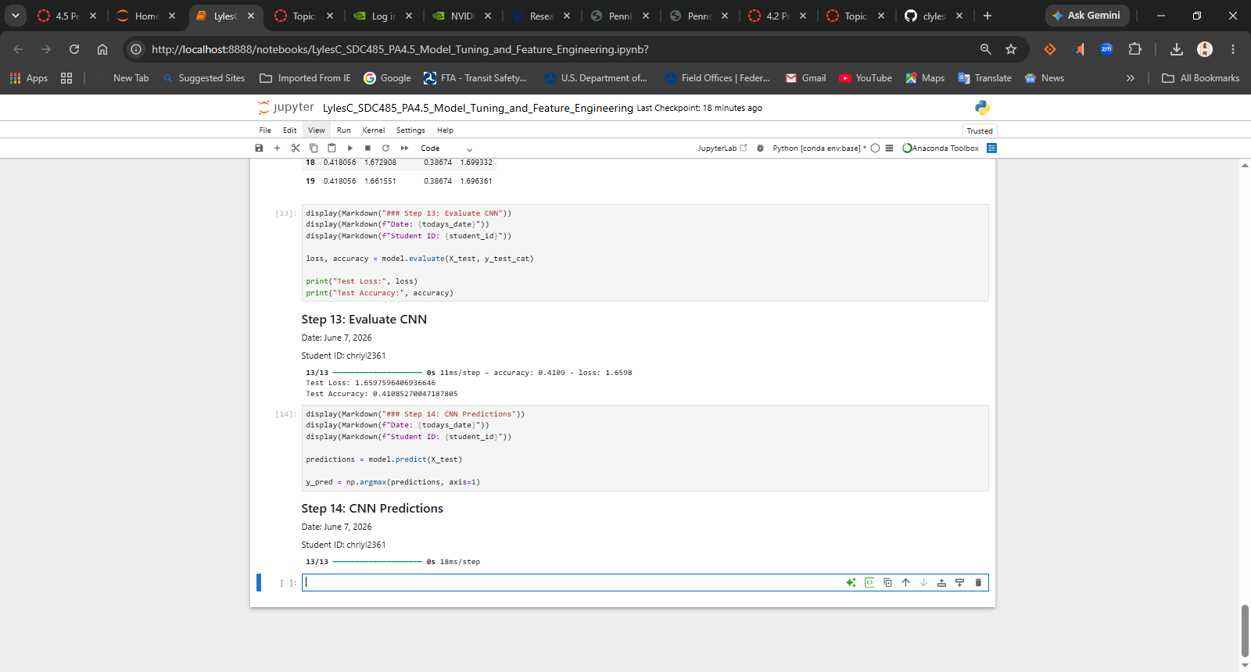
Step 15 - Confusion Matrix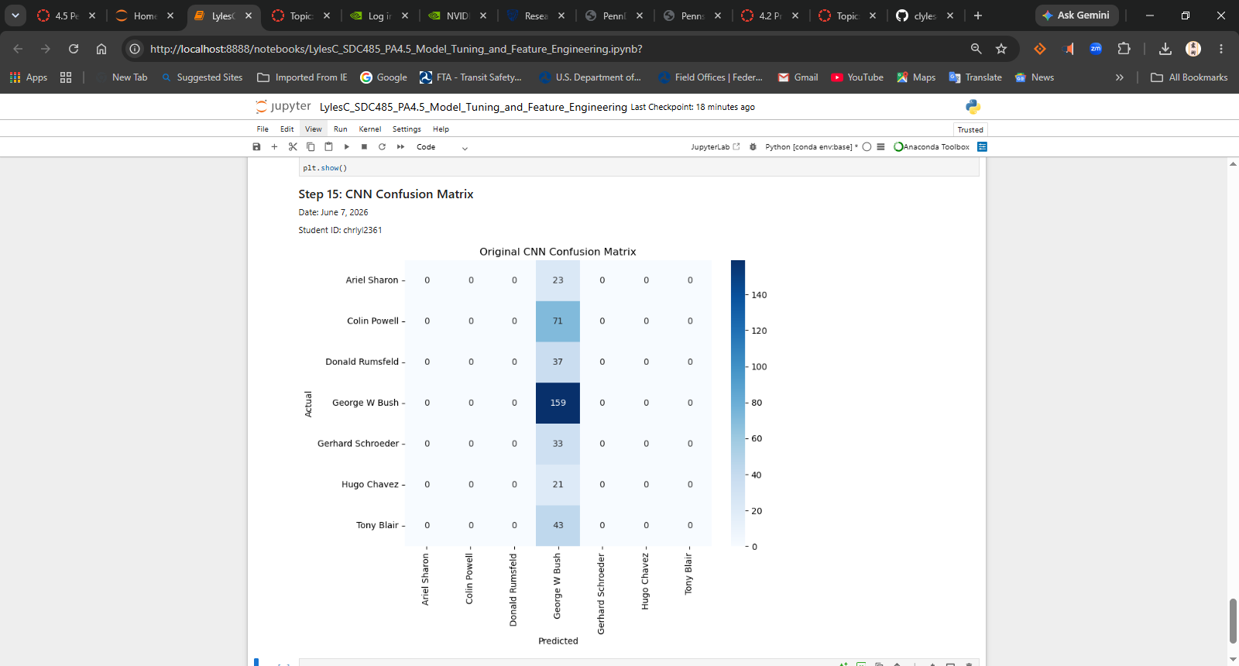
Step 16 - Apply PCA
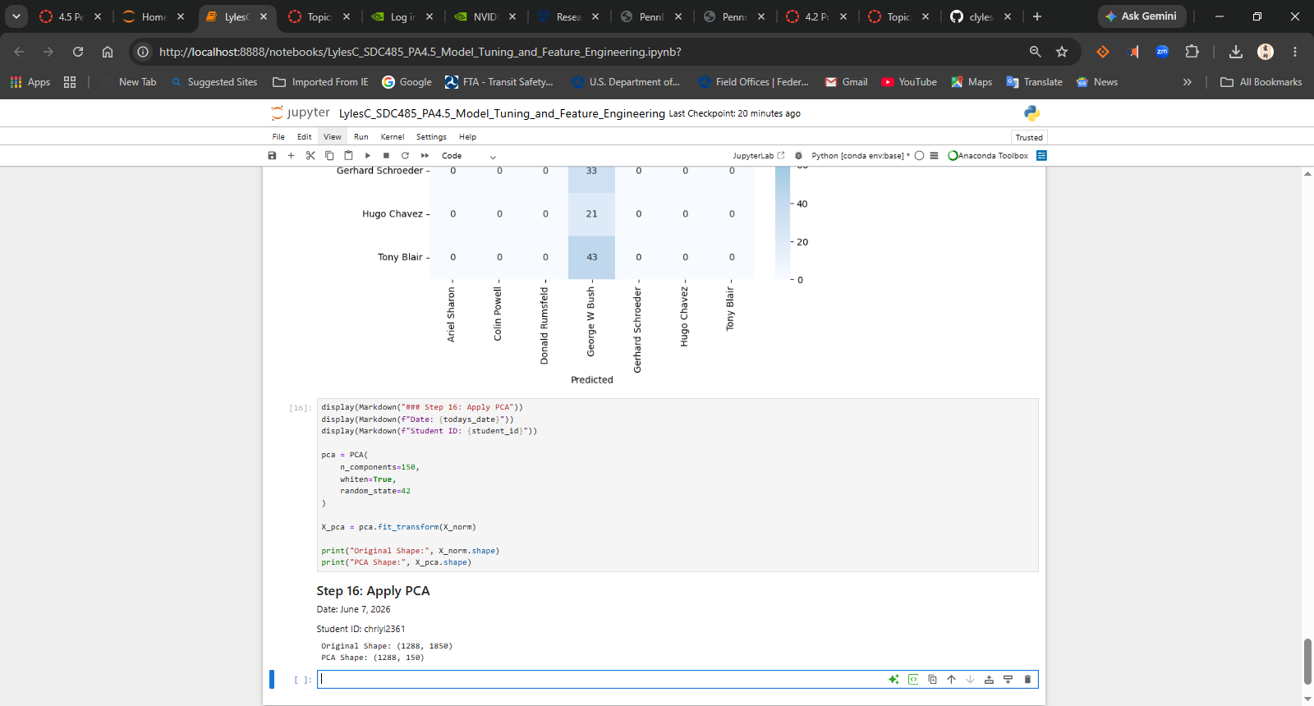
Step 17 - Add Min/Max Features to PCA Data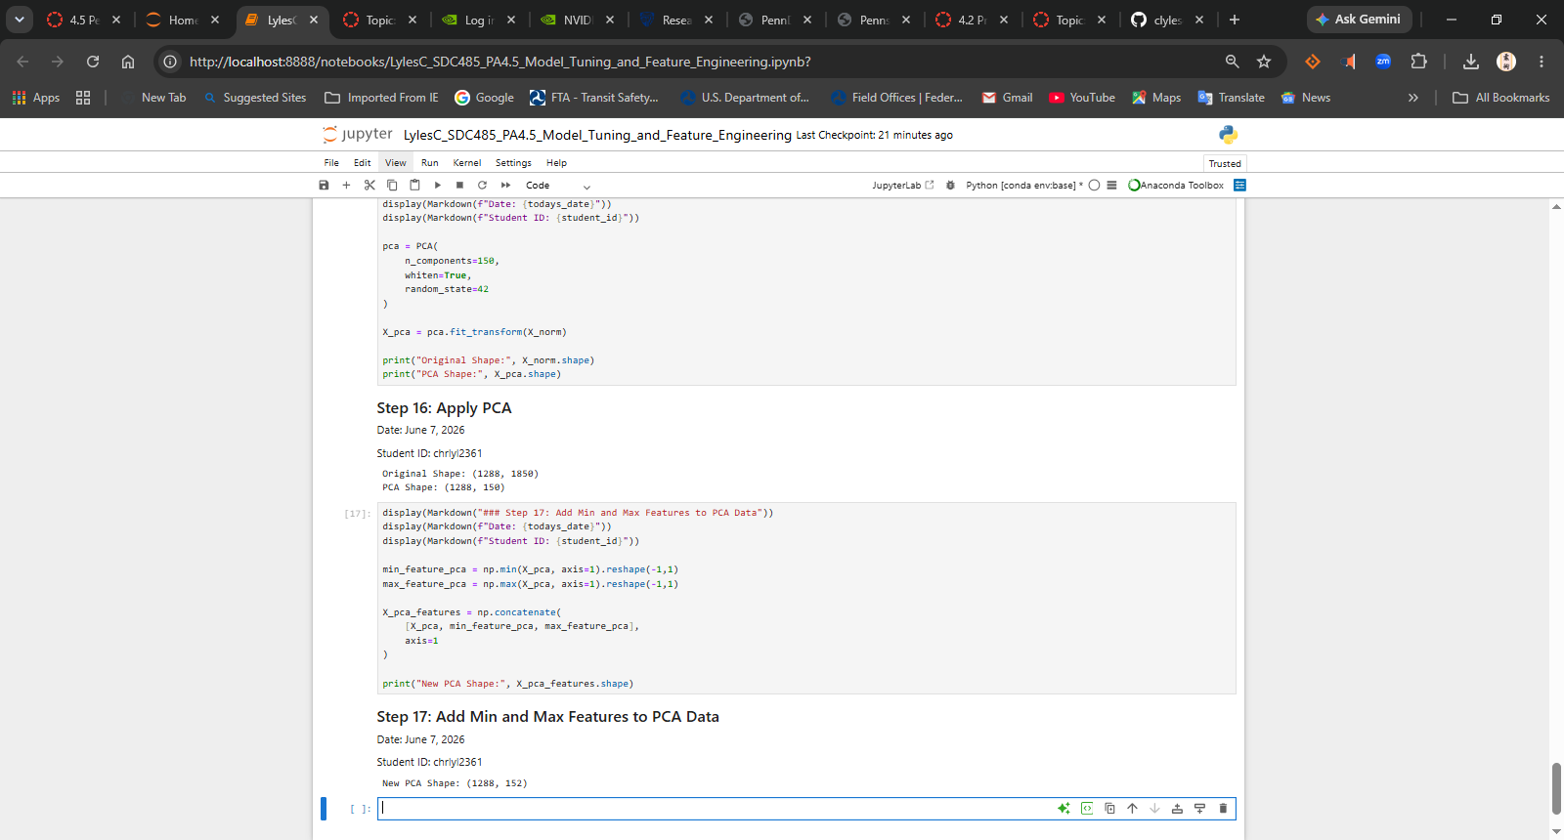
Step 18 - Split PCA Data
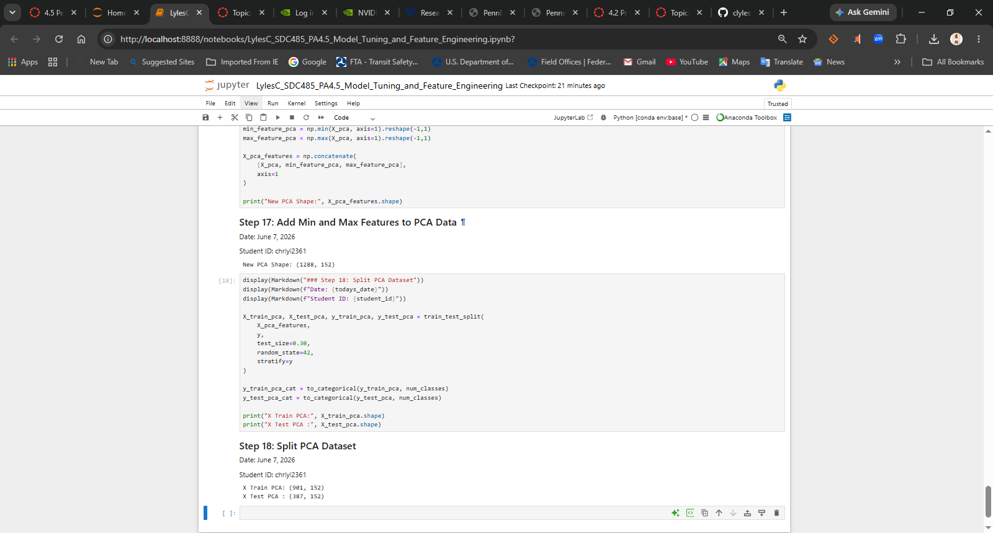
Step 19 - Build Tuned Model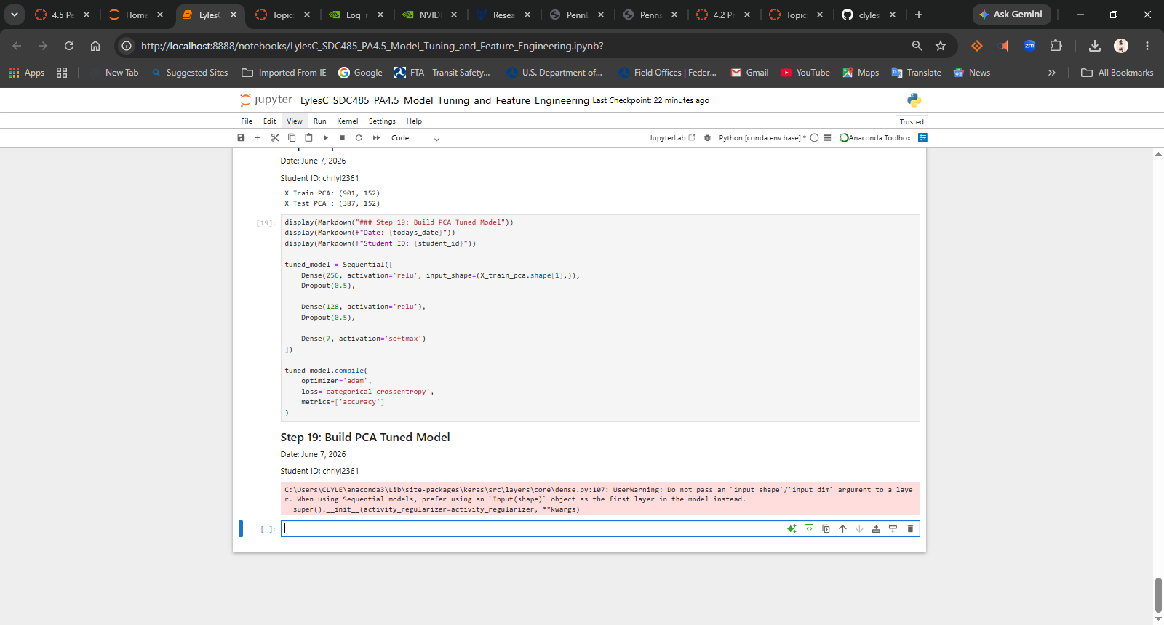
Step 20 - Tuned Model Summary
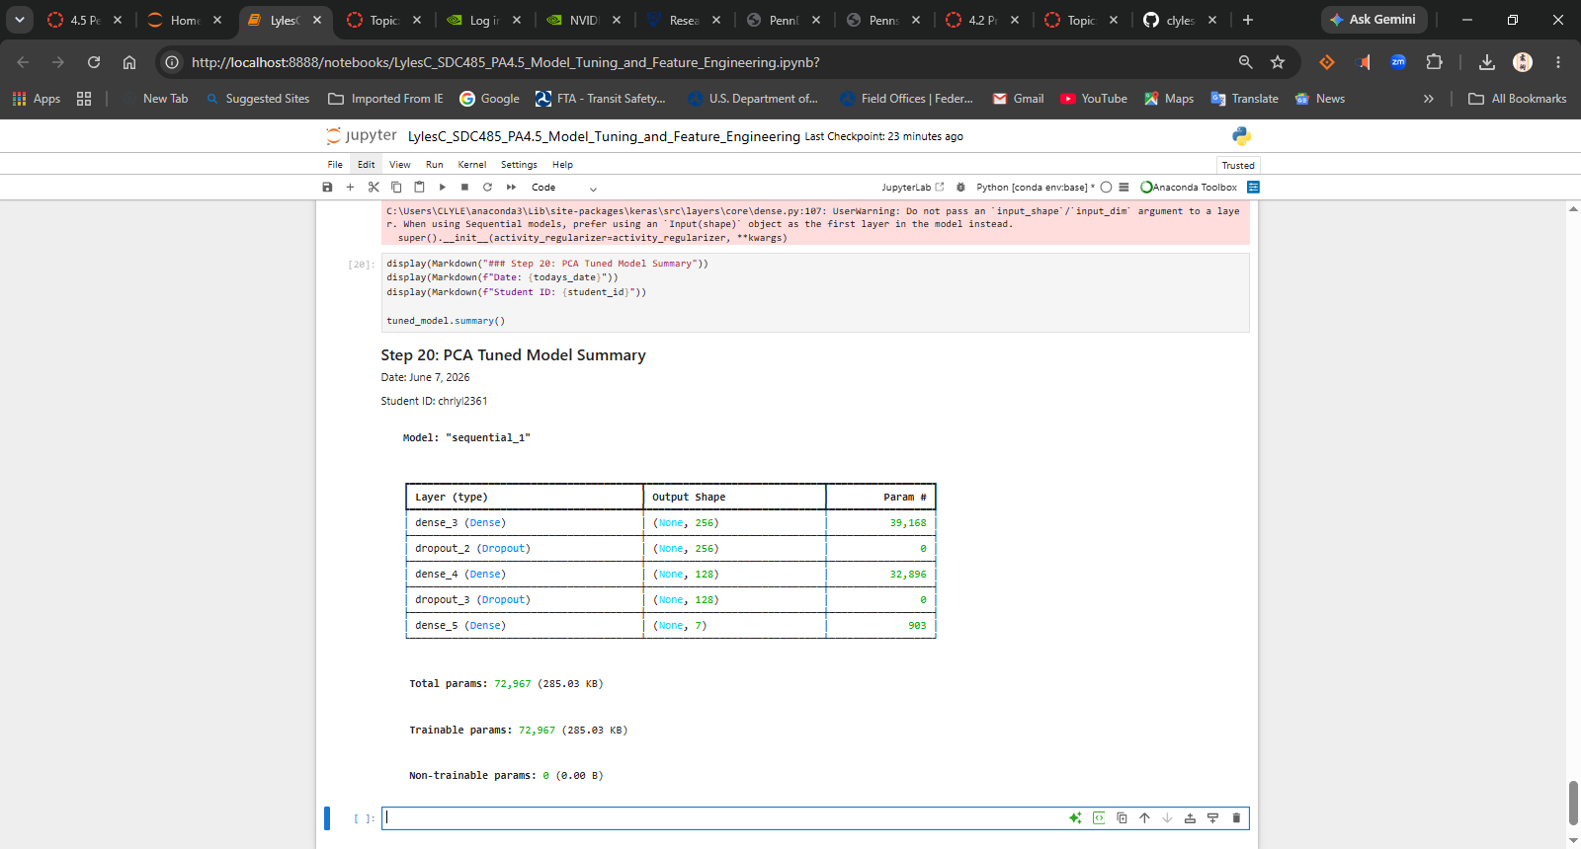
Step 21 - Train Tuned Model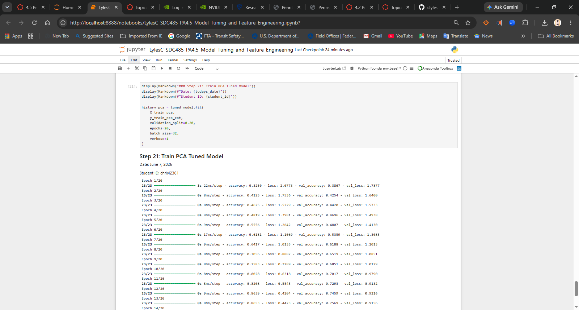
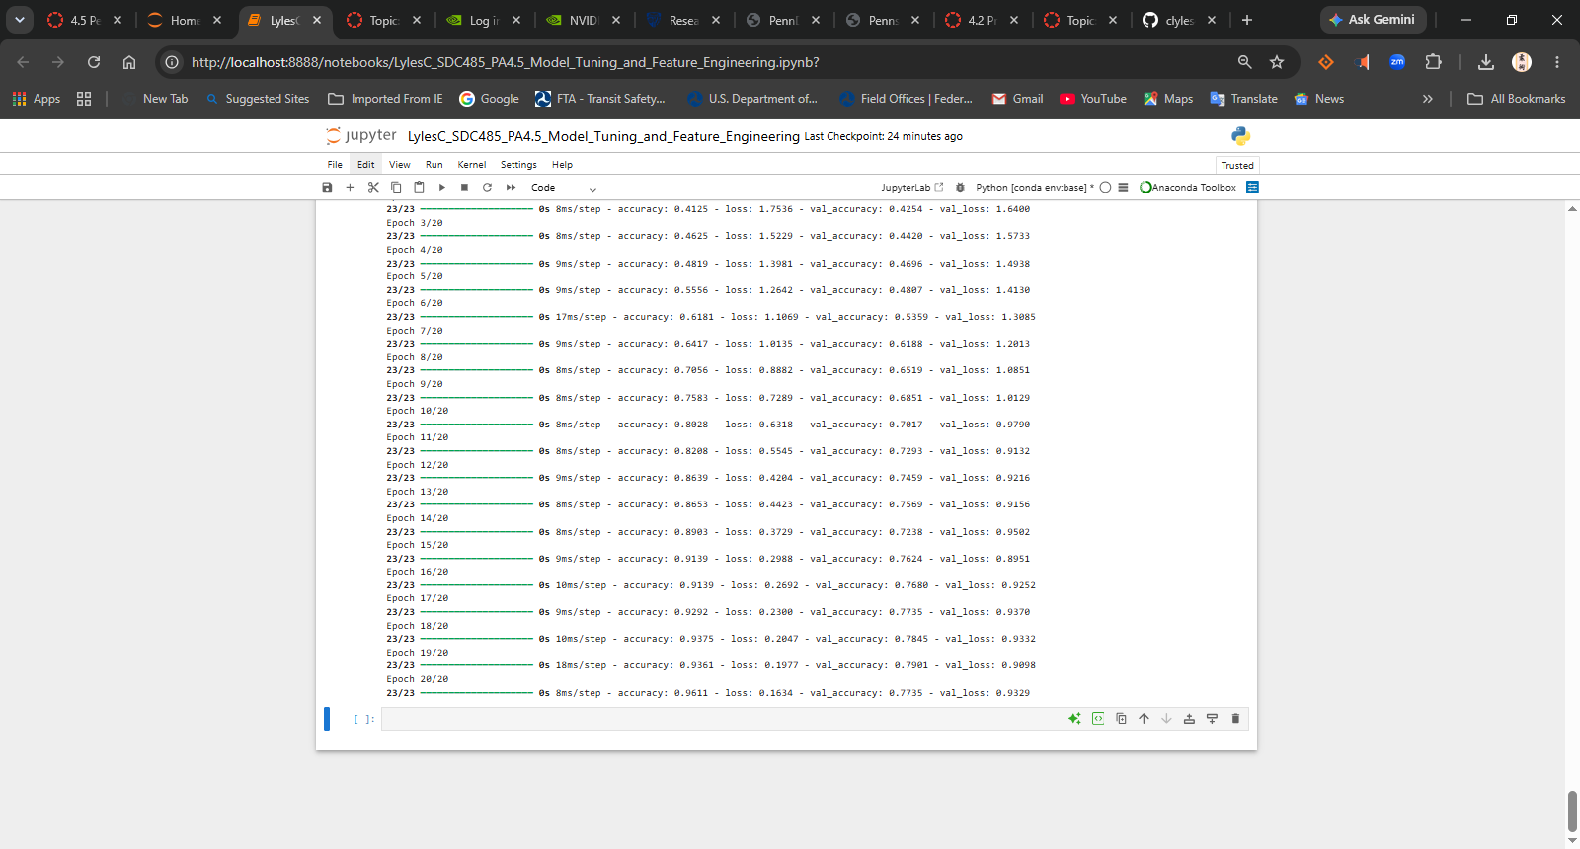
Step 22 - PCA Predictions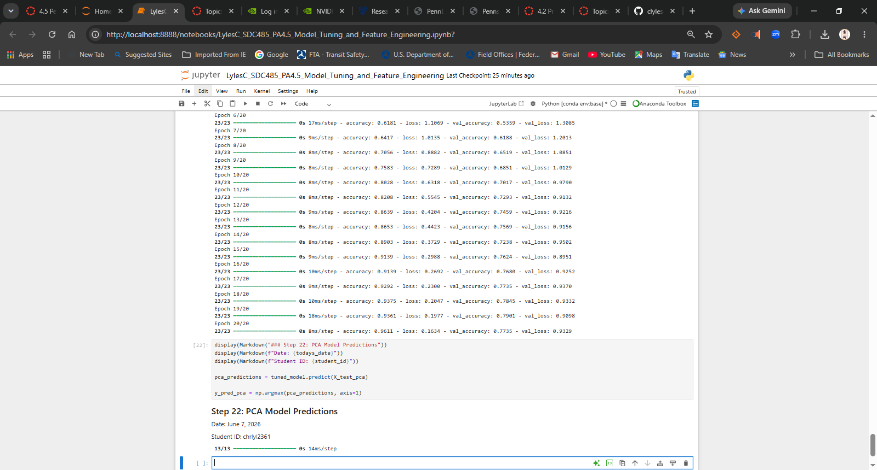
Step 23 – PCA Confusion Matrix
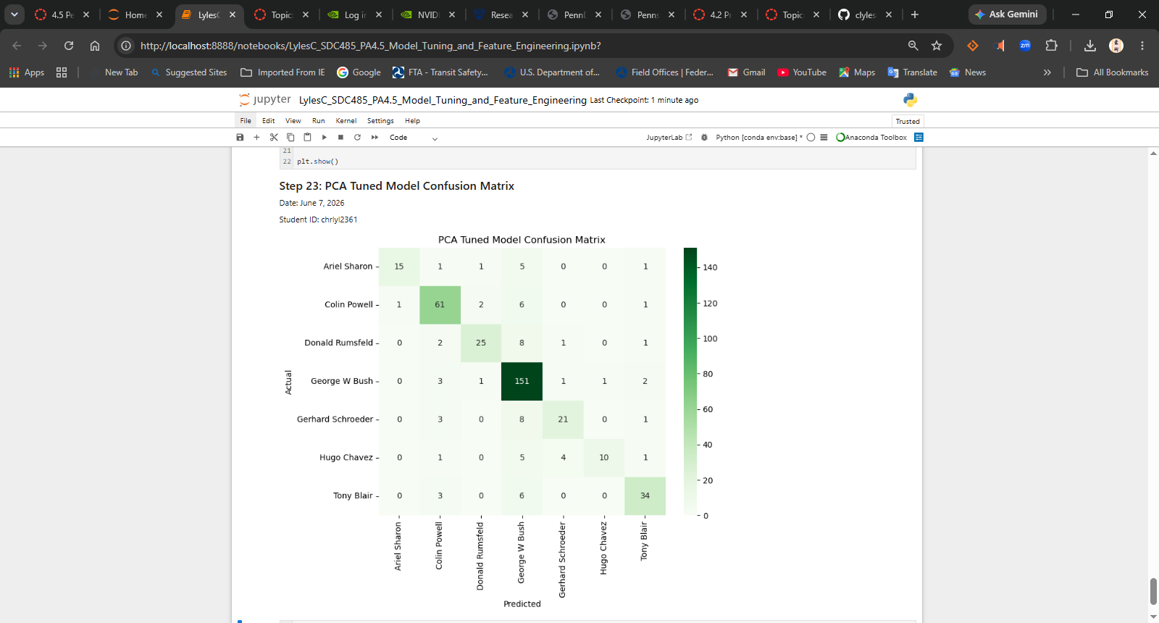
Step 24 – Compare Model Performance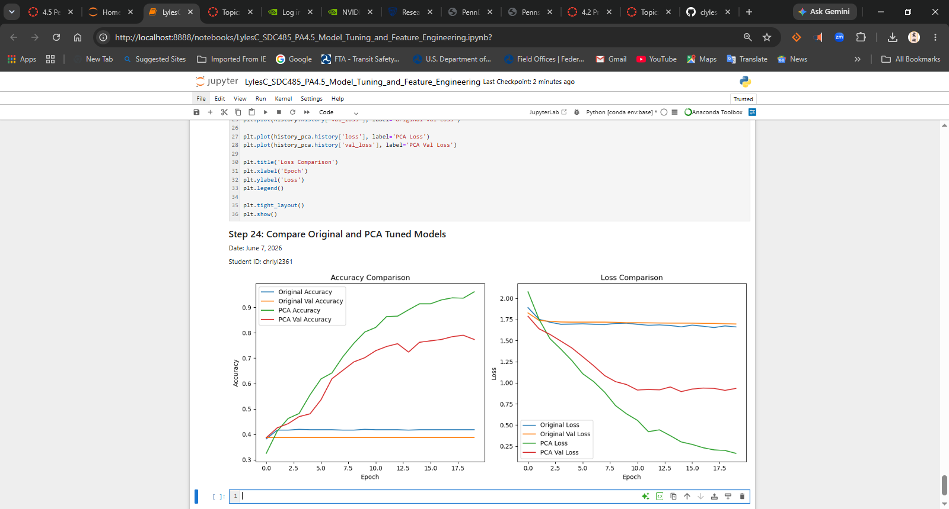
Markdown Cell – Analysis Questions
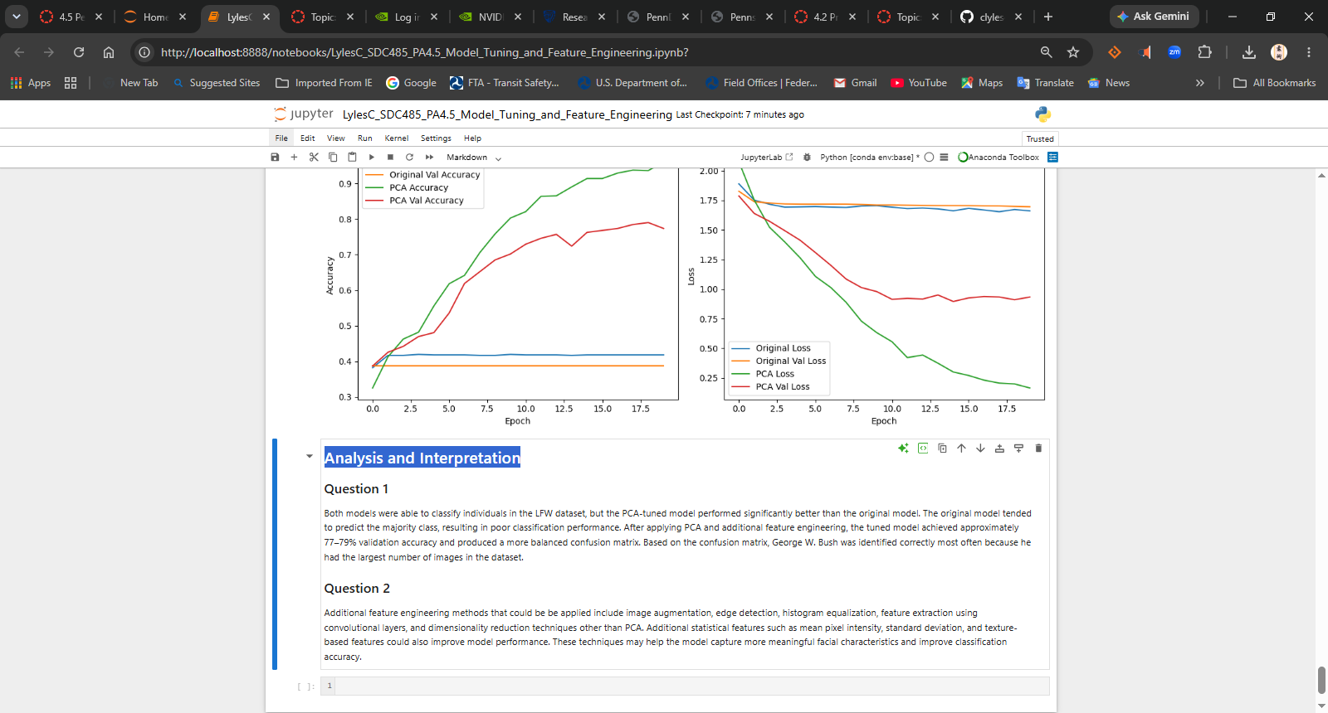

Markdown Cell – Analysis Questions
Answer the required questions in the space below.
- How well did the models perform on the dataset? Which individual was correctly identified the most often?
  - Both models were able to classify individuals in the LFW dataset, but the PCA-tuned model performed significantly better than the original model. The original model tended to predict the majority class, resulting in poor classification performance. After applying PCA and additional feature engineering, the tuned model achieved approximately 77–79% validation accuracy and produced a more balanced confusion matrix. Based on the confusion matrix, George W. Bush was identified correctly most often because he had the largest number of images in the dataset.
- What other feature engineering methods could be applied to the data used in this exercise?
  - Additional feature engineering methods that could be applied include image augmentation, edge detection, histogram equalization, feature extraction using convolutional layers, and dimensionality reduction techniques other than PCA. Additional statistical features such as mean pixel intensity, standard deviation, and texture-based features could also improve model performance. These techniques may help the model capture more meaningful facial characteristics and improve classification accuracy.

