AgriPilot Technical Architecture and User Guide
System design, business flows and operating instructions for the deployed CRM
Prepared for SCEA Vatan et fils, EARL Artemis and SCEA des Bonnédanes | 6 October 2026
This guide explains how the current AgriPilot demonstrator is structured, how information should move through the production system, and how operators use the principal screens. The system is designed around multi-company traceability and explicit human validation. External integrations shown in the interface are currently simulated.

1 System overview
AgriPilot provides one operational surface for three legal entities. The cockpit consolidates decisions, while every future persisted record must retain an enterprise identifier. A dedicated Terrain mode reduces navigation to the primary field workflows: dashboard, parcel intervention, voice, passport scanning and cameras.
Layer | Current build | Production target
Presentation | Responsive TypeScript interface with desktop and terrain navigation | Installable offline-first PWA
Application | Client-side workflows, calculations and confirmation feedback | Server-side domain services and policy enforcement
Data | Representative in-interface records | EU-hosted PostgreSQL or equivalent, object storage and backups
Integration | Safe simulations | Boviclic, Gmail/Outlook, DMSS, IGN, weather, Sheets, FMBV/MATIF, Twilio/Resend
Security | No active external writes or public camera URLs | Authentication, roles, encrypted secrets, signed media access and audit retention

2 Component architecture
The browser application presents the cockpit and terrain views. In production, domain services should own validation and calculations, a relational database should store structured records, object storage should hold images and clips, and an integration layer should isolate third party APIs. Every accepted command creates a Journal event in the same transaction as the business record.
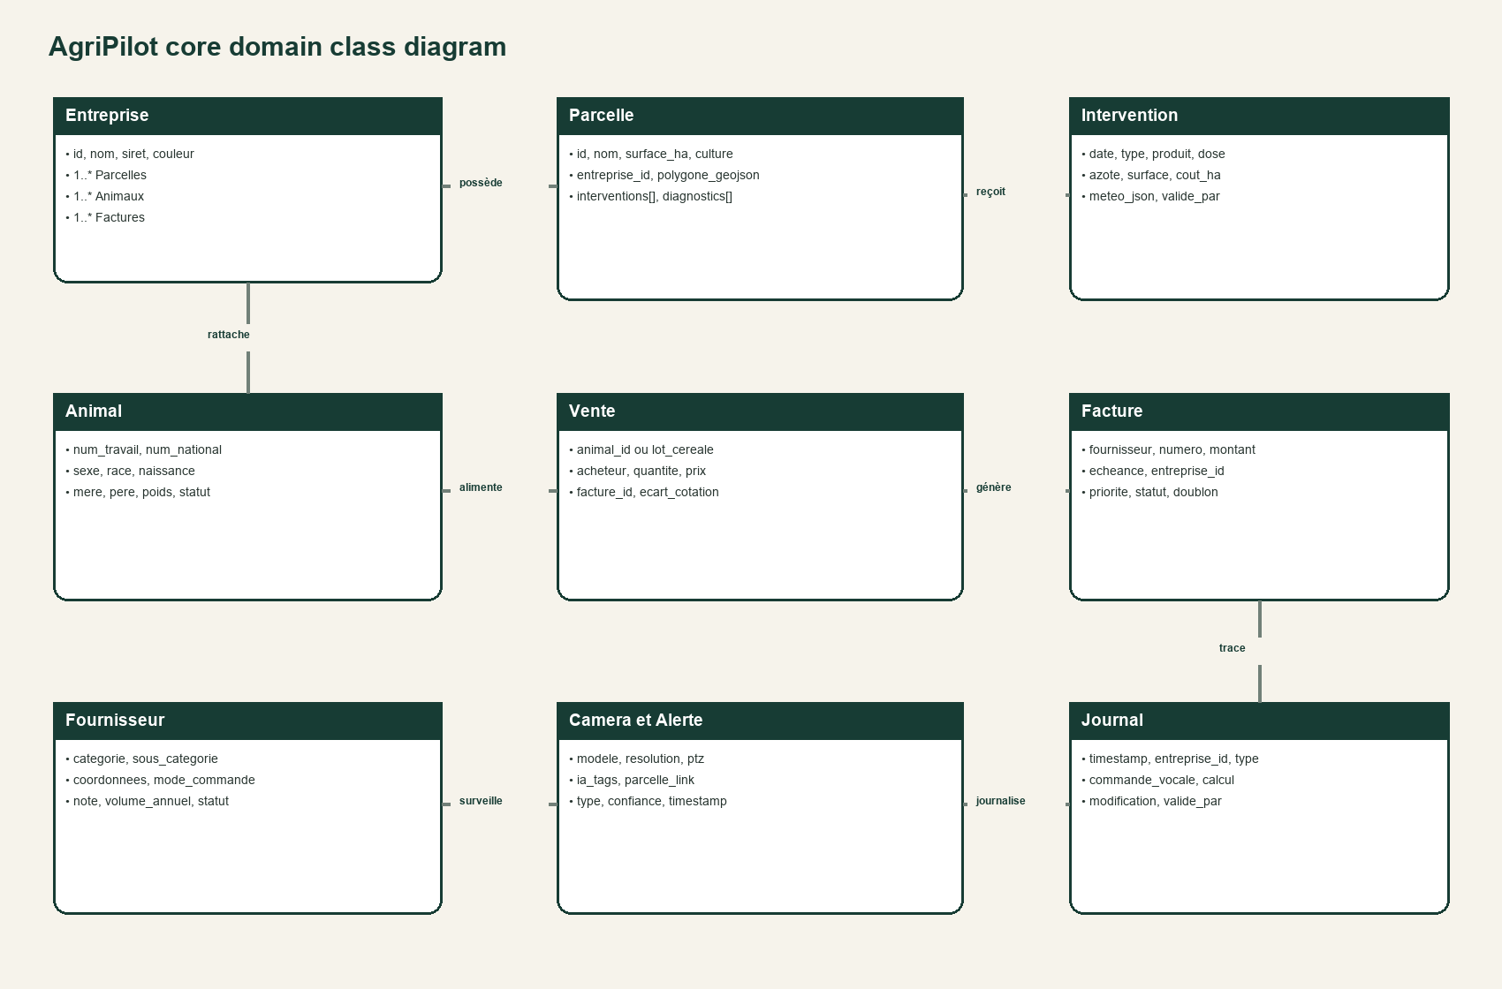
Figure 1 Core domain model and principal relationships

3 Core data model
Class | Key responsibility | Primary relationships
Entreprise | Legal ownership boundary for every business record | Owns parcels, animals, sales, invoices and Journal entries
Parcelle | Crop, area, geometry and field history | Receives interventions and wheat diagnostics
Intervention | Dated field operation with input, dose, weather and cost | Belongs to a parcel and company
Animal | National identity, pedigree, birth and lifecycle state | Belongs to a company; may link to media and sales
Fournisseur | Agricultural taxonomy, contacts and purchasing history | Receives orders; links to invoices
Camera and Alert | Secured device metadata and AI detection events | Links evidence to animals, parcels and Journal
Journal | Immutable audit narrative of commands, data, calculations and approvals | References company, user and capture identifiers

4 Business flow
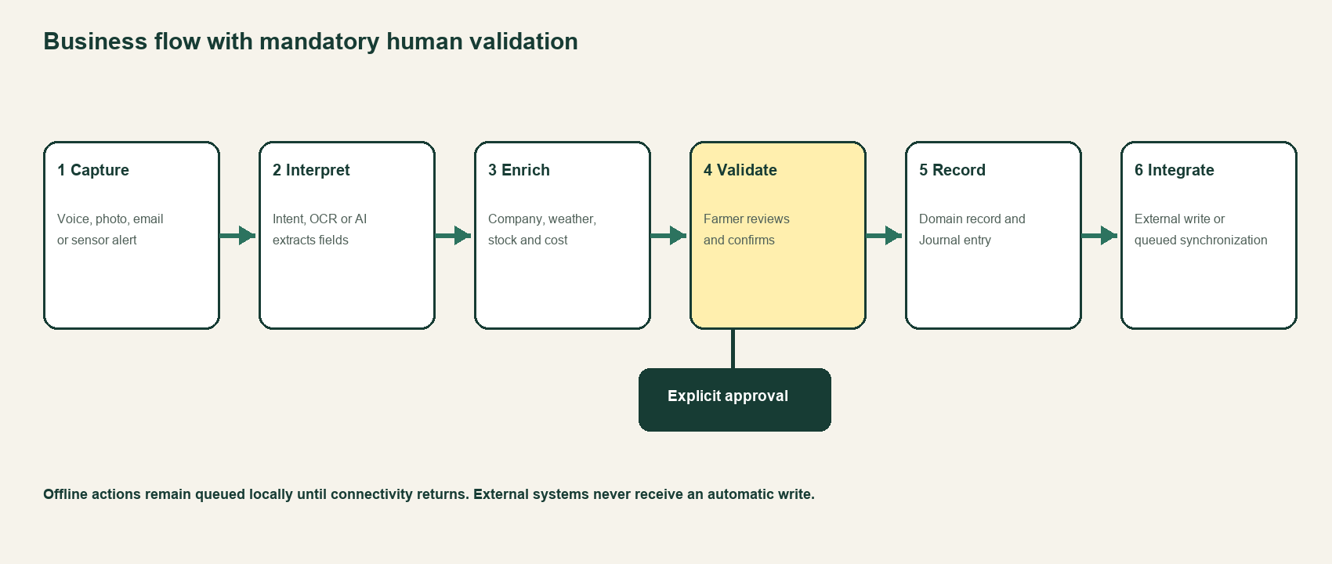
Figure 2 Standard capture to integration flow

4.1 Parcel intervention
The operator selects or speaks the parcel, operation, product and dose. AgriPilot enriches the draft with parcel area, weather, available stock and cost. The operator reviews the calculated total and confirms. Production processing then writes the intervention and stock movement, appends the Journal event and queues a Sheets or Isagri synchronization.

4.2 Birth and passport
A voice declaration or passport photo pre-fills animal identity and pedigree. A relevant CAM-01 capture may be proposed as evidence. The operator selects the owning company and validates the fields. Production processing creates the animal, stores media, writes the Journal and submits the approved Boviclic declaration.

4.3 Supplier purchase
A need is classified using the agricultural supplier taxonomy. Candidate suppliers are ranked and message drafts are generated. Nothing leaves the system until the operator approves a draft. After a quote is selected, the order state advances and the later invoice is matched to the company and order.

5 Operating guide

5.1 Use the control centre
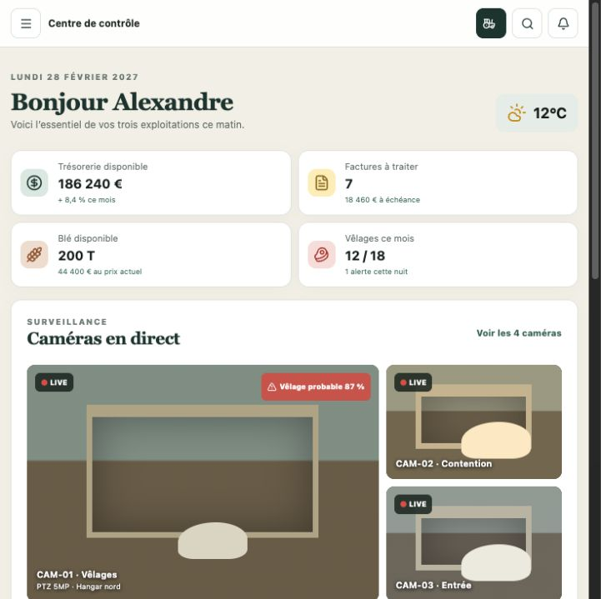
1. Review the four KPIs for cash, invoices, available grain and calvings.
2. Check the live camera area and prioritised alerts.
3. Use the left navigation on desktop or the menu button on compact screens.
4. Select Mode terrain for the field-optimised bottom navigation.

5.2 Record a parcel intervention
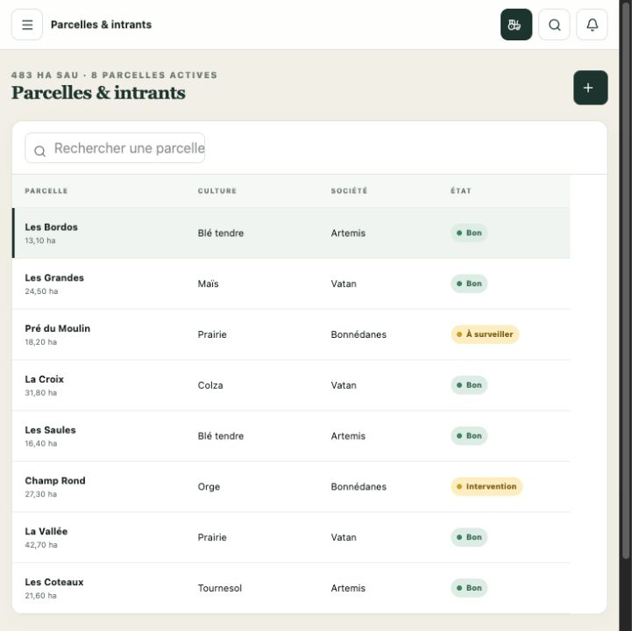
5. Open Parcelles et intrants.
6. Select a parcel to review its crop, area, status and recent history.
7. Choose Nouvelle intervention.
8. Enter operation type, product, dose, nitrogen units and treated area.
9. Review total quantity, cost and remaining stock, then validate.

5.3 Scan a bovine passport
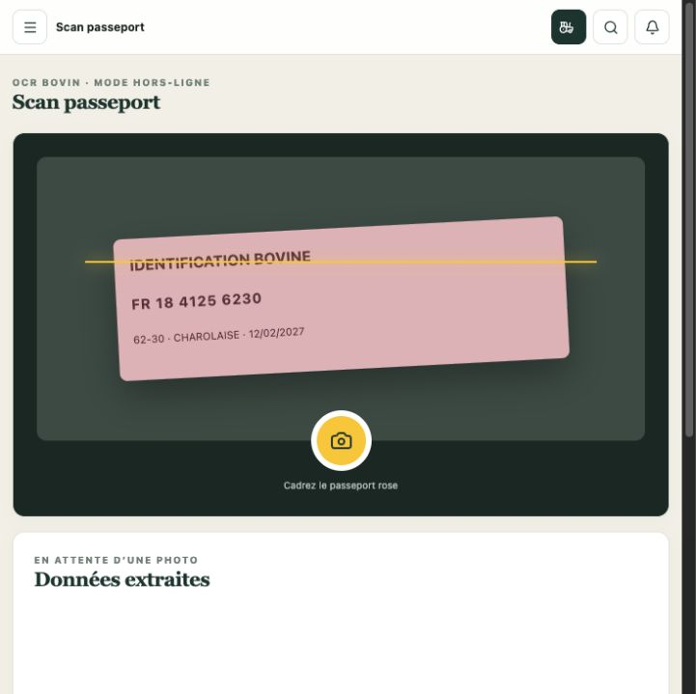
10. Open Scan passeport.
11. Frame the passport in the scanning area and press the yellow shutter.
12. Review national number, work number, breed, sex, birth date and destination company.
13. Correct uncertain OCR fields before choosing Create in herd.
14. Keep the Boviclic submission pending until the human validation step is complete.

5.4 Validate a wheat diagnosis
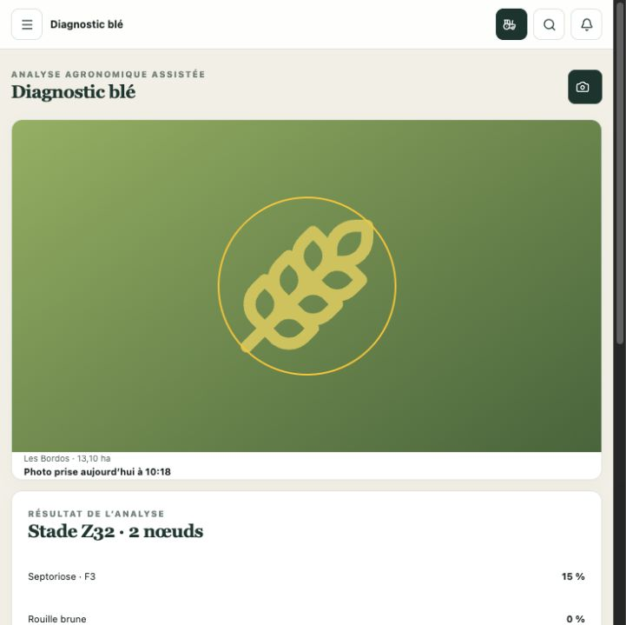
15. Open Diagnostic blé and capture the affected plant.
16. Review Zadoks stage and the disease percentages.
17. Compare the result with the displayed treatment threshold.
18. Check product, dose, cost, withholding period and weather window.
19. Validate to create the treatment task, or reject the recommendation.

5.5 Approve a supplier purchase
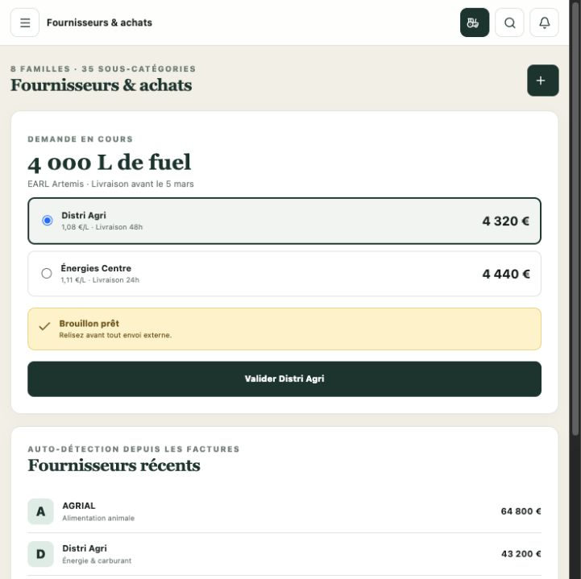
20. Open Suppliers and purchases and create a need.
21. Compare supplier price and delivery time.
22. Select the preferred quote.
23. Review the outbound draft and owning company.
24. Approve the order; the production system should record the decision in the Journal.

5.6 Review an extracted invoice
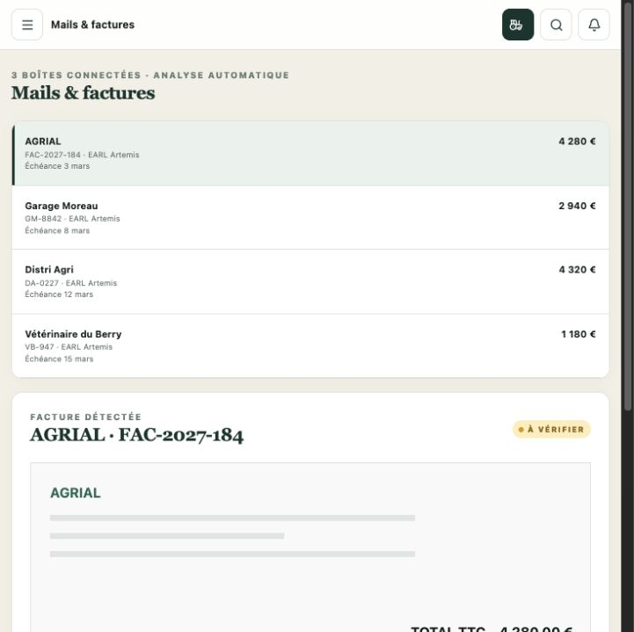
25. Open Mails and invoices.
26. Select an item from the queue.
27. Verify supplier, invoice number, amount, due date and proposed company.
28. Check the duplicate result and linked purchase evidence.
29. Validate and classify only after the extracted data is correct.

6 Roles and validation rules
Action | Draft allowed | Human approval required | Production side effect
Field intervention | Yes | Before record and stock update | Create intervention, stock movement and Journal event
Birth declaration | Yes | Before Boviclic submission | Create animal, attach evidence and send approved declaration
Supplier request | Yes | Before SMS or email | Send message and track responses
Purchase order | Yes | Before order validation | Advance order status and create future invoice link
Invoice classification | Yes | Before accounting handoff | Persist classification and reconciliation state
Payment or bank transfer | Yes | Always; never automatic | Future Ponto or Bridge operation only after explicit confirmation

7 Security and deployment guidance
- Keep every RTSP URL private. Publish only authenticated WebRTC streams through a secured gateway.
- Store FMBV credentials, API keys and OAuth tokens only as runtime secrets; never commit them to source control.
- Apply company-level authorization in every query and server action, not only in the user interface.
- Write an immutable Journal entry for every accepted mutation and every external synchronization result.
- Encrypt uploaded passports and camera evidence, use short-lived signed URLs, and define retention rules.
- Keep payment and external declaration actions behind explicit, contextual confirmation.

8 Production readiness checklist
☐ Authentication and role policies tested
☐ Database schema and migrations reviewed
☐ Company ownership enforced for all records
☐ Offline queue tested with conflict recovery
☐ External connectors use test and production environments
☐ Secrets stored in managed runtime configuration
☐ Camera streams never exposed as public RTSP
☐ Audit export reconciles with business records
☐ Accessibility and responsive tests completed
☐ Backups, restore test and incident runbook completed

