An AI-driven dashboard for life sciences laboratories

In this post, we present how scientific researchers can implement AI-driven solutions that improve day-to-day lab productivity and accelerate scientific discovery. We discuss some of the scientific and data challenges to this space as a whole and how AWS solutions can be the foundation for greater automation and central data governance across life science enterprises. We also provide a solution architecture with this post to help labs get started.

At the heart of life sciences research and development (R&D) organizations are researchers who are focused on running experiments and generating high quality data. That data is the fuel for exploratory early research, for technology development, and for progressing those discoveries through cross-functional development and eventually into candidates for clinical trials.

But in some unintended ways, researchers can be hindered by their own data. For example, manual data engineering tasks occupy an outsized amount of researcher bandwidth, taking their time away from innovation. The job of carefully combining data sources to harmonize datasets creates bottlenecks and slows the ability to conduct data science and get full value from the data. When software systems are disconnected from one another, it can detract from efficient coordination of people, information, and work. And when it is hard to aggregate and securely share datasets, collaboration is slowed. While these challenges can affect R&D groups differently—because organizations have varying levels of IT infrastructure maturity, application modernity, and personnel to support them—there are common patterns for data usage in the life sciences, and these lend an opportunity for a harmonized, simplified platform approach.

One common activity in research is troubleshooting experiments—finding sources of error such as bad reagents, equipment issues, and erroneous steps in a protocol. Another activity is optimizing lab protocols—for example, optimizing time, temperature, concentration, and reagents to improve chemical yield, assay signal-to-noise, or molecular purity. A third important activity is collaboration, which requires making data findable and accessible by others—for example, a “gold standard” dataset being shared with a collaborator.

What’s stopping labs from fully automating these activities today? These activities often require a number of data engineering steps that can be time-consuming: file transfer, uncovering the structure of files, data processing, data filtering, statistical analysis, and machine learning model building. Collaboration requires other tasks including data cataloging and access controls. Scientists are looking for tools to make this possible, without learning new systems and without a great deal of hassle.

In this post, we present how AWS can be used to create automated, AI-powered tools for the laboratory for troubleshooting, protocol optimization, and collaboration. We provide a solution architecture to help users get started, and that can be expanded upon in an overall digital lab strategy. This solution can be added into an existing lab software ecosystem, or it can be used in lab setting up their data strategy for the first time. This is a serverless architecture, meaning that this framework can be set up and maintained with minimal efforts from an IT perspective. We use the example of chemical library optimization in a high throughput screening lab, but it can be applied to many settings in the life sciences including assay development, hit-to-lead optimization, preclinical, and large molecular characterization. Taken together, this illustrates how digital lab solutions can accelerate the scientific process and improve productivity.

Solution Benefits
We take a user-centered approach, focusing on four personas within the R&D environment: the scientist, the data scientist, the data analyst, and the IT administrator. This solution delivers several major benefits to these users:

- Operational and troubleshooting insights for the scientist. An interactive dashboard that provides an operational summary and detailed views of the experiments in a lab and notifies lab members of important actions to take
- AI-based recommendations for the lab scientist and data scientist. Machine learning algorithms on the back end of the dashboard to infuse detailed insights, pattern recognition, and recommendations to help the lab can optimize its experiments (for example, “critical reagents,” “recommended next experiment”)
- Automated data pipelines for the data analyst. Data processing transformations that are built with or without the use of code, that are reusable within a library for the lab, and that can be deployed in a highly scalable cloud architecture
- Central data discovery for the IT administrator. Automated data cataloging and metadata generation, to keep track of the structure and contents of data, regardless of file type and schema (experimental data, databases), and system source (electronic lab notebooks [ELNs], laboratory information systems [LIMS], or other databases)
- Governance for the IT administrator. Simple creation of a data lake and convenient management of access policies based on roles or tags, which can be specified down to the individual data element (row and column permissions)

The Scientist User Experience

Scientists are looking to streamline their research and not looking for more tools to have to learn. That’s why the front-end of this solution uses Amazon QuickSight, a reporting tool that makes it easy to create, distribute, and conduct analyses using visual dashboards. This includes the type of filtering, pivoting, and normalizing data that many scientists are used to in Excel. But this also includes automation such as data refreshes to bring in your latest data from your instruments, LIMS, and ELN. And this encompasses alerts that will reach out to you by email if an event is observed. Did your last results fall below a quality control (QC) threshold? You can create an alert to notify you. Does your experiment plan clash with schedule of instrument availability? Get notified. Within the dashboard you can drill down into your experimental data to explore patterns and trends.

In this solution we assume the following set up for the scientist. A chemistry lab routinely carries out experiments in a 384-well format, which results in comma-separated value (.csv) file that contains a key metric—in this case, reaction yield. The experiments are documented in an ELN that contains experimental details—in this case, project number, protocol steps, and other reagent information.

The scientist begins by looking at the high-level result from their experimental runs to look at the average reaction yield of their protocols over a period of four months (Figure 1). You can quickly identify changes in the reaction yield compared to the 7-day average and dig deeper to look for root causes (bar chart). The dashboard shows sources of quality issues by comparing reaction yields to the composition of reagents in the chemical reactions, to see whether low yields are associated with specific reagents (area chart). We also visualize the reaction yields across our plate layouts (heat map). This shows whether low yields are associated with certain regions of the plate. In this way, with a quick visual glance, we can understand whether our yield is affected by the chemical reagents or by plate loading.

Figure 1
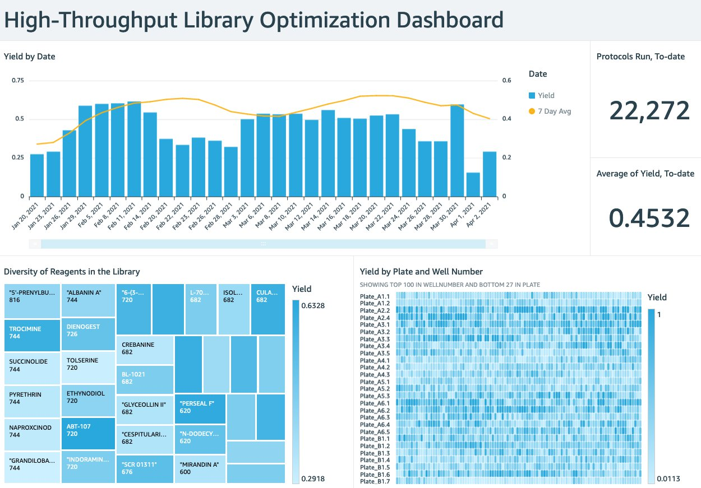

The QuickSight dashboard is also the place to become informed by machine learning (ML) insights from the data (Figure 2). In this example, a key parameter that the lab is trying to improve is reaction yield. Here we created a machine learning model to identify the chemical properties that are most associated with high yield. This shows that rotatable bonds, molecular weight, and aLogP are the most important factors (Figure 3, bar chart). This can help guide the chemical development strategy.

Next, we use the model to predict which combinations of reactants will have the highest and lowest yields. This creates a “next best experiment” list (Figure 3, table), which is a recommendation of protocols we should try in our experiments, and also a “warning list” of what combinations we should avoid. With a few glances at these ML insights, the dashboard guides scientists to conducting valuable experiments sooner, and avoiding wasted efforts.

ML can be applied uniquely to different laboratory goals. For example, in an assay development lab, the focus can be on recommendations to optimize assay performance. In a small molecule screening lab, the focus can be on reaction conditions to optimize profiling data. In a large molecule characterization lab the focus can be on optimizing post-translational status. The ML shown in the dashboard is enabled by Amazon SageMaker, including the Autopilot functionality that eliminates many of the planning steps of building and deploying models. We discuss this below as in the data science section.

So, just how does the data get into the dashboard? We look through the eyes of the IT admin next.

Figure 2
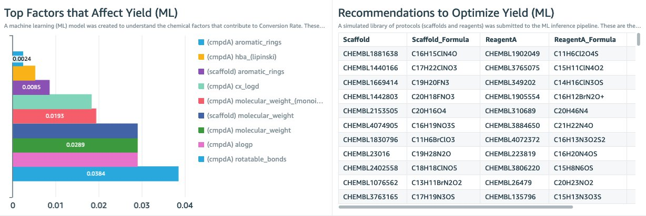

The IT Admin User Experience
How does the data get into the dashboard in the first place? The back end of this needs to be simple to set up, easy to add data sources to, simple to define metadata fields, convenient to conduct data transformations, and secure in its access management. To do this, we take several aspects from the Lake House Architecture and focus on certain areas that will make work easier in the laboratory world.

Figure 4
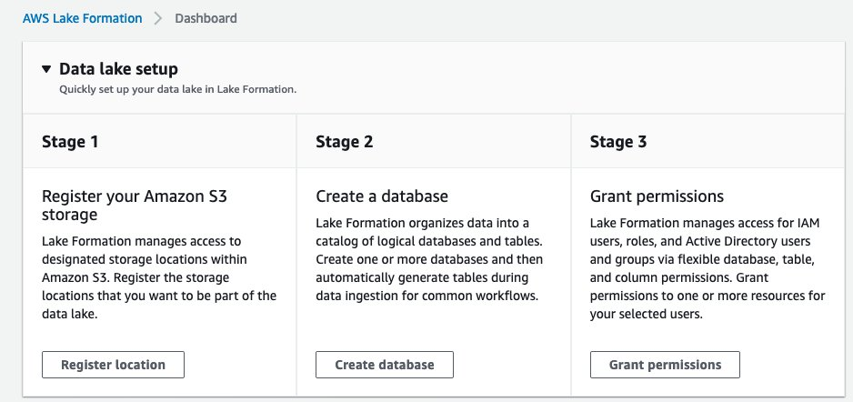

Here we create a data lake with AWS Lake Formation, which lets you build a data lake in days, not weeks. This step only needs to be done once for your organization. The Lake Formation process is composed of three stages (Figure 4). 1) Registering an S3 storage bucket. This is the cloud storage location where the lab data will be ingested into. In this example, we output the protocol information from our ELN application, from the results of our experimental data, and the external database, ChEMBL. 2) Creating a database for the metadata catalog. This is the database that stores the metadata of all data within the data lake and allows consumers of the data to search the contents of data sets through keywords. 3) Granting permissions. Here we define the task based access controls of different roles within the organization (Figure 5). Here we define a data lake administrator role that can add new data sources to the data lake. We define a lab scientist role, who can view the dashboard. We define a lab analyst role, who can create data transformations. And we define a data scientist, who can create dashboards and has access to SageMaker to create new models. With the data lake formation completed, we move to AWS Glue which populates the data catalog and processes the data.

Figure 5
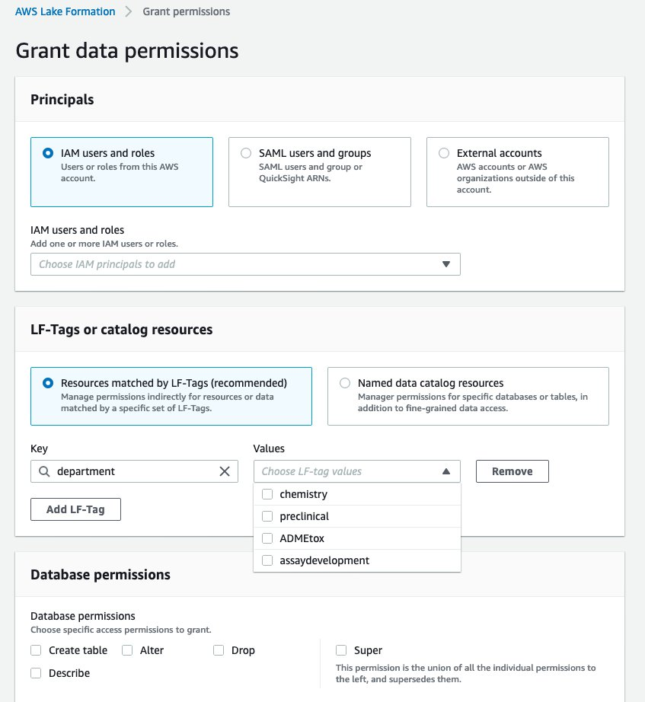

The Data Analyst User Experience
How do we define how the raw data is processed before getting to the dashboard? In this example we have three datasets in our workflow: protocol information from our ELN, the results from our experiment, and a table from the external database, ChEMBL. We want to discover the structure of those datasets then combine them based on common fields into a single, flattened dataset for downstream visualization and ML. An AWS Glue Workflow is used to do just that (Figure 6).

Glue Workflows are composed of two types of actions - crawlers and jobs. Glue Crawlers perform data discovery, by scanning datasets, understanding their schemas, and recording their composition within the metadata catalog. Glue Jobs take the data in the data lake and transform them by actions like Join to merge datasets, Select Fields to isolate data items, and Apply Mapping to rename data items. In this example, we set up this Glue Workflow to orchestrate the sequence of crawlers and jobs, and create a trigger to start initiate it when new data is sent into the S3 bucket. Whenever another protocol is run, the data enters S3, and a trigger starts the Glue Workflow.

This architecture makes Glue Workflows particularly modular and versatile. For a particular lab workflow, you simply set up a Glue Workflow once. For another workflow, (e.g. a different instrument or different external dataset), a separate workflow is needed. To do this you can author a workflow from scratch, or you can clone an existing workflow and perform modifications. In this way, your organization can build a library of workflows that can be reused. So, once you have a few Glue Workflows set up, you are never starting from scratch.

Figure 6
WILL BE UPDATED TO REMOVE AWSOMBUILDER REFERENCES
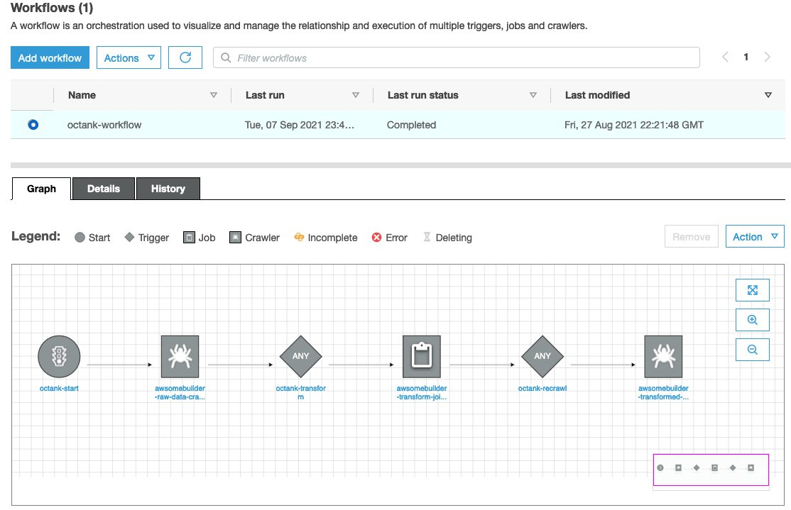

One of the powerful elements of Glue Workflows is using AWS Glue Studio to author jobs (Figure 7). Glue Studio is a visual, point and click interface to create data transforms. With a simple front end, the Studio automatically creates the script needed to run transforms in a managed Apache Spark environment. Spark is the industry standard in extract, transform, and load processes, providing a high degree of scalability and performance tuning. This ensures that regardless of the size of your datasets and number of users of the data lake, you have a ETL platform that can handle cloud-scale analytics.

What if your data requires processing other than ETL, such as image analysis or another domain-specific data processing algorithm? These processing steps can be orchestrated by configuring the AWS Lambda step in this pipeline. This is not the focus of this blogpost, but we have other blogpost examples such as imaging and genomics that illustrate how that preprocessing step can be included here.

After the data is processed in the Glue Workflow, we can use Amazon Athena to conduct SQL queries. This can be used to isolate subsets of the data, to filter, and review ad hoc queries. This is a good tool to spot-check the data the first time it is being connected to a QuickSight dashboard to make sure the transforms are producing the flattened format accurately. When we are sure the data is being transformed properly, the data can be consumed in two ways. QuickSight can point to Athena table as the data source, as discussed above. And SageMaker can ingest the datasets for ML, as we will discuss next.

Figure 7
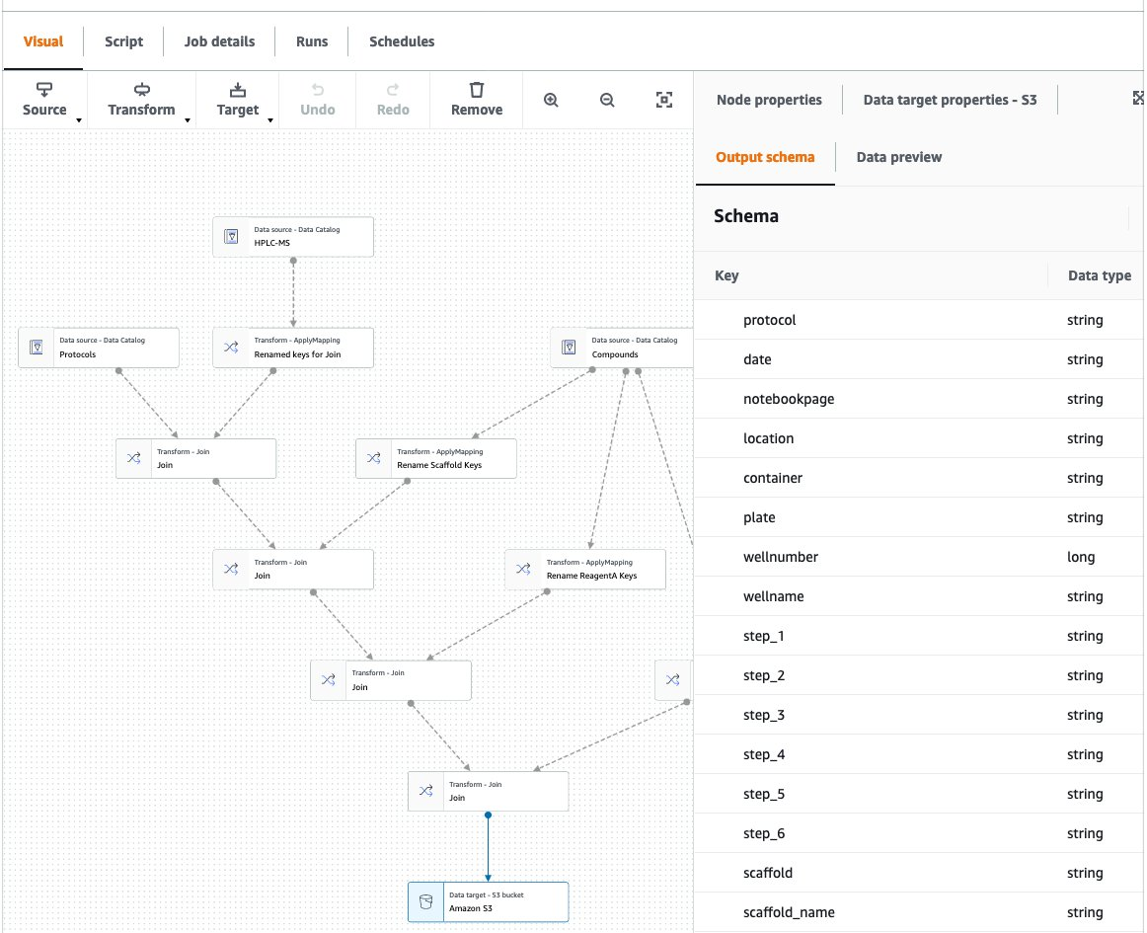

The Data Scientist User Experience
At this stage, the transformed data has brought together protocols, experimental results, and the ChEMBL dataset, which is now available within the QuickSight dashboard. The next opportunity is to apply ML to the dataset to give insights that will improve and optimize our reaction chemistry. To prepare, train, and deploy a model in the most automated way, we used SageMaker Autopilot. Autopilot is essentially a model of models, which evaluates various data preparation approaches, various algorithms, and various hyperparameter values, and suggests a model that fits the data best when applied to an independent test set (Figures 8, 9).

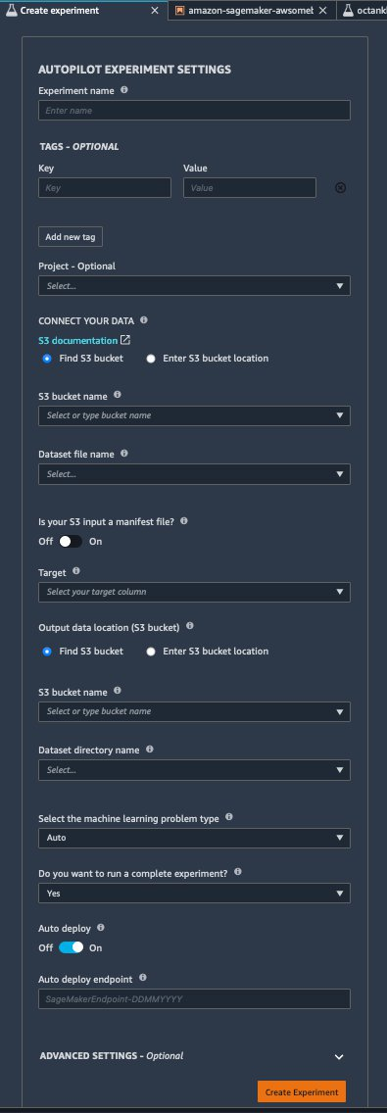
Figure 8

Figure 9
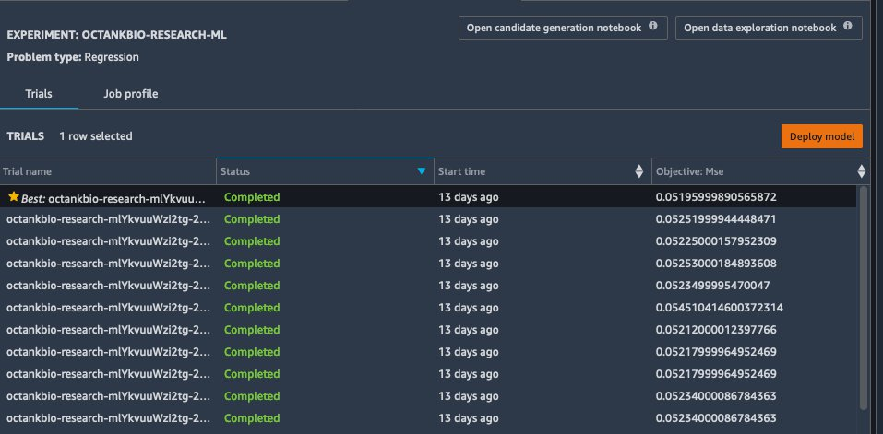
Figure 10
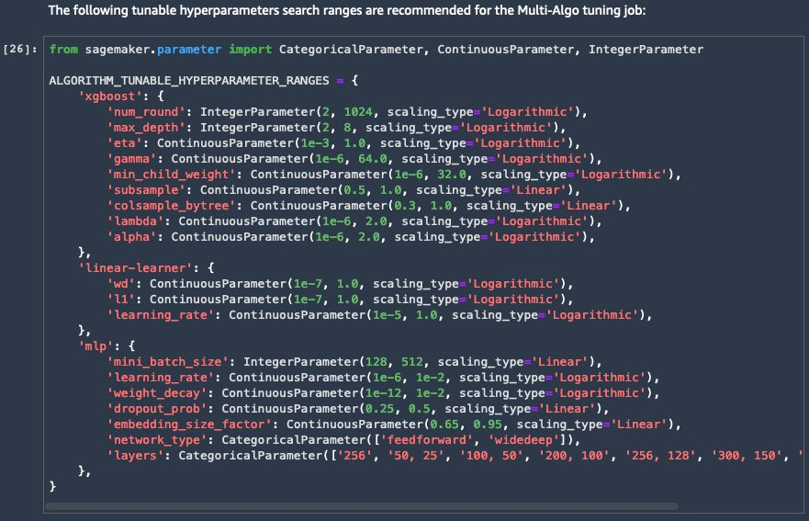

Here we use Autopilot as an entry point to building an ML model and then performed more optimization to gain greater understanding of the model. We can deeply examine the types of models being evaluated within SageMaker Autopilot and conduct more in-depth control of the hyperparameter optimization steps (Figure 10). Using SageMaker Clarify we can view which features are the most important, export this information to the data lake, and visualize that within the lab dashboard. This information can guide lab members in their experimental design.

ML can also make recommendations for improving the lab’s scientific protocols. In this example, the major factors in our chemical reactions are the combination of scaffold and reactant. Using SageMaker, we created a virtual set of protocols, using combinations of scaffold and reactant molecules. Then we performed inferences on that dataset using the model created. This resulted in predictions for reaction yields, for thousands of virtual protocols. We then imported these into the dashboard, rank-ordered, so that the scientist can see the recommended chemical combinations to use (i.e. the “next best experiment” they should carry out).

Machine learning insights using this framework may be helpful in a variety of ways:
- An assay development lab may like to choose the best reaction conditions (time, concentration, heat), to optimize assay performance
- A hit-to-lead optimization lab may like to exclude reaction conditions that would negatively affect the activity profiles of a hit
- A technology development team would like to choose solvents and reactants that maximize signal to noise ratio
- A large molecule characterization lab would like to uncover what gene expression affects the post-translational modification state of the molecule
- A lab manager would like to forecast the inventory needs for upcoming experiments, based on past activities

Cloud Architecture
The solution uses AWS Lake Formation, S3 data storage, Lambda, Glue Crawler, Glue Jobs, Athena, Quicksight and SageMaker (Figure 11). A notable aspect of this architecture is that it is serverless. This shortens the time to get started and simplifies the ability to add it to existing IT environments. No cloud presence is needed to get started- just an AWS account.

Figure 11

Discussion
Scientists want to get more knowledge out of the data they generate. They want more accurate and faster analyses of their experiments, more automation within their quality control steps, proactive notifications for activities in the lab, automated statistical tests within their data sets, and identification of patterns, anomalies, and trends through ML. At the same time, scientists want to spend less time handling their data, including file transfers, file conversions, spreadsheet manipulation, manual entry, data cleaning, data organization, data archiving, and one of the dreaded ones – spending time searching for old data. With the solution described here, scientists continue to use their existing systems for data acquisition, LIMS and ELN, yet on top of them can build a simple, but powerful, dashboard for decision-making. It also provides a back end that supports an enterprise-grade data strategy.

Collaboration is slowed when laboratory data isn’t interoperable, viewable, findable, and easily analyzable. However, today, even laboratories with advanced enterprise infrastructure can find it hard to find, combine, and reanalyze data coming various organizational divisions (e.g. discovery, translational, clinical), from various analytical instrument types (e.g. chemical, biochemical, genomic, proteomic), from various data systems (e.g. LIMS, LES, ELN), and from various geographies (e.g. global studies).

Today R&D organizations are focusing on ways to acquire more data per experiment, catalog that data, and make the data available for future consumption, either by the same lab, or other partners in or out of the organization. To do this more effectively, organizations are considering scientific data as a “data product”. Data products need to be FAIR: Findable through queries and keywords searches; Accessible to those who have permissions; Interoperable by other methods; Reusable through self-description. Metadata concerning data lineage is needed in regulated settings to show provenance and integrity. And again, most scientists cannot afford to expend additional effort to create a data product. All of this – cataloging, exporting, archiving - needs to be done as effortlessly as possible.

A new and growing trend to address this is called the data mesh. A major benefit of the data mesh is to afford more autonomy and ownership of data generation and processing to the laboratory (the data producer), while enforcing guideposts centrally. Scientists have data structures and data processing needs that are domain specific, so the most capable group to manage the data product is often the lab that generates it. However, any data solution that addresses this needs to make data cataloging as simple as possible for scientists.

As scientists become empowered with more data science tools, an organization’s data strategy needs to be able to set and enforce guideposts, to keep data secure and compliant. These may be needed to adhere to privacy policies, to regulatory policies, and to cybersecurity policies. The data mesh architecture, built on an AWS data lake, provides such a governance framework. This enables laboratories and departments to move quickly and autonomously, while working within a governance structure.

Conclusion
Life sciences organizations are seeking to integrate datasets rapidly in order to apply visualizations and data science techniques like machine learning and AI, with minimal overhead. They want to do this while maintaining system compliance, data quality, and data integrity. Interoperability of research data is a critical hurdle in the life sciences. The solution presented here illustrates the simplicity and power of AWS through the eyes of four personas: scientist, data analyst, IT admin, and data scientist. We hope this solution can inspire new tools that are adapted to life science labs, which can enrich existing ecosystems of scientific software and help set a foundation for scalable enterprise data strategies.

