Transforming site monitoring in clinical trials
Kannan Raman, Enterprise Service Manager, Professional Services

Clinical Trial Monitoring is a key and integral part of running a successful and compliant clinical trial. Currently the site monitoring process is manual, costly and is subject to data quality issues. This blog is to discuss how various aspects of site monitoring can be automated to optimize cost and increase quality. To give an estimate of the costs involved, about 25 to 30 % of the total cost of a clinical trial goes into monitoring. More importantly, effective monitoring enables better clinical outcomes. The COVID 19 situation has increased the urgency to move towards a centralized remote monitoring option. This will also help the speed of the clinical trial process while improving efficiency and reducing costs.

Monitoring is done to ensure the following:
- Human right of patients involved in the clinical trials are protected by ensuring that trial protocols are adequately followed and data relating to various aspects of the trial like adverse events and dosage information is collected
- Data that is collected & submitted by the clinical trial site is accurate
- The site complies with all FDA regulations relating to good clinical practice (GCP) and clinical trials

To ensure human rights of the patients involved, a site monitor (a.k.a. Clinical Research Associate – CRA) performs various checks that are currently done manually and on site. As an example, the site monitor checks all Informed Consent Forms (ICFs) to ensure they have been duly signed by the patient as a verification that informed consent forms have been read and understood by patients. The monitor also verifies the eligibility criteria and ensures that all subjects (patients) are eligible for the trial. The monitor also verifies if all the adverse events are being reported by the site by verifying the source systems and the reports. Accuracy and completeness of data in a clinical trial is of paramount importance not just from a safety and efficacy end point perspective but from a regulatory and compliance standpoint. The site monitors play a key role in this. The monitors have to verify the accuracy and completeness of the case report forms with respect to the source documents and any cross references among documents. They also need to verify the dose and therapy modifications done for specific patients are accurately documented. From a regulatory perspective, monitors are responsible to ensure that sponsors have provided investigative brochure to each site. They have to verify the qualifications of the investigators. Monitors also confirm if the investigator and staff are adequately informed about the trials and trained on the protocol. Site monitors spend about 20% time moving between sites and another 20% verifying different documents while at the same time communicate with the investigator and staff to ensure the protocol is followed and any deviations are appropriately captured and reported to the sponsor for further action. Monitor should also communicate any deviations from protocol, SOPs, GCP and the regulations to the investigator. Monitor will submit a written report to the sponsor after each visit. Reports will cover the following:
- Summary of what was reviewed
- Any significant findings
- Actions taken
- Recommendations

AWS services can be used in a design pattern to enable the digital transformation in this space. The objective is to automate the cross verification of documents and flag exceptions for the site monitor to review, intervene and resolve. This also helps eliminate errors due to manual verifications and improves the quality of the data and that in turn improves the safety of patients enrolled in a trial. Capturing this data and using AI/ML, the solution can also flag sites that are risk prone based on past deviations in clinical trial protocols, so that monitors can effectively use their time by focusing on those sites. This type of analysis will also provide a risk profile for the sites to be leveraged for future such trials.
Reference Architecture:
Data Collection: Amazon Textract- Read text from scanned hand written documents and store it (by patient) in S3 buckets. Optionally, leverage EFS for multiple patient files from multiple locations.
Informed Consent – Leverage Amazon Rekognition to verify signatures with a valid identity
EHR data stored in S3 buckets
AWS IoT Core for data collection from wearables through AWS Kinesis firehose into S3.
Data Transcription: Doctor – Patient conversation will leverage Amazon Transcribe Medical to convert to text and will be stored in S3
Confirmations: The monitor has to confirm whether the information brochure has been provided to the investigator’s office. This can be done by centrally storing the brochure and emailing links and getting read confirmations from people involved in trails at the investigators office. Any deviations can be reported and followed up. Similarly, monitor has to confirm if the staff in investigators office have knowledge of the trials. This can be done through proctoring via video recording along with an upload of identification document. Amazon Rekognition, Amazon Transcribe Medical & Amazon SageMaker can do the verifications and log the details or send it for action to the monitor if required.
Identify Source Data Deviations: By leveraging Amazon SageMaker, learning algorithms can be created to analyze the data and identify deviations among source documents and between the source documents and the Case Report Form (CRF) and send messages to the site monitor with details for further investigation and reporting. Missing source documents can also be identified and alerts can be sent to both the investigator and the monitor. Based on patterns, the algorithm can also suggest targeted onsite monitor visits while keeping the sponsors informed of any emerging deviation patterns among various sites. This provides a thorough risk based & high quality approach at a reduced cost.
Data Analytics: Bringing clinical trial data together in S3 has significant advantages not just for clinical trial monitoring, but for the trial as a whole. While S3 will store the structured and semi structured data, it can be analyzed to create structured data sets by leveraging Amazon Glue to load data into Amazon RedShift for data warehousing and querying. Amazon Quicksight can be used by sponsors and monitors for querying data.
HIPAA Compliance and GCP: Securing and encrypting patient data is essential as part of compliance. The architecture will leverage AWS KMS, AWS Macie and AWS Cloud Trail for encryption, monitoring PII data and having full traceability. Further, data quality, real time reporting and predictive analytics for risk assessment of various trial sites will ensure good clinical practice (GCP)
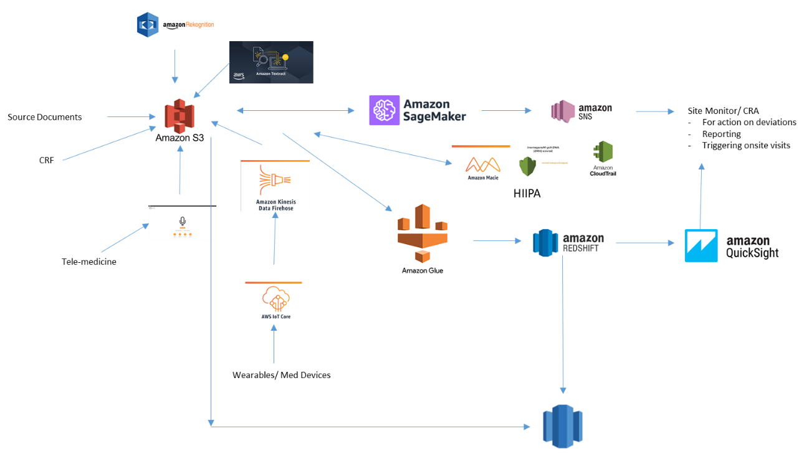

Conclusion
The current situation with COVID19 creates an urgent need to help pharmaceutical companies and CROs move towards a centralized risk based hybrid (remote + targeted onsite) monitoring approach that uses technology to automate many of the cumbersome and manual functions performed by site monitors and help them become more effective and efficient by focusing their time on the quality of the trials. This automation also eliminates errors and improves the data quality and hence the safety of clinical trial patients. This is a perfect opportunity to use the available AWS cloud technology and enable a significant digital transformation in this critical area of clinical trials.

[Optional] Author bio
Photo  | Kannan is with AWS ProServe Health care and Lifesciences practice at AWS. He has over 22 years of life sciences experience and provides thought leadership in digital transformation. He works with C level client executives to help them with their digital transformation agenda.

Suggested tags: [match these to the channel SEO strategy]

Editorial comments

DATE | EDITOR | EDIT TYPE | COMMENTS (copied to SIM issue)

