Reducing the complexity of mesh nodes by using reflective wavelength-selective switches

C. R. Doerr, G. Wilfong*, and S. Chandrasekhar

Lucent Technologies, Bell Laboratories
791 Holmdel-Keyport Road, Holmdel, NJ 07733
Doerr: 732-888-7067, FAX 732-888-7074, crdoerr@lucent.com
Chandrasekhar: 732-888-7234, FAX 732-888-7074, sc@lucent.com

*Lucent Technologies, Bell Laboratories
600-700 Mountain Avenue, Murray Hill, NJ 07974
908-582-3561, FAX 908-582-3340, gtw@lucent.com

IEEE indexing terms: Networks, wavelength division multiplexing

Abstract

We show that if one applies the constraint of symmetric demands in a network then one can significantly simplify the wavelength switching hardware at mesh nodes. We show designs for nodes of degree 3 through 6. All required components are commercially available. We experimentally demonstrate two of the designs.

1. Introduction

Today’s optical networks are mostly ring-based but are moving toward mesh-based. A mesh architecture has several advantages over a ring architecture, such as more efficient bandwidth utilization, more diverse protection, and less constrained network growth. At the mesh nodes one would like to be able to route wavelengths arbitrarily, using a wavelength-selective cross connect. The number of fibers entering the node determines its degree.
Wavelength-selective cross connects may be built out of wavelength-selective switches (WSSs). There are two main types of WSSs: transmissive and reflective. In a transmissive WSS, the input is directed in a one-way fashion to one of the K outputs, and the input is clearly distinct from the outputs. An example is the planar lightwave circuit (PLC) 1 × 9 WSS demonstrated in []. In a reflective WSS, the input is reflected back by a steering mirror, being directed to one of the K outputs; and the input is not distinct from the outputs. The basic concept of a reflective WSS is shown in Fig. 1. An example is the 1 × 4 WSS demonstrated in [], which used a bulk grating and micro-electro mechanical systems (MEMS) tilt mirrors. Another example is one using a vertical stack[] or horizontal arrangement[] of PLCs and MEMS tilt mirrors.

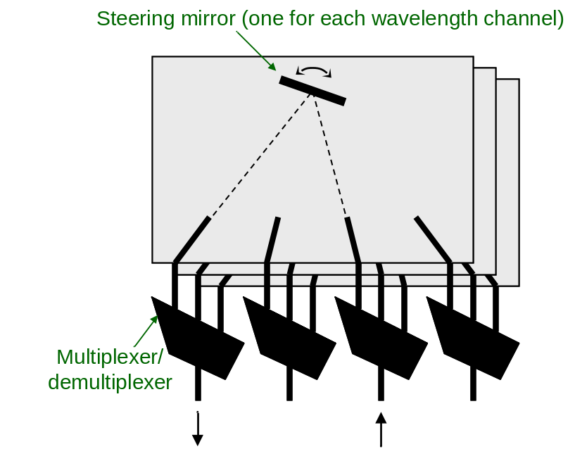
Fig. 1. Basic concept of a reflective WSS.

Any 1 × K WSS can be viewed as a K+1 × K+1 WSS with limited flexibility; a reflective WSS exhibits more flexibility than a transmissive one. This is due to the multiple terminal connection property of a reflective WSS, illustrated in Fig. 2. If we write the port numbers in a continuous sequence, not distinguishing between input and output ports, then for a given mirror tilt angle, a connection between ports p and q exists whenever they satisfy the equation m-p = q-m, where m is an integer divided by 2. m represents the mirror tilt angle. For example, in Fig. 2 the mirror position, m, is 2.5 (represented by the dot), so connections between ports 1 and 4 and between ports 2 and 3 are simultaneously made.

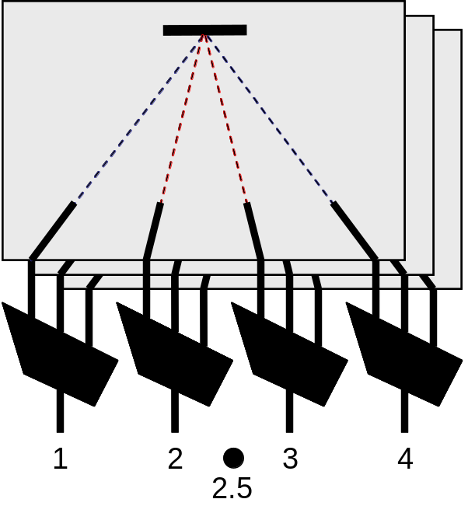
Fig. 2. Illustration of multiple terminal pair connection property of reflective WSS.

Current optical networks typically exhibit bidirectional symmetry in their connections[]. Taking advantage of the high flexibility of reflective WSSs and enforcing a symmetric demand constraint, this paper proposes and demonstrates mesh node designs with significantly reduced complexity over conventional designs.

2. Degree-3 nodes

Figure 3 shows a conventional design of a degree-3 mesh node. Traffic coming from one of the three locations can be routed to either of the other two locations or be dropped and added locally. It is made using 1 × 3 WSSs. WSSs with a K larger than 3 could also be used, and in all the following figures we show the WSS with the minimum required K. One can see that we depicted the WSSs as reflective ones, and all the WSSs depicted in this paper are of the reflective type. The small dots inside the WSS represent the possible mirror tilt angles. Each dot represents one state of the WSS for a given wavelength. As explained in the Introduction, pairs of ports that are symmetric about a dot make an optical connection. For example, the left-most dot in the upper WSS in Fig. 3 means location A will receive the given wavelength from location B. The large dots represent optical couplers (i.e., optical combiners/splitters). All couplers in this paper perform equal combining/splitting unless otherwise noted (e.g., all 1 × 2 couplers have a 50/50 coupling ratio).

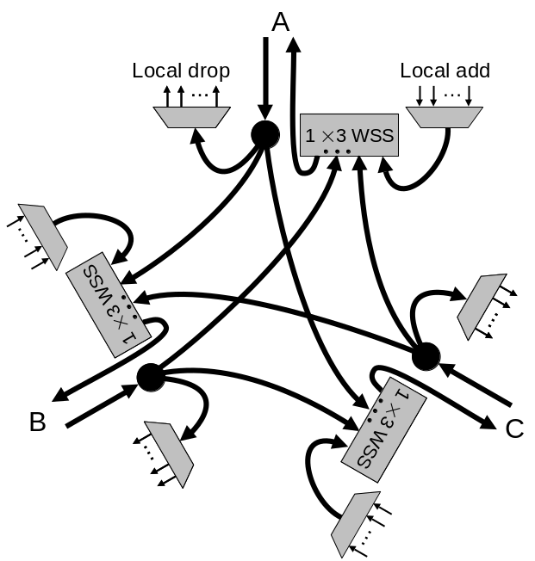
Fig. 3. Conventional design of degree-3 node.

The conventional design of Fig. 3 is highly flexible in that a given wavelength coming from A can be routed to B while simultaneously that same wavelength coming from B can be routed to A or C. However, such asymmetric connection flexibility may needlessly complicate networks. For example, asymmetric connections would likely mean that transceivers would transmit on a different wavelength than they receive. Load-balanced networks, especially, may not need such flexibility. If we give up the asymmetric flexibility and enforce symmetric demands (as mentioned in the Introduction), e.g. if a wavelength is routed from A to B then it must also be routed from B to A, then we can greatly simplify the hardware required to make the node. Our proposed simplified design is shown in Fig. 4.
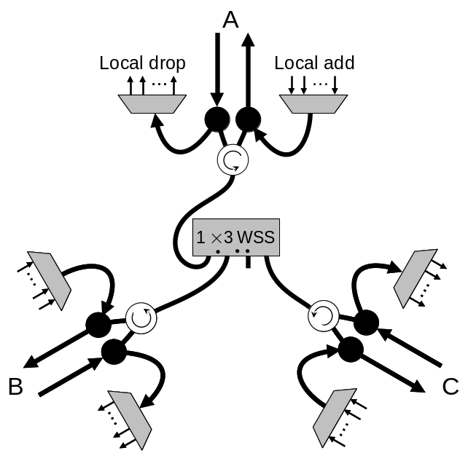
Fig. 4. Proposed more efficient design for degree-3 node.

Now instead of three 1 × 3 WSSs, we need only one. This saves significant cost, space, and fibering. We have designed it so that when a channel is being routed between two locations, the connection to the third location is blocked so that it can be dropped and added. The design of Fig. 4 relies on optical circulators, the white circles containing a circular arrow, which are widely available. In an optical circulator, if you enter one port, you exit from a second port. If you enter the second port, you exit from the third port.
However, besides having a symmetric demand constraint, we have two other drawbacks. The first is that the proposed node cannot balance the channel powers in all cases, as it can in a conventional node. If the channel powers of a given wavelength coming from all the directions are equal, then the WSS can control that wavelength’s attenuation to balance its channel powers with respect to the channel powers of the other wavelengths. However, if the channel power of a given wavelength coming from one direction is substantially different from that of the same wavelength coming from another direction, the proposed node cannot balance these channel powers. Other network elements would be necessary to do the channel-power balancing. Note that the average of the channel powers coming from each direction can be balanced by appropriate setting of the gain of optical amplifiers that are placed in the lines before reaching the circulators,
The other drawback is that the node now has a single point of failure. However, we still have full protection for the add/drop channels (because they do not connect to the network through the WSS), and the loss of a node in a mesh network can be compensated for by re-routing at other nodes.

3. Partitioned degree-4 nodes

Degree-4 nodes have more variations than degree-3 nodes. In this section we discuss “partitioned” degree-4 nodes, and a conventional design without local wavelength add/drop is shown in Fig. 5. The ports are partitioned into two sets, set AB and set CD. There is connectivity between sets but no connectivity within a set. A partitioned node has limited flexibility: e.g., traffic from A cannot be routed to B. A partitioned degree-4 node might be used to couple two rings together.

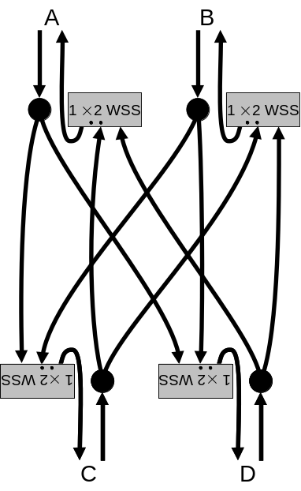
Fig. 5. Conventional design of partitioned degree-4 node without local add/drop.

Our proposed simplified design for a partitioned degree-4 node is shown in Fig. 6. The dummy coupler (which is really just acting as an optical attenuator) in line D is required for loss balancing, to prevent channel power divergence. Instead of four 1 × 2 WSSs, we now need only one 1 × 4 WSS. As before, this saves cost, size, and fibering. Not including circulator losses, the insertion loss is the same for both Figs. 5 and 6. The left-most dot makes the connection A-D, B-C, and the right-most dot makes A-C, B-D.
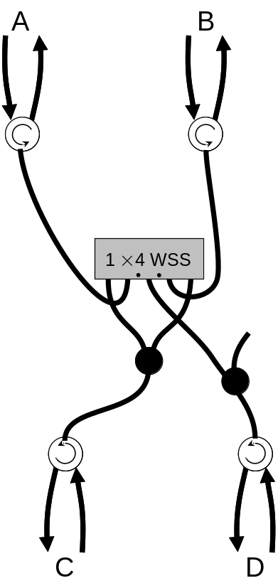
Fig. 6. Proposed more efficient design of partitioned degree-4 node without local add/drop.

Figure 7 shows a conventional partitioned degree-4 node with local add/drop. Channels can be locally dropped and added (with drop and continue if desired) or sent through the node. Figure 8 shows our proposed simplified design for a partitioned degree-4 node with local add/drop. The main new aspect is that we need “ROABM”s (reconfigurable optical add-block multiplexers). A ROABM can either pass a channel or block it and add a new one. Each ROABM in Fig. 8 replaces a multiplexer in Fig. 7, and if the ROABM is made in PLC technology, the additional cost should be low compared to the cost of a WSS.

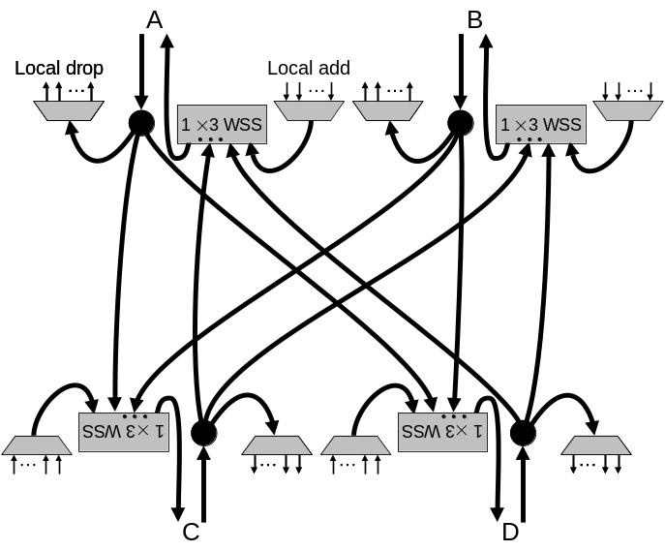
Fig. 7. Conventional design of partitioned degree-4 node with local add/drop.

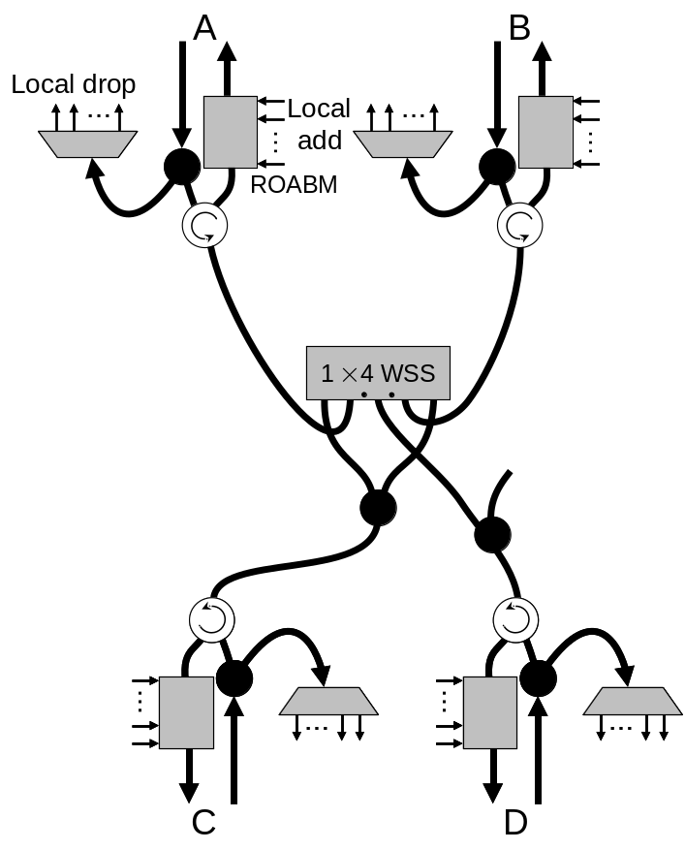
Fig. 8. Proposed more efficient design of partitioned degree-4 node with local add/drop.

ROABMs are often used in conventional add/drops, as shown in Fig. 9. Thus the architecture of Fig. 8 allows one to change a conventional add/drop node, such as Fig. 9, into a mesh node. No initial investment in equipment is lost, and transceivers do not have to ever be disconnected from the network. In the conventional mesh node design of Fig. 7, one would need to anticipate turning an initial add/drop node into a mesh node and would have to build the initial add-drop node using WSSs and multiplexers and reserve valuable ports on the WSSs for the possible future mesh.
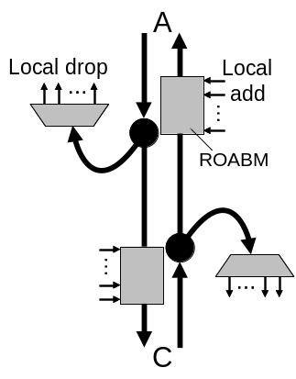
Fig. 9. Conventional add-drop. This add-drop node can grow into a mesh node, such as Fig. 8 or Fig. 14.

4. Degree-4 nodes

A conventional design for a degree-4 node (non-partitioned) without local add/drop is shown in Fig. 10. Traffic can be routed from any direction to any other direction (except back to the direction from which it came, which is probably not needed in networks).
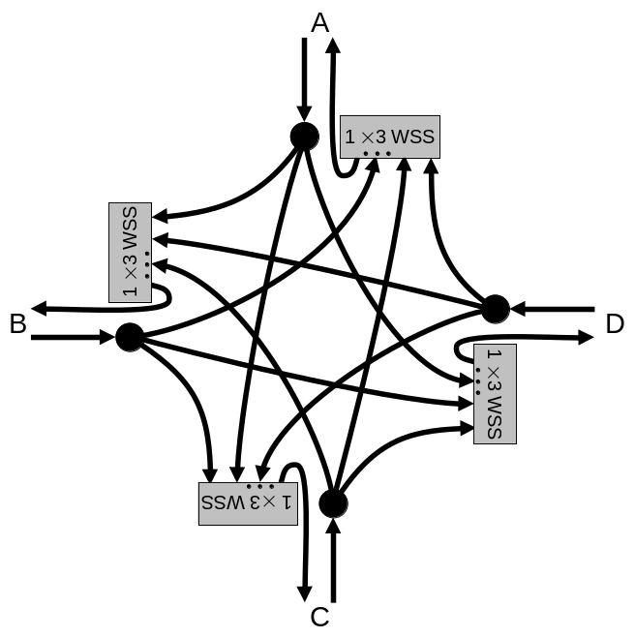
Fig. 10. Conventional design of degree-4 node without local add/drop.

Figure 11 shows our proposed simplified node without local add/drop. We have replaced four 1 × 3 WSSs with one 1 × 6 WSS, again saving significant cost, size, and fibering. Again, the dummy couplers are for loss balancing. A proof that the design of Fig. 11 is optimal, in that it must contain at least two splitters and the WSS must have at least seven ports, is given in the Appendix.

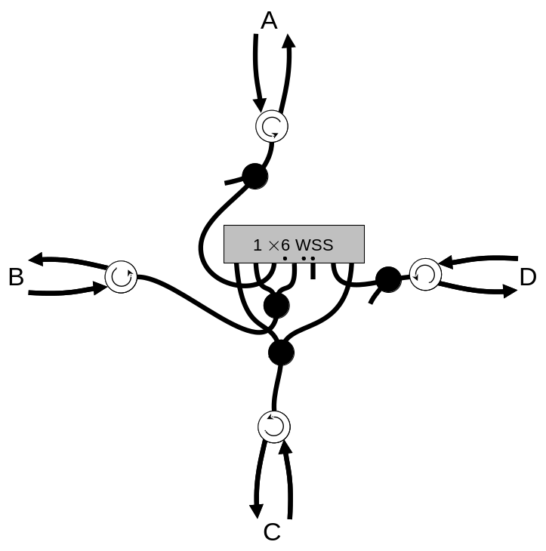
Fig. 11. Proposed more efficient design of degree-4 node without local add-drop, using a one-dimensional tilt mirror array.
For K > 4, some WSSs are made using two-dimensional arrays of ports. In such a case, one could use the design shown in Fig. 12. Again, connections are made symmetrically about the dots. For example, the left-most dot in Fig. 12 depicts connection A-B, C-D.
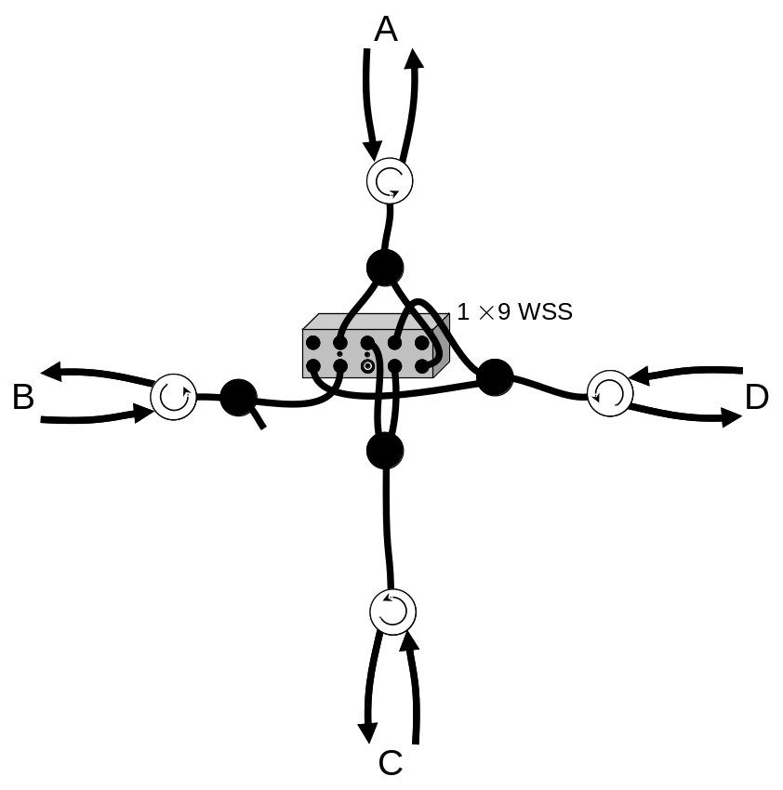
Fig. 12. Same as previous figure, but using a two-dimensional tilt mirror array.

Figure 13 shows a conventional design for a degree-4 node with local add/drop.
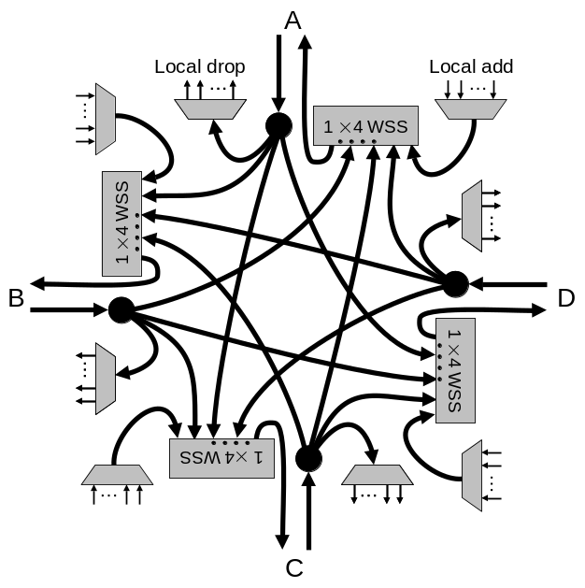
Fig. 13. Conventional design of degree-4 node with local add/drop.

Figure 14 shows our proposed simplified design for a degree-4 node with local add/drop. As in the partitioned degree-4 node, we need to use ROABMs. Also, this architecture allows one to grow to a mesh node from a conventional add/drop such as the one in Fig. 9. The ROABMs can provide channel power balancing, so theoretically we do not need the dummy couplers. The coupler values shown in Fig. 14 are optimized for minimum worst-case insertion loss through the node.

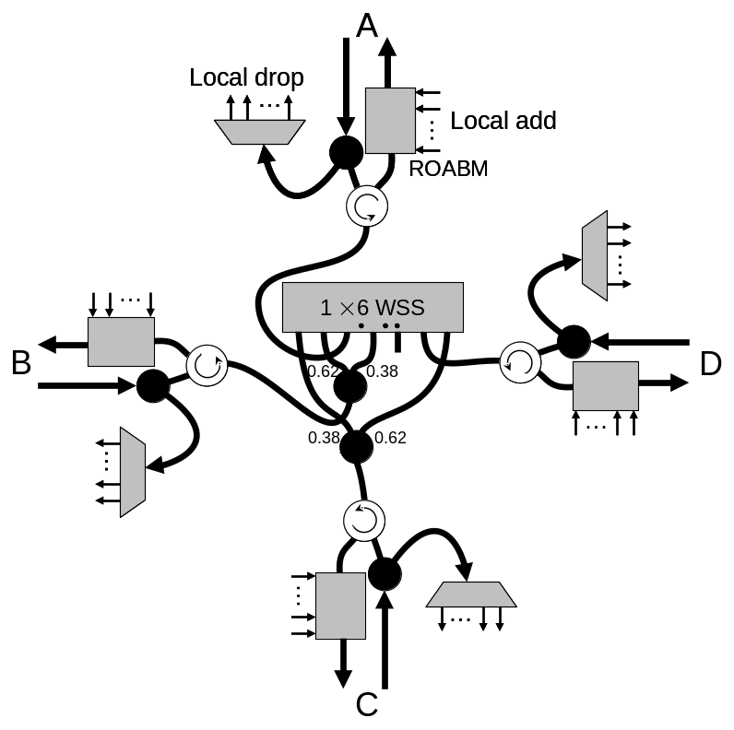
Fig. 14. Proposed more efficient design of degree-4 node with local add/drop. This design is using a one-dimensional tilt mirror array, but could use a two-dimensional tilt mirror array as in Fig. 12.

5. Degree-5 and -6 nodes

For mesh nodes of degree higher than four, there can no longer be only one steering mirror per wavelength. This is because for such nodes, it is possible that one connection for a given wavelength must remain intact while another connection for the same wavelength must be rerouted. Today’s commercially available WSSs have only one steering mirror per wavelength, so we must construct nodes of degree higher than four by using a plurality of WSSs.
Conventional designs for degree-5 and -6 nodes follow the pattern used in jumping from Fig. 3 to Fig. 13. If we ignore local add/dop, then five 1×4 WSSs and six 1×5 WSSs would be required to construct degree-5 and -6 nodes, respectively. For even higher degrees the pattern continues, requiring N 1×(N-1) WSSs for a node of degree N.
However, if we apply the constraint of symmetric demands, we require only N 1×(N-1)/2 WSSs for a node of degree N, again ignoring local add/drop. This is possible because each WSS needs to connect to only half of the nodes, the other WSSs being responsible for the connections to the other half of the nodes. Actually, there are many possible designs, a necessary criterion being that for the N 1×K_{i} WSSs being used, 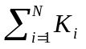 ≥ N(N-1)/2,
In general, this WSS port count reduction requires transmissive WSSs, because transmissive WSSs make only one connection in each state. Unfortunately, transmissive WSSs are not widely commercially available. In the degree-3 and -4 designs shown earlier, we used the multiple connection property of a reflective WSS to our advantage. However, for higher degree nodes the multiple connection property creates stray connections. The stray connections become almost unmanageable for degrees above six, so six is the highest degree we consider in this paper. In [], using a different approach, we show designs for mesh nodes of arbitrarily large degree. Our proposed designs for degree-5 and -6 nodes using reflective WSSs are shown in Figs. 15 and 16, respectively.
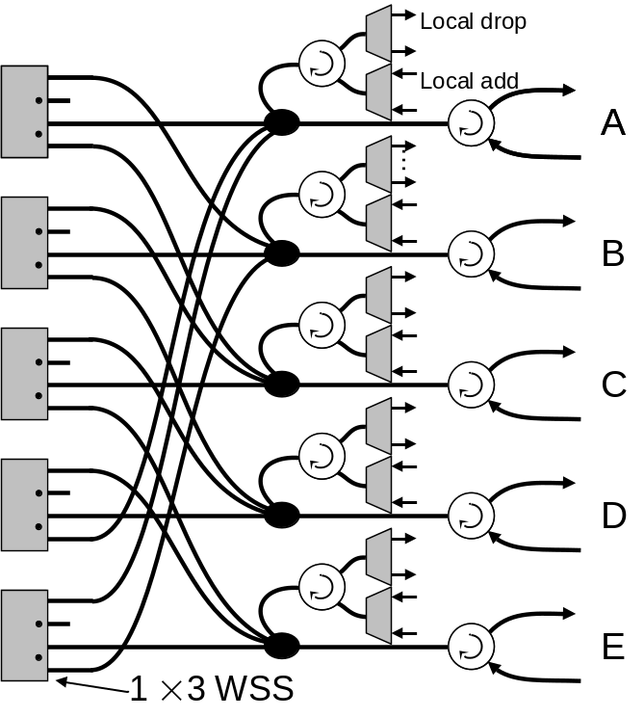
Fig. 15. Proposed efficient design of degree-5 node with local add/drop.
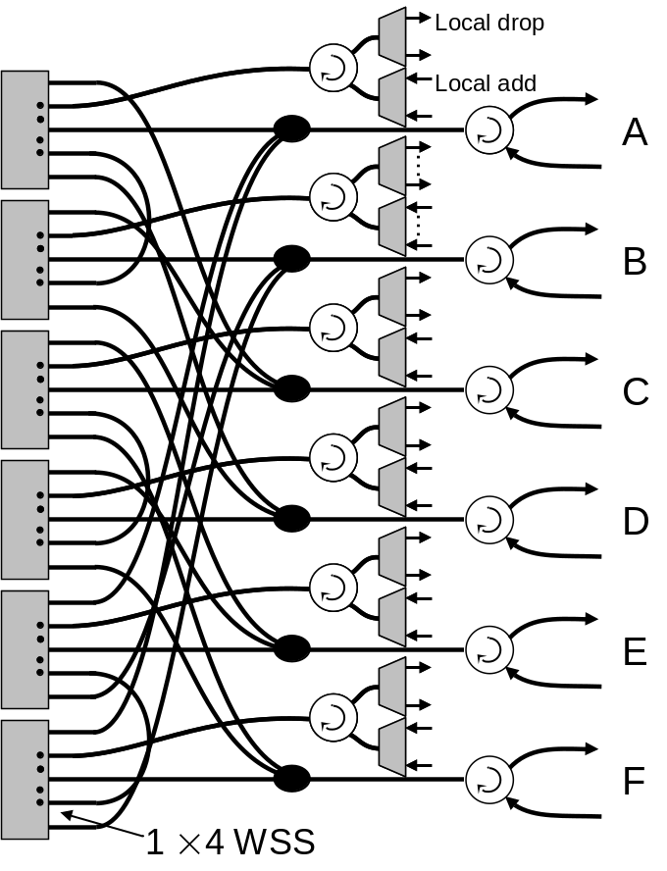
Fig. 16. Proposed efficient design of degree-6 node with local add/drop.
The proposed degree-5 node requires only five 1 × 3 WSSs, and the degree-6 nodes requires only six 1 × 4 WSSs, thus saving WSS port count over the conventional design. If we had used transmissive WSSs, we could have constructed the degree-5 nodes with five 1 × 2 WSSs, and the degree-6 node with five 1 × 3 WSSs. The insertion loss is reduced as compared to the conventional design because there is less power splitting. The WSSs in these designs must be able to switch in a hitless fashion and must be able to extinguish the signal (i.e., make no connections at all).

6. Experimental demonstration of degree-3 and -4 nodes

In this section we show experimental demonstrations of low-complexity degree-3 and -4 nodes. Figure 17 shows the experimental setup for the degree-3 node. We used a commercially available 1 × 4 reflective WSS from Metconnex, connected as shown in Fig. 17. This WSS uses PLC technology for the de/multiplexing and MEMS technology for the optical steering. The port numberings are as given on the device. To connect A to B, we tell the software to connect the “input” (port 1) to port 2. Likewise, A-C is given by routing to port 3, and B-C is given by routing to port 5. We took 24 wavelengths, split them in an 8-skip-0 band splitter[] to three sets of eight channels each and sent each set to an input, as shown in Fig. 18. The band splitter had only ~25-dB crosstalk. Within each group of eight, we set the WSS for A-B for the left three channels, A-C for the center three channels, and B-C for the right two channels.
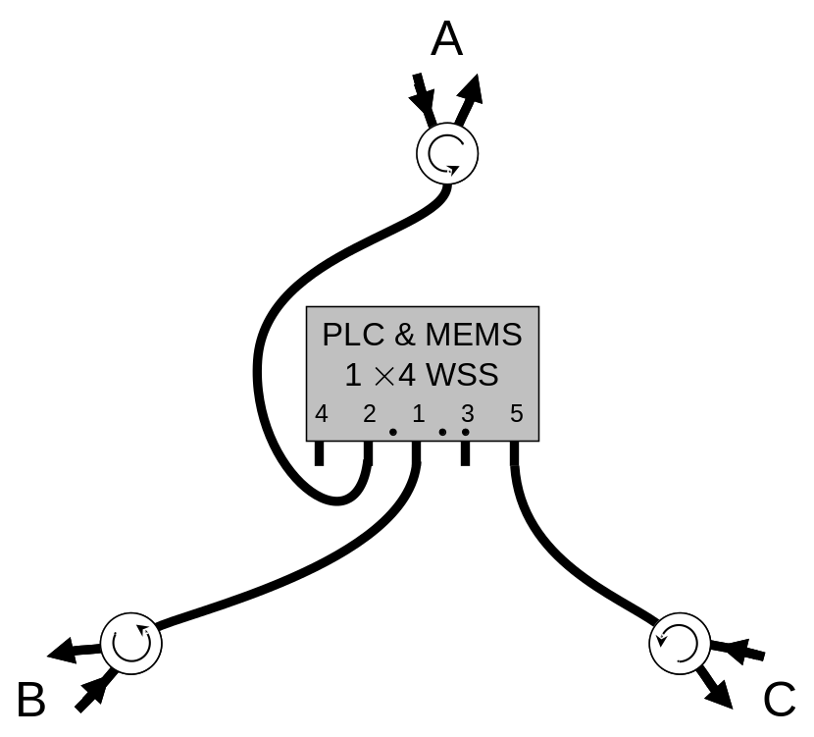
Fig. 17. Experimental setup of degree-3 node.
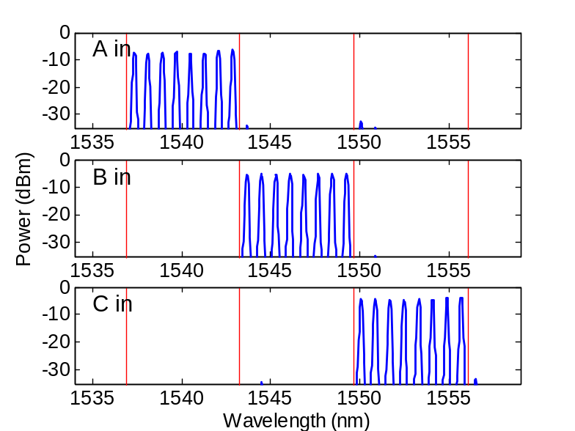
Fig. 18. Spectra input to the degree-3 node. The vertical lines were added as visual aids.

Figure 19 shows that the mesh node works as expected. The total number of channels exiting the node is less than that entering because in a degree-3 node with symmetric demands one port is terminated. Note that this experiment is for illustrative purposes only, and in a real application all channels would enter all three inputs simultaneously.
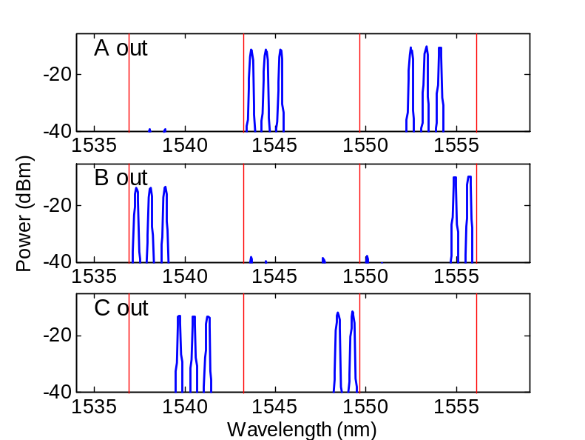
Fig. 19. Spectra output from the degree-3 node.

Figure 20 shows the experimental setup of the degree-4 node. We used a commercially available 1 × 9 reflective WSS that uses a diffraction grating for the de/multiplexing and liquid crystal on silicon (LCOS) for the optical steering. After experimenting with the device, it was found that all ten ports are not contiguous. Thus we had to modify the design from that of Fig. 11. The port numberings are as given on the device. To connect A-C, B-D, we tell the software to route from port 0 to port 1. To connect A-D, B-C, we route 0 to 4, and for A-B, C-D, we route 0 to 5. We used a separate WSS to split 40 channels into four groups of ten channels and sent each set to an input, as shown in Fig. 21. Within each group of ten, the left three channels were set for A-C, B-D; the middle three channels for A-D, B-C; and the right four channels for A-B, C-D.
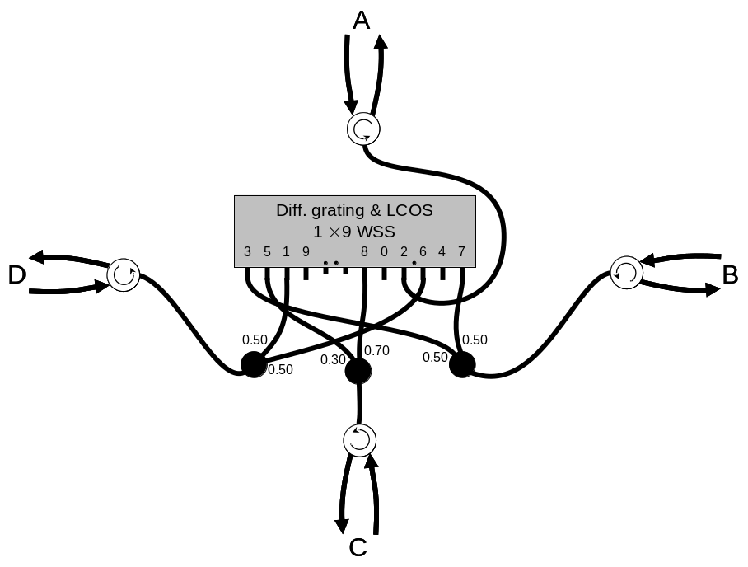
Fig. 20. Experimental setup of degree-4 node. The coupler value choices are based mainly on was readily available.
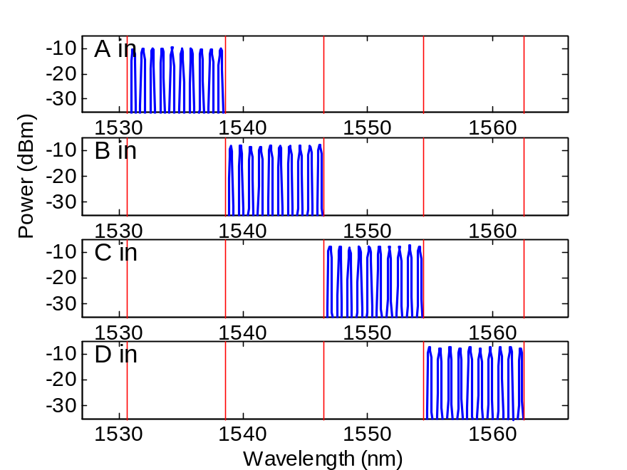
Fig. 21. Spectra input to the degree-4 node.

Figure 22 shows that the mesh node operates as expected. In a degree-4 node with symmetric demands, the total number of channels exiting the node does equal the total number entering. We did see some significant back reflection from within the WSS, especially from C. Hopefully such stray reflections could be reduced by modifications to the WSS. We later repeated the degree-4 experiment using a different commercially available 1 × 9 WSS (uses a diffraction grating for the de/multiplexing and MEMS for the optical steering) which did not exhibit stray reflections, and we achieved high performance with extremely good directivity[].
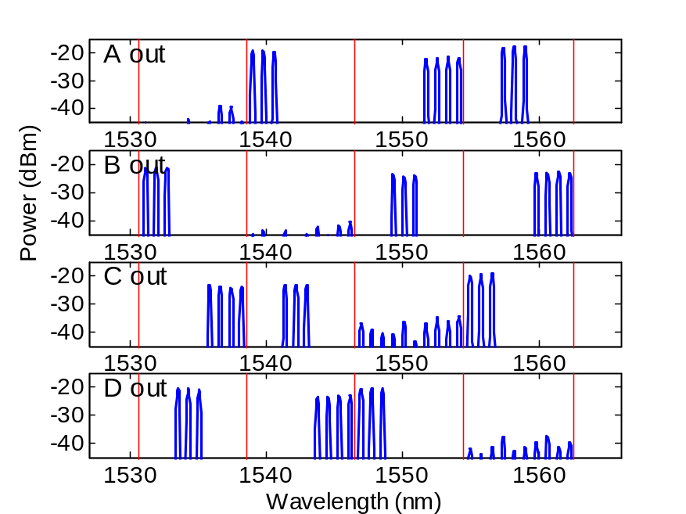
Fig. 22. Spectra output from the degree-4 node.

7. Conclusion

By taking advantage of the flexible nature of reflective WSSs and the practical constraint of symmetric demands, we proposed designs for degree-3 through -6 mesh nodes with significantly reduced complexity than conventional designs. The proposed designs can be implemented using today’s commercially available components. The drawbacks are the symmetric demand constraint, no individual through channel power control, and a single point of failure for transiting channels (for the degree-3 and -4 designs; add/drop channels avoid this).

Acknowledgments

We thank M. Zirngibl for support and J. Fernandes for assistance.

Appendix: Proof that simplified degree-4 design is optimum

In the simplified degree-4 1-D design (Figs. 11 and 14) we used two splitters and seven ports on the WSS. Here we show that no design could use fewer splitters or ports.
Suppose no splitters were used. Without loss of generality assume that the ports on the WSS connect to locations A, B, C, and D in that order from left to right. Then a dot (mirror tilt angle) that connects A and B lies between the ports connected to A and B. But that means that C and D are both to the right of the dot and hence are not connected. Thus there must be at least one splitter.
Suppose there is exactly one splitter. Without loss of generality assume that C is the location that gets split (and hence C is connected to two ports of the WSS), and that the left to right ordering of the lines other than the two C’s is ABD. Then there is a dot connecting A and B, and this implies that there must be a C to the left of A so as to be able to connect this C via this dot to D. The dot that connects B with D must lie to the right of B and so it must connect A with a copy of C to the right of D. Thus the ordering is CABDC. Then the dot that connects A and D cannot connect B to either C. So there must be at least one more splitter.
Since we have that there must be at least two splitters, then there must be at least six ports in the WSS. Suppose there are exactly six. Then all ports have a line into them, and so no dot occurs at a port position (otherwise there will be a location routed back to itself). Also, any dot must have at least two ports on either side of it. Then the three necessary dots must occur between ports 2 and 3 (dot 1), between ports 3 and 4 (dot 2), and between ports 4 and 5 (dot 3). But then dot 2 will create three connections contradicting the criterion that each dot should connect two pairs. Thus six ports is insufficient.

References

C. R. Doerr, L. W. Stulz, D. S. Levy, M. Cappuzzo, E. Chen, L. Gomez, E. Laskowski, A. Wong-Foy, and T. Murphy, “Silica-waveguide 1 x 9 wavelength-selective cross connect,” Optical Fiber Communication Conference, postdeadline paper FA3, 2002.
D. M. Marom, et. al., “Wavelength-selective 1x4 switch for 128 WDM channels at 50 GHz spacing,” Optical Fiber Communication Conference, paper FB7, 2002.
D. M. Marom, C. R. Doerr, N. R. Basavanhally, M. Cappuzzo, L. Gomez, E. Chen, A. Wong-Foy, and E. Laskowski, “Wavelength-selective 1×2 switch utilizing a planar lightwave circuit stack and a MEMS micromirror array,” Optical MEMS 2004, Takamatsu, Japan, Aug. 2004.
T. Ducellier, A. Hnatiw, M. Mala, S. Shaw, A. Mank, D. Touahri, D. McMullin, T. Zami, B. Lavigne, P. Peloso, and O. Leclerc, “Novel high performance hybrid waveguide-MEMS 1x9 wavelength selective switch in a 32-cascade loop experiment,” European Conference on Optical Communications, postdeadline paper Th4.2.2, 2004.
J. M. Simmons, A. A. M. Saleh, E. L. Goldstein, and L. L. Lin, “Optical crossconnects of reduced complexity for WDM networks with bidirectional symmetry,” IEEE Photon. Technol. Lett., vol. 10, p. 819-821, Jun. 1998.
J. M. Simmons, A. A. M. Saleh, E. L. Goldstein, and L. L. Lin, “Optical crossconnects of reduced complexity for WDM networks with bidirectional symmetry,” IEEE Photon. Technol. Lett., vol. 10, p. 819-821, Jun. 1998.
G. Wilfong and C. R. Doerr, “Undirected (or bidirectional) widesense nonblocking cross connects,” to be submitted to J. Lightwave Technol.
S. Chandrasekhar, C. R. Doerr, and L. L. Buhl, “Flexible waveband optical networking without guard bands using novel 8-skip-0 banding filters,” IEEE Photon. Technol. Lett., vol. 17, pp. 579-581, Mar. 2005.
C. R. Doerr, “Degree-4 nodes using a single wavelength-selective switch,” Optical Fiber Communication Conference, postdeadline paper, 2006.

