# Setting up Broadview AvidPopupApplet

## Description :

Broadview AvidPopup applet is used to edit and capture comments from Avid .

## Files Attached :

**AvidPopup.Avx**

This is core Avid applet file which allows users to mark comments from AVID UI.

**AvidPopupHook.Ini**

This is ini file that stores configurations required for Avid Applet file to work. This is based on AVID instructions

**PBSAvidPopupwindow.Ini file**

A custom PBS “ini” file which stores title which will be used when searching for matching “AVID window”. The matching text is specified under the section [”Window”] with key “Name”.

## Pre-requisites

1. On the “C” drive of AVID Machine , place the attached “PBSAvidPopupWindow.ini “ file.

# AvidPlugintester Application and Instructions

## Description

AvidPluginTester application allows PBS IT /MOC engg to emulate AVID applet behavior without having to install AVID Media Composer.

## Instructions

1. Run “AvidPluginTester.exe”
2. It will launch application with following screen

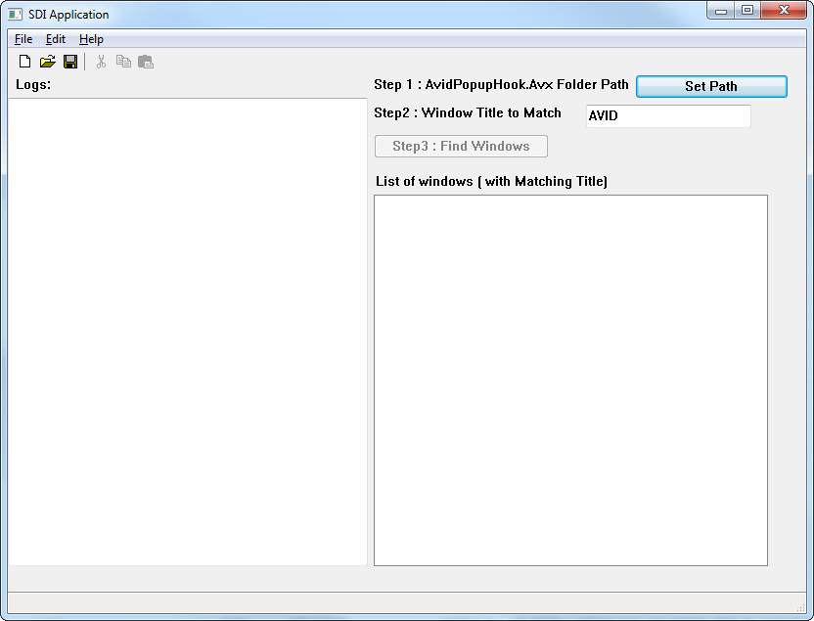

1. Click on Set Path button.
2. Select the “AvidPopupHook.Avx” file

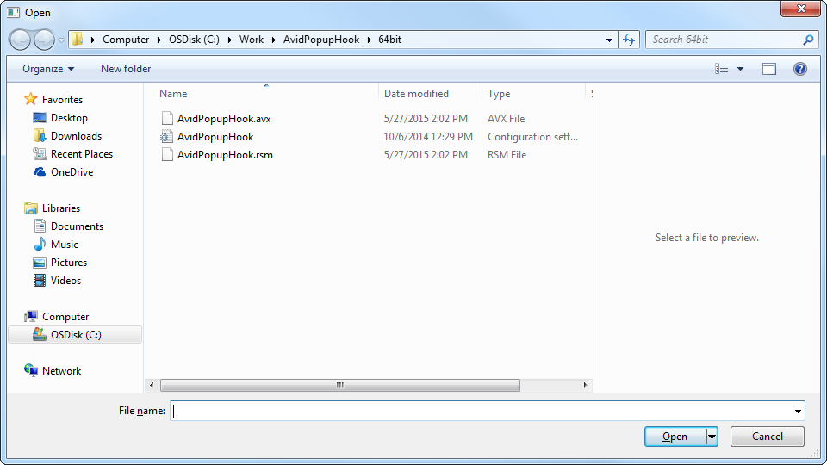

1. On the main window , select “Find Windows”

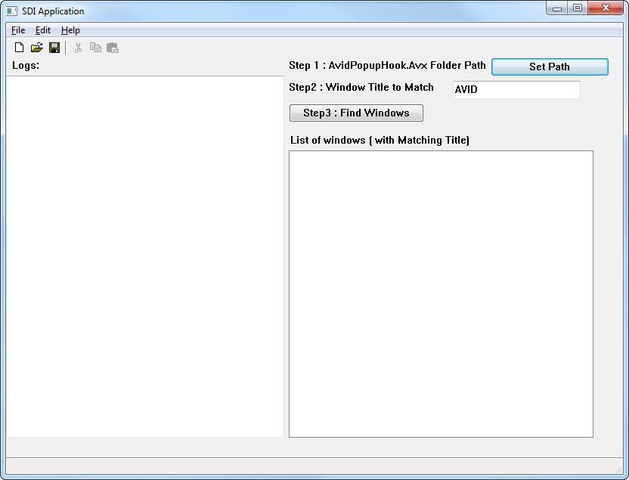

1. Application will launch an additional form that will interface with applet. It will also update the log window on main screen

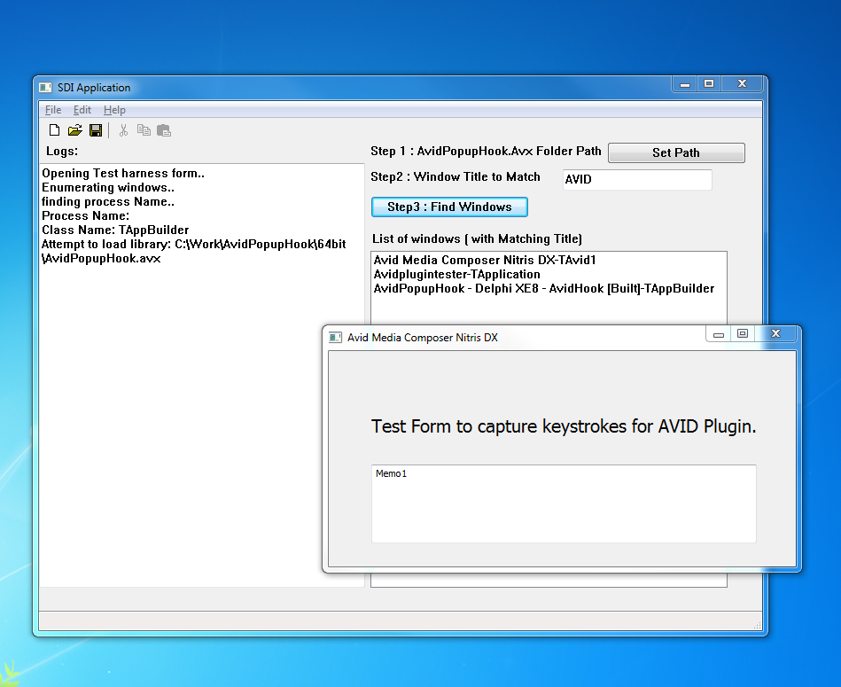

On the Memo field , press CTRL+CC , this will bring the Broadview Clip Comments dialog ( from AvidPopupHook.Avx)

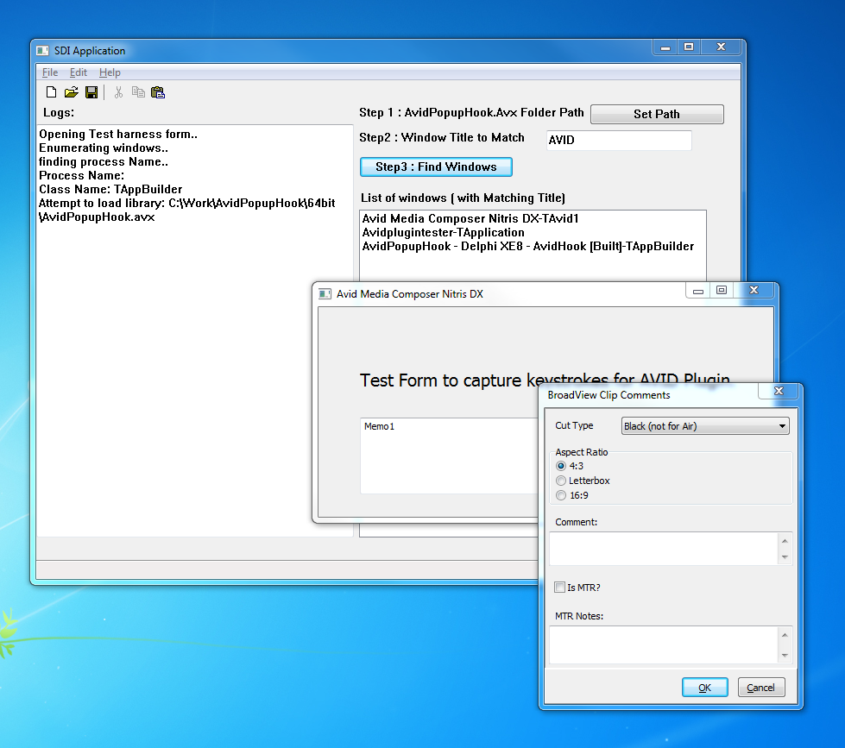

1. Enter text on comments field and press “OK”

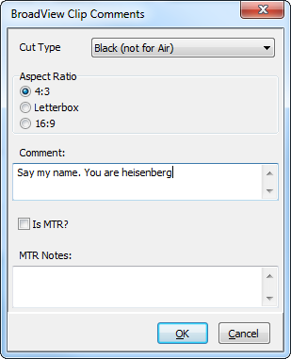

1. Application will update test form with Marker text.

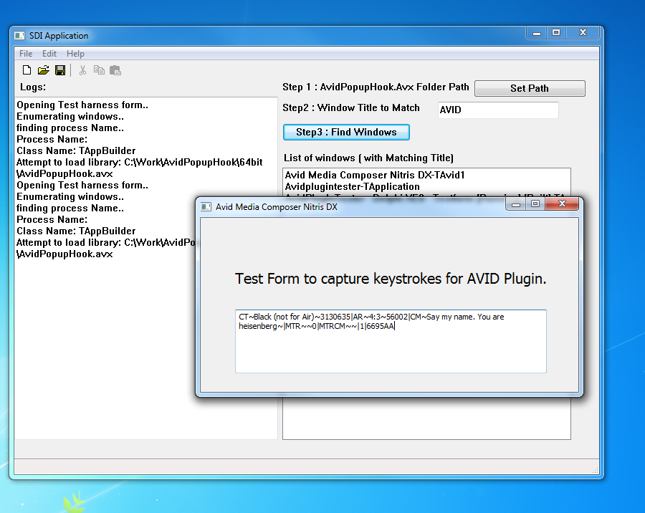

1. Select text and press CTRL+CC again. Broadview Clip comment form should reflect updated comment.