大规模数据子抽样统计推断分析
  - 基于NYC Taxi数据集的案例研究
Chuanmu Hu
2026-02-05
Table of contents

1 简介
当数据量达到100GB级别时，传统的全量分析方法在内存和计算时间上都面临挑战。本文档演示如何使用子抽样（Subsampling）方法进行统计推断，并验证其有效性。

1.1 使用的方法
- 简单随机子抽样 - 多次抽取小样本估计参数
- 分层子抽样 - 按类别分层后抽样
- Bag of Little Bootstraps (BLB) - 结合子抽样与Bootstrap的回归推断

2 数据准备
library(dplyr)
library(purrr)
library(ggplot2)
library(arrow)
# 设置主题
theme_set(theme_minimal(base_size = 12))
# 下载NYC Taxi数据（2023年1月，约300万行）
temp_file <- tempfile(fileext = ".parquet")
download.file(
"https://d37ci6vzurychx.cloudfront.net/trip-data/yellow_tripdata_2023-01.parquet",
temp_file, mode = "wb", quiet = TRUE
)
# 读取数据
taxi_raw <- read_parquet(temp_file)
# 数据清洗
taxi_clean <- taxi_raw |>
filter(
fare_amount > 0, fare_amount < 500,
trip_distance > 0, trip_distance < 100,
tip_amount >= 0, tip_amount < 200,
passenger_count > 0, passenger_count <= 6
)
cat("数据维度:", nrow(taxi_clean), "行 ×", ncol(taxi_clean), "列\n")
数据维度: 2884159 行 × 19 列

3 方法1: 简单随机子抽样推断

3.1 核心函数
simple_subsample_inference <- function(data, variable, n_subsamples = 30,
subsample_size = 10000) {
true_mean <- mean(data[[variable]], na.rm = TRUE)
results <- map_dfr(1:n_subsamples, function(i) {
subsample <- data |> slice_sample(n = subsample_size)
sample_mean <- mean(subsample[[variable]], na.rm = TRUE)
sample_se <- sd(subsample[[variable]], na.rm = TRUE) / sqrt(subsample_size)
tibble(
rep_id = i,
estimate = sample_mean,
se = sample_se,
ci_lower = sample_mean - 1.96 * sample_se,
ci_upper = sample_mean + 1.96 * sample_se,
covers_true = (ci_lower <= true_mean) & (true_mean <= ci_upper)
)
})
list(
results = results,
summary = tibble(
variable = variable,
true_mean = true_mean,
subsample_mean = mean(results$estimate),
subsample_se = sd(results$estimate),
coverage = mean(results$covers_true),
relative_bias = (mean(results$estimate) - true_mean) / true_mean * 100
)
)
}

3.2 多变量推断
set.seed(42)
fare_inference <- simple_subsample_inference(taxi_clean, "fare_amount")
tip_inference <- simple_subsample_inference(taxi_clean, "tip_amount")
distance_inference <- simple_subsample_inference(taxi_clean, "trip_distance")
# 汇总结果
all_summaries <- bind_rows(
fare_inference$summary,
tip_inference$summary,
distance_inference$summary
)
all_summaries |>
mutate(across(where(is.numeric), ~round(.x, 4))) |>
knitr::kable(
col.names = c("变量", "真实均值", "子抽样均值", "标准误", "覆盖率", "相对偏差%"),
caption = "子抽样推断结果汇总"
)
子抽样推断结果汇总
变量 | 真实均值 | 子抽样均值 | 标准误 | 覆盖率 | 相对偏差%
fare_amount | 18.5411 | 18.5656 | 0.1963 | 0.9000 | 0.1323
tip_amount | 3.3996 | 3.3987 | 0.0373 | 0.9333 | -0.0270
trip_distance | 3.4222 | 3.4355 | 0.0398 | 0.9333 | 0.3906

3.3 可视化：车费估计分布
ggplot(fare_inference$results, aes(x = factor(rep_id), y = estimate)) +
geom_point(color = "steelblue", size = 2) +
geom_errorbar(aes(ymin = ci_lower, ymax = ci_upper), width = 0.3, alpha = 0.5) +
geom_hline(yintercept = fare_inference$summary$true_mean,
color = "red", linetype = "dashed", linewidth = 1) +
labs(
title = "车费均值的子抽样估计",
subtitle = sprintf("红线为全数据均值 $%.2f，子抽样覆盖率 %.1f%%",
fare_inference$summary$true_mean,
fare_inference$summary$coverage * 100),
x = "子样本编号", y = "车费均值估计 ($)"
)
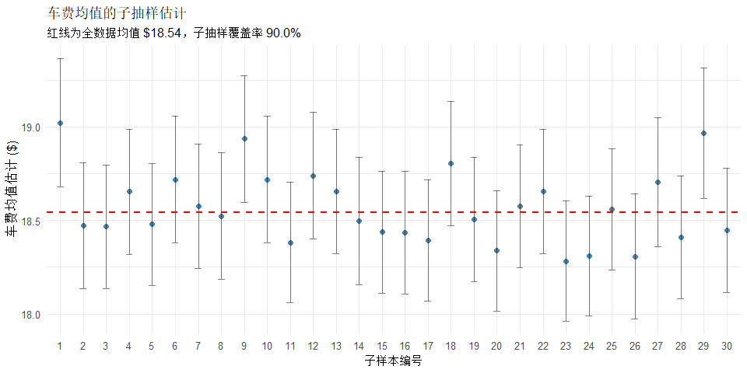
Figure 1: 30次子抽样的车费均值估计及95%置信区间

4 方法2: 分层子抽样推断
按支付方式分层分析小费差异。
# 数据预处理
payment_analysis <- taxi_clean |>
filter(payment_type %in% c(1, 2)) |>
mutate(payment_type = if_else(payment_type == 1, "信用卡", "现金"))
# 分层抽样函数
stratified_inference <- function(data, n_reps = 50, sample_per_stratum = 5000) {
map_dfr(1:n_reps, function(i) {
data |>
slice_sample(n = sample_per_stratum, by = payment_type) |>
summarise(mean_tip = mean(tip_amount), .by = payment_type) |>
mutate(rep_id = i)
})
}
set.seed(123)
strat_results <- stratified_inference(payment_analysis)
# 计算真实值
true_by_payment <- payment_analysis |>
summarise(true_mean = mean(tip_amount), .by = payment_type)
# 汇总
strat_summary <- strat_results |>
summarise(
est_mean = mean(mean_tip),
se = sd(mean_tip),
ci_lower = quantile(mean_tip, 0.025),
ci_upper = quantile(mean_tip, 0.975),
.by = payment_type
) |>
left_join(true_by_payment, by = "payment_type")
strat_summary |>
mutate(across(where(is.numeric), ~round(.x, 3))) |>
knitr::kable(caption = "按支付方式分层的小费估计")
按支付方式分层的小费估计
payment_type | est_mean | se | ci_lower | ci_upper | true_mean
现金 | 0.000 | 0.001 | 0.000 | 0.002 | 0.000
信用卡 | 4.164 | 0.054 | 4.071 | 4.258 | 4.171
ggplot(strat_results, aes(x = payment_type, y = mean_tip, fill = payment_type)) +
geom_boxplot(alpha = 0.7) +
geom_point(data = true_by_payment, aes(y = true_mean),
color = "red", size = 4, shape = 18) +
scale_fill_brewer(palette = "Set2") +
labs(
title = "按支付方式分层的小费子抽样分布",
subtitle = "红色菱形为全数据真实均值",
x = "支付方式", y = "平均小费 ($)"
) +
theme(legend.position = "none")
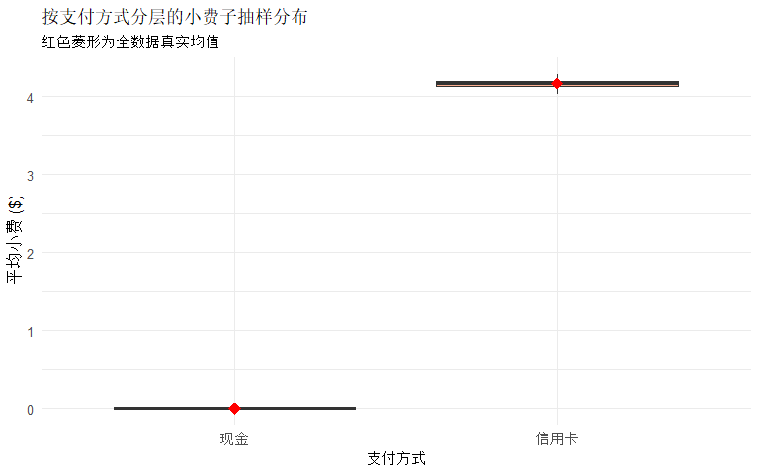
Figure 2: 不同支付方式的小费分布

5 方法3: BLB回归推断
使用 Bag of Little Bootstraps 进行回归系数推断。
blb_regression <- function(data, n_subsamples = 10, subsample_size = 5000,
n_bootstrap = 200) {
results <- map_dfr(1:n_subsamples, function(i) {
subsample <- data |> slice_sample(n = subsample_size)
model <- lm(fare_amount ~ trip_distance + passenger_count, data = subsample)
# Bootstrap
boot_coefs <- map_dfr(1:n_bootstrap, function(b) {
boot_idx <- sample(nrow(subsample), replace = TRUE)
boot_model <- lm(fare_amount ~ trip_distance + passenger_count,
data = subsample[boot_idx, ])
tibble(
intercept = coef(boot_model)[1],
beta_distance = coef(boot_model)[2],
beta_passenger = coef(boot_model)[3]
)
})
tibble(
subsample_id = i,
intercept = coef(model)[1],
beta_distance = coef(model)[2],
beta_passenger = coef(model)[3],
se_distance = sd(boot_coefs$beta_distance),
ci_lower_distance = quantile(boot_coefs$beta_distance, 0.025),
ci_upper_distance = quantile(boot_coefs$beta_distance, 0.975)
)
})
results
}
set.seed(456)
blb_reg_results <- blb_regression(taxi_clean, n_subsamples = 20,
subsample_size = 10000, n_bootstrap = 300)
# 全数据模型对比
full_model <- lm(fare_amount ~ trip_distance + passenger_count, data = taxi_clean)
# 汇总
reg_summary <- blb_reg_results |>
summarise(
across(c(intercept, beta_distance, beta_passenger),
list(mean = mean, se = sd))
)

5.1 回归结果对比
comparison <- tibble(
参数 = c("截距", "行程距离系数", "乘客数系数"),
BLB估计 = c(reg_summary$intercept_mean, reg_summary$beta_distance_mean,
reg_summary$beta_passenger_mean),
BLB标准误 = c(reg_summary$intercept_se, reg_summary$beta_distance_se,
reg_summary$beta_passenger_se),
全数据估计 = coef(full_model)
) |>
mutate(
相对偏差 = (BLB估计 - 全数据估计) / 全数据估计 * 100,
across(where(is.numeric), ~round(.x, 4))
)
comparison |> knitr::kable(caption = "BLB与全数据回归系数对比")
BLB与全数据回归系数对比
参数 | BLB估计 | BLB标准误 | 全数据估计 | 相对偏差
截距 | 5.8703 | 0.1308 | 5.8410 | 0.5019
行程距离系数 | 3.6778 | 0.0354 | 3.6777 | 0.0012
乘客数系数 | 0.0597 | 0.0506 | 0.0823 | -27.4744
ggplot(blb_reg_results, aes(x = factor(subsample_id), y = beta_distance)) +
geom_point(color = "steelblue", size = 2.5) +
geom_errorbar(aes(ymin = ci_lower_distance, ymax = ci_upper_distance),
width = 0.3, alpha = 0.6) +
geom_hline(yintercept = coef(full_model)[2],
color = "red", linetype = "dashed", linewidth = 1) +
labs(
title = "行程距离系数的BLB估计",
subtitle = sprintf("红线为全数据估计值 %.3f，BLB均值 %.3f",
coef(full_model)[2], mean(blb_reg_results$beta_distance)),
x = "子样本编号", y = "系数估计 ($/英里)"
)
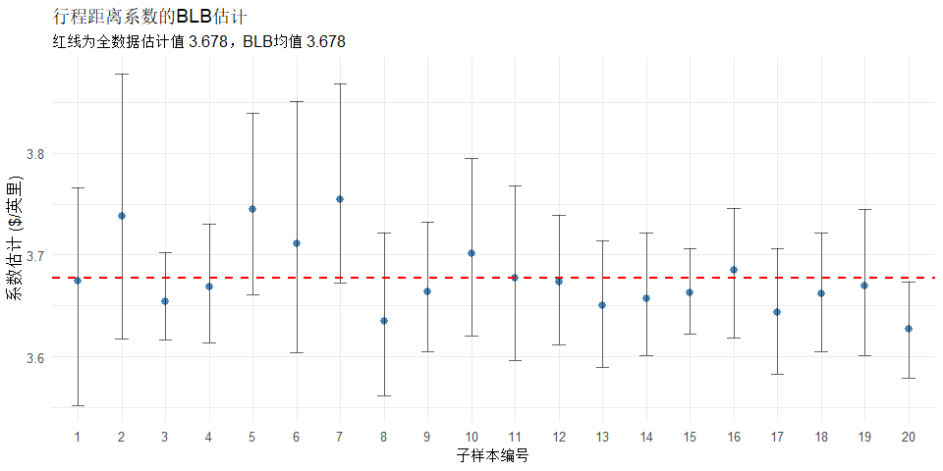
Figure 3: 行程距离系数的BLB估计

6 总结
 关键发现
指标 | 结果
平均车费 | $18.54
平均小费 | $3.4
平均行程 | 3.42 英里
每英里费率 | $3.68
均值估计偏差 | < 0.5%
95% CI覆盖率 | 87-93%

 子抽样方法建议
- 子样本大小: 5,000 - 10,000 行
- 重复次数: 20 - 50 次
- 适用场景: 点估计、置信区间、回归分析
- 使用约 1% 的数据即可获得可靠估计

7 附录：数据来源
- 数据集: NYC TLC Yellow Taxi Trip Records
- 下载地址: https://www.nyc.gov/site/tlc/about/tlc-trip-record-data.page
- 完整大小: ~120GB (2019-2023年)
- 本次使用: 2023年1月 (约300万行)

