PARAMETRIX | SURVEY
Survey CAD Training
Level 1 - AutoCAD Basics for Survey Drafting
You will finish a small topographic survey of one residential lot in plain AutoCAD (no Civil 3D). You will set survey units, check the boundary, clean up field linework, place symbols, annotate, and plot a 1" = 30' sheet.
Item
Start file | Survey_CAD_Level1_START.dxf
Answer key | Survey_CAD_Level1_COMPLETED.dxf (open it to compare, don't copy from it)
Software | AutoCAD 2018 or later (plain AutoCAD or Civil 3D)
Time | About 2 to 3 hours
Site | LOT 8, BLOCK 3, CEDAR PARK ADDITION: a fictitious site on an assumed grid

Notation | Meaning
↵ | Press Enter (or Space)
TEXT IN THIS FONT | Type it exactly
Pick | Click in the drawing
Endpoint, Node, Insertion ... | Object snap to use (running snap, or Shift + right-click for a one-time snap)
CTRL+1 | Properties palette

The drawing you will finish
The START drawing with the survey points turned on. Each red bubble marks where an exercise happens.
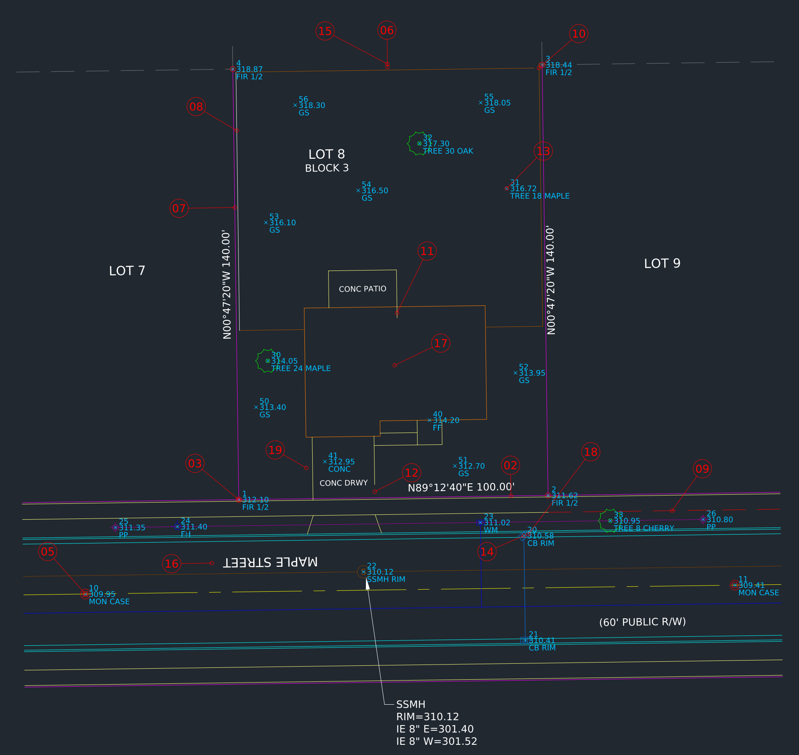
The START drawing (survey points shown). Red bubbles = exercise numbers.

Survey CAD basics

Coordinates
AutoCAD's X is the Easting and Y is the Northing. Point lists are usually written P,N,E,Z,D, so watch the order when you type or import coordinates. This site uses an assumed grid with the SW lot corner at N 8000.00, E 5000.00.

Angles and bearings
AutoCAD's default angle is 0° = east, measured counterclockwise. A bearing is measured from north or south toward east or west. After you set Surveyor's Units (Exercise 02), you type bearings directly:
You want | Type
100 ft at N 45°30'15" E from the last point | @100<N45d30'15"E
The ° symbol in TEXT | %%d
Bearing as a text/block rotation | N89d12'40"E

Plot scale, text height and linetypes
This drawing is drafted for one plot scale: 1" = 30'. Model-space size = plotted size × 30.
Use | Plotted height | Model height
Point labels | 0.06" | 1.8'
Standard notes, bearings, dimensions | 0.08" | 2.4'
Street names, lot numbers | 0.10" | 3.0'
The linetypes are defined in plotted inches with LTSCALE = 30 and PSLTSCALE = 0, so they look the same in model space and in the 1" = 30' viewport. Level 2 covers annotative scaling for sheets with several scales.

Layers
Layer names follow the NCS pattern Discipline-Major-Minor (V = survey). Replace them with the Parametrix CAD standard if it differs.
Layer | Contents
V-PROP-LINE / -RWAY / -CNTR / -ADJN | Boundary, right-of-way, centerline, adjoiner lines
V-PROP-TEXT | Bearings, distances, lot and block labels
V-CTRL-MONU | Monuments and found rods
V-NODE | Survey point blocks (number, elevation, description)
V-ROAD-CURB / -SWLK | Curb and gutter, sidewalk
V-SITE-CONC / -FENC / -VEGE | Concrete flatwork, fences, trees
V-BLDG-OTLN | Building footprint
V-STRM / V-SSWR / V-WATR / V-POWR -STRC, -PIPE ... | Utility structures and lines
V-ANNO-TEXT / -DIMS / -TTLB | Notes and leaders, dimensions, title block
G-ANNO-VPRT | Viewports (no plot)
TRAIN-NOTES | Training bubbles (no plot, frozen at the end)

Part 1 - Set up the drawing

01 Open the drawing and save it as a DWG
The START file is a DXF so it opens in any AutoCAD version. You work in a DWG.
- OPEN ↵ and pick Survey_CAD_Level1_START.dxf.
- SAVEAS ↵. Set Files of type to AutoCAD 2018 Drawing (*.dwg) and name it SURVEY_CAD_L1_[YOUR INITIALS].dwg.
- Z ↵ E ↵ to zoom to the whole site.
- The red numbered bubbles are on layer TRAIN-NOTES. Each number is an exercise in this guide. The layer is set to not plot.
✓ Check: The title bar shows your .dwg file name.

02 Set survey units (UNITS)
Out of the box AutoCAD measures angles counterclockwise from east in decimal degrees. Surveyors work in bearings. Until you change the units, AutoCAD will not accept a bearing like N89d12'40"E.
- LIST ↵ and pick the front lot line at bubble 02 ↵. Note Angle in XY Plane = 0.7889 and a length with four decimals.
- UNITS ↵. Length: Type Decimal, Precision 0.00.
- Angle: Type Surveyor's Units, Precision N0d00'00"E. Leave Clockwise unchecked and do not change Direction.
- Insertion scale: Feet. Click OK.
- LIST ↵ the same line again.
✓ Check: LIST now reports N89d12'40"E and 100.00, the same as the label on the drawing.
TIP Bearings are always measured from north, so leave the base angle (Direction) at East. Changing it breaks coordinate and bearing input.

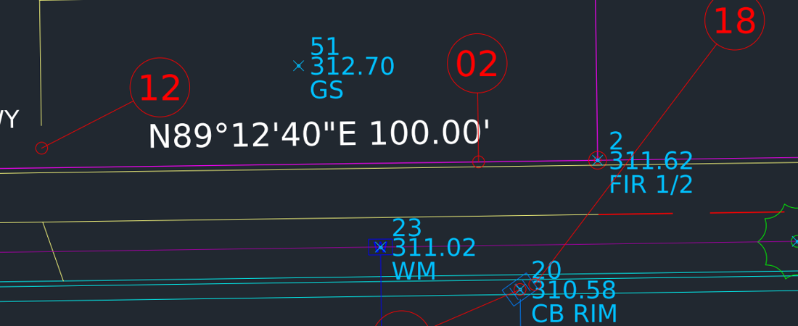  Before (START) | 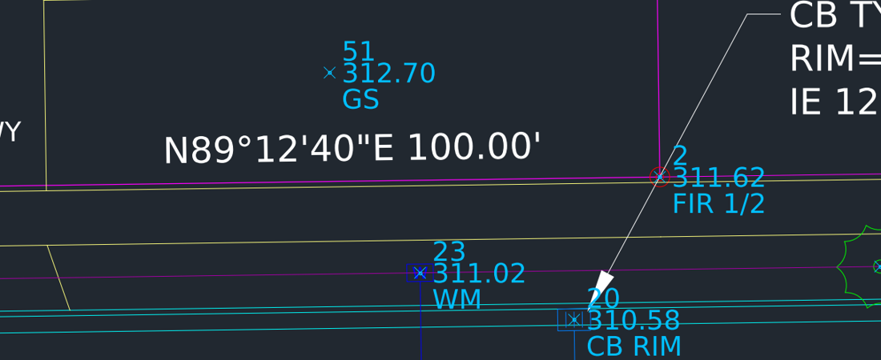  After (COMPLETED)

03 Object snaps and ID a monument
Everything in survey CAD is drawn from something: a point, a monument, a line end. Running snaps make that automatic.
- OS ↵. Check Endpoint, Midpoint, Center, Node, Intersection, Insertion, Perpendicular. Leave Nearest off. Make sure Object Snap On (F3) is checked. OK.
- ID ↵. Hover the found iron rod at bubble 03 until the Insertion snap marker shows, then pick.
- For a one-time snap, hold Shift + right-click at any prompt and choose from the menu.
✓ Check: ID reports X = 5000.00 Y = 8000.00. In AutoCAD X is the Easting and Y is the Northing. Compare note 2 on the sheet.

04 Thaw the survey points layer
The survey points (number, elevation, description) are on V-NODE, which is frozen. You need them for the rest of the exercises.
- LA ↵ to open the Layer Properties Manager.
- Find V-NODE. The snowflake icon means it is frozen. Click it to thaw. Close the palette.
- LAYISO ↵, pick a lot line ↵. Only the boundary layer is shown. LAYUNISO ↵ to bring everything back.
- In the Layer Properties Manager, note that TRAIN-NOTES and G-ANNO-VPRT have the no-plot printer icon.
✓ Check: 26 survey points show, each with point number, elevation and description.
TIP OFF hides a layer. FREEZE also skips it during regens and ZOOM EXTENTS. Use freeze for layers you won't need for a while.

Part 2 - Check the survey

05 Inverse between two points (DIST)
An inverse (bearing and distance between two known points) is the most common check in survey CAD.
- DI ↵ (DIST). Snap Node on point 1 (the SW lot corner rod).
- Snap Node on point 10, the centerline monument at bubble 05.
- Read Distance and Angle in XY Plane on the command line. Record them: __________
✓ Check: Compare with the Answer Key. The direction is from the first pick to the second pick. Reverse the picks and you get the opposite bearing.

06 Draw the rear lot line by bearing and distance
The rear line was not drawn. You'll draw it from the deed call and prove it closes on the found rod.
- LAYMCUR ↵ and pick any lot line. V-PROP-LINE becomes current.
- L ↵. Snap Endpoint on the east lot line at the NE rod (point 3).
- Type @100<S89d12'40"W ↵ ↵ (degrees = d, no spaces).
- ID ↵ and snap the new line's west endpoint.
✓ Check: The line ends exactly on the NW rod (point 4): X = 4998.07, Y = 8139.99.
TIP If AutoCAD says "Invalid point", UNITS is not set to Surveyor's (Exercise 02).

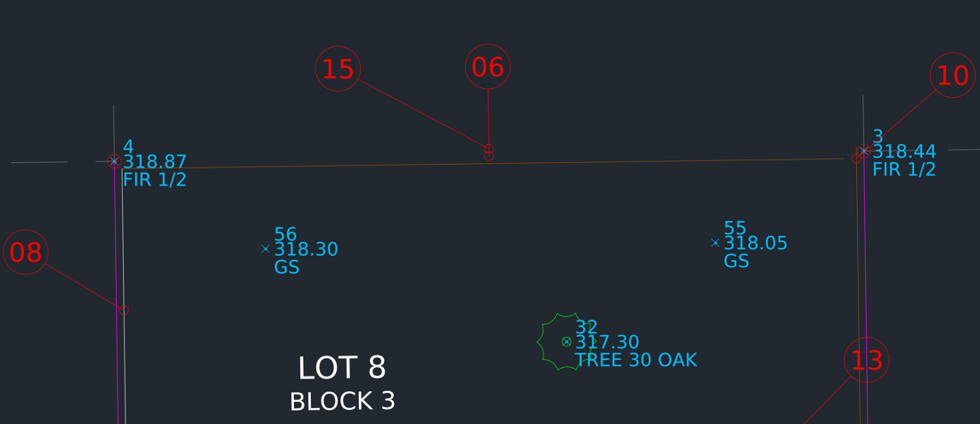  Before (START) | 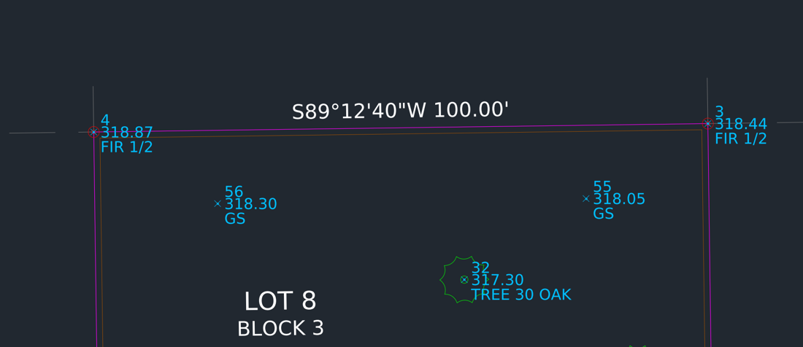  After (COMPLETED)

07 Join the boundary and check the area
- J ↵ (JOIN). Pick all four lot lines ↵. The command line says 4 objects converted to 1 polyline.
- LI ↵ (LIST) and pick the boundary.
- Or: AREA ↵ O ↵ and pick the boundary.
✓ Check: Closed polyline, Area = 14,000.00 sq ft (0.3214 ac), Perimeter = 480.00.
TIP If JOIN leaves separate objects, the ends do not touch. Redo Exercise 06 with snaps on.

Part 3 - Clean up the linework

08 Fix a fence on the wrong layer (LAYMCH)
The west fence (bubble 08) came in on layer 0. It shows white with no fence linetype and won't follow the layer standard.
- LAYMCH ↵. Pick the west fence ↵.
- Pick any correct fence line (for example the rear fence).
- CTRL+1. Confirm Layer = V-SITE-FENC.
✓ Check: The west fence now shows the ---X--- fence linetype.
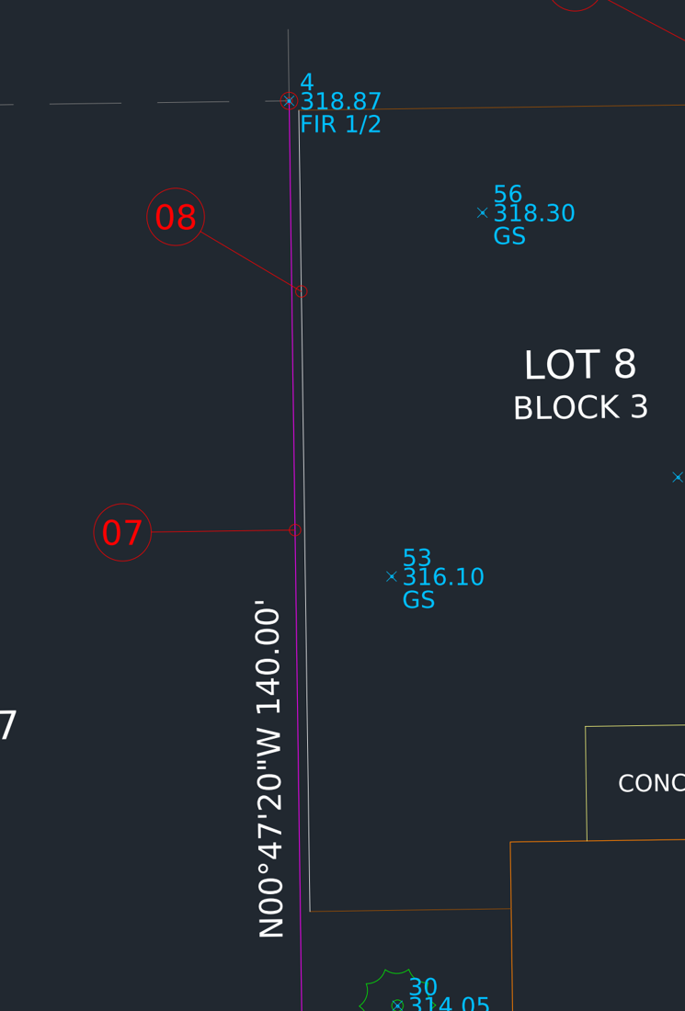  Before (START) | 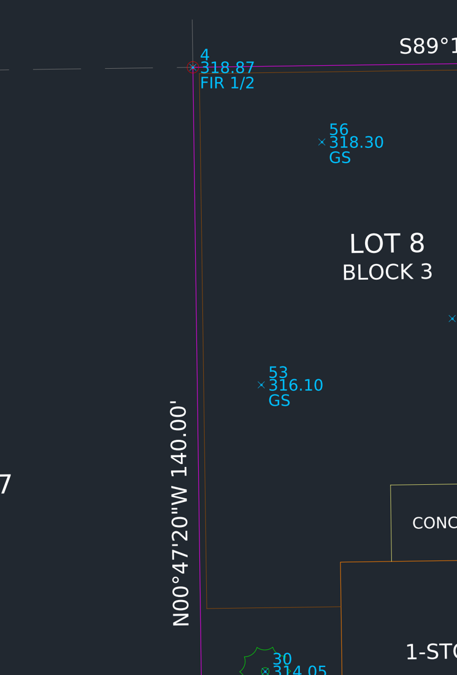  After (COMPLETED)

09 Remove property overrides (MATCHPROP)
East of the lot, the front-of-walk line (bubble 09) has a red color, dashed linetype and heavy lineweight typed directly onto it. Overrides like that break the standard and plot wrong.
- MA ↵. Pick the good front-of-walk line west of the lot first (the source).
- Pick the red dashed line ↵.
- CTRL+1. Color, Linetype and Lineweight all read ByLayer.
✓ Check: The line matches the rest of the sidewalk.
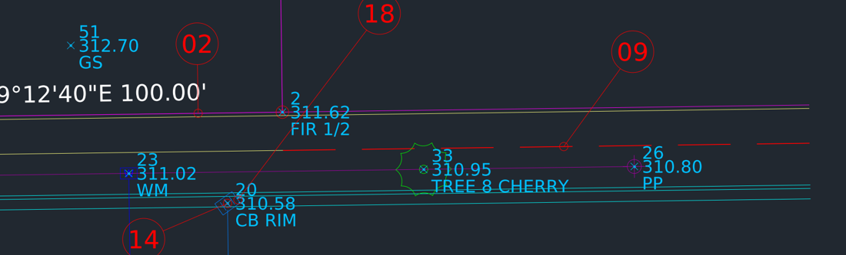  Before (START) | 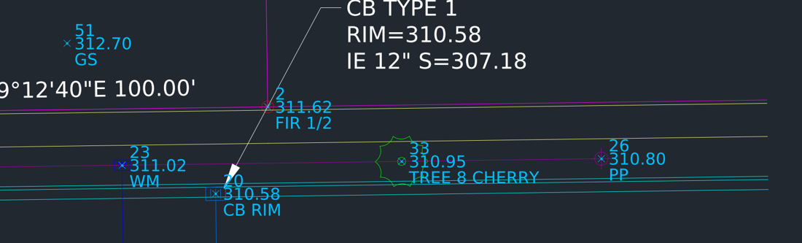  After (COMPLETED)

10 Close a corner with FILLET radius 0
Field linework rarely closes perfectly. At the NE fence corner (bubble 10) the rear fence stops 1.7' short and the east fence runs 1.6' past.
- F ↵ R ↵ 0 ↵.
- Pick the rear fence near the corner.
- Pick the east fence on the part you want to keep (just south of the corner).
✓ Check: Zoom in close. The two fences meet in one clean corner with no gap or overshoot.
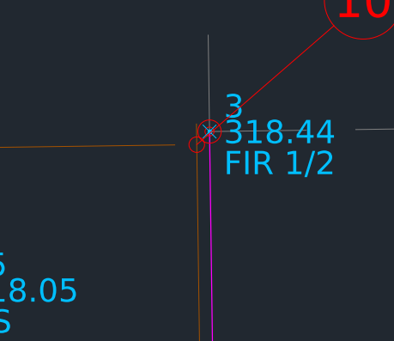  Before (START) | 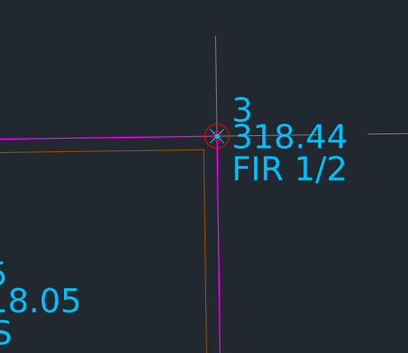  After (COMPLETED)

11 TRIM an overshoot
The patio's east edge (bubble 11) runs 3.6' into the house.
- TR ↵.
- Pick the part of the patio line that is inside the house ↵.
✓ Check: The patio edge stops on the house wall.
TIP AutoCAD 2021 and later trim in Quick mode: every object is a cutting edge, so just pick what to remove.

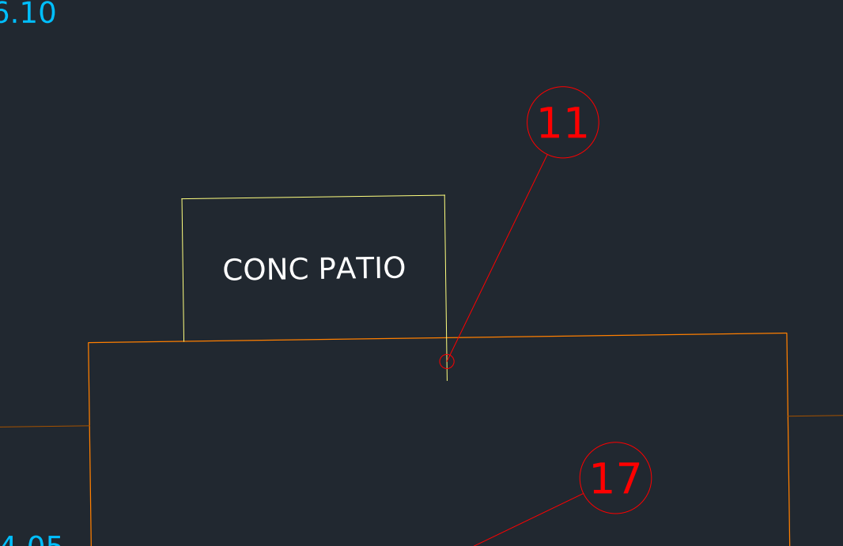  Before (START) | 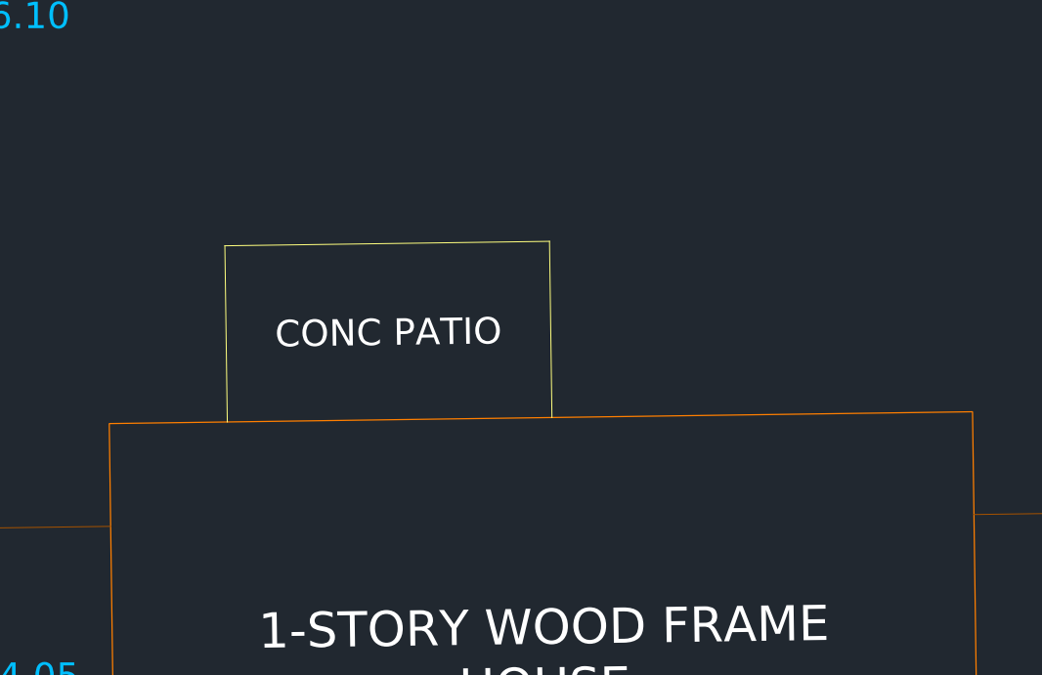  After (COMPLETED)

12 EXTEND to a chosen boundary
The driveway's east edge (bubble 12) stops 4.8' short. Concrete driveways run to the sidewalk, not to the property line.
- EX ↵ then B ↵ (Boundary edges).
- Pick the back-of-walk line (the upper sidewalk line) ↵.
- Pick the driveway's east edge near its south end ↵.
✓ Check: Both driveway edges end on the back of walk.
TIP Without the B option, Quick mode extends to the first thing it hits, which is the front lot line. On AutoCAD 2020 and earlier, EXTEND asks for boundaries first by default.

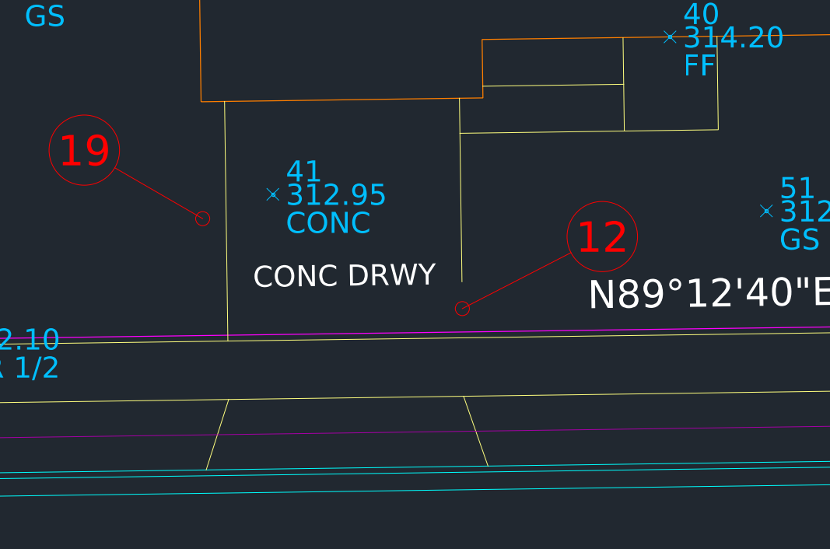  Before (START) | 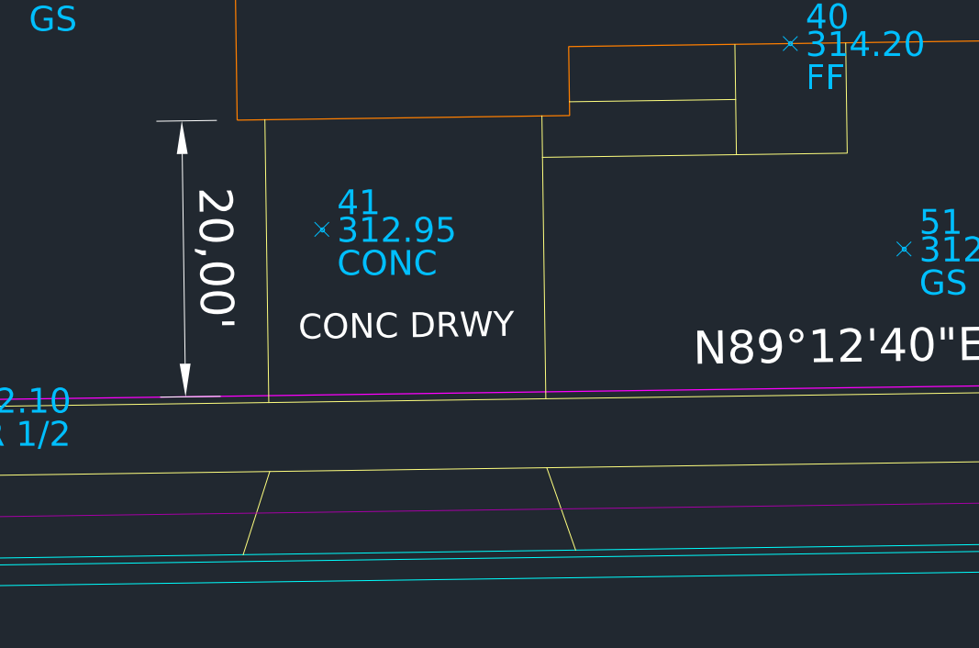  After (COMPLETED)

Part 4 - Symbols

13 INSERT a symbol at a survey point
Point 31 (TREE 18 MAPLE) at bubble 13 has no tree symbol.
- LAYMCUR ↵ and pick an existing tree symbol. V-SITE-VEGE becomes current.
- -INSERT ↵ TREE-DECID ↵.
- Snap Node on point 31. Press ↵ three times to accept X scale 1, Y scale = X and rotation 0.
- (Ribbon: Insert > Insert > TREE-DECID does the same thing.)
✓ Check: The tree is centered on point 31 and on layer V-SITE-VEGE.
TIP The blocks in this file are drawn on layer 0 with ByLayer properties, so a symbol takes on the layer you insert it on.

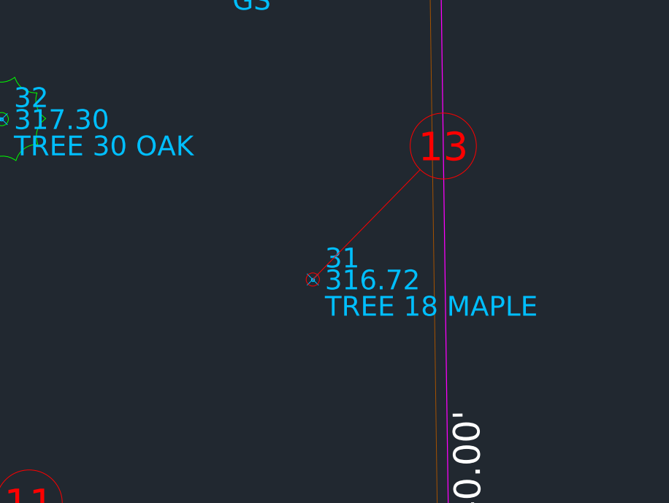  Before (START) | 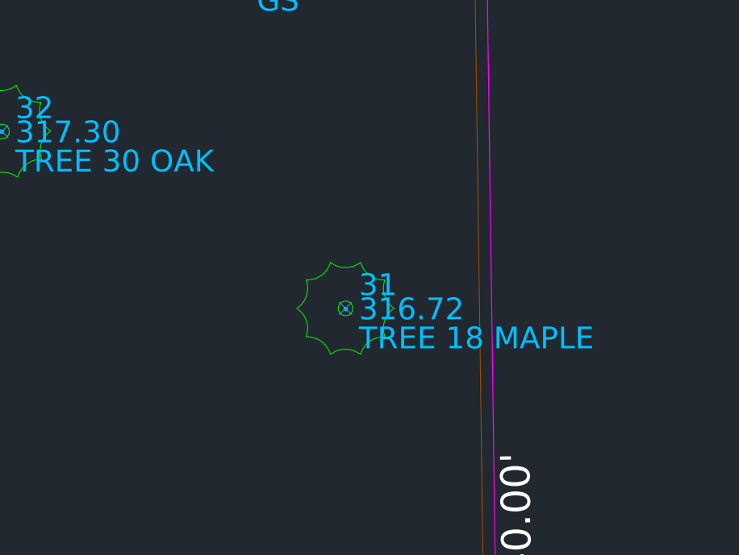  After (COMPLETED)

14 ROTATE with Reference to align a catch basin
The catch basin at point 20 (bubble 14) is 35° off the curb. Rotate with Reference lines it up exactly without working out any angle.
- RO ↵. Pick the catch basin ↵. Base point: Insertion snap on the catch basin.
- R ↵ (Reference). Snap Endpoint on one corner of a long side of the grate, then the other corner of the same side.
- P ↵ (Points). Pick two points along the face-of-curb line, west point first. Use Shift + right-click > Nearest.
✓ Check: The grate is parallel to the curb. In Properties (CTRL+1) Rotation reads N89d12'40"E.
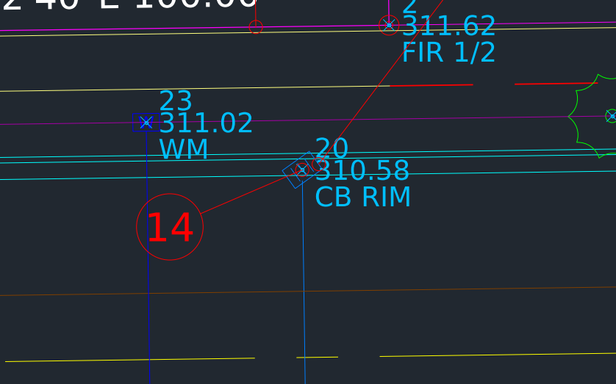  Before (START) | 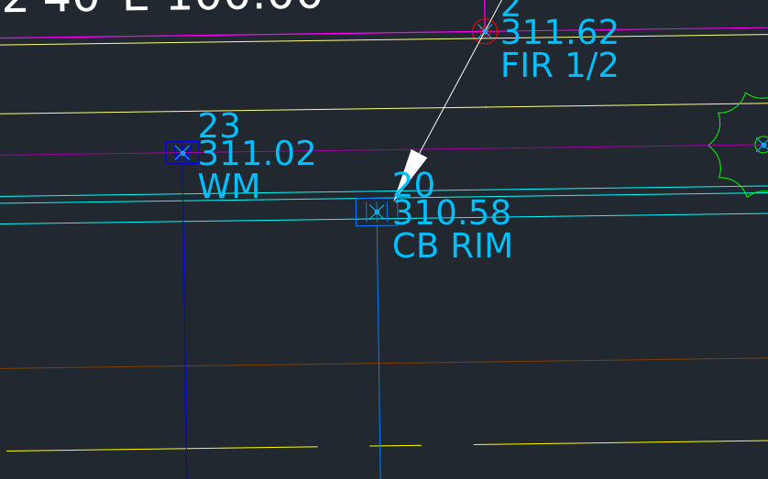  After (COMPLETED)

Part 5 - Annotation

15 Label a lot line with bearing and distance (TEXT)
- LAYMCUR ↵ and pick an existing bearing label. V-PROP-TEXT becomes current. Confirm text style SURVEY is current (Annotate tab).
- DT ↵ (TEXT) J ↵ BC ↵. Snap Midpoint of the rear lot line.
- Height 2.4 ↵. That is 0.08" plotted text × 30.
- Rotation N89d12'40"E ↵. The text is rotated so it reads left to right.
- Type S89%%d12'40"W 100.00' ↵ ↵. (%%d makes the ° symbol.)
- M ↵, pick the text ↵, pick any base point, then type @1<N00d47'20"W ↵ to move the label 1' off the line.
✓ Check: The label sits just outside the rear line and matches the other three.

16 Make text readable (TORIENT)
The street name (bubble 16) is upside down.
- TORIENT ↵. Pick MAPLE STREET ↵.
- Press ↵ to accept <Most readable>.
✓ Check: MAPLE STREET reads right side up in the same place. TORIENT fixes a whole selection at once and keeps each text's insertion point. Don't use MOVE and ROTATE for this.
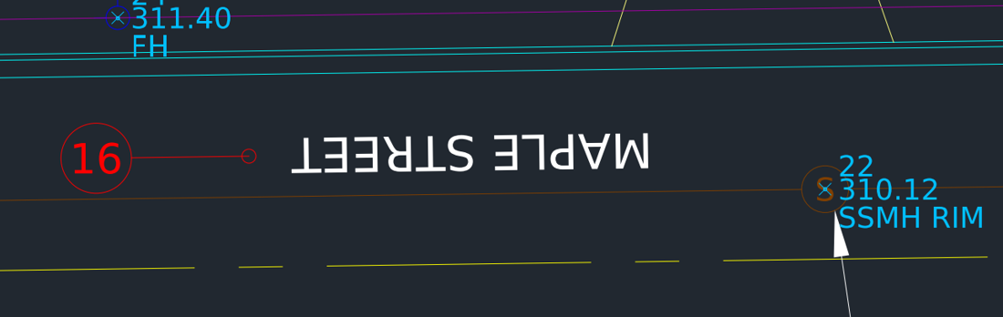  Before (START) | 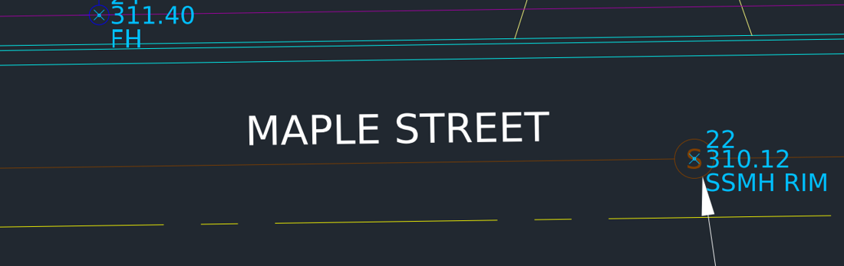  After (COMPLETED)

17 Label the building (MTEXT)
- Set V-ANNO-TEXT current from the layer dropdown.
- MT ↵. At Specify first corner: Shift + right-click > Mid Between 2 Points. Pick the house's upper-left corner, then the lower-right corner of the main house (not the garage).
- J ↵ MC ↵. R ↵ N89d12'40"E ↵. H ↵ 2.4 ↵. W ↵ 40 ↵.
- Type three lines: 1-STORY WOOD FRAME / HOUSE / FF=314.20. Read the FF elevation from point 40. Close the editor.
✓ Check: The label is centered in the house and aligned with it.
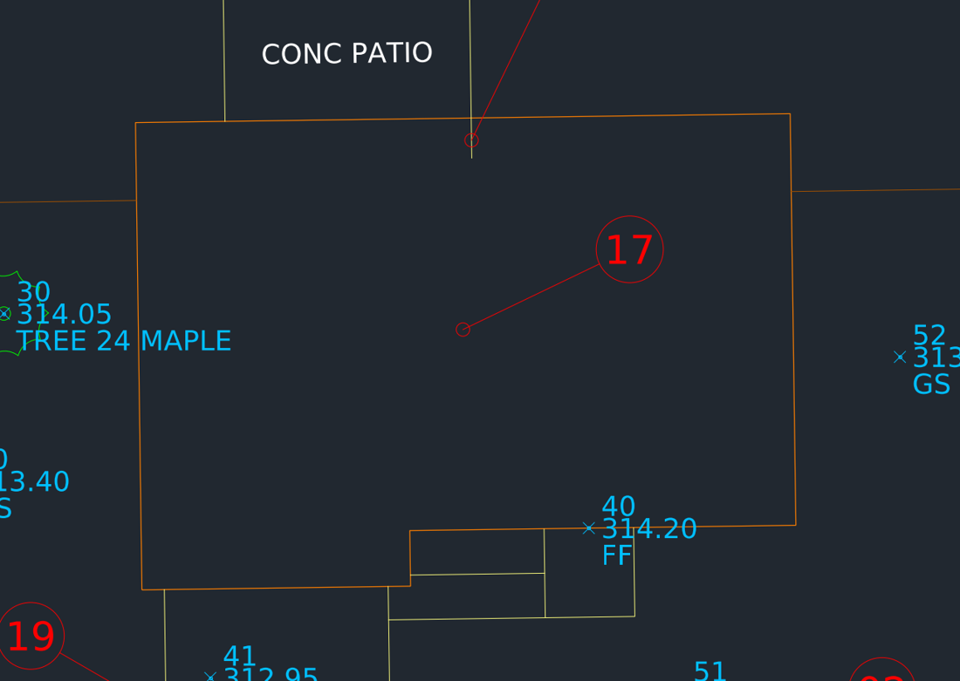  Before (START) | 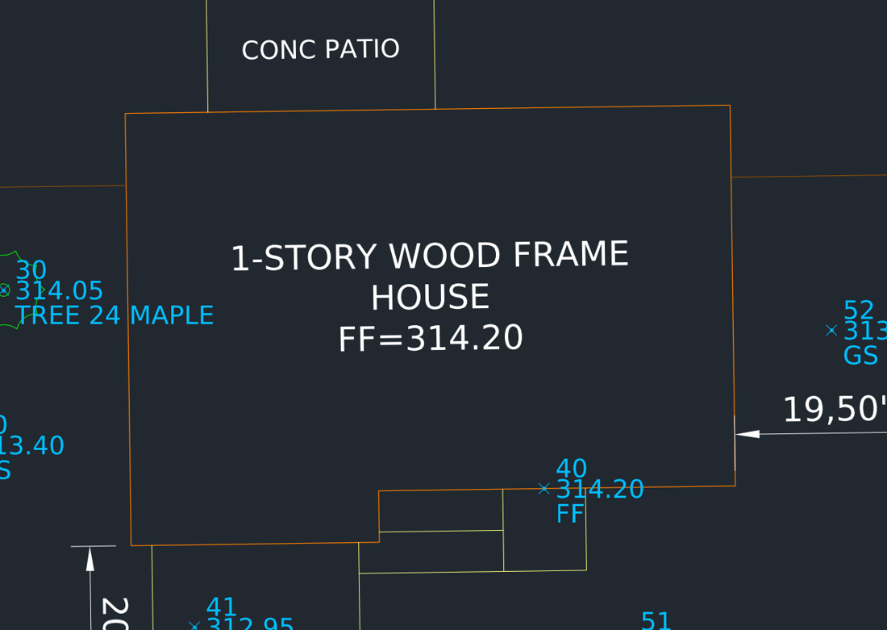  After (COMPLETED)

18 Label a structure with a multileader (MLEADER)
Structures get rim and invert callouts. Use the SSMH leader in the street as your pattern.
- On the Annotate tab > Leaders, set multileader style SRV-30 current. Keep V-ANNO-TEXT current.
- MLD ↵ (MLEADER). Arrow: Shift + right-click > Nearest on the edge of the catch basin at bubble 18.
- Landing: pick up and to the right, in the front yard of LOT 9.
- Type CB TYPE 1 / RIM=310.58 / IE 12" S=307.18. Close the editor.
- Adjust the text and landing with grips if needed.
✓ Check: The leader matches the SSMH example: same text height, arrow and landing.
TIP RIM comes from point 20. The invert comes from the field notes: 12" pipe south, measured 3.40' down from rim (310.58 - 3.40 = 307.18).

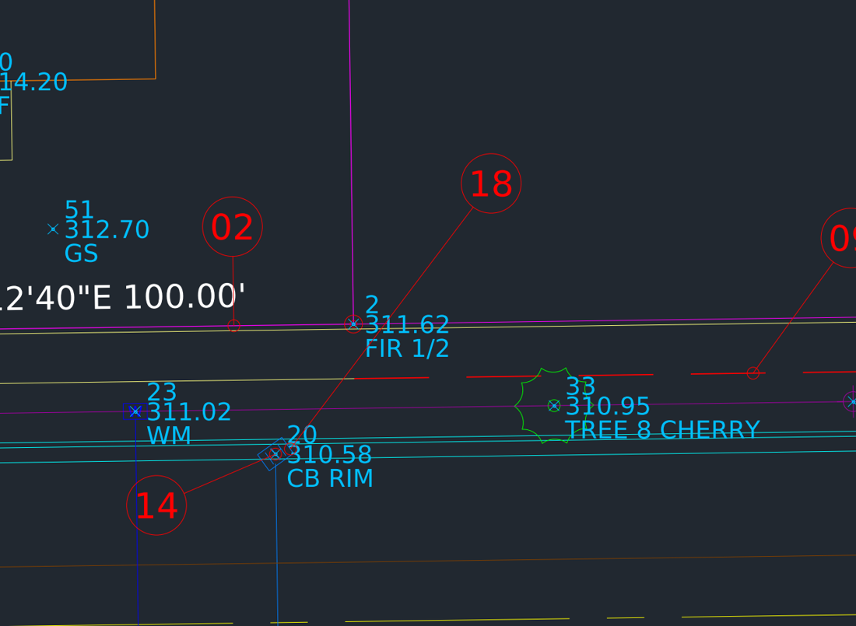  Before (START) | 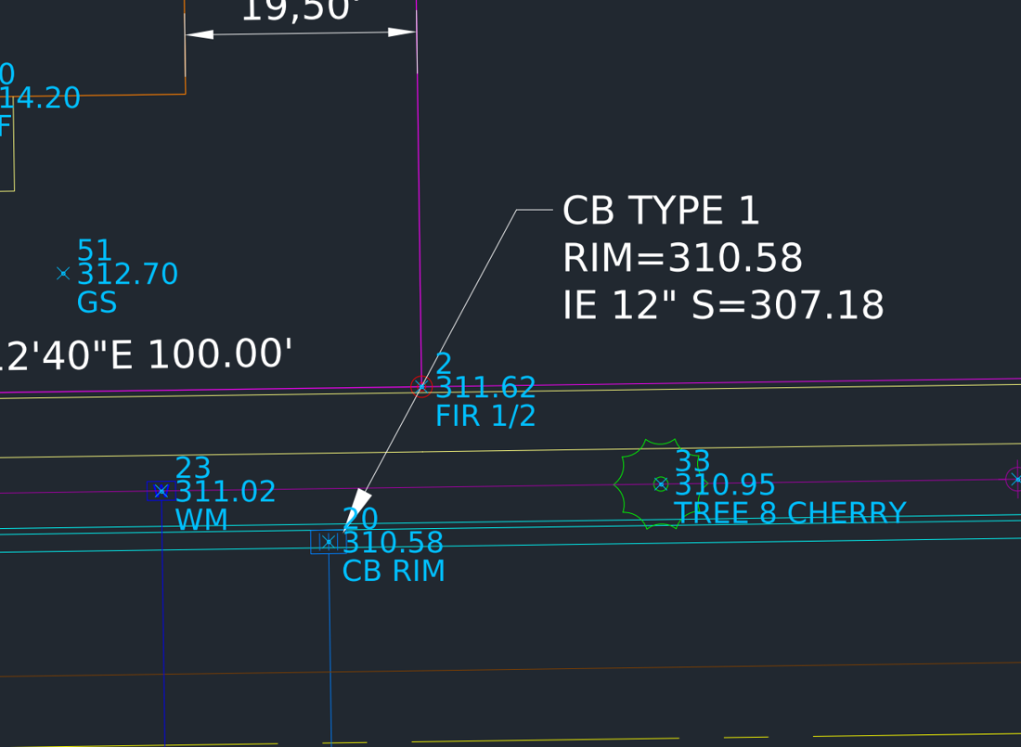  After (COMPLETED)

19 Dimension building setbacks (DIMALIGNED)
Setbacks are shown as the perpendicular distance from the building to the lot line.
- Set dimension style SRV-30 current (Annotate tab) and layer V-ANNO-DIMS current.
- DAL ↵ (DIMALIGNED). Snap Endpoint on the garage's front-left corner (bubble 19).
- Second point: Shift + right-click > Perpendicular, then pick the front lot line. Place the dimension about 4' to the left.
- ↵ to repeat. Endpoint on the house's front-right corner > Perpendicular to the east lot line. Place it about 5' up.
✓ Check: The dimensions read 20.00' and 19.50'.
TIP The SRV-30 dim style has DIMSCALE 30, so its 0.08" text plots at the same size as your 2.4' notes.

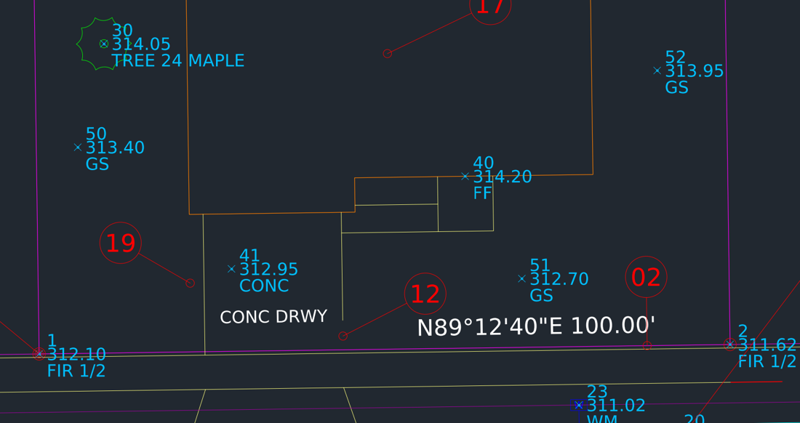  Before (START) | 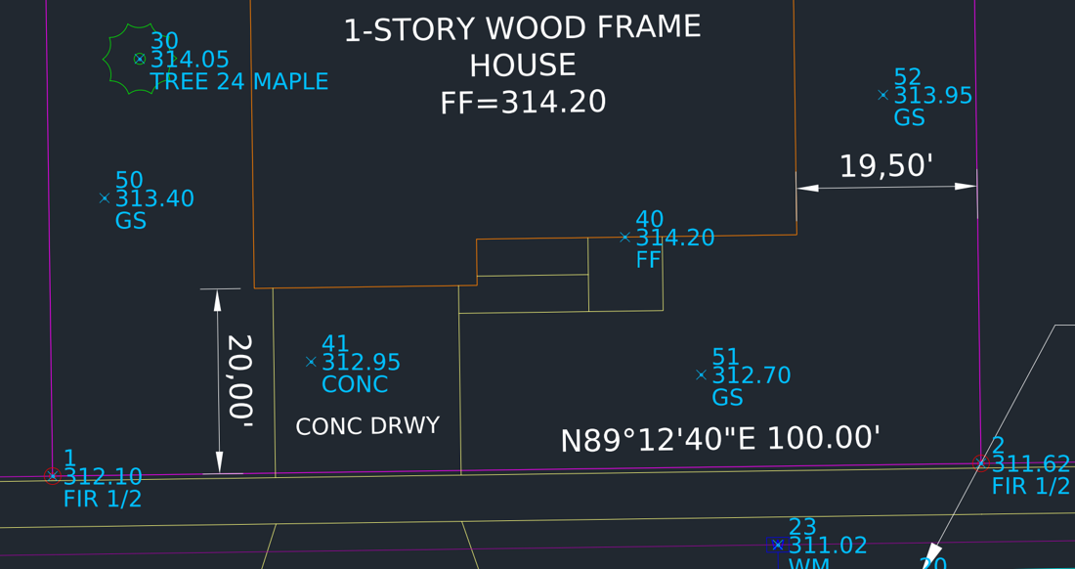  After (COMPLETED)

Part 6 - Sheet and plot

20 Create a scaled viewport
- Click the TOPO SHEET layout tab. Set G-ANNO-VPRT current.
- MV ↵ (MVIEW). Pick the corners of the red dashed box.
- Double-click inside the viewport. Z ↵ 1/30XP ↵.
- Pan with the wheel held down (don't roll it) until the site is centered.
- Double-click outside the viewport. Select its edge, CTRL+1: confirm the scale is 1" = 30' (Standard scale 1" = 30', or Custom scale 0.0333) and set Display locked = Yes.
✓ Check: In paper space, DI ↵ along the front lot line measures 3.33 (inches). The graphic scale bar agrees.

21 Plot to PDF
- PLOT ↵ (CTRL+P). The page setup is already filled in: DWG To PDF.pc3, ANSI B (17 x 11), Plot area Layout, Scale 1:1, Plot style table monochrome.ctb.
- Click Preview. Press ESC to close the preview, then click OK and save the PDF.
✓ Check: The PDF shows no red bubbles, no dashed box and no viewport frame. Fences show ---X---, pipes show ---SD--- / ---SS--- / ---W---, and all text is readable.

22 Clean up and save
- LA ↵. Freeze TRAIN-NOTES.
- PU ↵ (PURGE). Check Purge nested items and click Purge All. This removes the unused layer TEMP-OLD and block OLD-TREE.
- AUDIT ↵ Y ↵.
- QSAVE ↵.
✓ Check: AUDIT ends with no errors left unfixed. Your file matches the COMPLETED answer key.

The finished sheet
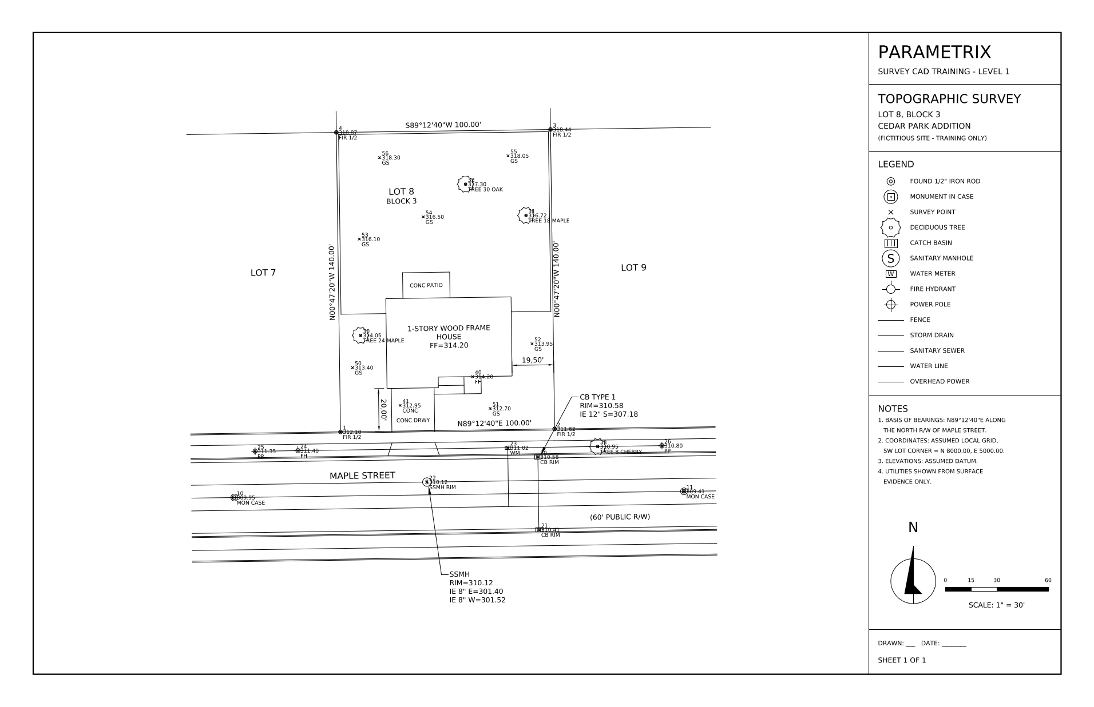
TOPO SHEET plotted with monochrome.ctb (from the COMPLETED answer key)

Completion checklist
☐ | Ex | Item
☐ | 02 | UNITS: Surveyor's, 0.00; LIST shows bearings
☐ | 03 | Running snaps set; ID of point 1 = 5000.00, 8000.00
☐ | 04 | V-NODE thawed
☐ | 05 | Inverse recorded
☐ | 06 | Rear line drawn by bearing; closes on point 4
☐ | 07 | Boundary is one closed polyline, 14,000.00 sq ft
☐ | 08 | West fence on V-SITE-FENC
☐ | 09 | Sidewalk overrides removed (all ByLayer)
☐ | 10 | NE fence corner closed
☐ | 11 | Patio edge trimmed at the house
☐ | 12 | Driveway edge extended to back of walk
☐ | 13 | Tree inserted at point 31
☐ | 14 | Catch basin parallel to the curb
☐ | 15 | Rear line labeled
☐ | 16 | MAPLE STREET reads right side up
☐ | 17 | Building MTEXT centered, with FF
☐ | 18 | Catch basin MLEADER with RIM and IE
☐ | 19 | Setback dims 20.00' and 19.50'
☐ | 20 | Viewport 1" = 30', centered, locked, on G-ANNO-VPRT
☐ | 21 | PDF plotted, nothing non-plot showing
☐ | 22 | TRAIN-NOTES frozen, purged, audited, saved

Answer key
Ex | Result
02 | Front lot line: before 0.7889 (decimal degrees); after N89°12'40"E, 100.00
03 | Point 1: X = 5000.00, Y = 8000.00
05 | Point 1 to point 10: S58°14'50"W, 58.31' (reverse: N58°14'50"E)
06 | Rear line S89°12'40"W 100.00' ends at X = 4998.07, Y = 8139.99 (point 4)
07 | Area 14,000.00 sq ft = 0.3214 ac; perimeter 480.00'
14 | Catch basin rotation: N89°12'40"E (was 35° off the curb)
19 | Garage to front line 20.00'; house to east line 19.50'
20 | 100' front line = 3.33" on the sheet

Field point list (PNEZD)
Pt | Northing | Easting | Elev | Description
1 | 8000.00 | 5000.00 | 312.10 | FIR 1/2
2 | 8001.38 | 5099.99 | 311.62 | FIR 1/2
3 | 8141.36 | 5098.06 | 318.44 | FIR 1/2
4 | 8139.99 | 4998.07 | 318.87 | FIR 1/2
10 | 7969.31 | 4950.42 | 309.95 | MON CASE
11 | 7972.21 | 5160.40 | 309.41 | MON CASE
20 | 7988.27 | 5092.17 | 310.58 | CB RIM
21 | 7954.27 | 5092.64 | 310.41 | CB RIM
22 | 7976.55 | 5040.33 | 310.12 | SSMH RIM
23 | 7992.57 | 5078.11 | 311.02 | WM
24 | 7991.23 | 4980.12 | 311.40 | FH
25 | 7990.95 | 4960.12 | 311.35 | PP
26 | 7993.57 | 5150.10 | 310.80 | PP
30 | 8045.13 | 5009.38 | 314.05 | TREE 24 MAPLE
31 | 8101.20 | 5086.61 | 316.72 | TREE 18 MAPLE
32 | 8115.82 | 5058.41 | 317.30 | TREE 30 OAK
33 | 7993.15 | 5120.11 | 310.95 | TREE 8 CHERRY
40 | 8025.85 | 5061.65 | 314.20 | FF
41 | 8012.38 | 5027.83 | 312.95 | CONC
50 | 8030.08 | 5005.59 | 313.40 | GS
51 | 8010.96 | 5069.86 | 312.70 | GS
52 | 8041.24 | 5089.44 | 313.95 | GS
53 | 8090.13 | 5008.76 | 316.10 | GS
54 | 8100.54 | 5038.62 | 316.50 | GS
55 | 8129.09 | 5078.23 | 318.05 | GS
56 | 8128.26 | 5018.24 | 318.30 | GS

Commands used
Command | Alias | Used for
UNITS | UN | Surveyor's angle units, precision
OSNAP | OS | Running object snaps
ID |  | Coordinate of a point
DIST | DI | Inverse: bearing and distance
LAYER / LAYISO / LAYUNISO | LA | Layer control
LAYMCUR / LAYMCH |  | Make an object's layer current / move objects to a layer
LINE | L | Lines by bearing and distance
JOIN | J | Lines into one polyline
LIST / AREA | LI | Length, bearing, area, perimeter
MATCHPROP | MA | Copy properties / clear overrides
FILLET | F | Close corners (R = 0)
TRIM / EXTEND | TR / EX | Clean overshoots and undershoots
INSERT / -INSERT | I | Place symbols
ROTATE (Reference) | RO | Align a symbol to linework
TEXT / MTEXT | DT / MT | Labels and notes
TORIENT |  | Make text readable
MLEADER | MLD | Leader callouts
DIMALIGNED | DAL | Setback dimensions
MVIEW | MV | Viewports
PLOT | CTRL+P | PDF output
PURGE / AUDIT | PU | Drawing cleanup

For the instructor
The drawings and this guide are generated by scripts in the training folder: build_drawings.py, render_images.py and build_guide.js. The COMPLETED file is built by applying each exercise's exact result to START, so the answer key matches what the commands produce. To change the site or add an exercise, edit the scripts and rebuild; don't hand-edit the DXFs.

