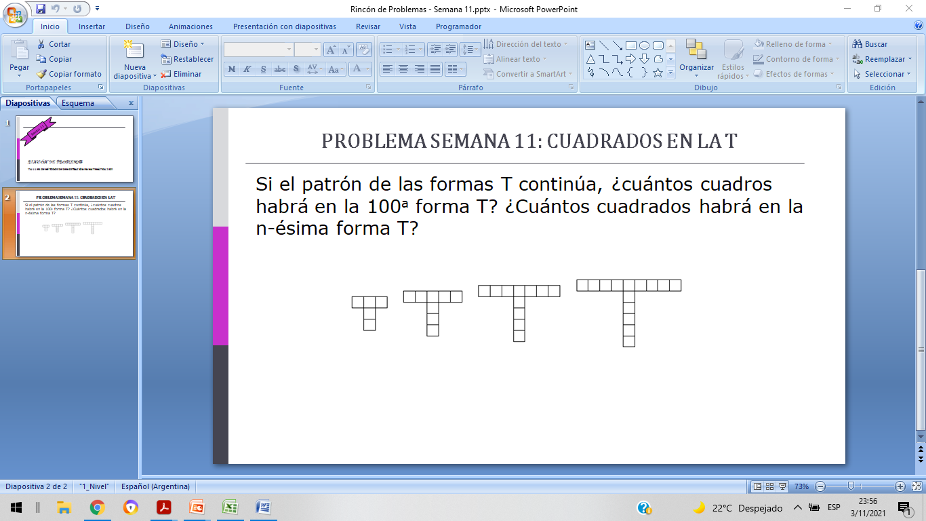1er figura

Horizontal = 3 cuadrados = X

Vertical = 2 cuadrados = Y

|  |  |  |  |  |
| --- | --- | --- | --- | --- |
|  | 1 figura | 2 figura | 3 figura | 4 figura |
| HORIZONTAL | X | X+2 =5 | X+2+2 = 7 | X+2+2+2=9 |
| VERTICAL | Y | Y+1=3 | Y+1+1=4 | Y+1+1+1=5 |

PATRON HORIZONTAL = X +2 (n-1) = 3 +2(n-1)

PATRON VERTICAL = Y + 1(n-1) = 2 + 1(n-1)

Cantidad de cuadrados = 5 + 3(n-1)

FIGURA 100:

CANTIDAD DE CUADRADOS = 5 + 3(100-1) = 302