S I X P E A K C A P I T A L
Investment Committee Memorandum
Uplifters Foundation Pacific Palisades Disaster Rebuild Program
Development Management & Owner's Representative Engagement

CONFIDENTIAL // INTERNAL IC USE ONLY
Prepared April 20, 2026

TO: | Anthony Franks, Steven Cooney, Patrick Anderson, Ivan Karsten
FROM: | Bob Kennedy, Chris Aiello, Schuyler Dietz
DATE: | April 20, 2026
RE: | Proposed Development Management & Owner's Representative Engagement — Uplifters Foundation | Pacific Palisades Disaster Rebuild Program

~$200M  PROGRAM SIZE | 60 SFR  TARGET HOMES | $9.0M  GROSS FEE REVENUE | $4.1M  NET TO SIX PEAK | $0  CAPITAL AT RISK
PURPOSE
This memorandum requests Investment Committee authorization for Six Peak Capital LP to enter into a Development Management and Owner’s Representative Services Agreement with Uplifters Foundation. If approved, Six Peak would serve as the Foundation’s exclusive development and owner’s representative for its disaster rebuild program in Pacific Palisades following the January 2025 Palisades Fire.
EXECUTIVE SUMMARY
Uplifters Foundation is a California 501(c)(3) nonprofit established in 2025 to help rebuild Pacific Palisades through a mission-driven program expected to deliver approximately 60 single-family homes. Its business plan contemplates a $200 million effort aimed at returning displaced families to the community at below-market cost.
This engagement is structurally differentiated by the Foundation's use of tax-exempt municipal bond financing, a first-of-its-kind financing strategy to build market-rate single-family housing at scale. This financing innovation reduces the cost of capital, eliminates the traditional developer promote, and creates a platform Six Peak believes is replicable across other disaster-affected markets nationwide.
Under the proposed agreement, Six Peak would provide end-to-end development management and owner’s representative services, from site sourcing through final sale, without taking development risk, investing equity, or providing completion guarantees.
The proposed fee structure is expected to generate approximately $9.0 million of gross revenue over the life of the engagement, with estimated net income to Six Peak of approximately $4.1 million after staffing, overhead, and operating expenses.
BACKGROUND & MARKET CONTEXT

The January 2025 Palisades Fire was one of the most destructive wildfires in California history, destroying thousands of structures across Pacific Palisades and leaving a generation of families displaced from one of Los Angeles's most desirable residential communities. The scale of the destruction created an urgent need for coordinated, mission-aligned rebuilding infrastructure that the private market alone was unlikely to provide efficiently or affordably.
Uplifters Foundation is a 501(c)(3) nonprofit real estate developer dedicated to helping the most vulnerable victims of the Palisades Fire rebuild not just their homes, but their lives. The Foundation raises equity through private bond placements and rebuilds homes in Pacific Palisades designed to be attainable to the people who were displaced by the fires. Completed homes are first offered at a discounted price to former residents, in recognition of their commitment to return to the community. Net proceeds from home sales do not go to shareholders, they instead fund public facilities and infrastructure that benefit the surrounding community, including playgrounds, parks, and improved utilities.
While other organizations focus on immediate relief, Uplifters Foundation is focused on laying the groundwork for the long-term rebuilding effort by preserving neighborhood character, honoring residents' choices, and fostering community resilience over time. This approach, combined with the Foundation's nonprofit structure, creates a meaningful cost advantage over conventional private development:
Traditional Development Variable | Conventional For-Profit Projects | Uplifters Foundation's Tax Exempt Strategy
Cost of Debt | ~10% construction debt | ~6% tax-exempt bonds
Developer Promote | 15–20%+ of profit | None — nonprofit structure
Property Tax | Accrues during hold | Exempt during Foundation's ownership
Sales Tax on Materials | Full tax owed | ~$50K rebate per home
Profit Distribution | To shareholders | To various nonprofits rebuilding the community
Estimated Cost Advantage | — | ~10%+ per home

PLATFORM OPPORTUNITY
Six Peak and the Foundation believe this model is not limited to Pacific Palisades. Disaster-affected communities across California and the United States face the same structural challenge: private developers build for profit, nonprofit infrastructure is too slow and undercapitalized, and government programs are chronically underfunded. The Uplifters model threads this needle, and the use of tax-exempt municipal bond financing to fund market-rate, for-sale single-family housing has no direct precedent in U.S. real estate.
If the program is successful in the Palisades, Six Peak would be the only operator in the country with a demonstrated track record executing this financing and delivery model. The opportunities for replication include:
- Adjacent disaster markets: Altadena, Maui, and future wildfire-affected communities face similar dynamics and would be natural next deployments of this model.
- Workforce and attainable housing: The nonprofit bond structure is directly applicable to workforce housing programs where municipalities and employers are seeking creative below-market delivery mechanisms.
- Institutional adoption: Once the first bond issuance closes and homes are successfully delivered and sold, the template becomes underwriteable by a much broader pool of institutional bond investors.
SCOPE OF ENGAGEMENT
The draft term sheet provides a well-defined scope spanning the full development lifecycle across five service categories:

A. Program-Level Services
- Develop and recommend homebuilding parameters, product standards, resiliency standards, and design guidelines.
- Identify, evaluate, and recommend qualified design-build firms; negotiate master or project-specific agreements.
- Act as the Foundation's primary development liaison with all design-build groups constructing the new homes.
- Establish program-wide budgets, schedules, reporting formats, procurement procedures, and project controls.
- Support the Foundation in structuring and implementing leasing, marketing, and disposition strategy.

B. Acquisition & Predevelopment
- Source and underwrite on-market and off-market lots consistent with the Foundation's buy box.
- Manage all due diligence (title, zoning, geotechnical, environmental, utilities) and coordinate with Foundation counsel.
- Prepare and maintain project budgets, schedules, and development timelines from acquisition through completion.
- Oversee the closing process in coordination with escrow, title, lenders, and Foundation representatives.

C. Project-Specific Development Management
- Oversee design development, value engineering, permitting strategy, and agency coordination for each project.
- Monitor construction execution, quality control, change orders, contingency usage, and project risk.
- Review and process draw requests in coordination with the third-party disbursement agent, lender, and Foundation.
- Oversee substantial completion, punch list, certificate of occupancy, and final project closeout.

D. Sales, Leasing & Exit
- Support leasing and lease-to-sale strategy and execution, including interim rental period management.
- Develop pricing recommendations and coordinate brokers, marketing consultants, and transaction professionals.
- Manage escrow, contract administration, and closing support through final disposition.

E. Post-Completion Services
- Coordinate warranty claims, punch list follow-up, and post-completion correction items.
- Assist with final cost reconciliation and release of retained contingency balances.
FINANCIAL MODEL & ECONOMICS TO SIX PEAK

Fee Structure
Six Peak earns fees at each phase of the program. The following table summarizes the fee structure per property and in aggregate across all 60 homes:
Fee Category | Rate | Basis | Per Property | Total (x60)
Acquisition Fee | 1.0% | Lot Price ($1,400,000) | $14,000 | $840,000
Development Management Fee | 6.0% | Construction Cost ($1,609,391) | $96,563 | $5,793,808
Leasing Commission | 3.0% | Annual Rent ($180,000/yr) | $5,400 | $324,000
Exit / Disposition Fee | 1.0% | Sale Price ($3,419,763) | $34,198 | $2,051,858
TOTAL GROSS FEE REVENUE |  |  | $150,161 | $9,009,665

Program P&L: Gross Fees to Net Income
After accounting for staffing, overhead, and operating expenses, the economics to Six Peak are as follows:
Line Item | Amount
Gross Fee Revenue (60 properties) | $9,009,665
Staffing Cost (Accountant, Project Coordinator, 2 PMs) | ($1,500,039)
Other Operating Expenses (Insurance, Office, Accounting, IT) | ($456,000)
Net Fee Income | $7,053,626
SP Overhead Fee (10% Rev., max $150K/yr) | $563,193
Net Before Bonus | $6,490,433
Schuyler Bonus (40/45/50% tiered) | ($2,951,666)
Net Income After Bonus (to Six Peak) | $3,538,767
Six Peak Overhead Fee (retained separately) | $563,193
TOTAL TO SIX PEAK | $4,101,960

Annual Fee Revenue Schedule
Fee revenue is earned as acquisitions, construction completions, leases, and dispositions occur across the program's five-year operating period (FY 2027–2031):
Metric | FY 2027 | FY 2028 | FY 2029 | FY 2030 | FY 2031 | Total
Fee Revenue | $1.1M | $3.7M | $2.4M | $1.4M | $0.4M | $9.0M
Net Fee Income | $0.8M | $3.2M | $1.9M | $0.8M | $0.4M | $7.1M
Net to Six Peak | $0.5M | $1.9M | $1.0M | $0.5M | $0.2M | $4.1M

Staffing Plan
Role | Annual Comp | Start | Duration | Total Cost
Accountant | $110,000 | Month 19 (Oct 2027) | 39 months | $357,513
Project Coordinator | $90,000 | Month 14 (May 2027) | 44 months | $330,000
Project Manager 1 | $125,000 | Month 11 (Feb 2027) | 47 months | $489,599
Project Manager 2 | $125,000 | Month 27 (Jun 2028) | 31 months | $322,927
TOTAL STAFFING COST |  |  |  | $1,500,039

CASE STUDY: REPRESENTATIVE ACQUISITION & CONSTRUCTION
The following examples illustrate the program's acquisition and construction approach, drawing directly from real properties in Pacific Palisades.

Case Study 1 | Example Lot: 16915 Bollinger Drive, Pacific Palisades
Metric | Detail
Address | 16915 Bollinger Drive, Pacific Palisades, CA 90272
List Price | $1,595,000
Sale Price | $1,360,000 (closed December 2, 2025)
Lot Size | 6,899 sq. ft.
Dimensions | 60' wide × 115' deep
Building Envelope | 50' × 80' — standard Palisades lot
Six Peak Acquisition Fee (1.0%) | $13,600

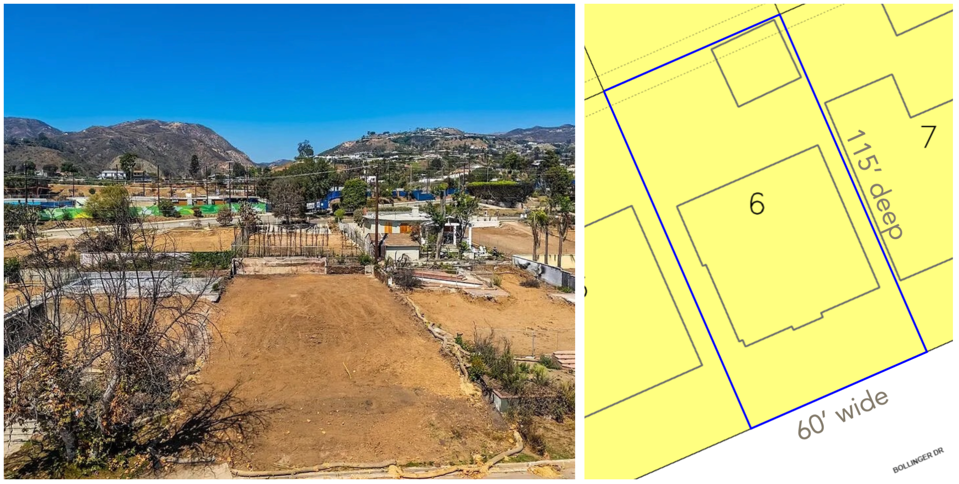
Left: Aerial view of 16915 Bollinger Drive, Pacific Palisades.
Right: Parcel map showing lot boundary and building envelope.

Case Study 2 | Example Project: 15880 Seabec Circle

Currently in construction by Westward Homes
Cost Component | Amount
Plans & Permits | $62,000
Construction Cost | $1,205,105
GC Overhead & Profit | $300,000
Contingency | $100,000
Total Project Cost | $1,667,105
Six Peak Development Fee (6%) | $100,026
Proposed Floor Plan (Sheet A-2.0)
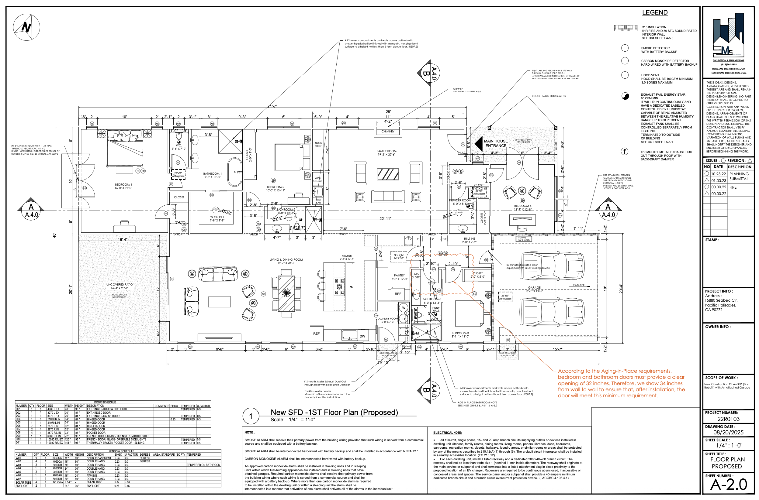
Proposed Site Elevations — South & East (Sheet A-3.1)
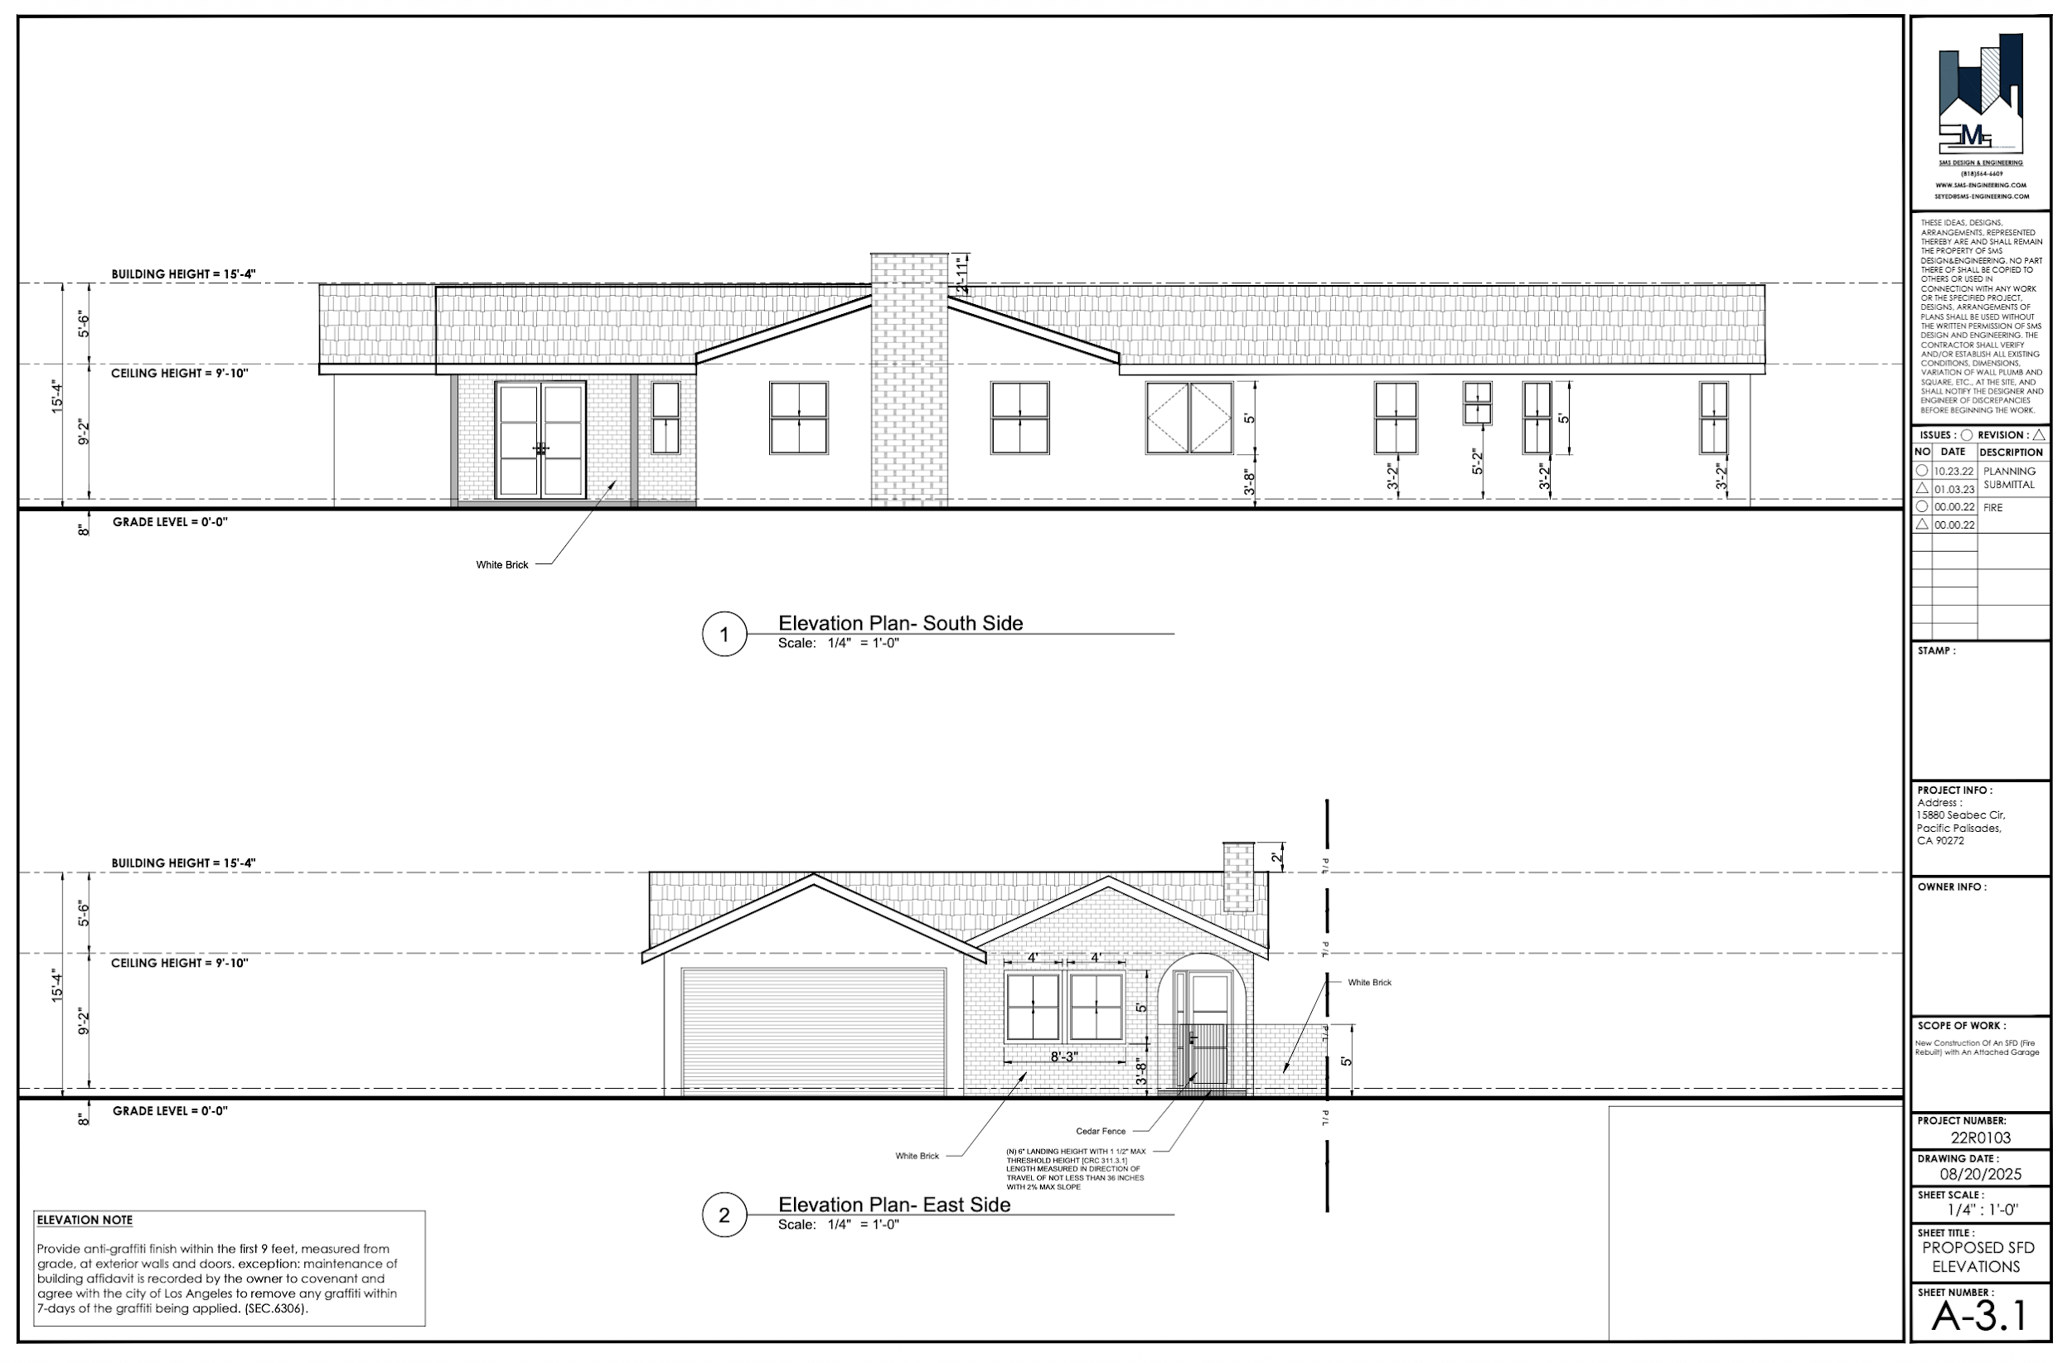
PROJECTED DEVELOPMENT TIMELINE

Program Milestones
Milestone | Target Date
Fundraise Launch | June 2026
Fund Raised & Acquisitions Begin (Phase 1) | January 2027
Acquisition Rate (Phases 2–4) | ~4 lots per month (Jul 2027 – Jun 2030)
Peak Construction Completions | FY 2028 (majority of 60 homes)
Lease-to-Sale Dispositions Begin | FY 2029
Program Completion | December 2031

Per-Home Timeline
Month | Activity
Month 1 | Lot Acquisition
Month 3 | Permit Submittal to City of Los Angeles
Month 5 | Construction Begins
Month 17 | Substantial Completion
Months 18–29 | Rental / Lease-to-Own Period
Month 30 | Lot Disposition (Sale)
RISK ASSESSMENT
The engagement is a fee-based services arrangement, not a principal-risk investment. Six Peak does not contribute equity, assume a completion guarantee, or take ownership risk. The principal risks are execution-related and are assessed as follows:
Risk | Assessment | Mitigant
Scattered-site coordination complexity | Medium / Medium | Standardized product templates, established design-build roster, program-wide controls.
Fundraise does not reach $200M target | Medium / High | $21M in written commitments already in hand; the program can scale with capital raised.
Regulatory / governance approval delays | Low / Medium | The process is progressing smoothly; Foundation's advisors are experienced in the regulatory pathway.
Multi-stakeholder nonprofit governance | Medium / Low | Clear approval matrix in term sheet; Six Peak operates within established Foundation parameters.
Fee timing vs. staffing cost ramp | Low / Medium | Staffing is variable and matched to acquisition cadence; overhead is manageable relative to fee scale.
Professional / contractor liability | Low / Low | Term sheet limits Six Peak liability to own gross negligence or willful misconduct only.
DEAL STATUS & PROBABILITY OF CLOSING
The team estimates the probability of the program moving forward at approximately 50/50 at this stage. The two primary variables are regulatory completion and bond fundraising:
- Regulatory pathway: The Foundation is progressing through required regulatory and local governance approvals. The process is moving smoothly, though at the measured pace typical of California public agency coordination. The team expects this process to clear within the next several weeks.
- Fundraising: The Foundation's founders quickly secured $21 million in written commitments when they began early outreach. Formal bond issuance and full commitment collection remain ahead. Target buyers are high-net-worth former Palisades residents expected to redirect allocations from tax-exempt fixed-income portfolios into these short-duration, community-impact bonds.
- Credit profile: The bond structure carries no traditional hard equity at inception. However, the $200 million of debt is supported by approximately $198 million of hard assets (land, construction-in-progress, and capitalized interest), with repayment funded by rental income and home sale proceeds.
Six Peak's authorization to proceed does not require the program to be fully subscribed. The Committee is being asked to authorize negotiation and finalization of definitive documentation on terms substantially consistent with this memorandum, subject to management's judgment on final terms.
STRATEGIC BENEFITS TO SIX PEAK

1. Profile & Institutional Positioning
Six Peak would sit at the center of one of the most high-profile rebuilding efforts in Los Angeles. Association with a community-centered, mission-driven recovery program is expected to strengthen the firm's relationships with institutional capital providers, municipalities, public agencies, and local stakeholders in ways that conventional development assignments rarely do.

2. Direct Alignment with Core Capabilities
This is not a passive advisory role. It is a full execution mandate requiring the precise capabilities Six Peak has built: site sourcing, underwriting, design-build management, construction oversight, draw administration, and disposition execution. The engagement is squarely within the firm's operating strengths and represents meaningful fee revenue without capital deployment.

3. First-Mover Position in a New Asset Category
If the program succeeds, Six Peak will be the only operator with a proven track record in this financing and delivery model — giving the firm a durable competitive advantage in future disaster-recovery and mission-driven residential programs. The investment in learning, relationships, and operational playbook that happens in Palisades is not replicable by competitors without executing a similar program from scratch.
RECOMMENDATION & AUTHORIZATION
The undersigned sponsoring members recommend that the Investment Committee authorize Six Peak Capital LP to negotiate and finalize definitive documentation with Uplifters Foundation, and to take such further steps as are reasonably necessary to pursue the engagement on terms substantially consistent with this memorandum.
By signing below, the Board of Directors authorizes Six Peak Capital to proceed:

____________________  Anthony Franks | ____________________  Steven Cooney | ____________________  Chris Aiello | ____________________  Bob Kennedy

[Remainder of Page Intentionally Left Blank]

E X H I B I T A
Draft Term Sheet
Development / Owner's Representative Services Agreement

EXHIBIT A // DRAFT TERM SHEET

Development / Owner's Representative Services Agreement

Parties
Uplifters Foundation, a California nonprofit public benefit corporation (the “Foundation”).
Six Peak Capital LP, and its subsidiaries (“Six Peak”).

Appointment
The Foundation appoints Six Peak as its exclusive development and owner's representative for approximately 60 projects to build single family homes of which numerous projects will also include an ADU and all projects are located in Pacific Palisades during the Term. In such capacity, Six Peak will oversee and coordinate the planning, acquisition, design, permitting, construction, completion, and lease-to-sale process for Foundation projects, subject to the direction and approvals of the Foundation's Executive Director and Board of Directors.

Role
Six Peak will serve as the Foundation's exclusive development and owner's representative, responsible for end-to-end development execution from site identification through acquisition, design, permitting, construction, project completion, and exit through a lease-to-sale, leasing, or sale process, as applicable.
Six Peak will act in a representative and managerial capacity only and will not itself perform legal, tax, brokerage, architectural, engineering, or contractor means-and-methods services unless separately engaged under a written agreement.
All General Contractors will contract with the individual entity owning each property which is in turn owned by the Foundation.

Scope of Services

A. Program-Level Services
Six Peak will provide the following services on a program-wide basis:
- Act as the primary liaison between the Foundation and the design-build groups engaged to construct homes under the program.
- Assist the Foundation in identifying and implementing cost-saving measures, value engineering strategies, and procurement efficiencies consistent with the Foundation's mission and quality standards on a best efforts basis.
- Develop and recommend homebuilding parameters, product standards, resiliency standards, design guidelines, and project criteria that best meet community needs, subject to Foundation approval.
- Identify, evaluate, and recommend a roster of qualified design-build firms capable of providing turnkey new-construction homes within the parameters established by the Foundation.
- Negotiate master or project-specific agreements with design-build firms, including direct cost plus fixed fee or guaranteed maximum price clauses.
- Create a success-based framework and incentive system for design-build firms that aligns performance with the Foundation's mission, budget, schedule, quality, and community objectives.
- Establish program-wide underwriting assumptions, budgets, schedules, reporting formats, procurement procedures, and project controls.
- Select, manage, and coordinate architects, engineers, builders, designers, consultants, expediters, and other third-party professionals, subject to Foundation approval as required under the approval matrix.
- Support the Foundation in structuring and implementing the overall leasing, lease-to-sale, marketing, and/or disposition strategy for the program.
- Prepare program summaries, risk assessments, pipeline updates, and other materials for Foundation management and Board review.

B. Acquisition and Predevelopment Services
For each development project, Six Peak will:
- Source and identify on-market and off-market acquisition opportunities consistent with the Foundation's approved buy box and mission.
- Underwrite acquisition opportunities and prepare written recommendations for Foundation review.
- Coordinate letters of intent, purchase agreements, access agreements, amendments, and extensions with Foundation legal counsel.
- Manage due diligence, including title, survey, zoning, code analysis, utility availability, geotechnical review, environmental review, drainage review, and other customary diligence items.
- Coordinate third-party reports required by the Foundation, lenders, bond parties, insurers, or other stakeholders.
- Prepare and maintain project budgets, schedules, and development timelines from acquisition through completion.
- Coordinate satisfaction of acquisition conditions and closing checklist items.
- Oversee the acquisition closing process in coordination with escrow, title, counsel, lenders, and Foundation representatives.

C. Project-Specific Development Services
For each approved project, Six Peak will:
- Recommend the design-build firm and consultant team best suited for the specific lot and project objectives.
- Oversee programming, design development, consultant coordination, and value engineering for each project.
- Review design documents for consistency with Foundation objectives, lot constraints, code requirements, resilience goals, target pricing, and constructability.
- Establish and manage project budgets, schedules, milestones, and cash flow forecasts.
- Oversee permitting strategy, agency coordination, and permit expediting.
- Monitor construction execution, progress, quality control, and project risk.
- Conduct or coordinate regular project meetings and maintain decision logs, action-item lists, and progress reporting.
- Review RFIs, submittals, change orders, contingency requests, and schedule updates, and make recommendations to the Foundation.
- Review and process draw requests in coordination with the disbursement agent, lender, and Foundation.
- Monitor lien releases, insurance compliance, budget variances, and claims or delay issues.
- Oversee substantial completion, punch list completion, certificate of occupancy, final completion, and project closeout.
- Coordinate delivery of closeout materials, warranties, manuals, as-built documents, and final reconciliations.

D. Sales, Leasing, and Exit Services
For each completed project, Six Peak will:
- Support leasing, lease-to-sale, marketing, and/or disposition strategy and execution, as directed by the Foundation.
- Develop project-level pricing recommendations and disposition plans.
- Coordinate and oversee brokers, marketing consultants, sales agents, and transaction professionals, if any.
- Assist with marketing materials, buyer qualification criteria, and transaction process management.
- Coordinate escrow, due diligence responses, contract administration, and closing support.
- Prepare final project summaries comparing budget, schedule, and outcomes to underwriting.

E. Post-Completion Services
Six Peak will also:
- Coordinate warranty claims and contractor follow-up during applicable warranty periods.
- Track unresolved punch list and post-completion correction items.
- Assist the Foundation with final project cost reconciliation and release of retained contingency balances.
- Provide post-close / post-sale reporting as reasonably requested by the Foundation.

Standard of Care
Six Peak shall perform its services in a professional and diligent manner, consistent with the standard of care ordinarily exercised by institutional development and owner's representative firms performing comparable services for projects of similar type, size, and complexity.

Governance and Approvals
Six Peak shall operate within the parameters established by the Foundation's Board of Directors and Executive Director.
Unless otherwise approved in writing by the Foundation, the following shall require prior Foundation approval:
- Acquisition of any site.
- Execution of any material contract.
- Engagement of any consultant or contractor above an agreed threshold.
- Approval of project budgets and material revisions thereto.
- Change orders in excess of $10,000 per item or $100,000 in the aggregate per project.
- Use of contingency above approved thresholds.
- Final pricing and disposition decisions.
- Settlements of claims or disputes above an agreed threshold.
- Any deviation from Foundation-approved product standards, design guidelines, or mission criteria.
A more detailed approval matrix will be attached to the definitive agreement.

Reporting
Six Peak shall provide:
- Monthly reporting for each active project, including budget vs. actuals, schedule status, major milestones, draw status, change orders, contingency usage, and key risk items.
- Quarterly program summaries for the Foundation Board, including pipeline, portfolio budget and schedule overview, financing status, major issues, and disposition status.
- Such additional project memoranda, acquisition summaries, or special reports as reasonably requested by the Foundation.

Compensation
Subject to the terms of the definitive agreement, Six Peak shall be compensated as follows:
Fee | Basis
Acquisition Fee | 1% of land acquisition cost
Development Management Fee | 6.0% of total construction costs, inclusive of hard and soft costs
Leasing Fee | 3% of Gross Rent collected
Direct-to-End-User Exit Fee | 1% of sales price
Fees shall be paid monthly in arrears, or at such other times as may be set forth in the definitive agreement.

Reimbursable Expenses
The Foundation shall reimburse Six Peak for reasonable, documented out-of-pocket expenses incurred in connection with performance of the services, subject to any budget or preapproval requirements set forth in the definitive agreement. Reimbursable expenses may include travel, printing, messenger, filing fees, diligence materials, permit runners, and similar third-party costs, but shall exclude Six Peak's general overhead.

Disbursement and Controls
- A third-party disbursement agent, such as JPMorgan Chase or another approved institution, shall control project fund flows.
- Six Peak shall prepare and submit draw packages for review and approval.
- The Foundation shall retain final approval authority over all disbursements.
- Six Peak shall assist with budget tracking, draw support, lien release monitoring, and supporting documentation required by the disbursement agent, lender, or bond parties.

Compliance and Mission Alignment
Six Peak shall perform its services in a manner intended to support the Foundation's charitable mission and nonprofit status. Six Peak shall reasonably cooperate with the Foundation's legal, tax, accounting, bond, and compliance advisors in connection with governance, financing, regulatory, and tax-exemption matters.
Six Peak shall not knowingly take any action on behalf of the Foundation that would reasonably be expected to jeopardize the Foundation's tax-exempt status or violate applicable financing, governance, or nonprofit compliance requirements.

Conflicts; Affiliate Transactions
Six Peak shall disclose any actual conflicts of interest relating to Foundation projects.
Any engagement of an affiliate of Six Peak, or any transaction in which Six Peak or its affiliates has a direct economic interest beyond the fees described in this term sheet, shall require prior written approval from the Foundation after full disclosure of the relevant facts and terms.
The definitive agreement may also include competitive bidding, benchmarking, or commercial reasonableness requirements for major contracts.

Intellectual Property
Intellectual Property (IP) for the “standardized designs” created for the program belongs to the Foundation.

Insurance
Six Peak shall maintain commercially reasonable insurance coverage customary for development and owner's representative services, including general liability, workers' compensation as applicable, automobile liability as applicable, and professional liability or errors and omissions coverage if available and appropriate for the services being performed.
Coverage limits shall be set forth in the definitive agreement.

Indemnification
The parties shall provide mutual indemnification for losses arising from their respective gross negligence, willful misconduct, or material breach of the definitive agreement, subject to customary limitations and procedures.
The Foundation acknowledges that Six Peak is acting in a representative and advisory capacity and shall not be responsible for the acts or omissions of third-party contractors, architects, engineers, consultants, brokers, or governmental agencies, except to the extent arising from Six Peak's own gross negligence, willful misconduct, or material breach.

Exclusions
Unless separately agreed in writing, Six Peak's services do not include:
- Legal advice or legal services.
- Tax, accounting, or securities advice.
- Licensed brokerage services.
- Architectural or engineering services.
- General contracting or responsibility for construction means, methods, techniques, sequences, procedures, or site safety.
- Property management following completion.

Term
The initial term shall be three (3) years, unless earlier terminated in accordance with the definitive agreement. The term may be extended by mutual written agreement.

Exclusivity
During the Term, Six Peak shall serve as the Foundation's exclusive development and owner's representative for Foundation projects in Pacific Palisades.
Any expansion of exclusivity to other geographic areas, project types, or affiliated Foundation programs shall be subject to mutual written agreement.

Termination
- For Cause: Either party may terminate immediately upon written notice for material breach, gross negligence, willful misconduct, insolvency, or other customary cause events, subject to any negotiated cure periods.
- Once acquisitions begin, Six Peak shall operate on a yearly contract that can be cancelled upon 90 days written notice.
The definitive agreement should also address:
- If a project is under construction and an issue with the design/build group, Six Peak will lead the process of finding a suitable replacement to the original builder.
- If a project is only in “Site Identification,” the Foundation should have the right to terminate with no further obligation.
- Payment of accrued but unpaid fees through the termination date.
- A tail period for projects originated or substantially advanced by Six Peak prior to termination.
- Transition cooperation obligations upon termination.

Confidentiality
Each party shall keep confidential all nonpublic information received from the other party in connection with the services, except as required by law, financing requirements, donor reporting obligations, or with the consent of the disclosing party.

Assignment
Neither party may assign its rights or obligations under the definitive agreement without the prior written consent of the other party, except to an affiliated entity under common control, provided the assigning party remains responsible for performance unless otherwise agreed.

Definitive Agreement
This term sheet is intended as a non-binding summary of principal business terms for discussion purposes only, except for any provisions expressly stated to be binding, such as confidentiality, exclusivity, governing law, or expense reimbursement during negotiation, if the parties choose to designate them as such.
The parties contemplate entering into a definitive Development / Owner's Representative Services Agreement containing the terms above and such other customary terms and conditions as the parties may mutually agree.

____________________  Chris Aiello  Managing Partner  Six Peak Capital | ____________________  Lee West, President  Uplifters Foundation

E X H I B I T B
Six Peak Homebuilder Brand Roadmap
A four-phase plan to build an independent homebuilder brand on the Uplifters platform.

EXHIBIT B // SIX PEAK HOMEBUILDER BRAND ROADMAP

A Durable Homebuilder Business Unit
The Uplifters program creates a once-in-a-cycle opportunity for Six Peak to stand up a homebuilder brand that outlives the disaster rebuild. The volume, visibility, and standardization of the Uplifters engagement act as the launch market for a branded homebuilder product line. By FY 2029+, Six Peak intends to be shipping 10+ spec homes per year outside the Uplifters allocation on a repeatable, branded spec book.

Phase Detail & Key Milestones
Phase | Fiscal Year | Focus | Success Metric
Phase 1 | FY 2026 | Brand identity — name, logo, product tiers, design language. | Launch-ready brand package and collateral kit.
Phase 2 | FY 2027 | First branded homes delivered via Uplifters + early Palisades inventory. | Showroom built: photography, case studies, press.
Phase 3 | FY 2028 | Spec book + buyer financing partnerships + warranty program. | Brand can sell non-Uplifters homes at scale.
Phase 4 | FY 2029+ | Brand independence — homes outside Uplifters allocation. | 10+ homes per year; durable P&L unit.

Why Build the Brand Now
- Volume first, brand second. 60 Uplifters homes generate a library of product, photography, and press before the brand needs to sell a house on its own reputation.
- Standardization lowers cost. A Six Peak spec book built during Uplifters execution becomes the production system that prices non-Uplifters homes competitively post-program.
- Buyer pipeline handoff. Uplifters lease-to-own buyers, waitlist families, and adjacent Palisades homeowners become warm demand for the branded homebuilder unit in Phase 3.
- Competitive moat. By the time competitors catch up to the disaster-rebuild playbook, Six Peak's brand, architect roster, and buyer pipeline are already entrenched.

E X H I B I T C
TEFRA-Approved Lot Inventory
Map of targeted streets approved at the TEFRA public hearing.

EXHIBIT C // TEFRA-APPROVED LOT INVENTORY

Every acquisition Six Peak underwrites must trace back to an APN on the TEFRA-approved lot schedule. The universe of approximately 750 eligible lots was fixed at the TEFRA public hearing and is the gating criterion for the Section 1 eligibility check in the Lot Acquisitions Checklist (Exhibit D). The map below highlights the approved street corridors across Pacific Palisades.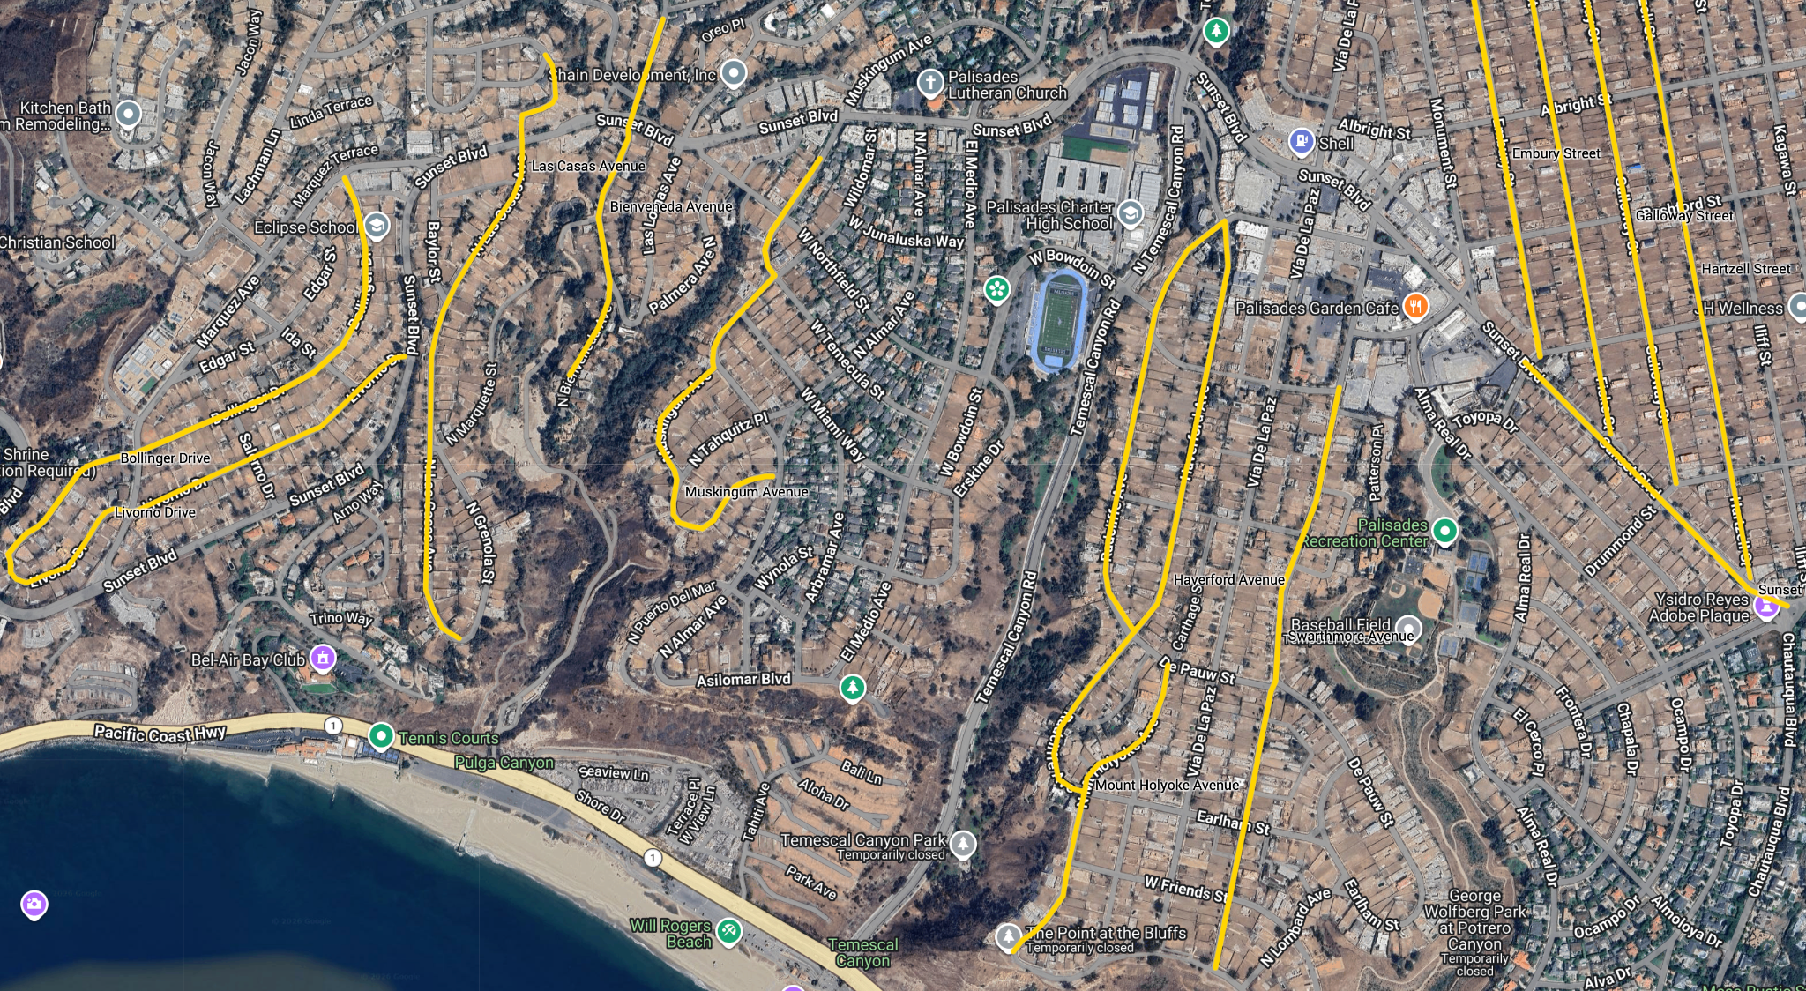

Highlighted Street Clusters
Sub-Market | Representative Streets | Program Notes
Las Casas and Bluffs and Bienveneda Canyon | Bienveneda Avenue & Las Casas Avenue | Smaller, canyon-side lots. Low price point: $900k-1.3mm
Marquez Knolls | Bollinger Drive & Livorno Drive | Flat lots, mid-range price point: $1.3-1.5mm
Alphabet Streets | Embury Street, Fiske Street, Galloway Street & Hartzell Street | Small flat lots, premium location $1.4-$1.8mm
Via and El Medio Bluffs | Muskingum Avenue, Radcliffe Avenue, Haverford Avenue, Mount Holyoke Avenue & Swarthmore Avenye | Mix of flat and hillside lots, small and large lots in a premium location. $1.4-$2mm
Note: The stylized graphic above is provided for orientation. The authoritative TEFRA-approved schedule is the master APN list circulated with the TEFRA hearing materials; every underwriting file must reference the hearing exhibit line number in Section 1 of the Lot Acquisitions Checklist before any further diligence spend.

E X H I B I T D
Lot Acquisitions Checklist
Six Peak Capital // LV Construction — Uplifters Rebuild

EXHIBIT D // LOT ACQUISITIONS CHECKLIST

Uplifters Rebuild — Lot Acquisitions Checklist

Deal Header
Property Address
APN
Date of Review
Reviewer / Lead
Seller / Listing Brokerage
MLS # / Off-Market
Status (Active / Pending / Closed)

Section 1 — Gating Check: TEFRA Eligibility
This property MUST be one of the ~750 lots already approved through the TEFRA process. Confirm before progressing any further in underwriting.
- Property address appears on the current TEFRA-approved lot schedule.
- APN cross-checked against the TEFRA master list (exact match, not by street alone).
- TEFRA approval tier / bucket identified.
TEFRA List Reference / Line #
TEFRA Tier / Bucket
Confirmed by
Date Confirmed
STOP: If the property is not on the TEFRA-approved list, do not proceed. Flag and archive.

Section 2 — Product Strategy: Design-Build Selection
Select the floor-plan/spec family this lot will be built to. Decisions should align with the lot envelope, slope, and acquisition cost.
Plan Family / Model
Architect / Designer
Stories
Target Conditioned SF
Target Total SF (incl. garage/covered)
Bed / Bath Count
Garage (car count / config)
Style / Exterior
ADU Included? (Y / N)
Existing Pool / Spa (Y / N)
Estimated Hard Cost / SF
Rationale for this Plan on this Lot

Section 3 — Permit Path: Executive Order Selection (EO 1 vs EO 8)
Determine which post-fire executive order path governs this rebuild. EO 1 = like-for-like / expedited footprint rebuild; EO 8 = expanded scope (ADU, up-size, reconfiguration). Selection drives timeline, review path, and cost.
EO 1 (Like-for-Like / Expedited) | EO 8 (Expanded / Reconfigured)
☐ | ☐

Path selected
Rationale
Footprint change vs. prior home? (Y/N, and %)
Square footage change vs. prior home? (Y/N, and %)
ADU being added under EO 8? (Y / N)

Section 4 — Bid Strategy: How Competitive Is My Offer?
Rank the market intensity around this lot to calibrate offer strength.
Low | Moderate | Competitive | Very Competitive | Bidding War
☐ | ☐ | ☐ | ☐ | ☐

Pricing
List Price | $
Offer Price | $
Max Price (Walk-Away) | $
$ / Lot SF at Offer | $
$ / Buildable SF at Offer | $
Number of Competing Offers (known)
Days on Market
Seller Motivation (1–5)
Comp Support for Max Price

Offer Terms
- All-cash
- Escalation clause (cap: ________________)
- Contingency Period ______ days
- Closing period: ______ days
- Other info pertinent to the lot: _________________________________________

Section 5 — DD Posture: Due Diligence Competitive Scale
Calibrate contingency posture to the competitiveness of the bid. Tighter DD = more competitive offer, more risk carried.
Standard DD | Short DD | Non-Contingent
☐ | ☐ | ☐

Selected Posture
DD Period (days)
Financing Contingency? (Y / N)
Appraisal Contingency? (Y / N)
Pre-DD work already completed
Risk accepted by going tighter
EMD ($ and % of price)
Hard money date

Section 6 — Prior Structure: Previous Home Stats
Captures the pre-fire structure. Relevant for EO 1 like-for-like qualification and for sizing the new design against what was there. If the lot supports a large home regardless of prior footprint (e.g., a 4,500 SF+ two-story), note that the prior structure doesn't govern.
Footprint (SF, first floor only)
Total Living SF (per assessor)
Estimated True / Measured SF
Stories
Bed / Bath (prior)
Garage (prior)
Pool / Spa on prior?
Year Built (prior)
Prior structure governs design? (Y / N)
If N — target size and why prior is irrelevant

Section 7 — Site: Existing Site Conditions

Earthwork
Is Soil Export Needed (Y / N) & estimated amount
Is Soil Import Needed (Y / N) & estimated amount
Haul Route / Access Constraints
Geotech report on file? (Y / N)
Remediation reports (soil / debris)
Fire-debris clearance status (Phase 1 / Phase 2)
Environmental clearance letter received?

Existing Improvements to Demo or Re-Use
- Existing flat work (driveway, walkways, patio)
- Retaining walls — location, height, condition
- Pool / spa — re-use or demo
- Site walls / fencing
- Mature trees
- Protected trees
- Existing foundation

Easements & Encumbrances
- Recorded easements reviewed (utility, access, drainage)
- Title commitment pulled
- CC&Rs reviewed
- Lis pendens / liens cleared

Section 8 — Pre-Con: Site Work Needed
Itemize everything required to make the site construction-ready, with rough order-of-magnitude cost.
Work Item | Needed? | ROM Cost | Notes
Fire debris / ash removal
Tree removal / protection
Demolition of foundation / flatwork
Retaining wall demo / build
Grading & soil export / import
Erosion control / SWPPP
Temporary power
Temporary water / construction meter
Sewer lateral assessment
Storm drain tie-in
Driveway / curb cut
Site fencing & security
Survey (ALTA / topo)
Geotech & soils testing
Arborist report
Protected trees
Wildlife report

Section 9 — Utilities: Locations & Service
Water Main — location / side of street
Water Service Size (existing)
Sewer Main — location / depth
Sewer Lateral condition (camera'd? Y/N)
Gas Service — location
Electric — overhead / underground
Storm drain — street inlet location

Curb Cuts & Driveway
Existing Curb Cut Location
Curb Cut Width
New Curb Cut Required?
Driveway Width / Slope
Ample Street Parking (Y/N)

Section 10 — Hazard & Context: Coastal, Bluff, Wildlife & Fire

Coastal Bluffs
- In the Coastal Zone?
- Bluff-top lot? Setback from bluff edge: ______ ft
- Geotech bluff stability study required / on file

Wildlife / Environmental
- In a designated Wildlife Area
- Oak / heritage tree(s) on lot
- Biological survey required?

Fire Hazard
- In VHFHSZ (Very High Fire Hazard Severity Zone)
- Defensible space requirements reviewed
Nearest Fire Hydrant — distance & side of street: ______________________________________________

Section 11 — Governance: HOA Information
Is it within an HOA? (Y / N)
HOA Name
HOA / ARB contact
Monthly / Annual Dues
Transfer Fee at Closing
Architectural Review Required? (Y / N)
ARB typical review timeline
Height / massing restrictions
Material / color palette restrictions
Setback overlays stricter than zoning?
Special assessments pending
CC&Rs reviewed (date)

Section 12 — Neighborhood: Surrounding Context
# Neighboring Homes Currently Under Construction
# Neighboring Lots Sold (post-fire)
# Neighboring Lots Still Listed
# Neighbors Rebuilding vs. Selling
Typical neighboring lot $ / SF (recent sales)
Active GC / builders on the street
Construction staging / parking density
Nearest recently completed rebuild
Street / access constraints for trucks

Section 13 — Zoning: LA Single-Family Zoning & Entitlements
Zone Designation (e.g., R1, RE, RA)
Specific Overlay (-V1, -1VL, etc.)
Hillside Ordinance applies? (Y / N)
Baseline Hillside / BMO?
Baseline Mansionization Ordinance (BMO)?
Coastal Zone overlay? (Y / N — appealable?)
Max Height by Zone / Slope Band
Previous Home Height
Max RFA (Residential Floor Area)
FAR limit
Required Setbacks (F / S / R)

Section 14 — Lot: Metrics
Lot Size (SF)
Frontage (ft)
Depth (ft)
Lot Shape (rect / flag / irregular)
Corner Lot? (Y / N)
Buildable Envelope (SF)
Max Footprint after setbacks (SF)
Estimated Grade / Slope %
Orientation (N/S/E/W facing)
View (ocean / canyon / mountain / street)
Privacy (1–5)

Summary — Underwriting
All-In Land Basis (purchase + closing) | $
Pre-Con Site Work Budget | $
Hard Cost (design-build selection) | $
Soft Costs (A+E, permits, financing) | $
Contingency (%)
Total Project Cost | $
ARV (projected sale price) | $
Projected Profit / Margin % | $ / %
Timeline (months, land close → C of O)
Key Risks

Go / No-Go Decision
Pass | Monitor | Offer at List | Aggressive Offer | Walk-to-Max
☐ | ☐ | ☐ | ☐ | ☐

Recommendation
Reviewer Signature
Date
IC Approval

E X H I B I T E
Sample Deal — 701 Radcliffe Ave.
Comparable Westward Homes acquisition — illustrative Six Peak underwrite.

EXHIBIT E // SAMPLE DEAL: 701 RADCLIFFE AVE.

701 Radcliffe Avenue, Pacific Palisades
This exhibit illustrates how the Uplifters underwriting playbook prices against a real comparable transaction. 701 Radcliffe Avenue was acquired by Westward Homes in December 2025 for $1.2 million. The property is in the Huntington Palisades sub-market and sits on a standard Palisades lot. Using Westward's realized RTI cost of $62,000 and total construction cost of $1.6 million, the table below shows what the Six Peak fee schedule would generate if this deal were routed through the Uplifters program. This ignores the discount Uplifters realizes through our cost advantages.

Deal Snapshot
Metric | Detail
Address | 701 Radcliffe Avenue, Pacific Palisades, CA
Buyer | Westward Homes
Close Date | December 2025
Purchase Price | $1,200,000
RTI / Plans & Permits | $62,000
Total Construction Cost | $1,600,000
All-In Project Basis | $2,862,000
Product Type | New single-family home with optional ADU

Illustrative Six Peak Fee Build-up (If Routed Through Uplifters)
Under the Six Peak fee schedule of 1% acquisition, 6% development, 3% leasing on annual rent, and 1% disposition, applied to 701 Radcliffe's actual cost basis, Six Peak would earn the following:
Fee Category | Rate | Basis | Basis Amount | Six Peak Fee
Acquisition Fee | 1.0% | Lot purchase price | $1,200,000 | $12,000
Development Management Fee | 6.0% | RTI + construction cost | $1,662,000 | $99,720
Leasing Commission | 3.0% | Illustrative annual rent | $180,000 | $5,400
Exit / Disposition Fee | 1.0% | Illustrative ARV | $3,419,763 | $34,198
TOTAL SIX PEAK FEES |  |  |  | $151,318
Six Peak captures approximately $151K per comparable deal at no capital deployment. Scaled across the 60-home program target, this is the per-asset building block that rolls into the $9.0M aggregate fee plan in the IC Memo.

Architectural Visuals
The renderings and floor plans below illustrate the product the Six Peak design-build roster is targeting for a typical Palisades Lot: a ~3,250 SF two-story home with a pool, one car garage and rooftop terrace.
Rendering — 701 Radcliffe Ave.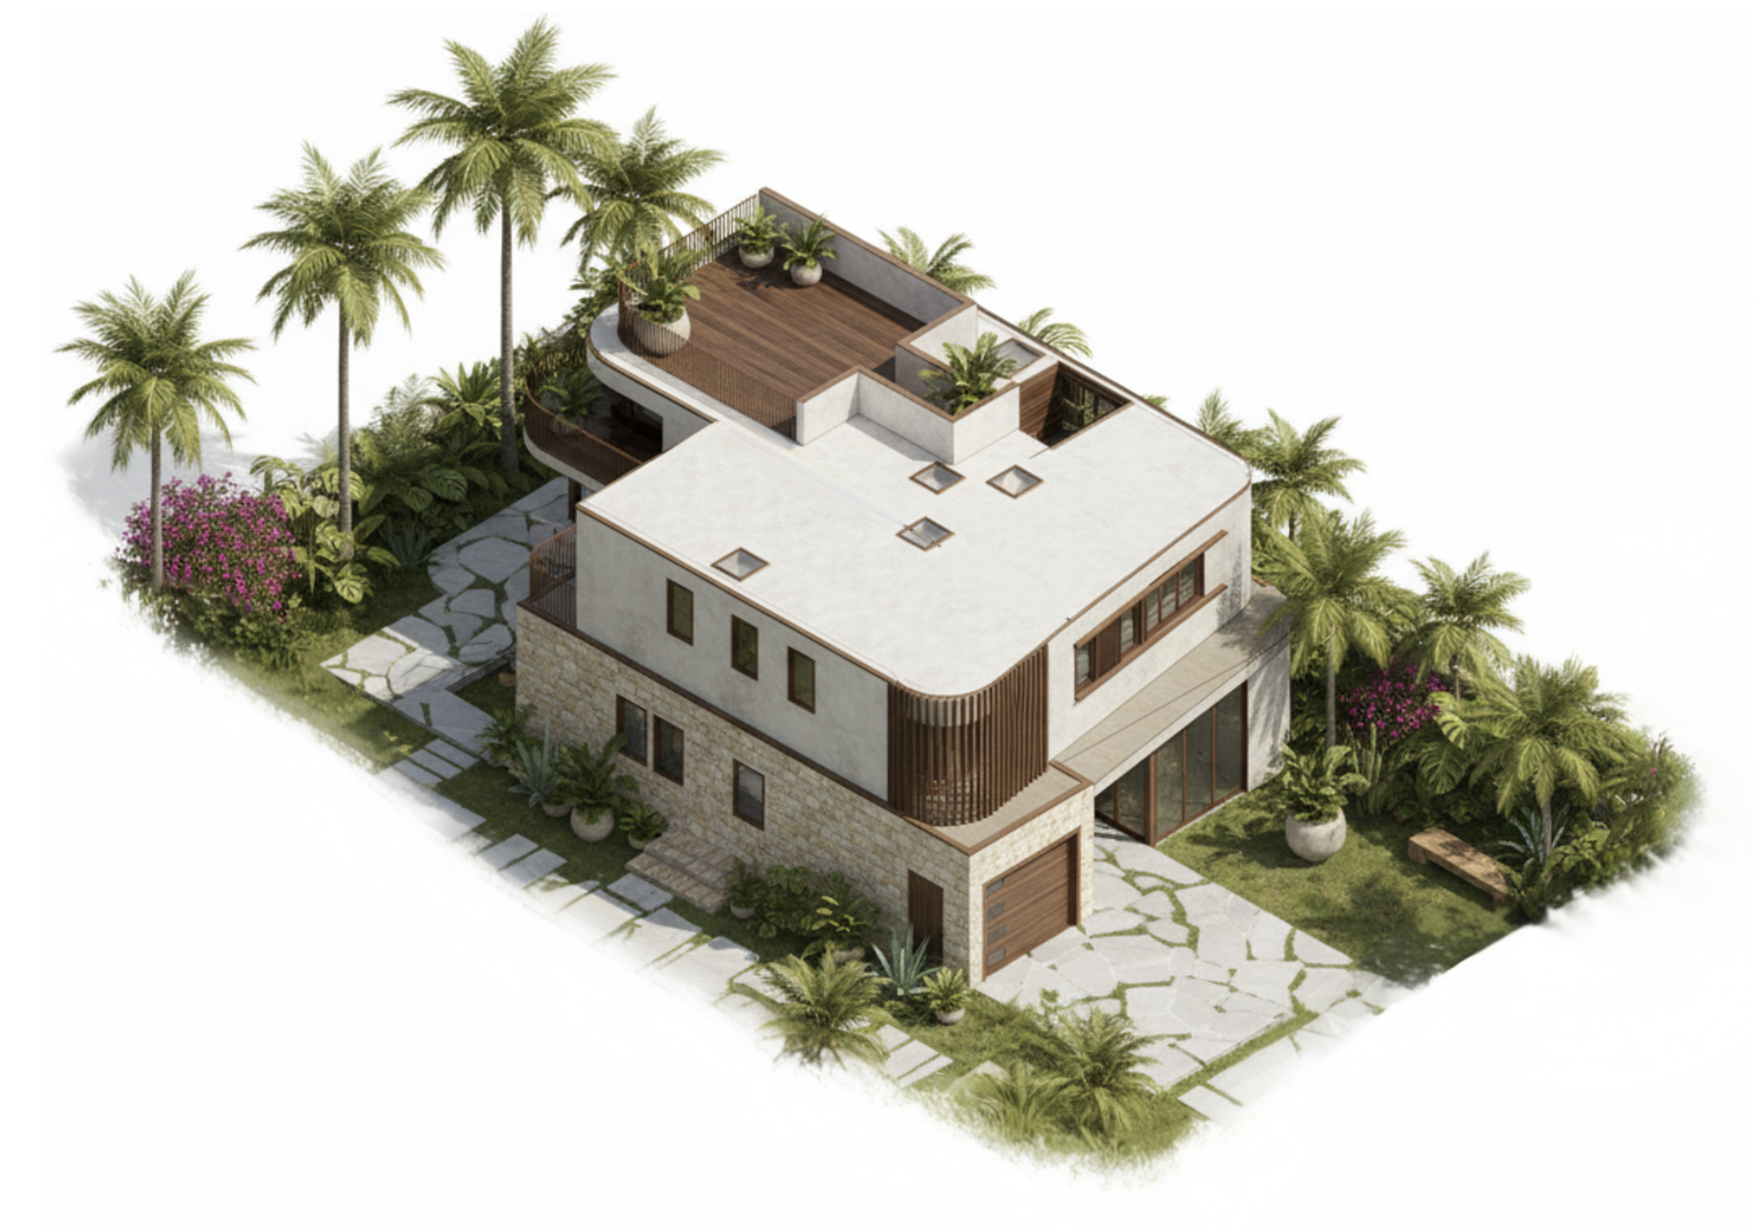

Proposed Ground Floor Plan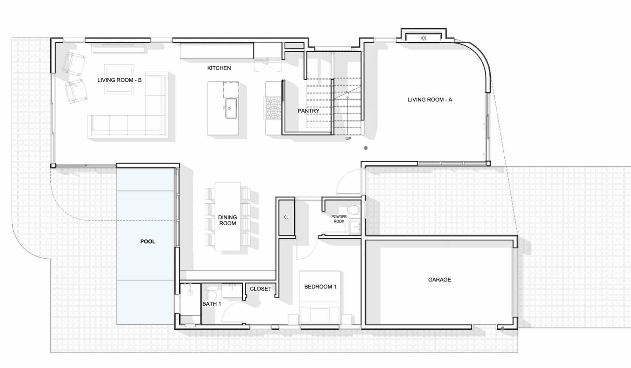
Proposed Second Floor Plan
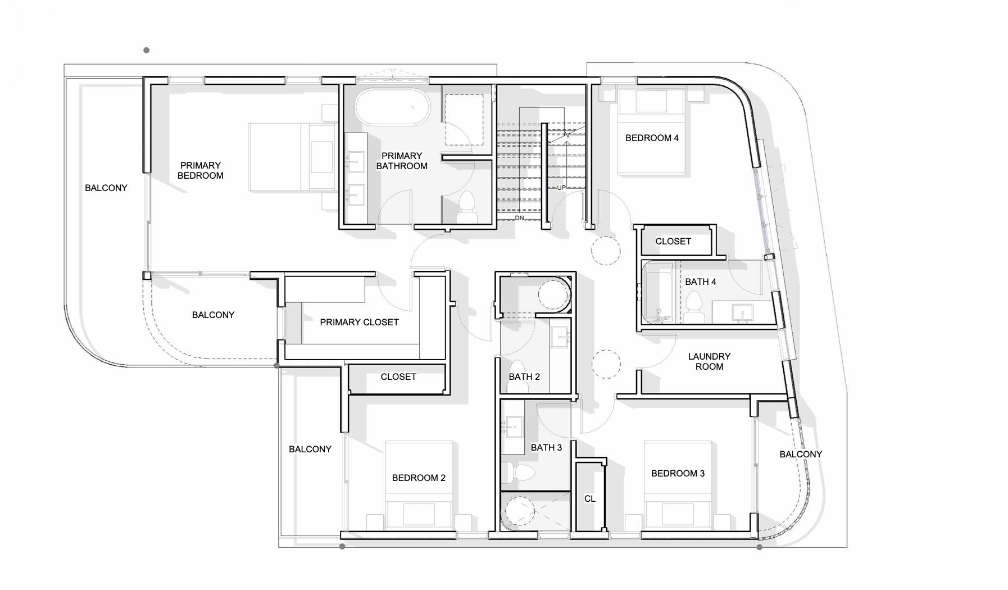

End of Memorandum // Six Peak Capital // Confidential

