

School of Computer Science Engineering

2017-06-26

GestUsers: User Management System

**CITIZEN PARTICIPATION**

Aquilino A. Juan Fuente

José Emilio Labra Gayo

Begoña Cristina Pelayo García-Bustelo

Jordán Pascual Espada

Vicente García Díaz

*Software Architecture for GestUsers. Description of the practice work (2017)*

Description of the practice work done by the work teams of the course “Software Architecture” during the academic year 2016-17.

**Grado de Ingeniería Informática del Software**

|  |  |
| --- | --- |
|  |  |

**GestUsers: User Management System**

**Authors**: **Aquilino Adolfo Juan Fuente**

PhD. Computer Science

Dept. Computer Science, University of Oviedo

**Jose Emilio Labra Gayo**

PhD. Computer Science

Dept. Computer Science, University of Oviedo

**Juan Luis Mateo Cerdán**

PhD. Computer Science

Dept. Computer Science, University of Oviedo

**Katia Fernández Fernández**

Student of Software Engineering at Universidad de Oviedo

**Andrei Manu**

Student of Software Engineering at Universidad de Oviedo

**Christian Martínez Abad**

Student of Software Engineering at Universidad de Oviedo

**Date**: 26/06/2017

**Version**: 2017.EN.004

Table of Contents

1 Introduction and Goals 6

2 Requirements 7

2.1 CitizensLoader 7

2.2 Participants 7

2.3 ParticipationSystem 8

2.4 Dashboard 8

3 Methodology 9

4 Stakeholders 10

4.1 Students that develop the assignment 10

4.2 System administrator 10

4.3 Citizens 10

4.4 Developers of the System 10

4.5 Course teachers 11

4.6 Council staff, councilmen and other authorities 11

5 Quality Attributes 12

5.1 List of Quality Attributes 13

5.2 Quality Attributes and stakeholders 14

6 Architecture Constraints 16

6.1 Technical constraints 16

6.2 Organizational Constraints 16

7 System scope and context 17

8 Quality Scenarios 19

9 Views 23

9.1 Context 23

9.1.1 Main overview 24

9.1.2 Elements Catalogue 24

9.2 Citizens List 28

9.2.1 Main overview 28

9.2.2 Catalogue of Elements 28

9.2.3 Context Diagram 30

9.2.4 Rationale 30

9.3 Participants 31

9.3.1 Main overview 31

9.3.2 Catalogue of elements 31

9.3.3 Context Diagram 32

9.3.4 Rationale 33

9.4 ParticipationSystem 33

9.4.1 Main overview 33

9.4.2 Catalogue of elements 33

9.4.3 Context Diagram 34

9.4.4 Rationale 34

9.5 Dashboard 34

9.5.1 Main overview 34

9.5.2 Catalogue of elements 34

9.5.3 Context Diagram 35

9.5.4 Rationale 35

10 Package view and deployment view 36

11 References 37

# Introduction and Goals

The goal of this document is to describe the structure of an architecture of User Management that will be reused. Although the system that we describe has its own functionality, the main goal is that it will be part of a general system of citizen participation.

This document describes the laboratory work of the course "*Software Architecture*" which is taught by the three first authors. The course is part of the Degree in Software Engineering, School of Computer Science Engineering, University of Oviedo.

The system is divided in four different parts: CitizensLoader, to load data about citizens; Participants, to check if a user can participate; ParticipationSystem, to configure different parameters in order to allow the required actions; Dashboard, to view the evolution of the participation system in real time.

The development of the hole system will be done by a group of three people.

# Requirements

User Management will be divided in four parts:

* CitizenLoader: loads the list of users from the Council, for example the municipal census.
* Participants: checks if a citizen can participate.
* ParticipationSystem: manages the citizen participation and allows to configure different parameters in order to do the required actions.
* Dashboard: offers a dashboard to the Council staff, councilmen and other authorities in order to view the evolution of the participation system in real time.

## CitizensLoader

The System administrator must be able to introduce data from the citizens list. That data can be obtained from different sources like the municipal census, lists of immigrants without official residence, bystanders, etc. Those lists will be delivered by some institution to the Council.

The introduction of data will be made from Excel files that contain a list of rows with the following information:

* First name
* Last name
* Email
* Date of birth
* Address
* Nationality
* ID (National ID, the residence card ID, etc.)

When importing the citizens data, the system will create a user (whose login name will be the email) and a random password which will enable the user to enter the system to check if the data is correct as well as to later participate in the system. The system will generate personal letters that will be sent to each user by email. This task will be done by the Council and is not part of this system.

If a user appears in two different lists, this event will be recorded and informed in a log file. A user can only be created once. If the data is different from the current data available in the system, the current data will not be modified and an error will be recorded in the log.

The system is extended in order to emit the letters in two different formats: PDF and txt.

All the errors detected in the input file, will be reported in a log file.

## Participants

Citizens should be able to login into the system to check that they can participate once the notification letter has been received. In order to implement that feature, a simple web service will be created that has two parameters passed as a POST message: login name and password and returns the data available about the citizen if the information is correct or reports an error if it isn't. Both the call parameters and the return information will employ JSON format.

The web service offers a simple HTML interface where a user can login and see his information in a human- friendly way.

## ParticipationSystem

The personnel from the Council must be able to configure the participation system in order to configure different parameters like proposal categories, dates in which they will be active or not allowed words as other kind of issues.

Non-appropiate proposals will be deleted by the personnel.

The popularity of each proposal comes from the votes of other users. A proposal will be accepted only in case it is supported by other users. A proposal is considered accepted if is satisfies the minimal number of users supporting it. This number is configured by the portal administrators.

Once a proposal enters the acceptance phase (it has at least the minimum number of supporters), the portal administrators receive a notification of this event.

A proposal that has passed the acceptance phase could be updated by the votes that result from the corresponding parliament.

Users can also comment proposals in order to generate some discussion about them and also improve them. These comments can be ordered by chronological order.

The different proposals, supports and comments that they obtain will be recorded in the application log which will be connected to a Kafka Stream.

**[Optional]** The system could be extended in order to allow users vote the comments.

## Dashboard

The Council staff, councilmen and other authorities will have the possibility to view the evolution of the participation system in real time. They can see graphically the key performance indicators that affects to the participation system which are constantly updated.

Those key performance indicators are:

• Show the changes that appear in the participation system as they are produced.

• Update information in all of the concurrent clients that are connected at update time.

• Offer information about the evolution of the proposals (the number of votes that they receive as well as the different comments).

# Methodology

This document employs the ADD (Attribute-Driven Design) methodology (Bass, Clements, & Kazman, 2003) and the SEI norm (ANSI/IEEE 1471, 2000).

The templates have also been inspired by the Arc42 templates (<http://arc42.org/>) where documentation architecture templates are defined in English, German and Spanish.

Another project that follows those templates for a biking domain is available at:

<http://biking.michael-simons.eu/docs/index.html>

# Stakeholders

The stakeholders identified are:

1. Students that develop the assignment
2. System Administrator
3. Citizens
4. Developers of the system
5. Course Teachers
6. Council staff, councilmen and other authorities

| Code | Stakeholder | Interests (Modules) |
| --- | --- | --- |
| ST-01 | Students | All of them |
| ST-02 | System administrator | Load files |
| ST-03 | Citizens | Check data and participate |
| ST-04 | Developers of Participation System | Check data, implement the configuration options of the system and a Kafka Stream |
| ST-05 | Course Teachers | All of them |
| ST-06 | Council staff, councilmen and other authorities | Configuration and view evolution of the participation system |

Table 1. List of stakeholders/interests

## Students that develop the assignment

This group is formed by the team that will develop the system. Some of their goals are:

* Use of known technologies and methodologies minimizing the risks to learn new ones.
* Learn how to develop software collaboratively and in a professional way.
* Use of simple technologies that can interoperate with other systems.

## System administrator

This is the person who is in charge of loading the citizens list.

Some of the goals are:

* Use of simple and well-known technologies for input files.
* Files that can be read by humans.
* Be able to automate the loading process.
* Be able to debug the loading process in case of failures.

## Citizens

These are the final users of the system. Some of their goals are:

* Get access to the system in a simple way.
* Being able to participate from their homes in a safe way.
* Being able to query their status in the system.
* Being able publish a proposal and comment and vote all of them.

## Developers of the System

In this case, the team that will implement the system is the same for all of the modules, so because of this there is no clear distinction between the developers of the different modules of the system.

Some of their goals are:

* Have a simple way to detect if a citizen can participate in the system as soon as possible.
* Use of simple technologies that can interoperate with other systems.
* Implement the configuration options of the system.
* Offer to the Council staff, councilmen and other authorities the possibility to see the statistics and the evolution of the participation system.
* Implement a Kafka Stream.

## Course teachers

They are responsible for the results of this assignment. Some of their goals are:

* Use technologies that help students acquire skills related with Software Architecture by developing a practical assignment.
* Introduce the students in collaborative and professional software development through TDD (Test driven development) techniques.
* Show the students an example documentation of a software architecture.

## Council staff, councilmen and other authorities

This is the team responsible of the configuration of the participation system. Some of their goals are:

* Configure the different options of the participation system, such as proposal categories, dates in which they will be active, not allowed words, minimal number of support votes...
* View in a friendly way the evolution of the participation system in real time. Each type of people will be able to see a different type of visualization of the system.

# Quality Attributes

We have identified the following quality attributes:

* **Availability**
  + The system must be able to process data 24x7.
  + The system must be able to serve millions of requests at the same time.
  + The system will show in real time the results.
* **Modifiability**
  + Easily change some parts of the application: Add an error reporting feature.
  + Easily modify some parts of the application: Add other output files to generate the letters.
  + Easily modify the configuration of the system: Enable different options to be configured.
  + Easily modify some parts of the application: Restrict who and how the dashboard will be seen.
* **Performance**
  + The performance of the data loading system is reasonable.
  + Querying information about a user through the web service should be fast.
  + The system must be able to process a big workload without breaking.
  + The dashboard reflects the changes in participation system as they are being produced.
* **Security** 
  + The system should warrant the confidentiality of the citizens’ data.
  + The system must warrant the confidentiality of the votes.
  + The system must warrant that only allowed people have access to configure the system.
  + The system should warrant that the dashboard can only be viewed by the authorized people.
* **Testability**
  + It must be testable that the citizens’ data loading process is correct.
  + It must be testable that the web service behaves as expected.
  + It must be testable that the Kafka Stream shows the statistics properly. It will be testes independently with a small simulator that generates random events.
* **Usability**
  + The data loading system must be easy to use by System administrator users which are familiar with Unix-like tools.
  + The system must be easy to use by all the users and allow them to do what they want in a simple way.
  + The results shown have to be clear and impossible to misunderstand.
* **Interoperability**
  + This system will be used by the Participation System which will leverage on it for user management. The Participants web service must be used by an automated process that can query the status of a user.
  + The results must be updated dynamically and in real time without user interaction.
* **Simplicity**
  + The four modules should be simple and easy to develop.
* **Deployability**
  + The system should be easily deployable, especially in a cloud based server.
* **Scalability**
  + The system will be able to show the data of the users even if the number of users reaches 5 million.

## List of Quality Attributes

The list of quality attribute is the following:

| **Code** | **Description** | **Type of Attribute** | **Module** |
| --- | --- | --- | --- |
| **AT001** | The system must be able to process data 24x7 | Availability | Participants, Participation system |
| **AT002** | The system must be able to serve millions of requests at the same time | Availability | ParticipationSystem |
| **AT003** | The system will show in real time the results | Availability | Dashboard |
| **AT004** | Easily change some parts of the application: Add an error reporting feature | Modifiability | CitizensLoader |
| **AT005** | Easily modify some parts of the application: Add other output files to generate the letters | Modifiability | CitizensLoader |
| **AT006** | Easily modify the configuration of the system: Enable different options to be configured | Modifiability | ParticipationSystem |
| **AT007** | Easily modify some parts of the application: Restrict for whom and how the dashboard will be seen | Modifiability | Dashboad |
| **AT008** | The performance of the data loading system is reasonable | Performance | CitizensLoader |
| **AT009** | Querying information about a user through the web service should be fast | Performance | Participants,  ParticipationSystem |
| **AT010** | The system must be able to process a big workload without breaking | Performance | ParticipationSystem |
| **AT011** | The dashboard reflects the changes in participation system as they are being produced | Performance | Dashboard |
| **AT012** | The system should warrant the confidentiality of the citizens’ data | Security | All of them |
| **AT013** | The system must warrant the confidentiality of the votes | Security | ParticipationSystem, Dashboard |
| **AT014** | The system must warrant that only allowed people have access to configure the system | Security | ParticipationSystem |
| **AT015** | The system should warrant that the dashboard can only be viewed by the authorized people | Security | Dashboard |
| **AT016** | It must be testable that the citizens’ data loading process is correct | Testability | CitizensLoader |
| **AT017** | It must be testable that the web service behaves as expected | Testability | Participants, ParticipationSystem |
| **AT018** | It must be testable that the Kafka Stream shows the statistics properly. It will be testes independently with a small simulator that generates random events | Testability | ParticipationSystem, Dashboard |
| **AT019** | The data loading system must be easy to use by System administrator users which are familiar with Unix-like tools | Usability | CitizensLoader |
| **AT020** | The system must be easy to use by all the users and allow them to do what they want in a simple way | Usability | All of them |
| **AT021** | The results shown have to be clear and impossible to misunderstand | Usability | Dashboard |
| **AT022** | This system will be used by the Participation System which will leverage on it for user management. The Participants web service must be used by an automated process that can query the status of a user | Interoperability | Participants |
| **AT023** | The results must be updated dynamically and in real time without user interaction | Interoperability | Dashboard |
| **AT024** | The four modules should be simple and easy to develop | Simplicity | All of them |
| **AT025** | The system should be easily deployable, especially in a cloud based server | Deployability | All of them |
| **AT026** | The system will be able to show the data of the users even if the number of users reaches 5 million | Scalability | ParticipationSystem, Dashboard |

Table 2. List of quality attributes and their types

## Quality Attributes and stakeholders

The following table shows which attribute qualities are interesting for which stakeholder:

| **Attributes**  **vs**  **Stakeholders** | **ST-01** | **ST-02** | **ST-03** | **ST-04** | **ST-05** | **ST-06** |
| --- | --- | --- | --- | --- | --- | --- |
| **AT001** | X |  | X | X |  | X |
| **AT002** | X |  | X | X |  | X |
| **AT003** | X |  | X | X |  | X |
| **AT004** | X |  |  | X |  |  |
| **AT005** | X |  | X | X |  |  |
| **AT006** | X |  |  | X |  | X |
| **AT007** | X |  | X | X |  | X |
| **AT008** | X |  | X | X | X | X |
| **AT009** | X |  | X | X |  | X |
| **AT010** | X |  |  | X | X |  |
| **AT011** | X |  | X | X |  |  |
| **AT012** | X |  | X | X |  |  |
| **AT013** | X | X | X | X |  | X |
| **AT014** | X |  | X | X |  | X |
| **AT015** | X |  | X | X | X | X |
| **AT016** | X | X |  | X | X |  |
| **AT017** | X |  | X | X |  | X |
| **AT018** | X |  |  | X | X |  |
| **AT019** | X | X |  | X |  |  |
| **AT020** | X | X | X | X | X | X |
| **AT021** | X |  | X | X | X | X |
| **AT022** | X |  | X | X |  | X |
| **AT023** | X |  |  | X | X |  |
| **AT024** | X |  |  | X | X |  |
| **AT025** | X |  |  | X | X |  |
| **AT026** | X |  |  | X | X |  |

Table 3. List of stakeholders: interests vs quality attributes

# Architecture Constraints

## Technical constraints

We have detected the following set of technical constraints in the project:

| **Code** | **Constraint** | **Background/Motivation** |
| --- | --- | --- |
| **TC001** | All the systems will be implemented in Java | The developer team (ST001) has knowledge of Java |
| **TC002** | The data will be stored in a relational database. | The developer team (ST001) has knowledge of relational databases and there are a lot of libraries to work with relational databases from Java |
| **TC003** | The web service will be based on REST using JSON format | The REST style of web services using JSON is very popular and easy to implement nowadays. |
| **TC004** | The input data format to load data is Excel | Excel is a popular format for data exchange and there are several libraries to process Excel files |
| **TC005** | The output data of the citizens loader module will be a set of text files | In order to facilitate the implementation, text files are the easier format to generate. However, the developer team can optionally implement other generators. |
| **TC007** | Automated testing | The tests should be run automatically and a continuous integration system must be used |
| **TC008** | The web service will be implemented using the Spring Boot web framework | Spring Boot web framework leverages on Spring, which is a well-known framework very popular in Industry. It contains lots of examples and help info that can help students to learn to use it. |
| **TC009** | Use of Kafka Stream | Kafka is used for building real-time data pipelines and streaming apps. For this reason is a perfect solution to publish log data that will be updated in real time to the subscribers |

Table 4. Technical constraints

## Organizational Constraints

| **Code** | **Constraint** | **Background/Motivation** |
| --- | --- | --- |
| **OC001** | The system will be implemented by a small team of student developers. | The size of the teams will be of 3 students. The goal is that students learn to work collaboratively by developing a simple project |
| **OC002** | The source code will be available as a github repository | Github offers a very powerful project management tool for this kind of projects. |

Table 5. Organizational constraints

# System scope and context

The system is decomposed in four modules:

* CitizensLoader: This module will be responsible to convert data from Excel files and load it into the database. The system will be invoked by a system administrator.
* Participants: This module will check if users can participate obtaining information from the database.
* ParticipationSystem: This module will be in charge of managing citizen participation. It will allow to configure different parameters like proposal categories, dates in which they will be active, not allowed words and other kind of issues.
* Dashboard: This module will offer a dashboard with statistics from the ParticipationSystem.



Figure 1. Business Context

The following figure contains a BPMN diagram showing the whole process of all the system.

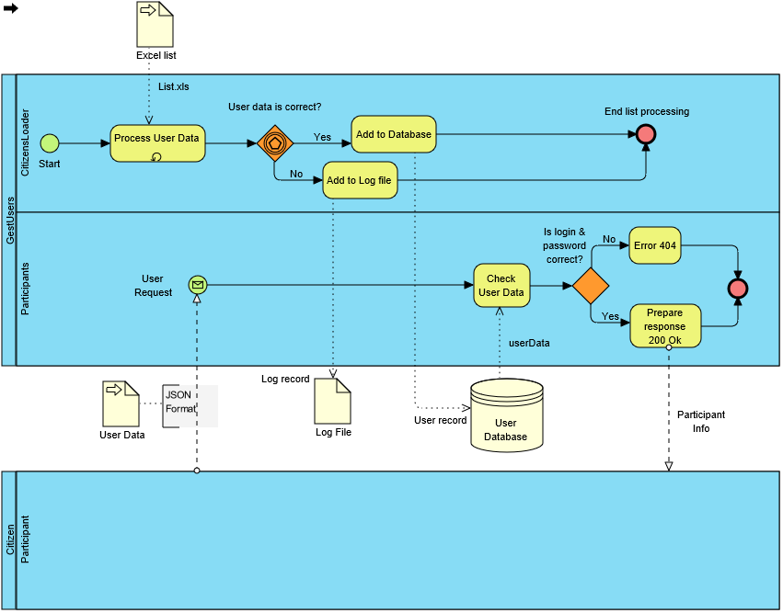

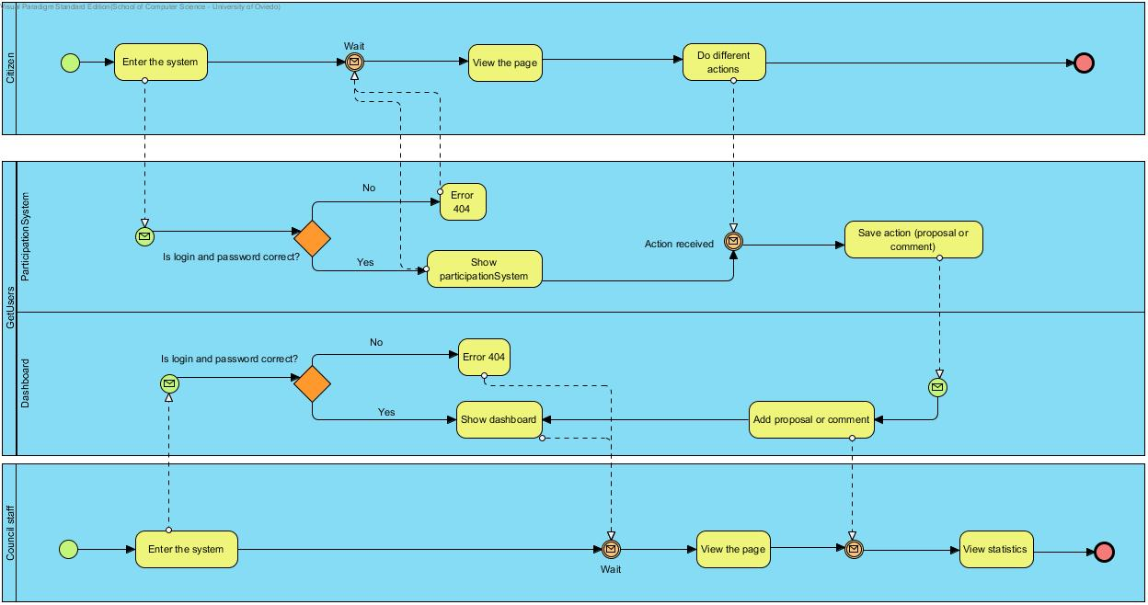

Figure 2. BPMN Diagram

# Quality Scenarios

The table below contains the quality scenarios that have been identified:

| Scenario | Source Stimulus | Stimulus | Environment | Artifact | Response | Measure | Affected  Attribute Quality |
| --- | --- | --- | --- | --- | --- | --- | --- |
| 1 | Participation System | Ask information about a user | Runtime | Participants | Participation System obtains the required information in less than 15seg at any time in the day | The required information is obtained | **AT001** |
| 2 | Participation System | Ask information about a user | Runtime | Participants | Participation System obtains the required information for several users at the same time | The required information is obtained | **AT002** |
| 3 | Participation System | Ask information about a user | Runtime | Participants | Participation System obtains the results at the same time the information is required. | The requested results are obtained | **AT003** |
| 4 | Student developer | A new option is implemented for the report file | Development | ReportWriter, DBUpdate and Parser | The option is implemented with minimal changes that affect only the report writer module | Less than one day of work | **AT004** |
| 5 | Student developer | A new output format is added | Development | Participants and DBManagement | The new output format is included with minimal changes to existing code. | Less than one day of work . | **AT005** |
| 6 | Council staff | The option to configure the service is selected | Runtime | Participants | The options are selected | The selected options started to work as expected | **AT006** |
| 7 | Dashboard System | Changes must be done easily | Development | Dashboard | Restrict who and in what manner will see the dashboard | System has to provide modifiability | **AT007** |
| 8 | System administrator | Load an Excel file into the System (DB) | Runtime | Parser, DBUpdate and ReportWriter | Loading an excel file without errors is done in a reasonable time. | < 1 second for each 10 Participantsparticipant | **AT008** |
| 9 | System administrated | Receive new information | Runtime | Parser, DBUpdate and ReportWriter | Receive the information without errors | <1 second per each 10 participants | **AT009** |
| 10 | System administrated | Receive high amounts of information | Runtime | Parser, DBUpdate and ReportWriter | Receive high amounts of information | Process the received information without breaking | **AT010** |
| 11 | Dashboard System | Show the information in real time | Runtime | Dashboard | Show graphically the results of participation system | The graphs must be updated in real time | **AT011** |
| 12 | Student developer | Load an Excel file into the system (DB) | Development/  Runtime | Parser, DBUpdate and ReportWriter (Optional) | Loading data should be done in a safe way | It is not possible to get access to the users’ personal data except by the system administrator who cannot get access to the password | **AT012** |
| 13 | Citizen | Privacy of votes | Runtime | Participation System | The votes must be anonymus | System has to provide privacy of the votes, don’t show people the information | **AT013** |
| 14 | Participation System | Restrict the access to the system | Runtime security | Participation System | The access to the configuration must be controlled and only accesed by authorized people | The system must accept authorized people and deny not authorized ones | **AT014** |
| 15 | Dashboard System | Restrict who and in what manner will see the dashboard | Runtime security | Dashboard | The dashboard can only be seen by authorized people | The system must distinguish between authorized and not authorized users | **AT015** |
| 16 | System administrator | Loads an excel file into the DB | Runtime | Parser, DBUpdate and ReportWriter | The loading process is made in a reliable way and it is possible to check that the data has been loaded | There are no errors in the database, no repeated record, and no citizen has less information than expected | **AT016** |
| 17 | Participants | Get access to the application | Runtime | Participants | A user can get access to his data but not to other user's data | Access to data is enabled only if the pair user name/password is correct | **AT017** |
| 18 | Participation System and Dashboard | Test the system | Test phase | Dashboard | Prove that Kafka Stream shows the correct data | Tested with a simulator of random events | **AT018** |
| 19 | System administrator | Loads an excel file into the DB | Runtime | Parser, DBUpdate and ReportWriter | The loading process behaves in a usual way and the options available to run the system are easy to understand | The system shows help options if the user asks for them. The error messages and other information can be understood by technical people | **AT019** |
| 20 | Participation System | Use the system | Runtime | Participation System | The system behaves as expected and everything is easy and intuitive to use | The system shows all the options in an intuitive way | **AT020** |
| 21 | Dashboard System | Show statistics | Runtime | Dashboard | The system shows the results in a way impossible to misunderstand | The system shows the results in a simple way | **AT021** |
| 22 | Citizen Participation System | Access to the web service | Runtime | Participants | The participation System requests information about a user by passing a combination of user name and password | A 200 OK response is sent with the correct format if the combination is OK or a failure information is returned | **AT022** |
| 23 | Dashboard System, Participation System | Share data to show it | Runtime | Dashboard, Kafka | Good communication between both systems to show the statistics | Graphs must show the actual statistics when the comments and likes are done | **AT023** |
| 24 | Student developer | Develops the system | Development | Participants  CitizensLoader | The student developers can implement the system | The system can be implemented and testes in 2/3 weeks by third year undergraduate students. | **AT024** |
| 25 | System administrator | Deploys the system | Deployment | CitizensLoader, Participants | The system is deployed in a production environment | The system can be deployed by a system administrator in less than an hour. | **AT025** |
| 26 | Participation System, Dashboard System | Manage flux of users | Runtime | Participation System, Dashboard | Same efficiency for 1-infinite users | The system design is not changed when the number of users grows exponentially | **AT026** |

Table 6. List of quality scenarios

# Views

In the following paragraphs the identified the views that will be documented following the learning guide instructions.

|  |  |  |  |
| --- | --- | --- | --- |
| View | Stakeholders | Quality Attributes | Scenarios |
| Context | ST-01, ST-02, ST-03, ST-04, ST-05, ST-06 | AT019, AT024, AT025 | 11, 19, 24, 25 |
| CitizensLoader | ST-01, ST-02, ST-03, ST-04, ST-05 | AT004, AT005, AT008, AT012, AT016, AT019, AT020, AT024, AT025 | 4, 5, 8, 12, 16, 19, 20, 24, 25 |
| Participants | ST-01, ST-03, ST-04, ST-05 | AT001, AT009, AT012, AT017, AT020, AT022, AT024, AT025 | 1, 9, 12, 17, 20, 22, 24, 25 |
| ParticipationSystem | ST-01, ST-03, ST-04, ST-05, ST-06 | AT001, AT002, AT006, AT009, AT010, AT011, AT012, T013, AT014, AT017, AT018, AT020, AT024, AT025, AT026 | 1, 2, 6, 9, 10, 11, 12, 13, 14, 17, 18, 20, 24, 25, 26 |
| Dashboard | ST-01, ST-02, ST-04, ST-05, ST-06 | AT003, AT007, AT011, AT012, AT013, AT015, AT018, AT020, AT021, AT023, AT024, AT025, AT026 | 3, 7, 11, 12, 13, 15, 18, 20, 21, 23, 24, 25, 26 |

## Context

The System view is divided in four main sub-systems.

### Main overview



Figura 3. Context view

### Elements Catalogue

#### Elements

|  |  |
| --- | --- |
| Element | Properties |
| CitizensLoader | It introduces citizens data in the system. It reads an Excel file with data, generates passwords, personal letters and reports any errors. |
| Participants | This is the module used by citizens to check that their information is available in the system. They can optionally change some of their personal information and their password (not implemented). |
| DataBase | This module encapsulates database access. |
| ParticipationSystem | This module allows citizens to offer, comment and vote different proposals. |
| Dashboard | This is the module used to show the results of the system. |
| KafkaStream | This module encapsulates the use of Apache Kafka |

#### Relationships

Citizens data are introduced in the system through the interface *ReadList* from module *CitizensLoader*. For each user, a password is generated as well as a personalized letter with information about the user.

That interface sends the data to the database through the interface *UpdateDB* from the DataBase module.

The *Participants* module allows an external system to check the information about a user through the web service *GetParticipantInfo*. In order to check the information, *Participants* asks data to the *DataBase* module through the *GetParticipant* interface.

The *Participation System* module allows users to access the application and use the whole system. This includes the possibility to make a proposal, as well as vote and comment other people’s proposals. The actions of add, comment or vote a proposal are done through the AddProposal, VoteProposal and AddComment interfaces.

The *Dasboard* module allows visualization of data from the system throw showInfo interface. The data update is done by Kafka through GetData interface.

#### Interfaces /Ports

##### CitizensLoader

|  |  |  |  |
| --- | --- | --- | --- |
| Interface | Type | Technology | Properties |
| ReadList | Interface | Command line invocation | This interface will be invoked from the main application as a console program |

##### Participants

|  |  |  |  |  |  |
| --- | --- | --- | --- | --- | --- |
| Interface | Tipo | Tecnología | | Propiedades | |
| GetParticipantInfo | | Interface | Web Service | | This interface will be invoked through an HTTP request |

##### DataBase

|  |  |  |  |
| --- | --- | --- | --- |
| Interface | Tipo | Tecnología | Propiedades |
| GetParticipant | Interface | Method invocation | Returns data from citizens |
| UpdateDB | Interface | Method invocation | Inserts into the database data about a citizen included its password |
| UpdateInfo | Interface | Method invocation | Updates the password of a user in the database |

##### ParticipationSystem

|  |  |  |  |
| --- | --- | --- | --- |
| Interface | Tipo | Tecnología | Propiedades |
| AddProposal | Interface | Method invocation | Creates a new proposal and sends the info to Kafka. |
| VoteProposal | Interface | Method invocation | Updates the proposal votes and sends a message to Kafka. |
| AddComment | Interface | Method invocation | Creates a new comment and sends the info to Kafka. |
| VoteComment | Interface | Method invocation | Updates the comment votes and sents a message to Kafka. |
| GetInfo | Interface | Method invocation | Obtains the info from the database. |
| SaveInfo | Interface | Method invocation | Sends the new info to kafka. |
| PublishData | Interface | Method invocation | Sends the new info to kafka. |

##### Dashboard

|  |  |  |  |
| --- | --- | --- | --- |
| Interface | Tipo | Tecnología | Propiedades |
| ShowInfo | Interface | Method invocation | Shows the data from the system |
| GetData | Interface | Method invocation | Obtains the data to show |

##### KafkaStream

|  |  |  |  |
| --- | --- | --- | --- |
| Interface | Tipo | Tecnología | Propiedades |
| GetData | Interface | Method invocation | Returns data. |

#### Behaviour

##### CitizensLoader

See 9.2.2.3.4.

It can also do the following options:

* The subsystem that generates the letters could implement the Adapter pattern which would enable to generate the letters in different formants in the future (Word, ODT, PDF, RTF, etc.).
* If the file contains errors, those errors should be detected and a report should be generated for its later treatment

##### Participants

It allows users to get access into the system to check if they can participate, using the information that they received in the letter. The users may not get access directly by a web browser, but through an external paticipation system that invokes the Participants module as a web service.

##### DataBase

All the operations done in this module will be integrated in a *Facade pattern* which will contain the operations that offer access to the database. It encapsulates all the operations that affect the database.

##### ParticipationSystem

It allows citizens to create a proposal, as well as comment other proposals and vote them with the negative or positive option.

##### Dashboard

The dashboard will show the evolution of the participation system (proposals, comments and votes). It will be updated in real time without user interation.

##### KafkaStream

The KafkaStream will be configurated to receive events from the participation system and send the data to the dashboard in order to update it.

## Citizens List

### Main overview

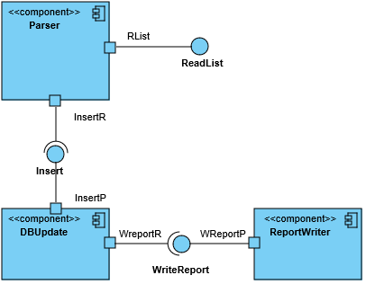

Figura 4. Citizens list view

### Catalogue of Elements

#### Elements

|  |  |
| --- | --- |
| Element | Properties |
| Parser | Reads data from the Excel file and transforms them into an in-memory object container that can be later iterated to insert the data in the database.  It will also generate the *password* of the citizen as well as the personal letter.  During the design and implementation this component can be divided into the sub-components needed to separate these services following the quality attributes AT004, AT005 and AT008. |
| DBUpdate | Encapsulates all the database operations using interfaces to allow the database access to be separated from some specific database implementations. |
| ReportWriter | It receives the pieces of data that were not possible to insert into the database as well as the reasons and writes a report containing all that information in a human-readable way |

#### Relationships

The *Parser* component receives the input file in Excel format and reads and converts the information about the different users. It generates a new password for each user and adds the information to the database using the *DBUpdate* component.

If there are any errors during the loading phase (duplicated DNIs, empty DNI fields, etc.) or if the database component returns an error, this information will be notified to the Reportwriter component through the *WriteReport* interface.

#### Interfaces/ Ports

##### Parser

|  |  |  |  |
| --- | --- | --- | --- |
| Interface | Type | Technology | Properties |
| ReadList | Interface | Method invocation | Read the Excel file with the citizens data. |
| Rlist | Port |  | Creates the needed subcomponents of the parser to process the input file. |
| Insert | Interface (Required) | Method invocation | It calls a method in the *DBUpdate* component to insert the information in the database. |
| InserR | Port |  | Verifies the data and creates the object to send to the *DBUpdate* component. |

##### DBUpdate

|  |  |  |  |
| --- | --- | --- | --- |
| Interface | Type | Technology | Properties |
| Insert | Interface | Method invocation | Receives and object with the information to insert in the database. |
| InsertP | Port |  | Verifies input data and generates and error if there is a lack of some mandatory attribute. |
| WriteReport | Interface (Required) | Method invocation | Calls a method from the *ReportWriter* component to write a new item in the report file. |
| WreportR | Port |  | Verifies the data to write |

##### ReportWriter

|  |  |  |  |
| --- | --- | --- | --- |
| Interface | Type | Technology | Properties |
| WriteReport | Interface | Method Invocation | Receives the data to write in the report file. |
| WreportP | Port |  | Adds data at the corresponding date and time. |

##### Parser

Introduces the citizens data in the system obtained from Excel files that contain a row for each citizen. Each row (except the first one that contains the headings) contains the following columns:

* First name
* Last name
* Email
* Date of birth
* Address
* Nationality
* ID (National ID, the residence card ID, etc.)

Invocation will be done through a batch program executed in the command line by the system administrator. During the import process a password will be generated so the combination of email/password enable a user to enter the system and participate in the system receive information about the polling station code where the user can participate.

This component will also generate personal emails (letters) communicating the user that he has been added to the system with a user name (his email) and a password.

##### DBUpdate

It updates the database. See 9.1.2.4.5.

##### ReportWriter

It stores in a text file information about the errors that were produced by the conversion process. The basic information to store is:

* Date
* Time
* Original Excel file
* Error information (with all the needed information)

### Context Diagram

See 9.1.

### Rationale

The main design decisions of this sub-system are:

|  |  |  |
| --- | --- | --- |
| Scenario | Quality attributes | Justification |
| 4 | AT004 | Defining an interface and an object for error reporting allows to add this functionality later. |
| 5 | AT005 | Sending more than one letters each one in a different format allows to make sure that the receiver can read it. |
| 8 | AT008 | Having a reasonale performance makes the user more confortable using the application. |
| 12 | AT012 | Using a standard database which can be queried using SQL can allow the students to verify that the data has been correctly loaded. |
| 16 | AT016 | The use of a batch application that can be executed manually or configured for its automatic execution is a common practice for system administrators. |
| 19 | AT019 | The system administrator must know how to use the application. |
| 20 | AT020 | The simple use of the application makes the user gets more confortable using it. |
| 24 | AT024 | The web service API defined is simple and contains the minimal functionality. Leveraging on Spring Boot web framework will facilitate the development by the students given that the framework has solutions for all the required functionality |
| 25 | AT025 | A batch application can be directly executed without any special needs for deployment |

## Participants

### Main overview

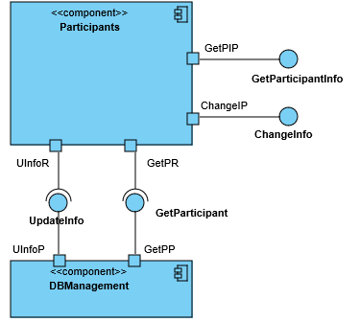

Figure 5. Participants View

### Catalogue of elements

#### Elements

|  |  |
| --- | --- |
| Element | Properties |
| Participants | It offers two web services: *GetParticipantInfo*, which allows to obtain information about a user and (Optional) *ChangePassword* that allows to change the password of a user (not implemented). |
| DBManagement | It offers two interfaces: GetParticipant, that returns the data of a participant from the database and (Optional) *UpdateInfo*, to update a password change in the database (not implemented). |

#### Relationships

The ParticipantParticipation System invokes *Participants* using a web service call which is processed by *GetParticipantInfo* (sending *email/password*) and it gets access to the DBManagement system using the interface *GetParticipant*. If the email/password are correct the data is returned as a JSON response.

#### Interfaces / Ports

##### Participants

|  |  |  |  |
| --- | --- | --- | --- |
| Interface | Type | Technology | Properties |
| GetParticipantInfo | Interface | Web service | Allows to get access to a citizen data through the email/password combination |
| GetPIP | Port |  | Validates a user before asking the data. |
| ChangePassword | Interface | Web service | Allows to change a password using the combination: *email/password/newPasswod*. |
| ChangeInfo | Port |  | Validates a user before asking to change his password. |
| ChangeIP | Port |  | Validates a user before asking to change the password |
| UndateInfo | Interface (Required) | Method invocation | Asks a password change for a user. |
| UInfoR | Port |  |  |
| GetParticipant | Interface (Requerida) | Method invocation | Asks information for the user |
| GetPR | Port |  |  |

##### DBManagement

|  |  |  |  |
| --- | --- | --- | --- |
| Interface | Tipo | Tecnología | Propiedades |
| UndateInfo | Interface | Method invocation | Handles the password change of a user. |
| UInfoP | Port |  |  |
| GetParticipant | Interface | Method invocation | Handles the information request for the user. |
| GetPP | Port |  |  |

#### Behaviour

##### Participants

It implements a REST web service to handle requests of information about users. The POST HTTP request will be done to the following address:

<WebServiceURI>/user

where <WebServiceURI> represents the URI where the web service has been deployed. The POST request contains JSON data with the following structure:

{"login": email, "password": password}

In case that the (email, password) combination are available in the database the response will be 200 OK with the a JSON body of the form:

{ "firstName": Nombre,

"lastName": Apellidos,

"age": Age (will be obtained from user's birth date and current time)

"ID": User ID,

"email": email

}

In case that the (email, password) is incorrect, the response will be 404 Not found.

An HTML interface will be implemented so the web service can be used by humans through a web browser.

##### DBManagement

This component encapsulates all the database access so it can be easy to change the underlying database system.

### Context Diagram

See 9.1.

### Rationale

The main design decisions have been:

| Scenario | Quality Attributes | Justification |
| --- | --- | --- |
| 1 | AT001 | Using a REST Web Service leverages on HTTP technology and makes it easier to deploy the system in some infrastructure with high availability. |
| 9 | AT009 | Allows the user to be more confortable using the application. |
| 12 | AT012 | Using a standard database which can be queried using SQL can allow the students to verify that the data has been correctly loaded. |
| 17 | AT017 | The development of a REST web service based on JSON formats will facilitate the development of tests. The Spring Boot framework contains several tools for unit and integration testing of web applications that can be used. . |
| 20 | AT020 | Allows the user to be more confortable using the application. |
| 22 | AT022 | The use of a REST web service enables the automatic access to the system through a software client |
| 24 | AT024 | The web service API defined is simple and contains the minimal functionality. Leveraging on Spring Boot web framework will facilitate the development by the students given that the framework has solutions for all the required functionality |
| 25 | AT025 | A batch application can be directly executed without any special needs for deployment |

## ParticipationSystem

### Main overview

### C:\Users\Usuario\Documents\VPProjects\ParticipationSystemView.jpg

Figure 6. Participation System View

### Catalogue of elements

#### Elements

|  |  |
| --- | --- |
| Element | Properties |
|  |  |
|  |  |

#### Relationships

#### Interfaces / Ports

##### XX

|  |  |  |  |
| --- | --- | --- | --- |
| Interface | Type | Technology | Properties |
|  |  |  |  |
|  |  |  |  |
|  |  |  |  |
|  |  |  |  |

#### Behaviour

##### XX

### Context Diagram

See 9.1.

### Rationale

The main design decisions have been:

| Scenario | Quality Attributes | Justification |
| --- | --- | --- |
| 1 | AT001 | Using a REST Web Service leverages on HTTP technology and makes it easier to deploy the system in some infrastructure with high availability. |
| 2 | AT002 | The system must serve millions of requests at the same time. |
| 6 | AT006 | The system must allow different configuration options in order to select the appropriate ones in each case. |
| 9 | AT009 | The system must be able to query information fast in order the user to not wait too much time. |
| 10 | AT010 | The system must process a big workload without breaking because it is thought to be used by lots of people simultaneously. |
| 11 | AT011 | The system must show the changes at the same time they are being produced. |
| 12 | AT012 | Using a standard database which can be queried using SQL can allow the students to verify that the data has been correctly loaded. |
| 13 | AT013 | The system must ensure the confidentiality of votes. |
| 14 | AT014 | The system must take into account that only allowed people have access to configure the system. |
| 17 | AT017 | The development of a REST web service based on JSON formats will facilitate the development of tests. The Spring Boot framework contains several tools for unit and integration testing of web applications that can be used. |
| 18 | AT018 | The system must test the Kafka results. |
| 20 | AT020 | Using a simple system makes the user be more confortable with the system. |
| 24 | AT024 | The web service API defined is simple and contains the minimal functionality. Leveraging on Spring Boot web framework will facilitate the development by the students given that the framework has solutions for all the required functionality |
| 25 | AT025 | A batch application can be directly executed without any special needs for deployment |
| 26 | AT026 | The system must be prepared to support a high number of users. |

## Dashboard

### Main overview

### C:\Users\Usuario\Documents\VPProjects\DashboardView.jpg

Figure 7. Dashboard View

### Catalogue of elements

#### Elements

|  |  |
| --- | --- |
| Element | Properties |
|  |  |
|  |  |

#### Relationships

#### Interfaces / Ports

##### XX

|  |  |  |  |
| --- | --- | --- | --- |
| Interface | Type | Technology | Properties |
|  |  |  |  |
|  |  |  |  |
|  |  |  |  |
|  |  |  |  |

#### Behaviour

##### XX

### Context Diagram

See 9.1.

### Rationale

The main design decisions have been:

| Scenario | Quality Attributes | Justification |
| --- | --- | --- |
| 3 | AT003 | The system must show the results in real time. |
| 7 | AT007 | The system must ensure that only authorized people have access to the dashboard. |
| 11 | AT011 | The system must show the changes at the same time they are being produced. |
| 12 | AT012 | Using a standard database which can be queried using SQL can allow the students to verify that the data has been correctly loaded. |
| 13 | AT013 | The system must ensure the confidentiality of votes. |
| 15 | AT015 | The system must allow access only for authorized people. |
| 18 | AT018 | The system must test the Kafka results |
| 20 | AT020 | Using a simple system makes the user be more confortable with the system. |
| 21 | AT021 | The system must show the results in a clear way in order to not be misunderstood. |
| 23 | AT023 | The system must show the results in real time without user interaction. |
| 24 | AT024 | The web service API defined is simple and contains the minimal functionality. Leveraging on Spring Boot web framework will facilitate the development by the students given that the framework has solutions for all the required functionality |
| 25 | AT025 | A batch application can be directly executed without any special needs for deployment |
| 26 | AT026 | The system must be prepared to support a high number of users. |

# Package view and deployment view

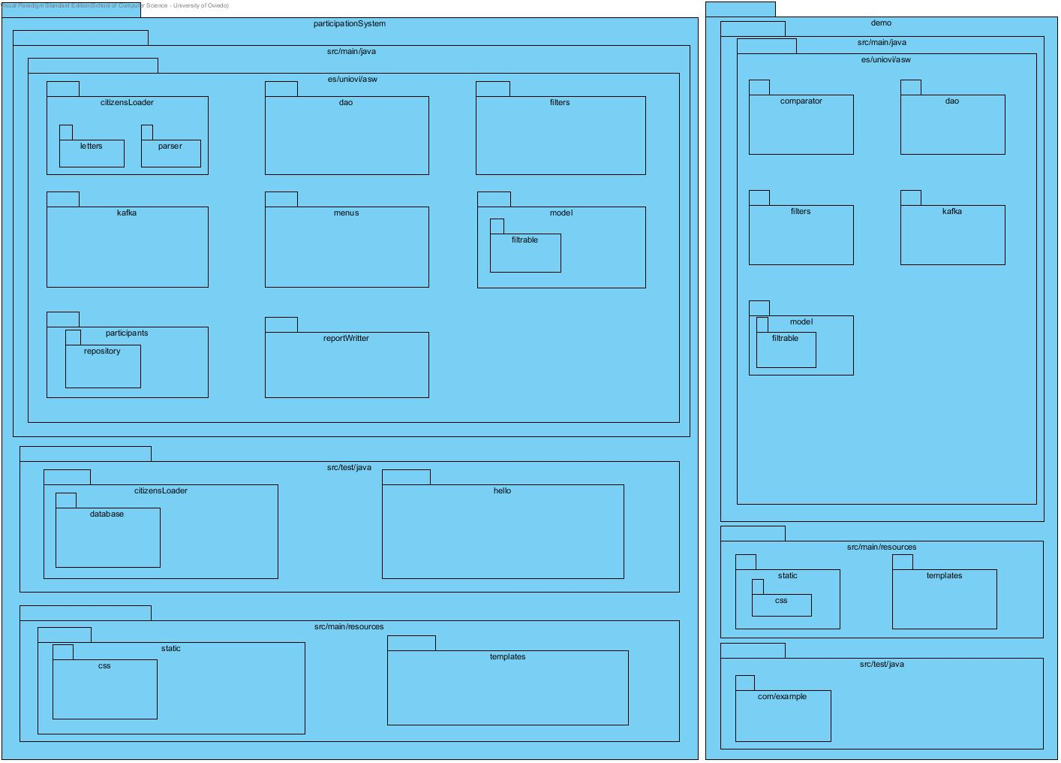

Figure 8. Package view



Figure 9. Deployment View

# References

ANSI/IEEE 1471. (2000). *Recommended Practice for Architectural Description of Software-Intensive Systems.* ANSI/IEEE.

Bass, L., Clements, P., & Kazman, R. (2003). *Software Architecture in Practice, Second Edition.* Boston: Addison Wesley.