The Development, Implementation, and Evaluation of Visual Presentation of Data

Communicated to Various Audiences

Carrie McDowell

Southern New Hampshire University

Abstract

This paper examines weather data and discusses the needs of data presentation to various audience members. Specifically, the data and visualization of data communicated to official government offices and to the public. Their different understanding of the data and individual need or uses of the data.

*Keywords:* data visualization, audience

The Development, Implementation, and Evaluation of Visual Presentation of Data

Communicated to Various Audiences

I have been commission to tailor the visual delivery of severe weather event data from the National Centers for Environmental Information to meet the varying needs of the state of Tennessee government leaders, emergency management personnel, and members of the Tennessee general public.

Generally, the Tennessee climate consists of warm summers and mild winters. However, the state's varied topography leads to a wide range of climatic conditions. Typically, the growing season is about 235 days, with an annual mean temperature of 62°. Severe storms occur infrequently with the greatest threats in the winter and early spring, especially March.

**Audience Analysis**

My audience will require a different level of granularity and complexity of presentation of the severe weather event data. Additionally, they will have a specific agenda and goal for the use of the data provided. The Tennessee state budget office will use the data to allocate stand-by emergency funds. Tennessee state emergency management (TEMA), will use past storm damage data to allocate resources such as equipment and first responders. The information will also help to estimate costs during and after severe weather events. Data and information provided to the public will facilitate storm preparedness. Data visualization will help to relay information to all of the above.

**Audience Visualization**

Data visualization is a tool used to bring data to life. Without data visualization, data lies boring and lifeless in spreadsheets and files (Clark, 2015). Vital information should be easy to understand, and delivered to an audience at their level of understanding, provided in a way that they want to receive it. The Tennessee state budget office has asked for a PowerPoint presentation to be given regarding storm activity. TEMA representatives have asked for an interactive dashboard they can utilize to analyze past and up to the minute storm activity and damage data. The state has requested a pamphlet and web page with storm safety information to present to members of the public.

**Varied Message**

This diverse audience demands tailored messages. The Tennessee state budget office will use last year’s data to determine where to allocate stand-by emergency funds. Combined with several years of data, the Tennessee state budget office can easily pinpoint which county will be in the most need for emergency funds. To the state budget office, I will relay costs by county consisting of past and forecast data.

TEMA will use past storm damage data along with photos to predict this year’s potential damage and costs of services. They will use past weather related costs to predict how to allocate resources of equipment and people state wide. Using this data will give them an opportunity to assess first responder training and purchasing new equipment as needed.

Data and information provided to the public will facilitate storm safety. The public should be made aware when and where the state predicts the greatest threat of severe weather, as well as what type of severe weather is predicted. Preparations made for a tornado is certainly different from the threat of lighting and flood waters. It is important that the public be made aware of all server weather threats and instructed the best procedure to prepare for each one.

**Limitations**

The problem to address here is what information to convey to each audience, and in what manner. The amount of data is available to accurately predict where and how much severe weather will hit the State of Tennessee. For accuracy of data, I will pull data from as far back as I can go, but not to a point where the data collection method changed. Additionally, statisticians should be hired to conduct probability studies based on the data given. From their results, I will provide the raw data and also the results provided by the probability studies to the Tennessee budget office and TEMA. Then I will prepare a pamphlet and website for the public. I will provide raw data to the public but not the probability study results as it is not necessary.

**The Message**

I will prepare data and information for three audiences. Each will understand the data differently and will use the data for distinctive purposes. The state budget office will be interested mainly in dollars and cents. How much money to allocate and where to assign it. They will not be interested in the duties or training of first responders. TEMA will need to know about dollars and cents as it pertains to pricing human resources, services, and equipment in the eye of devastation. They will also need to be prepared and a team trained to respond to the various severe weather issues, and will need to know where severe weather is predicted. The public will not need to be informed of the financials or cost of storm devastation, they will need to know when to be prepared for what type of alert and where the severe weather is predicted. The general public will not understand terminology used by TEMA, such as Prd, Crd, etc., so it is important that I relay the massage to the public in a way and education level it will be best received. I will also provide translations of the information in Spanish, German, French, Chinese and Arabic. I plan to use simple to understand language at a 6th grade level.

I plan to utilize Excel because of its ease of use visual tools. I will develop and interactive dashboard for TEMA as well as charts, graphs, and interactive reports for the public website and power point presentation. Raw data will come from an excel spreadsheet. I feel that these will be the best tools to relay information and to transform raw data. The interactive maps and charts will also peak the interests of the public data and facilitate preparedness.

**Data Visualization Strategy**

Creating a visualization to present information should be audience dependent. First, I will make it a point to understand my audience needs by interviewing with a representative of the end user. This will come easily for the Tennessee State Budget Office and TEMA, as I can sit down with managers or department heads to understand their needs. The public will be a different story. I will set up an initial website with interactive links and charts, and then bring in a panel selected from the general public. This panel will represent all races, age groups, education level, and language skills. From this panel I will extract ideas, and recommended modifications from which I will re-create the website before going live.

**Visual Elements and Formatting**

The elements contained in each visualization and formatting will vary from audience to audience, this will be dependent on their need, their level of understanding of the data, and perhaps cultural differences.

**The Tennessee State Budget Office**

The Tennessee state budget office will use historical data to determine where to allocate stand-by funds to easily pinpoint which county will be in the most need for emergency funds. It is important that the data collection methods are accurate and consistent throughout all counties within the state, and that this data collection protocol is followed year over year. The data I will relay to them is location and funds used (see attachment TN State Budget for the power point visuals created for the state budget office). Please note that 80 slides were removed to be respectful of time, therefore this document is an example of the presentation in its entirety.

I plan to commission a data analysis to use data for the last 50 years to forecast storm events by event type and county for the coming year. I plan to present historical and immediate information on the cost of severe weather in the form of a power point presentation. The power point presentation will be reviewed by people with knowledge of the events and data for budgetary purposes. The State Budget Office department heads, managers, and employees are solely concerned with funds needed to cover forecasted expenses for the New Year. While the details of severe weather make up the budgetary need, they only concern themselves with funds and how the funds will be allocated across the state.

The slide show will likely be presented in a dimly lit room so a bright white background will not be appropriate. The slides will be created in a soft light blue background with black font. Each slide will be formatted exactly the same. Each tile in the slide will be formatted to the exact specification as the slide before, same size, font, font size, color, chart, chart size, chart color, and so on. I will use contrasting colors to separate information on each variable, and will create the visual with large font so that a person at the back of a large room can see the data clearly. The slides will be in alphabetical order for ease and the information provided on each slide will be simple to understand. It will be written at a high school level, with very few variables per slide. I will not overwhelm the audience with a plethora of information to digest per slide. I will provide more slides rather than fewer to spread the information out.

The first two slides of the presentation will present an aggregate historical amount spent on damage due to severe weather for the years 1950 to 2014 for the state. I will present this data in the form of a table and a line chart with a light blue background with black font. The Y-axis will display the money spent in thousands and the X-axis will display the year. The next slides will present 2016-2016 and forecast 2016-2017 data for the state per storm type.

Each of the following slides will present data in a pie chart for each county and will be arranged in alphabetical order, the first being the actual data from 2015-2016 and then the forecast data for 2016-2017. Finally, the last slide will be a review of the first slide, and will be used for budgetary purposes.

In addition, I will provide a number of print-outs to pass out after the presentation, and will encourage the presenter to send the power-point presentation to the audience a few days before the meeting. I can easily add any missing information before the meeting is to occur.

**Tennessee State Emergency Management**

Tennessee state emergency management (TEMA) will use past storm damage data to predict this costs and how to allocate resources such as equipment and first responders for the upcoming year. TEMA representatives have asked for an interactive dashboard they can utilize to analyze storm damage cost data (see Appendix A).

The dashboard built for TEMA will be completely different in content and presentation. It will consist of one screen with several tiles that contain interactive charts. Above each chart I will give a brief explanation of what information is contained therein. Additionally, the user may access the raw data used to create the chart, and a more detailed explanation of each data point. I plan to write this using verbiage normal to their understanding. Between each tile, I will allow enough white space to differentiate each chart. Much like the power point for the State Budget Office, I will provide as few variables as possible per chart, and display more charts on the screen so that the information is not overwhelming. Each chart will be interactive and connected to one another meaning a user may sort through variables, or choose what information they wish to view. The information will come from the master raw data file, and the categories selected can be changed and reset at any time. I have created an easy to use manual as well (See attachment TEMA_Manual).

Each tile will be formatted the same. The background a light grey, and each category or variable from the master raw data list will have the same color on each chart for consistency. I plan to use line charts, bar charts, and maps.

I plan to build this dash board with several tiles using Excel visualization tools. The dashboard will contain up to the minute weather and storm data via a widget from the National Oceanic and Atmospheric Administration (NOAA). In addition, I plan to include historical data on the cost of storms and the number of resident’s effects. Each tile will be interactive and can lead to raw data which may include photos, cost of services, human resources and equipment used in each event. Event data can be assessable by event or county. In addition, I plan to add a tiles which indicate active events by type, and county, and the number of people effected as well as available human and equipment resources. I plan to build an entry form so that TEMA may add data as each new event passes. This will integrate with the data base and be included in the historical data record.

**The Public**

The public should be made aware when and where the state predicts the threat of severe weather, as well as what type of severe weather is predicted. I plan to mail pamphlets to all homes in each region, and build a website (see Appendix B - E for visuals created for the public).

Formatting the visuals for the public should be colorful and engaging. I will write the content to a sixth grade level and use words known in all cultures. I plan to provide translation of the content as well, and will not use offensive colors. The interactive charts for the kids will contain vivid colors and interactive games. Much like the visuals created to the Budget Office and FEMA, I plan to keep each visual simple with a limited number of variables. I do plan to give more instruction and written better explanations of the information provided. I will provide a link to the raw data and will use the same color for each category or variable on each visual.

I plan to format the website with a left margin to hold categories and subcategories. A window in the middle will return an activity, chart, or information once selected from the left margin. I will not open pages or re-direct the user. I plan to use an appropriate chart type to present information from raw data, these may include bar charts, line charts, pie charts, and maps.

The pamphlet will provide an overview of the need for storm event preparedness, and instruct them to register their home and family to the website. The website will allow the public to register their home and point and click on any of these attributes:

* The number of people in each household
* Language spoken
* Number and type of pets
* Deaf
* Speech impaired
* Blind
* On oxygen
* Have a basement
* Have a storm shelter

The administrator of the website will have the ability to add to this list. In addition, the public will have the opportunity to be notified by phone, text, or email of any emergency events. The website I will build will be written at a 6th grade level. I plan to build the visuals using Tableau for its interactive and color design which I feel will be pleasant to the public user. It will be very easy to use with many point and click features. I plan to format the website with a left margin to hold categories and subcategories. A window in the middle will return an activity, chart, or information once selected from the left margin. I will not open pages or re-direct the user. The user will select their language preference as well.

The interactive maps and charts that I will provide will also peak the interests of the public and facilitate preparedness. The information provided will include historical and forecast data. I plan to include preparedness information, and training. I plan to have a section just for kids, with interactive activities to help them be prepared as well. In addition, I will include a map to display open shelters, and free emergency training such as CPR. The website will also contain a suggestion box and contact us form as well as an email address to the administrator.

**Feedback**

Before going live with any visuals, as explained above I will sit down with end users and department heads to gather initial needs and then as I build the visuals I will communicate via phone, skype, email, and in person until the end product is perfected. It is very important that I present the right data in the format requested to each group. Once complete I will deliver the visuals to the State Budget Office and TEMA.

The State Budget Office will conduct a meeting prior to the new year, after this time, I will request feedback from the presenters of the visuals to improve next year’s visual.

The dashboard made for TEMA will be used every day, and will be ongoing. I plan to keep an open channel to the director of FEMA and to their technical department in case issues arise or changes are needed. I plan to check in at least once a quarter.

Feedback from the public will be done through a suggestion box and contact us form as well as an email address to the administrator. I plan to contact the administrator monthly for feedback, and will provide my contact information to them for immediate need.

At each turn, I will take the feedback to modify existing visuals as well as learn from the feedback to create better visuals in the future.

**Summary**

Data visualization should tell a story. It is best to work backwards in design and keep it simple. Be sure to build an outline to capture the story in a proper sequence and include context to incite feeling or action. Using what if analysis should provide the context needed in the visual especially in business (Brenner, 2016). A good data visualization analyst should be able to present large amounts of data in a simple and easy to understand visualization. There are a few easy steps one should follow to achieve this. First the visual analyst should be clear on the outcome of the visualization. What question will be answered or problem will be solved? Next you should know your audience, and present to your audience. Knowing these will determine what data to include on the visualization and how to present the data using the right chart type. The analyst should also pay close attention to color selections, font type size and color, and the description of labels (Georgin, 2015).

It is important to relay the most accurate information to the Tennessee state agencies and to the public. Providing the information to each audience in a way that best suits them will save time and perhaps lives. Each visual will be tailored to the benefit of the given audience.

References

Clark, D. (2015, March 31). Data Visualization Is The Future - Here's Why. Retrieved February 11, 2018, from <https://www.forbes.com/sites/dorieclark/2014/03/10/data-visualization-is-the-future-heres-why/#7e9765251884>

Brenner, M. (2016, November 10). How To Create Story-Driven Data Visualization In 5 Steps. Retrieved March 8, 2018, from <http://www.digitalistmag.com/customer-experience/2016/11/11/create-story-driven-data-visualization-in-5-steps-04628365>

Georgin, L., & Lei, P. (2015, January 28). A 5-step guide to data visualization. Retrieved March 9, 2018, from https://www.elsevier.com/connect/a-5-step-guide-to-data-visualization

N. (n.d.). Storm Events Database. Retrieved February 22, 2018, from https://www.ncdc.noaa.gov/stormevents/listevents.jsp?tornfilter=0&sort=DI&statefips=47%2CTENNESSEE&county=ALL&eventType=%28C%29%2BTornado&beginDate_yyyy=2015&beginDate_mm=11&beginDate_dd=01&endDate_yyyy=2016&endDate_mm=11&endDate_dd=30

Appendix A

TEMA Dashboard

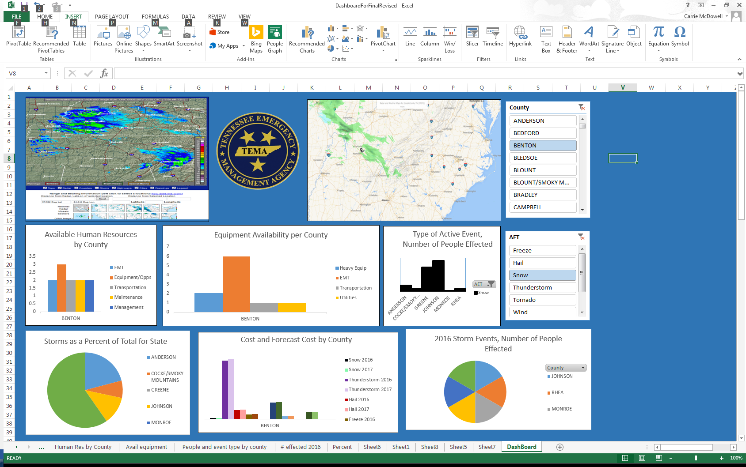

Appendix B

TEMA website: www.tnstorm.org

Homepage

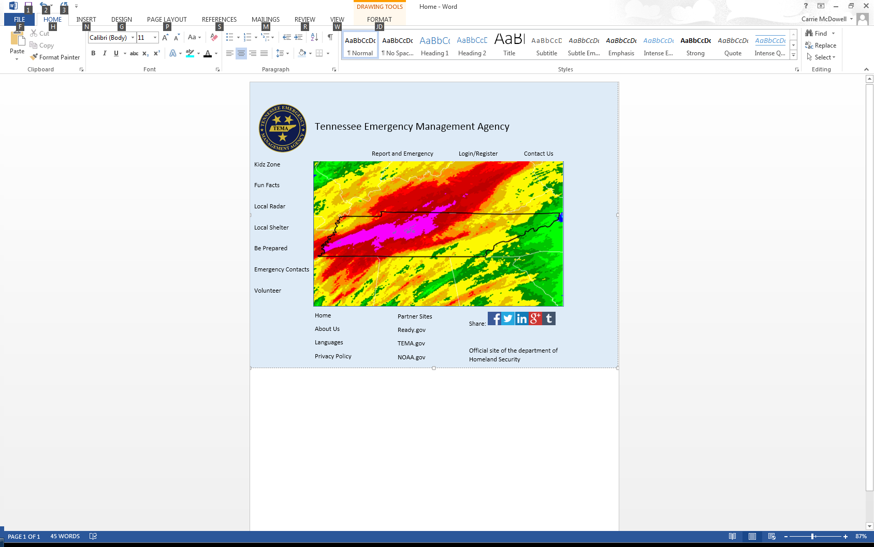

Figure: Weather Radar (NOAA, 2018)

Appendix C

TEMA website: www.tnstorm.org

Kidz 1

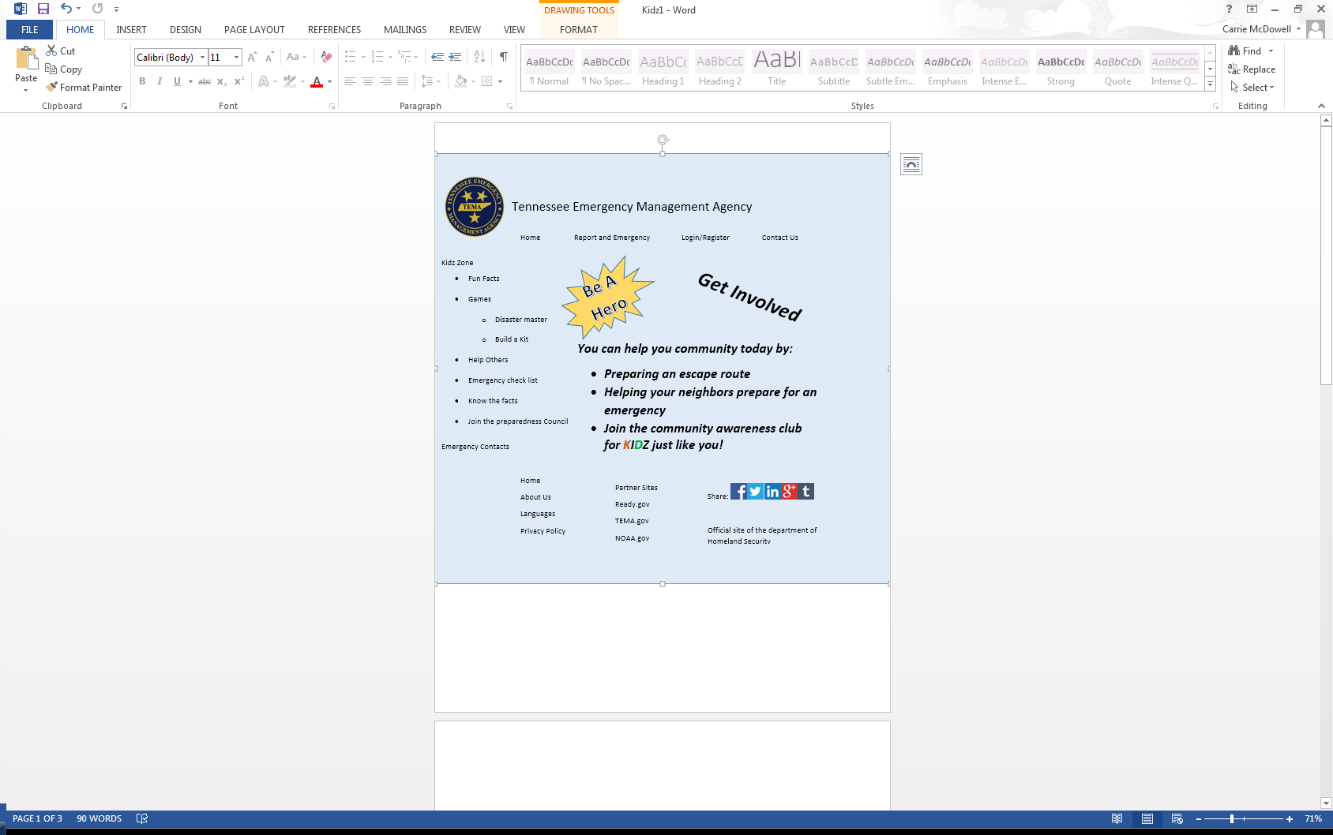

Appendix D

TEMA website: www.tnstorm.org

Kidz 2

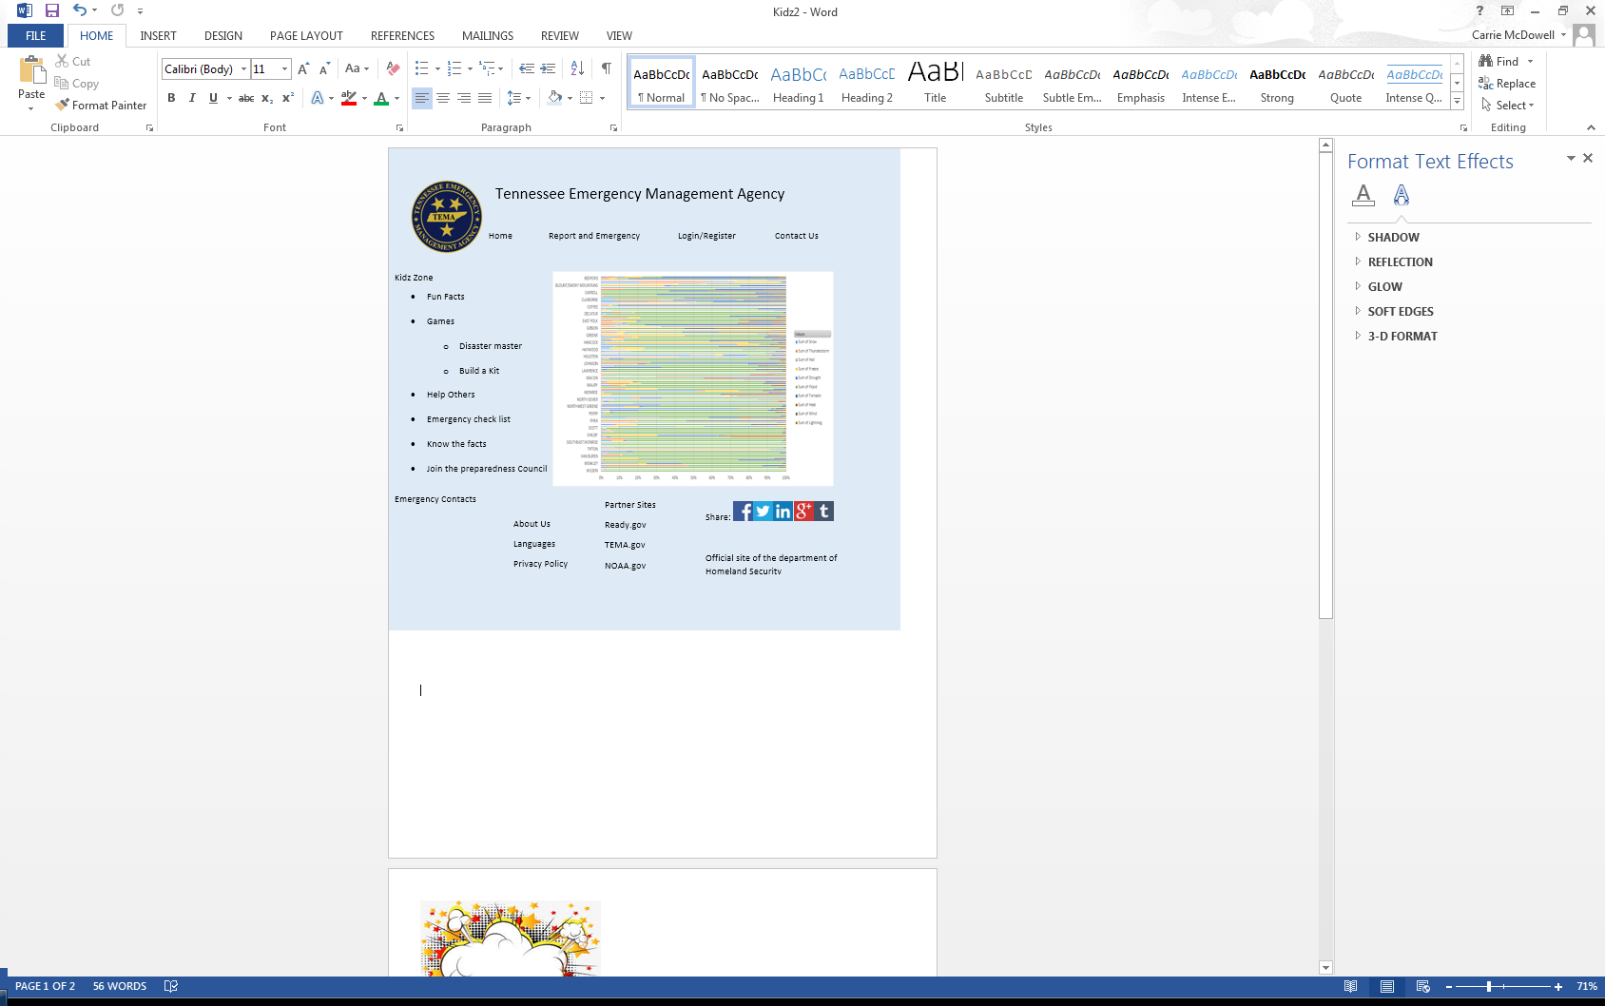

Appendix E

TEMA website: www.tnstorm.org

Registration Form

