Homework 1 -

Update your version to mimic these semantic HTML element. Keep in mind that you will have to update your CSS selectors in your style.css to match these new elements.

Notice that we use tags like <header> and <footer> in place of divs. Give semantic HTML a quick google and read and that should help in making sense of it.

// Navbar section

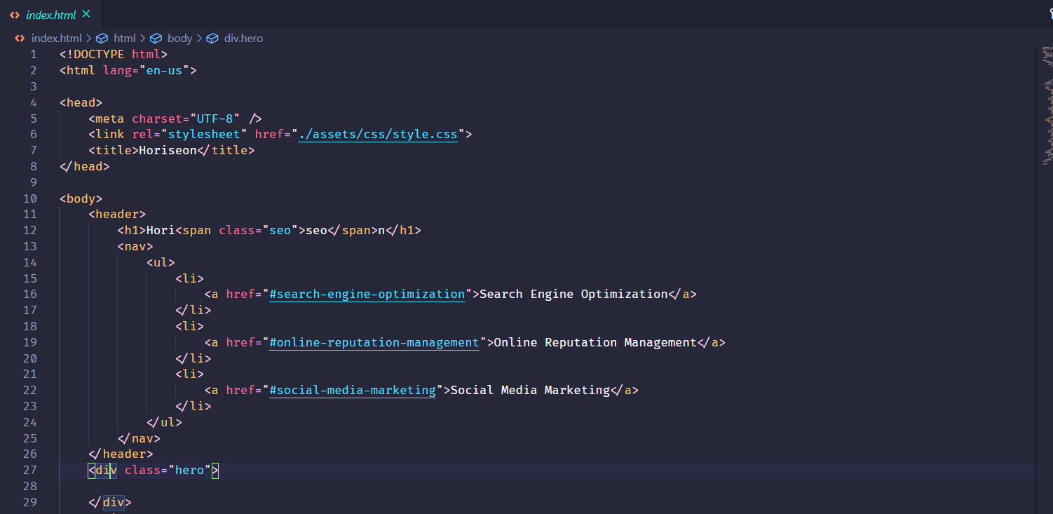

// Middle “section” section

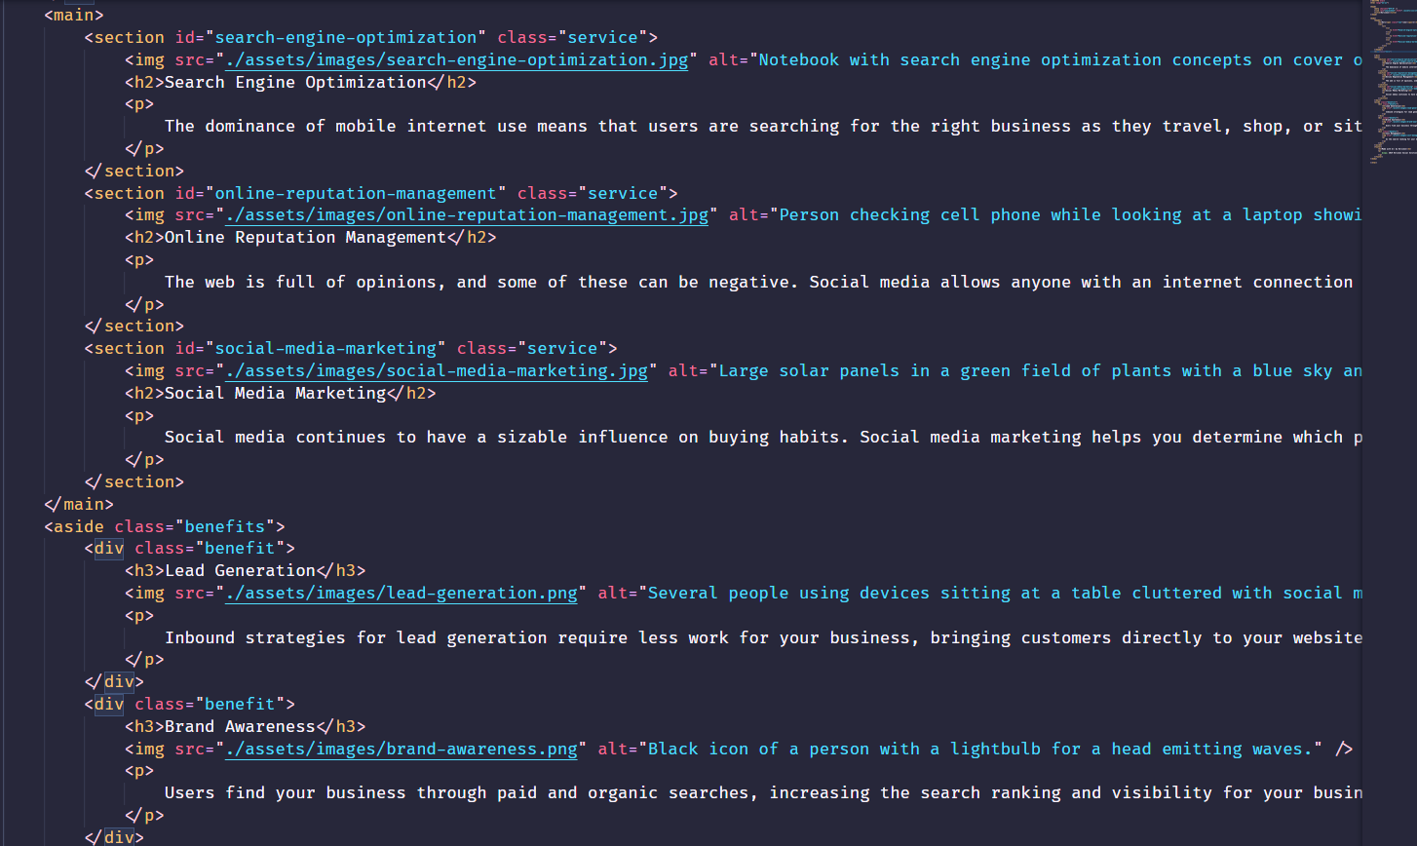

// footer

