Critical questions to answer during your presentation include:

* What is the company vision? It’s great if you can convey your five-year plan. However, at the very least, focus on communicating a concise, concrete vision for the immediate future and why it’s crucial for the current market.
* What is the problem being addressed? Without your product, how are people operating today and what’s wrong with the status quo? Use real world examples and sound bites that make your product memorable – such as “our technology takes the headache out of version control”.
* Where does your company fit in the market? Regardless of whether you offer a physical product, a software feature, application, or platform, you should candidly define that market reality, and present sales and marketing plans to back up your model. Why will you win versus the competition? If you win, who loses or what changes?

**The Basic Pitch Outline**  
Following is a sample outline that I have seen many successful startup presentations follow. Believe it or not, you can fit all of this into five minutes or less – especially if you use short video clips, images, graphics, and minimal text. You should mostly speak to each of the points below, using graphics to reinforce your spoken words.

* Headline (your vision)

Rahr & Sons Brewing Company started in 2004 as a full-scale brewery, in a time where Craft Breweries was still new. In the 15 years Dallas / Fort Worth Craft Beer scene exploded with now over 80+ breweries and brewpub. Most popular being brewpubs.

We want to help Rahr & Sons Brewing grow, by determining a second location to open a brewpub with a smaller “pilot” brew house.

Thus, meeting market demand by providing a brewpub with the ability to turn out new and innovative beers on a much higher scale than at your larger brewery.

* Company Purpose (short and sweet)

We believe Rahr & Sons can increase customers and more important, loyalty, by creating a brewpub footprint in Dallas.

* Problem (customer pain)

Rahr & Sons’ current beer list on your website consist of sixteen beers with 9 of those being seasonal and specialty brews, your available beer list is only 7. We see Rahr & Sons at risk of getting constrained and missing out on market share as a brewery due to its’ large-scale operation.

According to Untapped, beer social rating application, Rahr has produced a total of only 32 unique beers while its competitor down the street as a brew pub has made over 160 unique beers.

* Solution (value prop to customer – great to add real customer stories)

We want to help Rahr & Sons Brewing grow, by determining a second location to open a brewpub with a smaller “pilot” brew house.

Thus, meeting market demand by providing a brewpub with the ability to turn out new and innovative beers on a much higher scale than at your larger brewery.

This will offer you an opportunity to expand your footprint into the Dallas market.

This is a loyalty building project. Measured by check-ins. Predict check-ins (Place or Beer). Collect from existing places and predict for this location.

* Why Now (history and evolution)

There is a perfect opportunity at an existing brewpub location in the Dallas area.

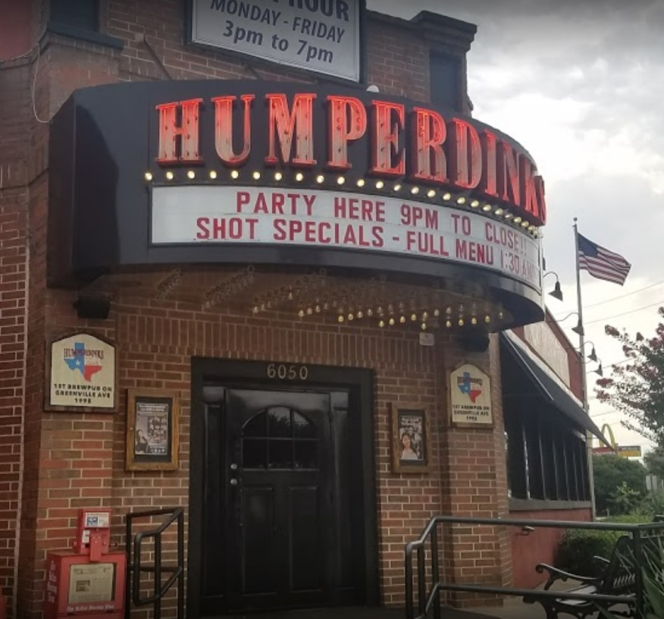

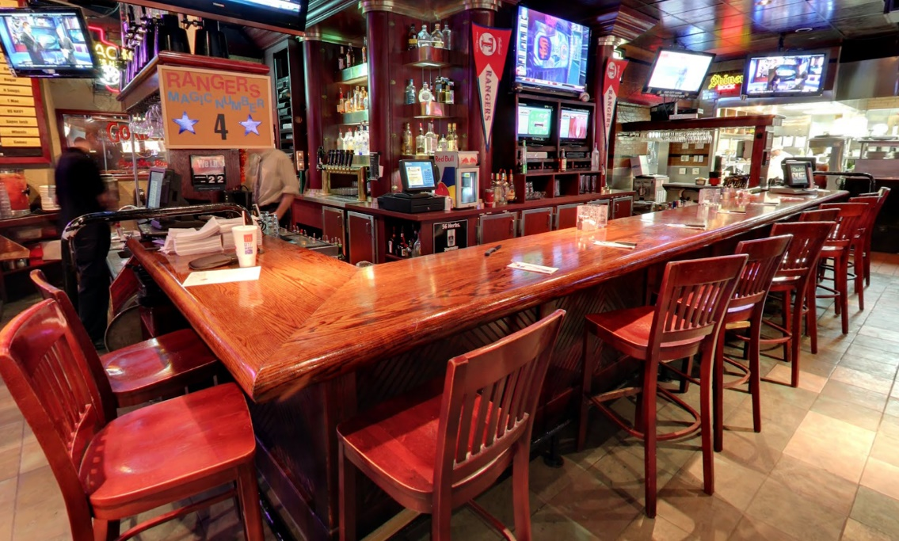

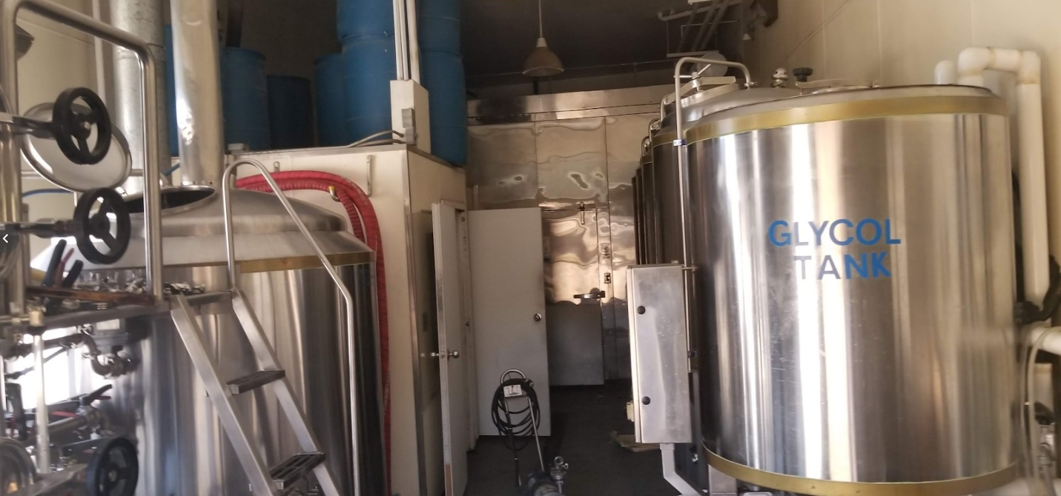

* Market Size (who are your target customers)

Studies show that Millennials (people born between the early 1980s and early 2000s) are what is driving the craft and brewpub industry. The reason for the failure of the current company shows to be a failure to inspire Millennials to return on a regular basis. Looking at the data of Humperdinks we see a downward trend in check-ins and ratings. Offering the same craft experience time after time is not what will keep this age group returning.

Jeanette Settembre with MarketWatch states: “People spend more on craft beer every month than they do on their monthly cell phone and utilities bills.”

Corie Brown with Zester Daily stated “With spirits, it's less about being offended by what has been on offer from large producers and more of an eagerness to discover something new.”

* Competition (honest list)

White Rock Alehouse (Brewpub)

Deep Ellum Brewing (Tap Room)

Oak Highlands Brewing (Tap Room)

Lakewood Brewing Co. (Tap Room)

* Product (description and road map)

Rahr Dallas Brewpub, serving food and small and large batch craft beer. Limited and Seasonal beers to grow brand loyalty and allow for a space to test beers in the market.

It might be worth noting that Rahr & Sons is in an older age area. The Humperdinks area has younger ages around it.

* Business Model (revenue, pricing etc.)

The building is for long term lease at $3.70 a SF. The space contains a full-size bar, large areas for eating a gaming section and a 15-barrel brewing area. The total square footage is 6,785 bring the monthly total to $25,104.50. Money will be generated by food and beer sales. There will be a loyalty program to encourage customer return. Several beers will be on tap including Rahr’s staples as well as several rotating inhouse beers.  
White Rock Alehouse & Brewery is a standalone brew house but I have been there several times and it is a great place. I think a place like this and Funkytown Fermatorium would be perfect templates for Rahr to look at for their new location.

* Customer Acquisition plan (marketing and sales)

Thomas Touring, director of restaurant operations for the House of Blues chain of music venues, says he shifted his restaurants to an all-craft beer menu because his customers were demanding local beers. Once he made the shift, beer sales went up and so did food sales.

The area shows to able to handle a newly reopened brewpub, with the 2019 median age in the area being 28 to 36 and one censes track away being 45 to 53. The disposable income, alone, in the area ranges from $39,000 to $188,000 per household.

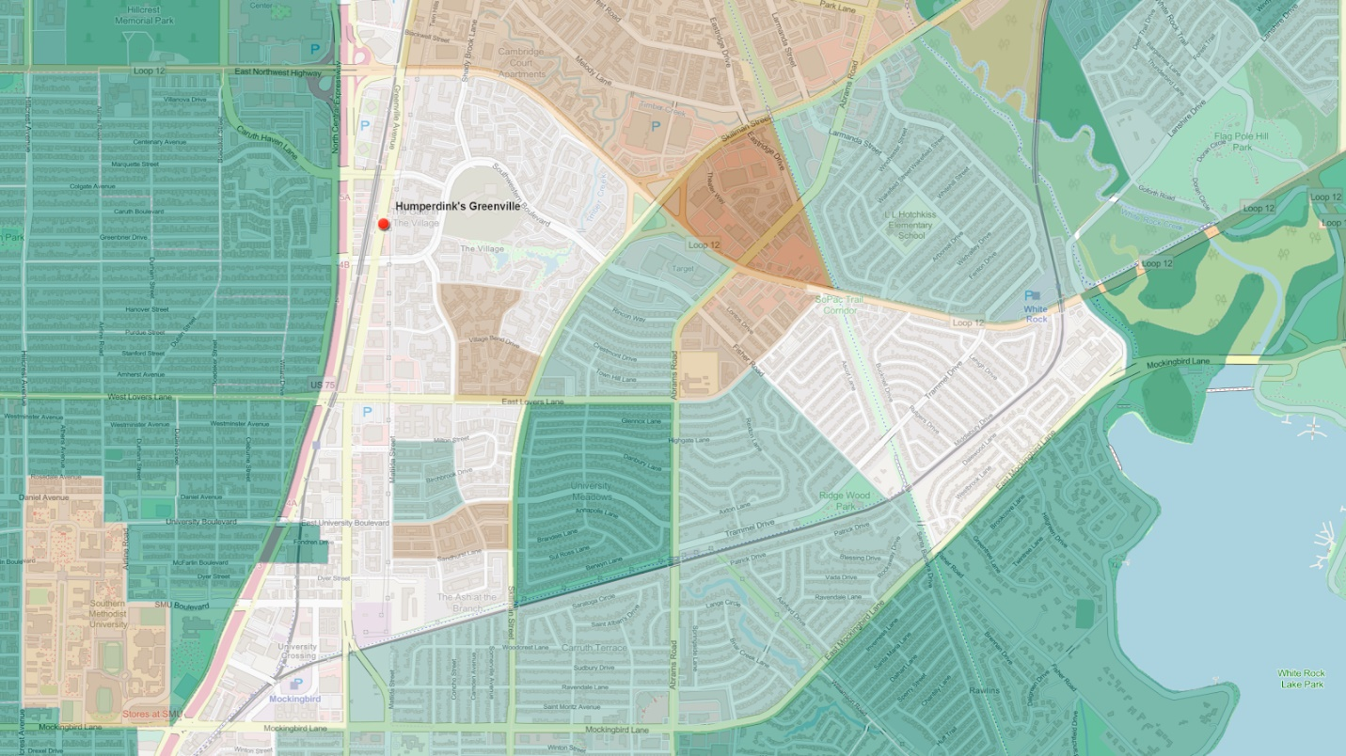

Traffic counts on Greenville Avenue are 24,008 and on North Central Expressway at a 10th of a mile away going up to 322,801.

* Team (founders & management)

We will be hiring management to run the facility and manage a monthly calendar of events. There will also be a brew master on staff to oversee local beer production. We also feel a management representative from Rahr should be involve in the buildout and training of the new management team to assure that the brand is correctly represented in the new facility.

Dallas is one of the ten largest cities in the United States and the heart of the largest metropolitan area in Texas. It is the county seat of Dallas County and small portions of the city also extend into the neighboring counties of Collin County, Denton County, Rockwall County, and Kaufman County. Dallas is the largest city of the Dallas-Fort Worth Metroplex, a large metropolitan area in North Texas.