Introduction

This information is also available online at <http://create.twu.ca/help/multi-access-learning/multi-access>

In planning for various scenarios pertaining to situations which prevent physical access to TWU campuses, the TWU GLOBAL Online team has adopted a Multi-Access Learning Framework (Irvine, 2009; Irvine, Code, & Richards, 2013) to support a virtual presence for teaching and learning.

This model is being suggested to assist TWU faculty as they attempt to balance between meeting the needs of on-campus learners with remote, isolated learners who are not able to access physical resources on one of our campuses. Remote or isolated learners and faculty may still access learning resources via Moodle – TWU’s Learning Management System (LMS) and with only a little preparation, teaching and learning activities can be shifted online and course access modes can be merged to enable learner choice and agency.

We have compiled a list of specific resources to assist faculty in setting up Moodle to enable both learner and faculty access to teaching and learning resources in the case of campus closures.

### Using Moodle

TWU provisions a Moodle site for every course that is offered for credit in every semester. Faculty do not need to do anything beyond logging into Moodle to access the site for their courses. We have listed below several tutorials designed to guide faculty through the process of setting up a minimal presence in Moodle to enable courses to proceed with minimal interruption while access to a TWU campus may be compromised for any reason (weather, illness, power loss, etc).

For shorter term interruptions to a physical campus, faculty might only need to post a link to a selection of articles using the EBSCO Curriculum Builder, and then create a discussion forum where learners engage in critical discourse about the articles. Longer term interruptions may require a more fulsome approach including uploading a syllabus, preparing assignment dropboxes and quizzes.

- [Accessing Moodle](https://create.twu.ca/help/moodle/basics/introduction)

- [Uploading files (syllabi, sample documents, etc) to Moodle](http://create.twu.ca/help/moodle/faculty/activity-or-resource/adding-resources)

- [Creating Assignment Dropboxes in Moodle](http://create.twu.ca/help/moodle/faculty/activity-or-resource/creating-an-assignment-dropbox)

- [Creating discussion forums](https://create.twu.ca/help/moodle/faculty/activity-or-resource/creating-a-forum)

- [Creating reading lists using EBSCO Curriculum Builder](http://create.twu.ca/help/moodle/faculty/activity-or-resource/ebsco-curriculum-builder)

- [Sending messages to your whole class.](https://create.twu.ca/help/moodle/faculty/participants/sending-mass-messages)

- [Using Moodle to track attendance.](http://create.twu.ca/help/moodle/faculty/activity-or-resource/attendance-activity)

### Using web-conferencing tools to connect synchronously

##### BlueJeans

TWU provides central management of BlueJeans for web-conferencing.

- [Tap or click here to create a ticket to gain access to BlueJeans](https://trinitywestern.teamdynamix.com/TDClient/1904/Portal/Requests/ServiceDet?ID=14119). Please make sure you specify that you would like access to BlueJeans.

- [Tap of click here to access BlueJeans support for getting started.](https://support.bluejeans.com/s/getting-started-meetings-user-step-1)

##### zoom.us

TWU is reviewing contracts related to using Zoom for web-conferencing.

- [Tap or click here to create a personal account on Zoom (limited to 45 minutes)](https://zoom.us/signup)

<https://www.youtube.com/watch?v=vFhAEoCF7jg>

##### https://www.youtube.com/watch?v=AYzPS28rg7E

##### Other services

There are several other options for faculty who may have already established means of synchronous communication such as Skype, FaceTime, Google Hangouts, Slack, Discord, etc. Our ability to troubleshoot these services will be very limited.

### Access TWU files through Microsoft OneDrive

TWU has provided access to MS Office 365 to all learners, faculty, and staff. This access includes storing files in MS OneDrive, which is accessible from any device connected to the web.

- [Tap or click here to access OneDrive.](https://portal.office.com)

### Access TWU files through VPN

## TWU provides VPN access to files so you can access from any device connected to the web.

### Use Audacity to record and edit audio files.

[Audacity](https://www.audacityteam.org/) is a free and open source audio recording and editing tool. You may want to record snippets of audio, or even a longer ‘lecture’ to send to your learners.

- [Tap or click here to learn how to install and use Audacity.](https://create.twu.ca/help/other-web-tools/audacity)

We are here to help, contact us at: elearning@twu.ca or, even better, drop by in the OARS offices on the 2nd floor of Reimer.

### References

Irvine, V. (2009). The Emergence of Choice in “Multi-Access” Learning Environments: Transferring Locus of Control of Course Access to the Learner (G. Siemens & C. Fulford, Eds.; pp. 746–752). *Association for the Advancement of Computing in Education (AACE).*

Irvine, V., Code, J., & Richards, L. (2013). Realigning higher education for the 21st-century learner through multi-access learning. *Journal of Online Learning and Teaching, 9*(2). http://jolt.merlot.org/vol9no2/irvine_0613.htm

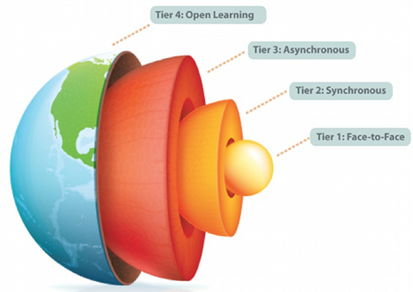

Multi-Access Learning Model (Irvine, 2009)