── Attaching core tidyverse packages ──────────────────────── tidyverse 2.0.0 ──  
✔ dplyr 1.1.4 ✔ readr 2.1.5  
✔ forcats 1.0.1 ✔ stringr 1.5.2  
✔ ggplot2 4.0.0 ✔ tibble 3.3.0  
✔ lubridate 1.9.4 ✔ tidyr 1.3.1  
✔ purrr 1.1.0   
── Conflicts ────────────────────────────────────────── tidyverse_conflicts() ──  
✖ dplyr::filter() masks stats::filter()  
✖ dplyr::lag() masks stats::lag()  
ℹ Use the conflicted package (<http://conflicted.r-lib.org/>) to force all conflicts to become errors  
Rows: 18 Columns: 5  
── Column specification ────────────────────────────────────────────────────────  
Delimiter: ","  
chr (2): Term, Course  
dbl (3): Class Size, Responses, pct_good  
  
ℹ Use `spec()` to retrieve the full column specification for this data.  
ℹ Specify the column types or set `show_col_types = FALSE` to quiet this message.

Warning: Removed 6 rows containing missing values or values outside the scale range  
(`geom_point()`).

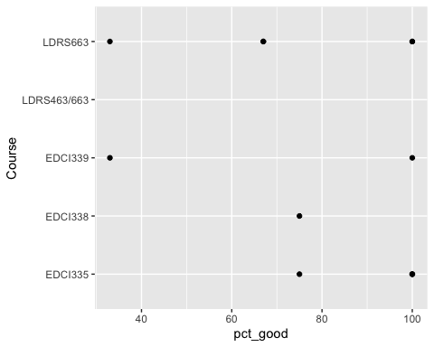

`geom_smooth()` using method = 'loess' and formula = 'y ~ x'

Warning: Removed 6 rows containing non-finite outside the scale range  
(`stat_smooth()`).

