ZALONGWA TECHNOLOGIES LIMITED

Step 1.0: Preparing the Import File
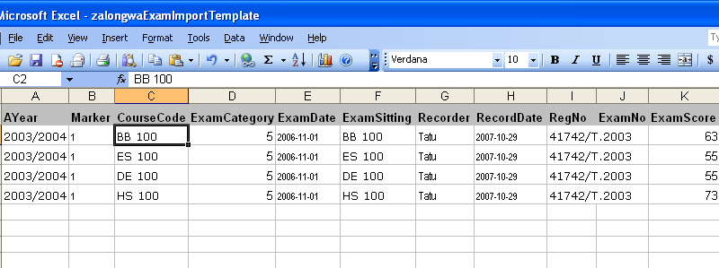

- Make sure you Fill in all the mandatory columns:
- Ayear - Academic Year of the Exam
- Coursecode – Course Code
- ExamCategory – Enter the ID of your Exam Category, see the Table below.
IdDescription4Continuous Assessment5End of Year Exam6Supplementary Exam7Special Exam8Final Year Project9Practical Training
- RegNo – Enter the student’s RegNo
- Checked = 1 (if published); = 0 (if not published)
- Status = 1
- Count = 0
- Comment = . (dot) or sensible comments

(b) Exam Date and Record Date must be in the ISO standard (YYYY-MM-DD). It is highly recommended that you fill in all the columns in order to ensure high quality of data

Step 2.0: Save your file
  - Click File – Save As
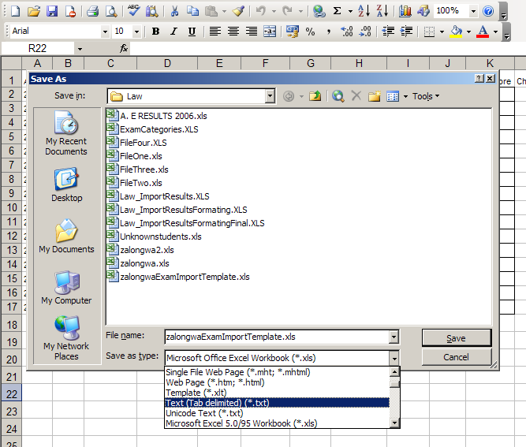
In the “Save as type” combo box, select Text (Tab delimited) (*.txt)
Click Save

If you get warning, click ‘OK’,
If you get warning click ‘Yes’

Step 3.0 Import Data to Zalongwa SARIS. While logged in, follow Step 1 to 4
4.0 Click Send File, to import your data
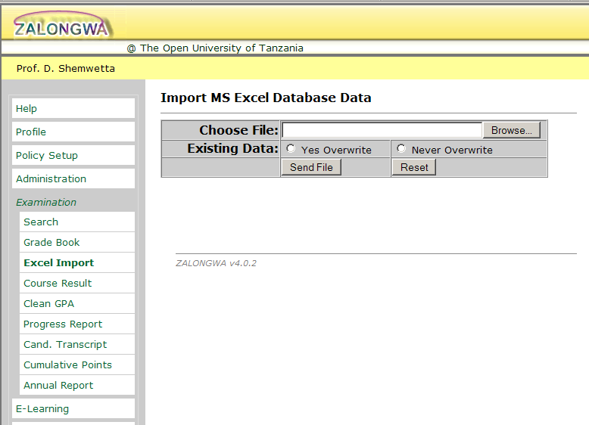
1.0 Click Excel Import Menu
2.0 Click Browse to Locate Your File
3.0 If you are importing Existing Data Chose either to overwrite or not
5.0 Summary:
In order to Import Examination Records from Excel Files, you need to follow Four Steps: (1) Click Excel Import; (2) Click Browse to locate and select your file; (3) Click ‘Yes Overwrite’ radio button if you want to Overwrite Existing records that ‘matches’ with those records you are importing OR Click ‘Never Overwrite’; (4) Click Send File command to start the process of importing your data.

The import file must be a tab delimited file (the extension should be .txt)

