Campus Map

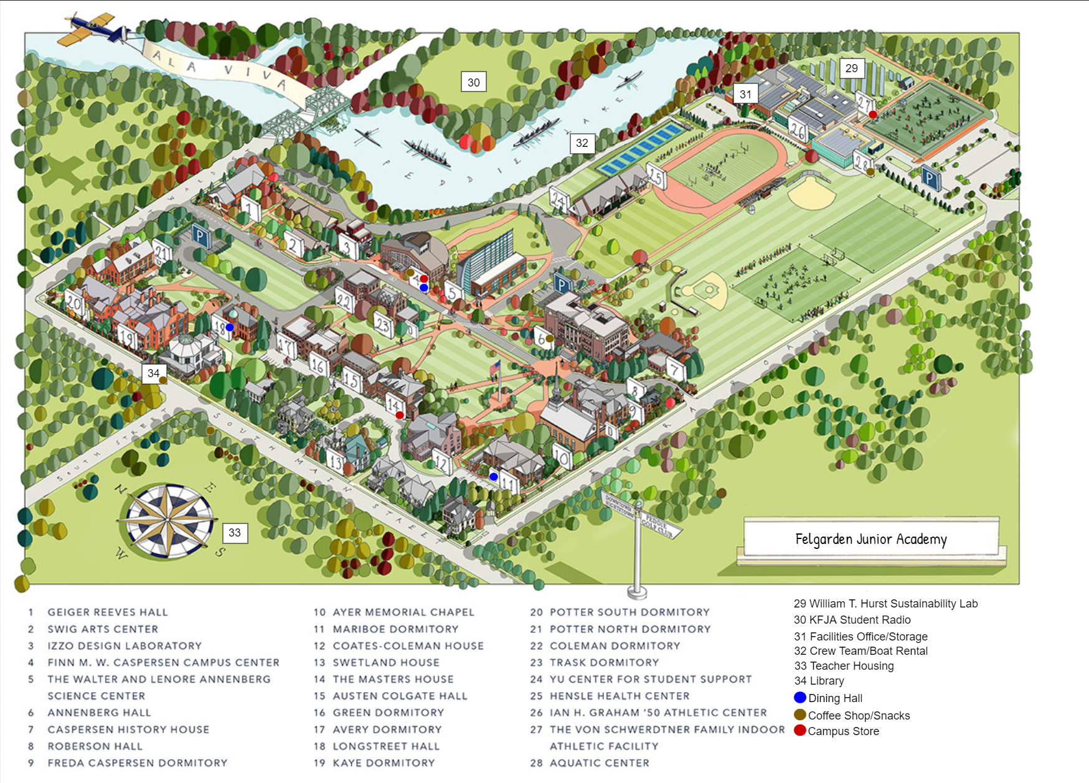

Places

1. Geiger Reeves – English classes, writing workshop, library rare collection

2. Arts Center – performing arts, music

3. Design Lab – sculpture, glassblowing, engineering, robotics

4. Campus Center – student union, dining, coffee shop, campus store

5. Science Center – science labs, computer labs, upper level science classes

6. Annenberg Hall – tons of general classes, some science/math lectures, coffee shop

7. History House – history dept, history library

11. Mariboe Dorm -- dining

14. Masters House – administrative offices, councilors, campus store

15. Colgate Hall – high-level classes, internship office, campus newspaper

18. Longstreet Hall – indoor clubs, storage and meeting rooms, dining

Scavenger Hunt

Rules

Each team of 6 has the whole night to collect as many items on the list as possible. Download the Felgarden Scavenger Hunt app on your phone and register your team leader’s phone with the app. Please register only one phone per team as this allows the app and our judges to instantly verify and score your collection. ***Only pictures taken and sent by this phone will count toward your score.***

To “collect” an item, you simply need to snap a picture on your phone with a member of your team (unless otherwise specified) touching or holding the item in question. When you are asked to take pictures of your team, one team member is allowed to be out of the scene to take the picture. Pictures of pictures are not permitted unless otherwise specified.

***Remember*** ***only pictures taken and sent by the registered team phone will count toward your score.***

This year, we have a new twist to the hunt. Each team is given 5 Red Tags. To tag an item, you leave your tag on it, and then simply submit your photo with it tagged. You can’t collect any specific item that has been Red-Tagged by another team (though you can collect other, similar items). You can tag unique items (though we have tried to make sure most of the items listed have multiple instances on campus), but you cannot tag people, or anything that someone is carrying around with them.

Facilities has kindly unlocked most of the doors on campus for this event. If a door is locked, please respect that decision and avoid that area of campus.

*(Meta: As players, you can make stuff up about campus on the fly as long as you can also create a good enough story, or justification, for it to be true. However, once you make up a campus fact, you cannot do so again until every other player has also done so.)*

The List

1. An oar
2. A statue
3. A copy of Felgarden’s yearbook from 1990 or before
4. A picture of all the team with their feet submerged in water
5. A chessboard
6. Someone wearing a bowtie
7. A vinyl album
8. A stuffed animal
9. A copy of the campus newspaper
10. You with Felgarden’s mascot
11. A parking cone
12. A video of you reciting (or reading) a famous poem
13. The entire teams’ reflection in something other than a mirror
14. A copy of the winter issue of 2600 Magazine
15. A Fish
16. You being chased by a robot
17. A student wearing a Felgarden t-shirt, sweatshirt, or jacket
18. You buying a delicious food item from one of our cafeterias or vendors
19. An umbrella
20. You typing on a computer lab’s computer
21. A 25lb dumbbell
22. You shaking hands with one of our janitorial staff
23. This year’s student handbook
24. Your team doing the “Abbey Road”
25. A purple dry erase marker
26. A $2 bill
27. A video of your team singing Felgarden’s Alma Mater
28. A picture of a puppy or kitten
29. A novel set in the Victorian Era
30. A trombone
31. A tire pump
32. A set of Platonic Solids
33. An autograph from one of Felgarden’s fine teachers
34. A picture or video of your team recreating a famous movie scene
35. A rotary phone
36. A lawnmower
37. You shaking hands with a member of student council
38. An out-of-state license plate
39. A video of Mr. Shainer saying something nice about you
40. A single picture showing 4 (or more) of your team touching different Felgarden buildings at the same time
41. You writing on a chalkboard
42. You standing next to a solar panel
43. A Bunsen burner
44. Your team playing poker
45. Your team all wearing wigs
46. A picture with three different species of tree in a single shot (bright red/orange; green; brown)
47. An airplane
48. A bullseye
49. The entire team dressed in matching attire
50. A sign with a clock on it
51. Something with glitter on it
52. An electric kettle
53. Rubber band ball 10cm or more diameter
54. Something scary