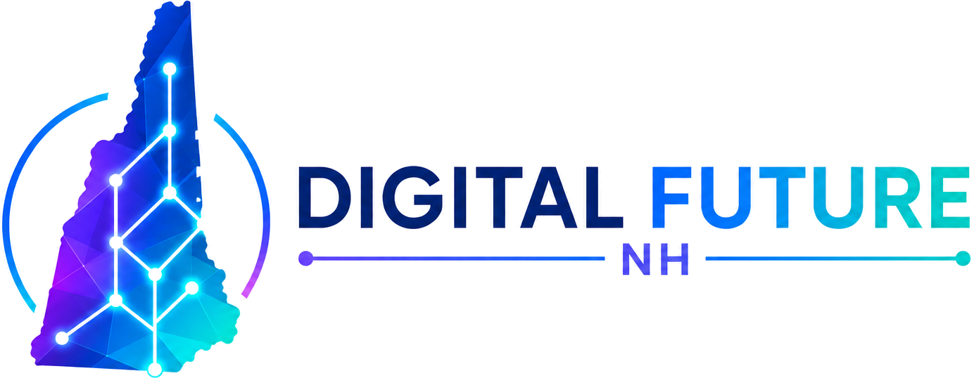

Certificate of Authority
of NH Digital Future PAC
Issued April 29, 2026
I, Christopher Maidment, being the duly serving Chair of NH Digital Future PAC, an unincorporated political committee organized under the laws of the State of New Hampshire and registered with the New Hampshire Secretary of State pursuant to RSA 664, do hereby certify as follows:
1. The Committee
Legal name | NH Digital Future PAC
Form of organization | Unincorporated political committee (NH RSA 664)
Federal tax classification | Section 527 political organization
Employer Identification Number | 42-2221221
Principal office | 248 Carley Road, Peterborough, NH 03458
Email | info@digitalfuturenh.com
Website | digitalfuturenh.com
2. Authorized signer
Name | Christopher Maidment
Title | Chair (and Treasurer)
Phone | 540-598-1130 (m)
Email | info@digitalfuturenh.com
3. Scope of authority
Pursuant to the Memorandum of Association and Articles of Association of the Committee, the Authorized Signer is fully authorized, acting alone and without the approval of any other person, to take the following actions on behalf of the Committee:
- Open, maintain, operate, and close bank accounts and merchant payment processing accounts (including with TD Bank, N.A., Stripe, BitPay, and any other lawful provider) in the name of the Committee;
- Accept, refuse, and refund contributions in U.S. dollars and in digital assets (including Bitcoin);
- Disburse funds, sign checks, initiate wire transfers and ACH transactions, and authorize card payments;
- Execute and deliver applications, agreements, terms of service, merchant processing agreements, and any related documents on behalf of the Committee;
- Provide identifying information, beneficial-ownership certifications, and supporting documents to financial institutions and payment processors;
- Make political contributions and independent expenditures, and publish endorsements, on behalf of the Committee;
- File reports required by New Hampshire RSA 664 and Section 527 of the Internal Revenue Code; and
- Take any other action reasonably necessary or convenient to carry out the lawful purposes of the Committee.
4. Specimen signature
The signature appearing below is the genuine signature of the Authorized Signer named in Section 2 and may be relied upon by any financial institution, payment processor, counterparty, or other person doing business with the Committee.
Christopher Maidment, Chair
NH Digital Future PAC · April 29, 2026
5. Effective date and reliance
This Certificate of Authority is effective as of April 29, 2026 and remains in full force until revoked in writing by an instrument signed by the Chair of the Committee and delivered to the relying party. Any party may rely on this Certificate without further inquiry.

