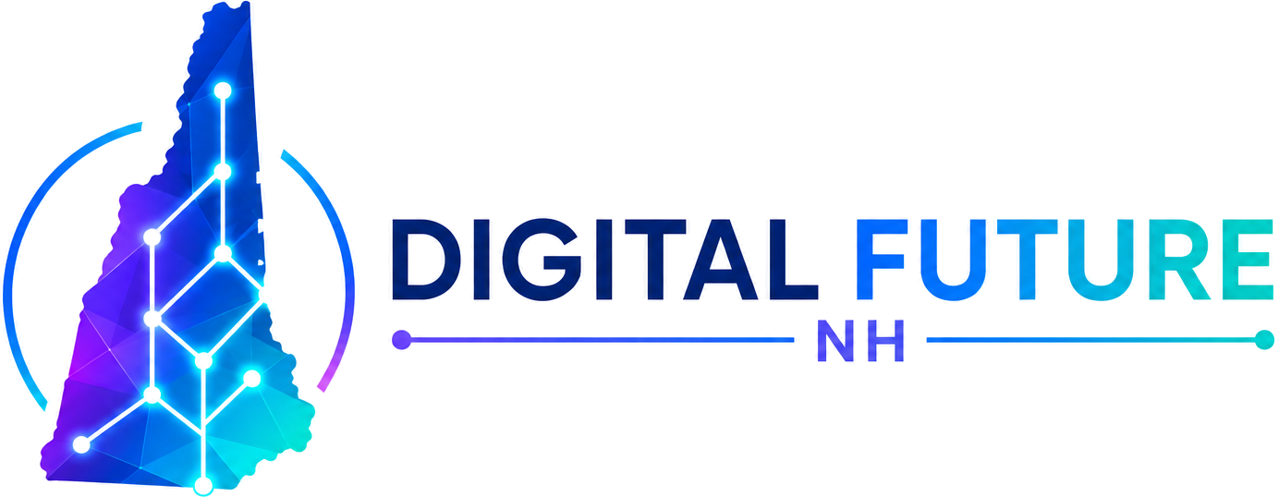

Memorandum of Association
of NH Digital Future PAC
This Memorandum of Association sets forth the formation, identity, purpose, and governing principals of NH Digital Future PAC, an unincorporated political action committee organized under the laws of the State of New Hampshire.
1. Name
The legal name of the committee is NH Digital Future PAC (the "Committee"). The Committee may also be referred to in branding and public-facing materials as "Digital Future NH."
2. Form of organization
The Committee is an unincorporated political committee organized and registered with the New Hampshire Secretary of State pursuant to New Hampshire RSA 664 (Political Expenditures and Contributions). The Committee is not incorporated and is not formed as a business entity for profit.
3. Federal tax classification
The Committee operates as a political organization within the meaning of Section 527 of the Internal Revenue Code of 1986, as amended. The Committee has been issued Employer Identification Number 42-2221221 by the Internal Revenue Service.
4. Registered office and mailing address
The principal office and mailing address of the Committee is 248 Carley Road, Peterborough, New Hampshire 03458. All official notices and correspondence may be sent to this address or to info@digitalfuturenh.com.
5. Purposes
The Committee is organized for the following non-partisan public purposes:
- To raise money and accept contributions in compliance with applicable New Hampshire and federal law;
- To endorse and contribute to candidates for public office in New Hampshire — without regard to political party — who support sound policy on digital property, blockchain, financial privacy, and the right of New Hampshire residents to build and use new technology;
- To educate New Hampshire voters and policymakers on issues affecting digital assets, encryption, self-custody, and emerging technology;
- To engage in any other lawful activity that advances the foregoing purposes and is permitted to a New Hampshire political committee under RSA 664 and applicable federal law.
6. Powers
In furtherance of its purposes, the Committee shall have the power to: (a) solicit and accept contributions of money, property, and services in U.S. dollars and in digital assets including Bitcoin; (b) make contributions to candidate committees and other political committees as permitted by law; (c) make independent expenditures; (d) hire and compensate staff and contractors; (e) maintain bank accounts and merchant payment accounts in its own name; (f) enter into contracts; (g) own and use intellectual property, including the trade name "Digital Future NH" and associated marks; and (h) take any other action necessary or convenient to carry out its lawful purposes.
7. Founding officer
The founding officer and Chair of the Committee is Christopher Maidment. The Chair has authority to act on behalf of the Committee, including authority to open and operate financial accounts, sign contracts, accept contributions, retain counsel and contractors, and file reports required by law. The Chair may delegate ministerial duties to a Treasurer or other officer as the governing rules of the Committee may provide.
8. Compliance
The Committee shall comply with all applicable provisions of New Hampshire RSA 664 governing political expenditures and contributions, including without limitation the registration, recordkeeping, and disclosure requirements of that chapter. The Committee shall not knowingly accept contributions from prohibited sources, including foreign nationals, anonymous contributors above the statutory threshold, or corporate treasury funds earmarked for specific candidates.
9. No member financial interest
The Committee is non-profit in form. No part of the net assets or income of the Committee shall inure to the personal benefit of any officer, founder, contributor, or other private person, except that the Committee may pay reasonable compensation for services actually rendered and may make payments and distributions in furtherance of its lawful purposes.
10. Dissolution
Upon dissolution of the Committee, after payment of or provision for all of the Committee's liabilities, any remaining assets shall be distributed in accordance with applicable New Hampshire and federal law to one or more political committees, candidates, or lawful organizations consistent with the purposes set forth above, as the Chair may determine.
11. Effective date
This Memorandum of Association is effective as of April 29, 2026, the date of execution below.
Executed by the founding officer:
Christopher Maidment, Chair
NH Digital Future PAC · April 29, 2026

