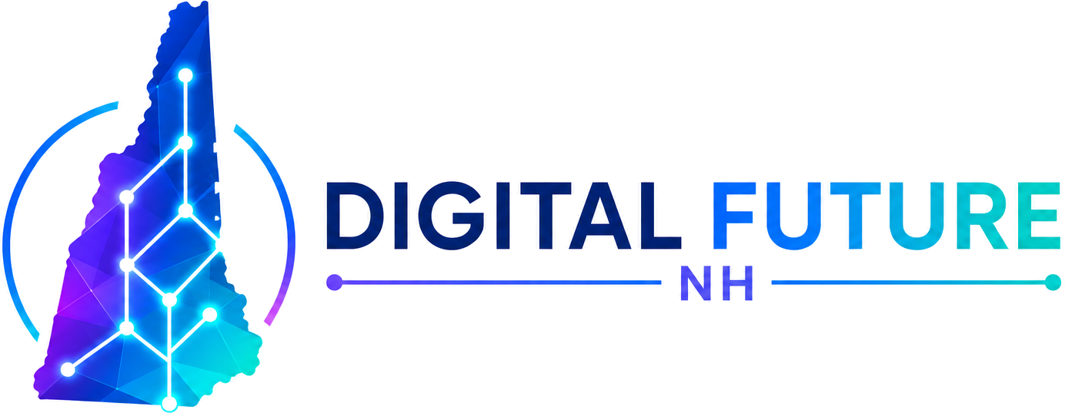

April 29, 2026
To Whom It May Concern:
Thank you for taking a moment with this letter. Digital Future NH PAC is a newly registered, non-partisan New Hampshire political action committee. We raise money, endorse New Hampshire candidates, and contribute to candidates who defend digital property, financial privacy, and the right of New Hampshire residents to build and use new technology.
We are organized under New Hampshire RSA 664 and report contributions to the New Hampshire Secretary of State at the thresholds the law requires. We accept contributions in U.S. dollars and in Bitcoin, with crypto contributions valued at the spot rate at time of receipt and reported the same way as cash.
What we are working on
New Hampshire is already the strongest state in the country on digital-asset policy. It was the first state to enact a Strategic Bitcoin Reserve law (HB 302, 2025, Chapter 4) and the first to grant decentralized autonomous organizations legal personhood through a permissionless-blockchain registry (RSA 301-B:14, effective July 2025). Our job is to help keep that ground — by endorsing and contributing to candidates from any party who will defend self-custody, oppose central bank digital currencies, protect the right to mine and run nodes, and recognize smart contracts under state contract law.
PAC information
Committee name | Digital Future NH PAC
State of registration | New Hampshire (RSA 664)
EIN | 42-2221221
Mailing address | 248 Carley Road, Peterborough, NH 03458
Chair | Christopher Maidment
Phone | 540-598-1130 (m)
Email | info@digitalfuturenh.com
Website | digitalfuturenh.com
If you need anything further to open or maintain a relationship with the PAC — W-9, Secretary of State filing confirmation, EIN letter, or a treasurer signature card — please reach out and we will turn it around the same day.
Sincerely,
Christopher Maidment
Chair, Digital Future NH PAC

