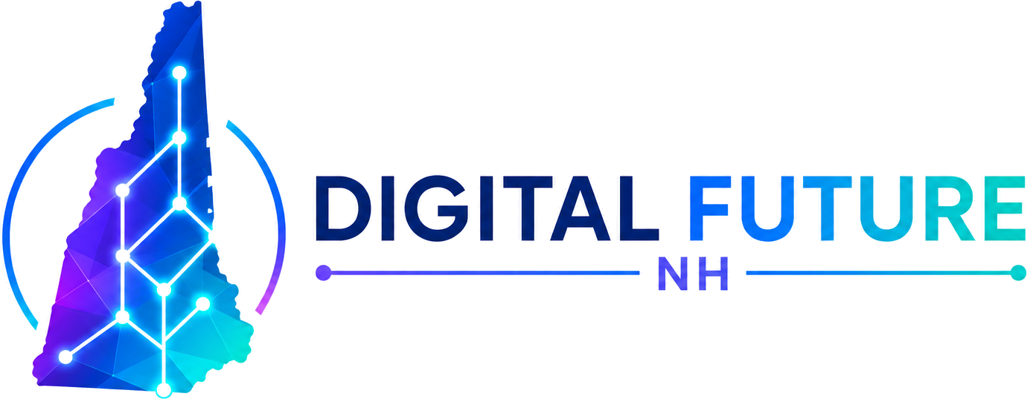

Wire Transfer Instructions
Issued April 29, 2026
Beneficiary (account holder)
Name on account | Digital Future NH PAC
Mailing address | 248 Carley Road, Peterborough, NH 03458
EIN | 42-2221221
Beneficiary bank
Bank name | TD Bank, N.A.
Bank location | Concord, New Hampshire
Account number | 9248656542
Account type | Business checking
Reference / memo | Digital Future NH PAC contribution
Routing numbers
FedWire ABA (incoming wires) | 031101266
ACH routing (electronic transfers) | 011400071
Notes for senders
- Include the sender's full name, address, and (above the NH disclosure threshold) occupation and employer in the wire memo.
- Anonymous contributions above the NH statutory threshold will be returned.
- Corporate-treasury contributions earmarked for specific candidates or bills will not be accepted.
- Foreign-national contributions are prohibited under federal law and will be rejected.
- After sending, email the wire confirmation to info@digitalfuturenh.com for a contribution receipt.
Contact
Christopher Maidment, Chair · 540-598-1130 (m) · info@digitalfuturenh.com

