Project Report

Library Management System

Java Swing technology

Abstract
Object oriented technology is a modern and popular software development methodology these days. This report has two sections. First section of the report lists class diagrams identified with relationship and sequence diagrams. The next section of the report evaluates the approach chosen for the testing of the developed system. The report also provides design and development evaluation throughout the design and implementation. Finally, the report tests the developed system using a test plan.

- Object Analysis and Design
The Figure 1 gives lists all the classes relevant to the book return system along with the any association and dependency among different classes. Throughout the design of the, it is strived hard to make the data types that are appropriate to hold the data we need keeping in mind the efficiency of the code. For example array data structure is used throughout the design since it provides the highest degree of efficiency. The classes identified are independent of each other to increase the modularity of the code and produce a high maintainable system. System shows the interaction (association, dependency) among classes in class diagrams; furthermore the detailed interaction is achieved using sequence diagrams.
    - Account Class
This class holds information about librarian who is the only one actor in given case. The attributes of interest for the class are id, user name and password. The operations that the class provides include getters and setters functions that are good practice to include in each class, plus the class one major function to check to validity of user from the database. I have manually created a record for one librarian with user name and password given on the section 1.4 of the report. It is being assumed that system only have only permanent operator, though the system can be developed to insert as many librarians with option for changing the password.
    - Book Class
This class holds information about book that can be borrowed by Borrower. The attributes of interest for the class are book id, title and isbn. The operations that the class provides include getters, setters and constructor methods. The class has a one-to-many association with BookBorrower class. As Borrower can borrow many books during the study, may be hundreds of book in one or more year.
    - BorrowerBook Class
This class holds works as a junction class between Book and Borrower class. There was need for this class as our data is stored on database system. The attributes of interest are borrower id, book title and isbn. The operations that the class provides include getters, setters and constructor methods. The class has a one-to-many association with Book and Borrower class. The three important operations are BookList() which returns the lists of owed books from database, getBookIsbn() returns the isbn number given the title of the book, lastly the removeItem() remove a book when book is returned by the Borrower. It is assumed that librarian only submit one book at a time for return.
    - DbConnection Class
This class holds the attributes like sql statement, connection string, database file to connect and database name to connect. The three required and necessary operations related to database are DbConnection(), openConnection() and closeConnection(). This class assumes that the database connection, file (exist on required location) and name (file name is consistent) all are ok. Additionally, it assumes the ODBC configuration has been setup properly.
    - Fine Class
This class is used to hold fine information of the Borrower. For this purpose book borrowing date, return date, return data, amount due and status is a Boolean attribute which is set true when book is returned. It is assumed that if book is returned within college opening hours on due date then fine imposed will be zero. The class contains two operations the important one is to get the amount of fine owed to a borrower.
    - JLibraryFrame Class
This is our main class that mostly contains the Java Swing interface elements (objects) and operations that librarian can perform on the system. This class actually holds the interface elements of the program. It is assumed that system doesn’t allow any book return, fine calculation and student identification. Hence, menu Library is disabled until the librarian in not login. This class is dependant upon the two other classes namely Account and Borrower.

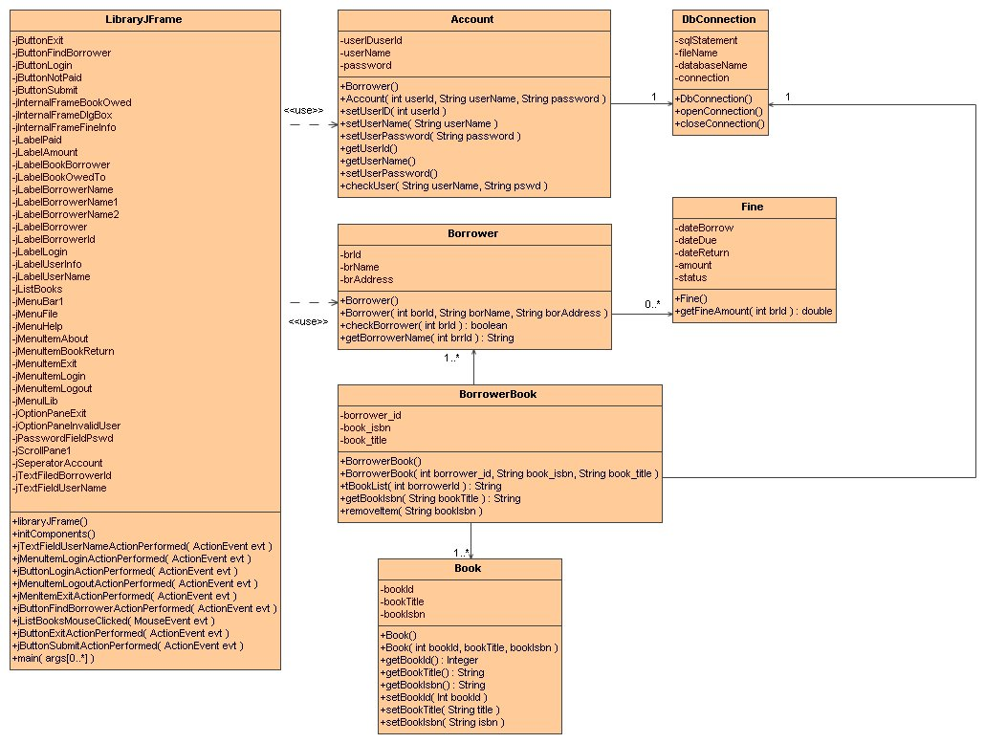
Figure 1: Classes along with Association and Dependency
  - Explanation, Assumptions and Justification of Sequence Diagrams
This section of the report explains the sequence diagrams to show the interaction among the objects. The college library book return system has three relevant sequence diagrams that are necessary to be explained here. In subsequent sections each of the sequence diagrams along with any assumptions will be briefed, and wherever appropriate section tries to justify the objects, methods and lifeline of the object.
    - Login Sequence Diagram
The first interaction of the librarian with the system is to login the system using interface (menu) provided in the system. In order to login to the system librarian go to Account menu and click on Login menu item. On clicking the login menu item an event is fired (a method is called) and a jInternalFrame object is created through which we perform three operations. Firstly, getText() method is called to get the librarian name, secondly same method is used to get the password but on javax.swing.JPasswordField class object. Thirdly, check user method is called which calls the method on Account class object. This method returns a Boolean value based on condition whether user name and password entered had relevant matching record in the database. Therefore, an alternative frame is shown to visualize the conditional behavior. If the record is found in the database then the Logout menu item and Library menu are activated and a window is set to appear to allow the librarian enter the id of the student. Else, in case if the no record in matched a message window appears to alert the librarian that information entered is wrong or invalid. At the very end, destroy method is called to dispose off the librarian login screen.
    - Student Identification and Book Listing Sequence Diagram
In Figure 2 there is an interaction of the librarian to enter into the system. On successful entrance the system display a window to identify the borrower (student). That interaction is finished here and a new interaction diagram is required. When the librarian enter the id of the student to be identified and click on button, an event is fired and getText() and getBorrowerName() method are called that returns the user id and borrower name that are required to be shown on book owed screen. Method 6 is calling a screen to display a list of books owed against the input student. When the screen becomes visible, getBookList() method is called which returns the list (array) of books owed to student. The method 9 is used to set the list of values for the javax.swing.List object. The method 10 set the fine window visible, method 11 and 12 are used to set the user name and password for the fine screen.
    - Fine Informationn Sequence Diagram
In Figure 3 there librarian gets the list of all books owed to a particular student. Librarian clicks on submit button to return the book, the current system date is used as a return date for the books returned. There is also a button for Exit by clicking which an event is fired and Books owed screen is disposed. The fine screen (window) appear using method 3, and method 4 is used to get the borrower id from text field. The main purpose of this sequence diagram is achieved using method 6, 7 and 8. Method 6 create a Fine class object and calls the getFineAmount() for a particular borrower. Method returns the amount as a double value. This amount is set to text field by which fine amount is viewable by the librarian.

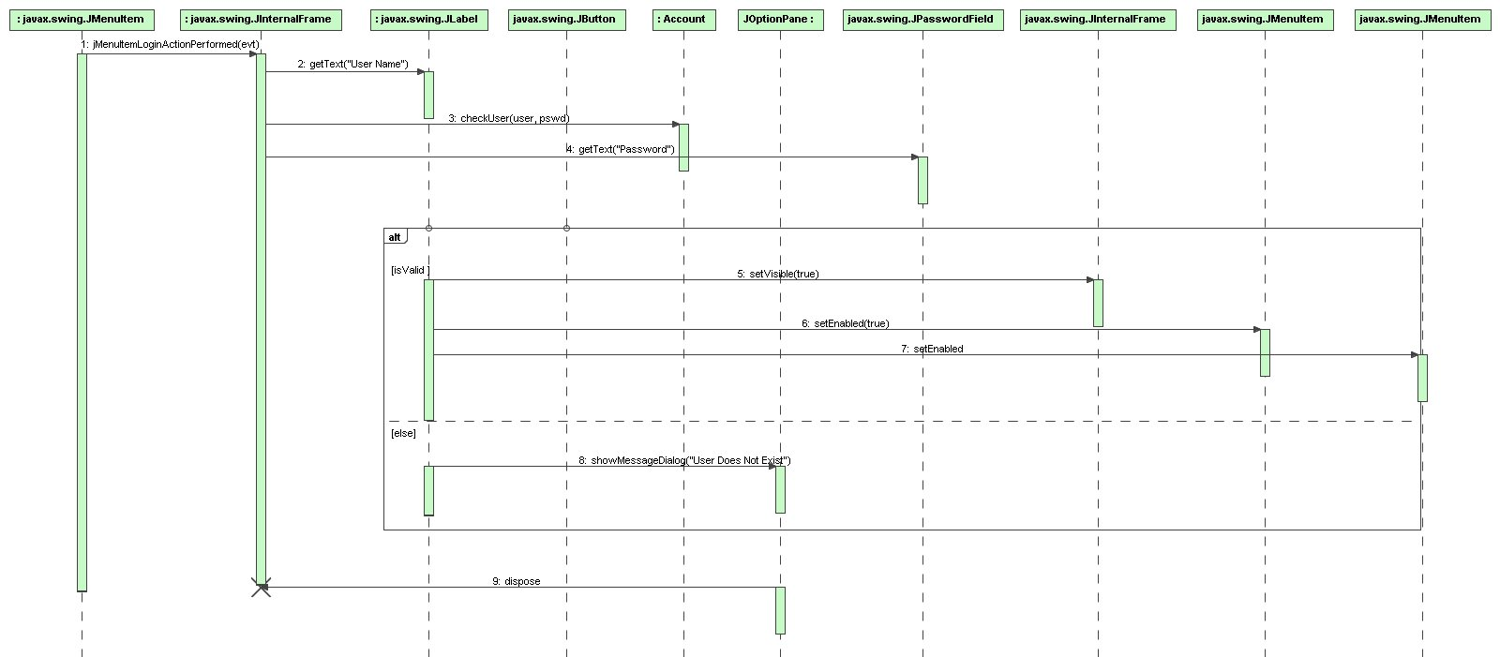
Figure 2: Sequence Diagram for Login System

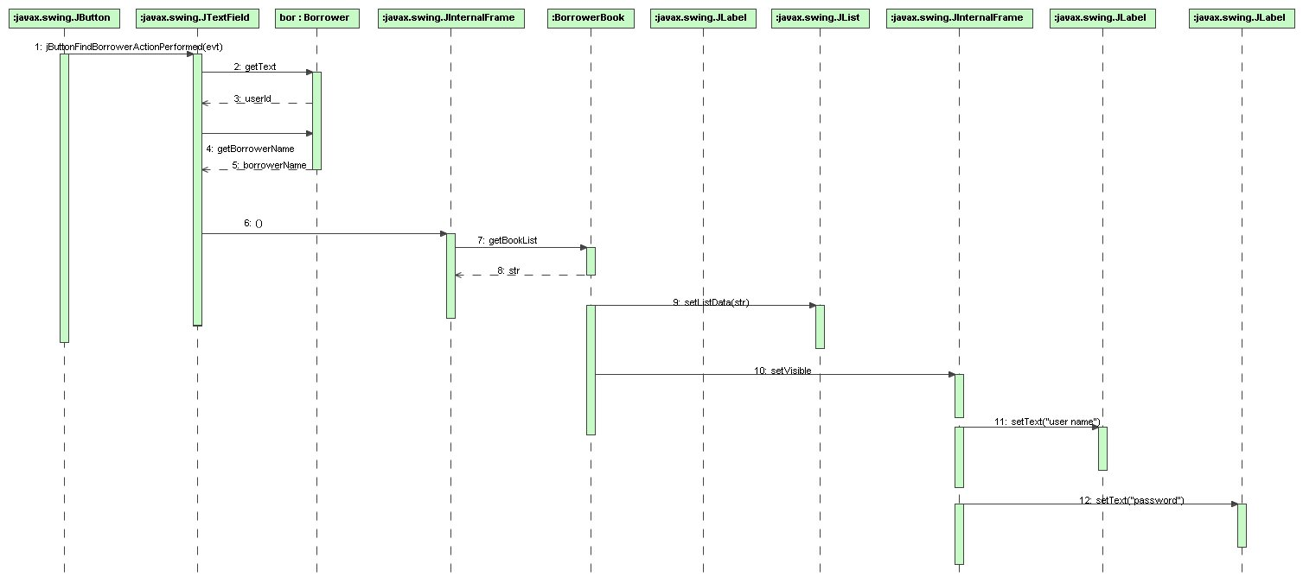
Figure 3: Sequence Diagram for Student Identification and Book Listing

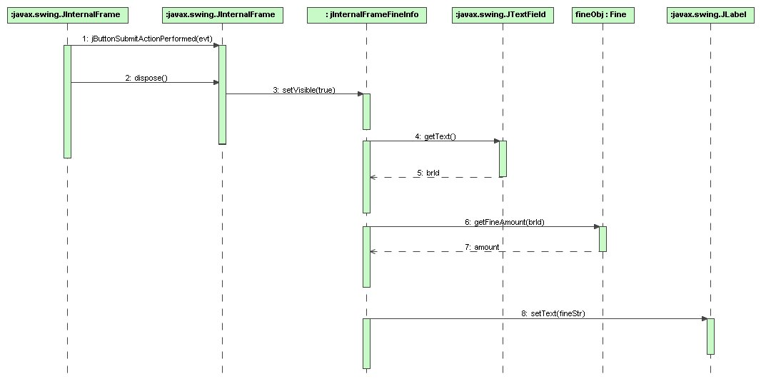
Figure 4: Sequence Diagram for Fine Information

- Source Code Listing
This part of the report list all the classes (source code) implementation that were developed and programmed for the college book return system. The code was implemented using the constructs that are provided by Java to ensure the efficiency of the program. The overall algorithm complexity is ?? as there are no control structure (loops) inside the code, hence the program executes in linear time. Modularity in the code is achieved where possible making the individual and independent class and creating association among them. Each class implemented provides pure modularity as each class is independent and reusable code. The data types used are chosen keeping in mind the size of the type and the range of values that is required by the attribute of the class.
  - Account.java
/**
* @author Sarfraz Ahmad
* @date 13 April, 2009
* @version 0.1
*/

package college.bookreturn;
import java.sql.*;

public class Account {
// Account holds the userID, UserName and password information
private int userID;
private String userName;
private String password;

public Account() {
this.userID=0;
this.userName=null;
this.password=null;
}

public Account(int userID, String userName, String password) {
this.userID=userID;
this.userName=userName;
this.password=password;
}

public void setUserID(int userID) {
this.userID=userID;
}

public void setUserName(String userName) {
this.userName=userName;
}

public void setUserPassword(String password) {
this.password=password;
}

public int getUserID() {
return (this.userID);
}

public String getUserName() {
return (this.userName);
}

public String setUserPassword() {
return (this.password);
}

/**
* @return boolean
* @params String userName
* @params String pswd
* check the validity of user and return true or false if or not user is found in database
*/
public boolean checkUser(String userName, String pswd) {
boolean flag = false;
try {
DbConnection myConnection = new DbConnection();
myConnection.openConnection();

String strSQL = "SELECT user_name,password FROM Account WHERE user_name = '" + userName + "' AND password = '" + pswd + "'";
ResultSet rs = myConnection.s.executeQuery(strSQL);
if(rs.next()) {
flag = true;
} else {
flag = false;
}
} catch(SQLException e) {
System.out.println("Error in DB " + e);
}
return (flag);
}
}
  - Borrower.java
/**
* @author Sarfraz Ahmad
* @date 13 April, 2009
* @version 0.1
*/

package college.bookreturn;
import java.sql.*;

public class Borrower {
// Borrower holds the borrower Id, name and address information
private int brId;
private String brName;
private String brAddress;

public Borrower() {
this.brId = 0;
this.brName = null;
this.brAddress = null;
}

public Borrower(int borId, String borName, String borAddress) {
this.brId = borId;
this.brName = borName;
this.brAddress = borAddress;
}

/**
* @return boolean
* @params String borrower id
* check whether a borrower with given id exist in the database or not
*/
public boolean checkBorrower(int brId) {
boolean flag = false;
try {
DbConnection myConnection = new DbConnection();
myConnection.openConnection();

String strSQL="SELECT b_id FROM Borrower WHERE b_id = '" + brId + "' ";
ResultSet rs = myConnection.s.executeQuery(strSQL);
if( rs.next() ) {
flag = true;
} else {
flag = false;
}
} catch(SQLException e) {
System.out.println("Error in DB " + e);
}
return (flag);
}

/**
* @return String
* @params int borrowerId
* returns the name of the borrower given the id
*/
public String getBorrowerName(int brrId) {
String borName = "";
try {
DbConnection myConnection = new DbConnection();
myConnection.openConnection();

String strSQL = "SELECT b_name, b_id FROM Borrower WHERE b_id = " + brrId + " ";
ResultSet rs = myConnection.s.executeQuery(strSQL);
if( rs.next() ) {
borName = rs.getString("b_name");
System.out.println("A match found in database for" + borName);
} else {
System.out.println("Not match found in database. Check Query");
}
} catch(SQLException e) {
System.out.println("Error in DB " + e);
}
return (borName);
}
}

  - BorrowerBook.java
/**
* @author Sarfraz Ahmad
* @date 13 April, 2009
* @version 0.1
*/

package college.bookreturn;
import java.sql.*;
import java.util.Date;

public class BorrowerBook {
// BorrowerBook holds the borrower Id, book isbn and book title information
private int borrower_id;
private String book_isbn;
private String book_title;

public BorrowerBook() {
this.borrower_id = 0;
this.book_isbn = "";
this.book_title = "";
}

public BorrowerBook(int borrower_id, String book_isbn, String book_title) {
this.borrower_id = borrower_id;
this.book_isbn = book_isbn;
this.book_title = book_title;
}

/**
* @param borrowerId
* @return String[]
* This method returns the list of books owed to given borrower
*/
public String[] getBookList(int borrowerId) {
String[] booksList = new String[5]; // Maximum 5 books can be owed to borrower
try {
DbConnection myConnection = new DbConnection();
myConnection.openConnection();

String strSQL = "SELECT b_name, bk_title FROM Borrower a, Book b, BorrowerBook c WHERE c.b_id_fk=" +
borrowerId + " AND c.status=0 AND b.bk_isbn=c.bk_isbn_fk";
ResultSet rs = myConnection.s.executeQuery(strSQL);
int i = 0;
while( rs.next() ) {
booksList[i] = rs.getString("bk_title");
i++;
}
} catch(SQLException e) {
System.out.println("Error in DB " + e);
}
return booksList;
}

/**
* @param bookTitle
* @return String
* This method returns the ISBN given the title of a book
*/
public String getBookIsbn(String bookTitle) {
String bookIsbn = "";
try {
DbConnection myConnection = new DbConnection();
myConnection.openConnection();

String strSQL = "SELECT bk_isbn_fk, bk_title FROM BorrowerBook a,Book b WHERE b.bk_isbn=a.bk_isbn_fk AND bk_title='"+bookTitle+"'";
ResultSet rs = myConnection.s.executeQuery(strSQL);
if( rs.next() ) {
bookIsbn = rs.getString("bk_isbn_fk");
}
} catch(SQLException e) {
System.out.println("Error in DB " + e);
}
return bookIsbn;
}

/**
* @param bookIsbn
* This method return a book when borrower returns the book
*/
public void removeItem(String bookIsbn) {
try {
DbConnection myConnection = new DbConnection();
myConnection.openConnection();

Date dt = new Date();
int date = dt.getDate();
int month = dt.getMonth();
int year = dt.getYear() + 1900;

String strDate = String.valueOf(date);
String strMonth = String.valueOf(month);
String strYear = String.valueOf(year);

String today = strMonth + "/" + strDate + "/" + strYear;

System.out.println(today);
String strSQL = "UPDATE BorrowerBook SET status=true, date_return='"+today+ "' WHERE bk_isbn_fk='"+bookIsbn+"'";
ResultSet rs = myConnection.s.executeQuery(strSQL);

} catch(SQLException e) {
System.out.println("Error in DB " + e);
}
}
}
  - DbConnection.java
/**
* @author Sarfraz Ahmad
* @date 13 April, 2009
* @version 0.1
*/

package college.bookreturn;
import java.sql.*;

public class DbConnection {
// DbConnection holds sql statement, database name, database driver and connection string
public Statement s;
private String fileName;
private String dataBase;
private Connection conn;

/**
* The constructor method to initiate the database configuration
*/
public DbConnection() {
try{
Class.forName("sun.jdbc.odbc.JdbcOdbcDriver");
this.fileName = "lib_db.mdb";
this.dataBase = "jdbc:odbc:Driver={Microsoft Access Driver (*.mdb)};DBQ=";
this.dataBase += this.fileName.trim() + ";DriverID=22;READONLY=true}";
this.conn=null;
this.s = null;
} catch (ClassNotFoundException e) {
System.err.println("Error in Loading Driver " + e );
}
}

/**
* The method to open connection to the database
*/
public void openConnection() {
try{
this.conn = DriverManager.getConnection( dataBase,"","");
this.s = conn.createStatement();
} catch(SQLException e) {
System.err.println("Error in connection " + e );
}
}

/**
* The method to close connection of the database
*/
public void closeConnection() {
try{

this.s.close();
this.conn.close();
} catch(SQLException e) {
System.err.println("Error in closing connection " + e );
}
}
}
  - Fine.java
/**
* @author Sarfraz Ahmad
* @date 13 April, 2009
* @version 0.1
*/

package college.bookreturn;
import java.sql.*;

public class Fine {
// Fine class holds information about date book borrowed, due date, date of return, fine amount and status
private Date dateBorrow;
private Date dateDue;
private Date dateReturn;
private double amount;
private boolean status; // set true when book is returned

Fine() {
this.amount = 0.0;
this.status = false;
}
/**
* @param borrowerId
* @return double
* The method returns the fine amount against a borrower
*/
public double getFineAmount(int brId) {
double fineAmount = 0.0;
try {
DbConnection myConnection = new DbConnection();
myConnection.openConnection();

String strSQL = "SELECT date_due,date_return FROM BorrowerBook WHERE b_id_fk='"+brId+"' AND status='true'";
ResultSet rs = myConnection.s.executeQuery(strSQL);
while ( rs.next() ) {
dateDue = rs.getDate("date_due");
dateReturn = rs.getDate("date_return");
dateBorrow = rs.getDate("date_borrow");
}
} catch(SQLException e) {
System.out.println("Error in DB " + e);
}
return fineAmount;
}
}

  - JLibraryFrame.java
/**
* @author Sarfraz Ahmad
* @date 13 April, 2009
* @version 0.1
*/

package college.bookreturn;
import javax.swing.*;

public class LibraryJFrame extends javax.swing.JFrame {

/** Creates new form LibraryJFrame */
public LibraryJFrame() {
initComponents();
}

/** This method is called from within the constructor to
* initialize the form.
*/
@SuppressWarnings("unchecked")
// <editor-fold defaultstate="collapsed" desc="Generated Code">
private void initComponents() {

jInternalFrameLogin = new javax.swing.JInternalFrame();
jLabelLoginLbl = new javax.swing.JLabel();
jLabelUserName = new javax.swing.JLabel();
jButtonLogin = new javax.swing.JButton();
jTextFieldUserName = new javax.swing.JTextField();
jLabelPswd = new javax.swing.JLabel();
jPasswordFieldPswd = new javax.swing.JPasswordField();
jInternalFrameUserInfo = new javax.swing.JInternalFrame();
jLabelUserInfo = new javax.swing.JLabel();
jLabelBorrowerId = new javax.swing.JLabel();
jTextFieldBorrowerId = new javax.swing.JTextField();
jButtonFindBorrower = new javax.swing.JButton();
jInternalFrameBookOwed = new javax.swing.JInternalFrame();
jLabelBkBr = new javax.swing.JLabel();
jLabelBkOwedTo = new javax.swing.JLabel();
jLabelBorrId = new javax.swing.JLabel();
jLabelBorrName = new javax.swing.JLabel();
jButtonExit = new javax.swing.JButton();
jLabelBorrId1 = new javax.swing.JLabel();
jLabelBorrName1 = new javax.swing.JLabel();
jLabelBorrName2 = new javax.swing.JLabel();
jButtonSubmit = new javax.swing.JButton();
jScrollPane1 = new javax.swing.JScrollPane();
jListBooks = new javax.swing.JList();
jInternalFrameFineInfo = new javax.swing.JInternalFrame();
jLabelFineInfo = new javax.swing.JLabel();
jLabelBorrower = new javax.swing.JLabel();
jLabelAmount = new javax.swing.JLabel();
jButtonPaid = new javax.swing.JButton();
jButtonNotPaid = new javax.swing.JButton();
jLabelFine = new javax.swing.JLabel();
jInternalFrameDlgBox = new javax.swing.JInternalFrame();
jOptionPaneInvalidUser = new javax.swing.JOptionPane();
jOptionPaneExit = new javax.swing.JOptionPane();
jMenuBar1 = new javax.swing.JMenuBar();
jMenuFile = new javax.swing.JMenu();
jMenuItemLogin = new javax.swing.JMenuItem();
jMenuItemLogout = new javax.swing.JMenuItem();
jSeparatorAcnt = new javax.swing.JSeparator();
jMenuItemExit = new javax.swing.JMenuItem();
jMenuLib = new javax.swing.JMenu();
jMenuItemBookReturn = new javax.swing.JMenuItem();
jMenuHelp = new javax.swing.JMenu();
jMenuItemAbout = new javax.swing.JMenuItem();

setDefaultCloseOperation(javax.swing.WindowConstants.EXIT_ON_CLOSE);

jInternalFrameLogin.setClosable(true);
jInternalFrameLogin.setResizable(true);
jInternalFrameLogin.setAlignmentX(0.0F);
jInternalFrameLogin.setAlignmentY(0.0F);
jInternalFrameLogin.setMinimumSize(new java.awt.Dimension(200, 200));
jInternalFrameLogin.setPreferredSize(new java.awt.Dimension(200, 231));

jLabelLoginLbl.setFont(new java.awt.Font("Tahoma", 0, 18));
jLabelLoginLbl.setHorizontalAlignment(javax.swing.SwingConstants.CENTER);
jLabelLoginLbl.setText("Login Here");
jLabelLoginLbl.setHorizontalTextPosition(javax.swing.SwingConstants.CENTER);

jLabelUserName.setText("User Name");

jButtonLogin.setText("Login Now");
jButtonLogin.addActionListener(new java.awt.event.ActionListener() {
public void actionPerformed(java.awt.event.ActionEvent evt) {
jButtonLoginActionPerformed(evt);
}
});

jLabelPswd.setText("Password");

javax.swing.GroupLayout jInternalFrameLoginLayout = new javax.swing.GroupLayout(jInternalFrameLogin.getContentPane());
jInternalFrameLogin.getContentPane().setLayout(jInternalFrameLoginLayout);
jInternalFrameLoginLayout.setHorizontalGroup(
jInternalFrameLoginLayout.createParallelGroup(javax.swing.GroupLayout.Alignment.LEADING)
.addGroup(jInternalFrameLoginLayout.createSequentialGroup()
.addContainerGap()
.addGroup(jInternalFrameLoginLayout.createParallelGroup(javax.swing.GroupLayout.Alignment.LEADING)
.addComponent(jButtonLogin)
.addGroup(jInternalFrameLoginLayout.createSequentialGroup()
.addGroup(jInternalFrameLoginLayout.createParallelGroup(javax.swing.GroupLayout.Alignment.LEADING)
.addComponent(jLabelUserName)
.addComponent(jLabelPswd))
.addGap(40, 40, 40)
.addGroup(jInternalFrameLoginLayout.createParallelGroup(javax.swing.GroupLayout.Alignment.LEADING, false)
.addComponent(jTextFieldUserName)
.addComponent(jPasswordFieldPswd, javax.swing.GroupLayout.DEFAULT_SIZE, 112, Short.MAX_VALUE))))
.addContainerGap(javax.swing.GroupLayout.DEFAULT_SIZE, Short.MAX_VALUE))
.addGroup(javax.swing.GroupLayout.Alignment.TRAILING, jInternalFrameLoginLayout.createSequentialGroup()
.addContainerGap(javax.swing.GroupLayout.DEFAULT_SIZE, Short.MAX_VALUE)
.addComponent(jLabelLoginLbl)
.addGap(1895, 1895, 1895))
);
jInternalFrameLoginLayout.setVerticalGroup(
jInternalFrameLoginLayout.createParallelGroup(javax.swing.GroupLayout.Alignment.LEADING)
.addGroup(jInternalFrameLoginLayout.createSequentialGroup()
.addContainerGap()
.addComponent(jLabelLoginLbl)
.addGap(18, 18, 18)
.addGroup(jInternalFrameLoginLayout.createParallelGroup(javax.swing.GroupLayout.Alignment.BASELINE)
.addComponent(jLabelUserName)
.addComponent(jTextFieldUserName, javax.swing.GroupLayout.PREFERRED_SIZE, javax.swing.GroupLayout.DEFAULT_SIZE, javax.swing.GroupLayout.PREFERRED_SIZE))
.addPreferredGap(javax.swing.LayoutStyle.ComponentPlacement.UNRELATED)
.addGroup(jInternalFrameLoginLayout.createParallelGroup(javax.swing.GroupLayout.Alignment.LEADING)
.addGroup(jInternalFrameLoginLayout.createSequentialGroup()
.addComponent(jLabelPswd)
.addGap(22, 22, 22)
.addComponent(jButtonLogin))
.addComponent(jPasswordFieldPswd, javax.swing.GroupLayout.PREFERRED_SIZE, javax.swing.GroupLayout.DEFAULT_SIZE, javax.swing.GroupLayout.PREFERRED_SIZE))
.addContainerGap(javax.swing.GroupLayout.DEFAULT_SIZE, Short.MAX_VALUE))
);

jInternalFrameUserInfo.setClosable(true);
jInternalFrameUserInfo.setAlignmentX(0.0F);
jInternalFrameUserInfo.setAlignmentY(0.0F);
jInternalFrameUserInfo.setMinimumSize(new java.awt.Dimension(480, 2227));

jLabelUserInfo.setFont(new java.awt.Font("Tahoma", 0, 18));
jLabelUserInfo.setText("User Information");

jLabelBorrowerId.setText("Borrower ID");

jButtonFindBorrower.setText("Find Borrower");
jButtonFindBorrower.addActionListener(new java.awt.event.ActionListener() {
public void actionPerformed(java.awt.event.ActionEvent evt) {
jButtonFindBorrowerActionPerformed(evt);
}
});

javax.swing.GroupLayout jInternalFrameUserInfoLayout = new javax.swing.GroupLayout(jInternalFrameUserInfo.getContentPane());
jInternalFrameUserInfo.getContentPane().setLayout(jInternalFrameUserInfoLayout);
jInternalFrameUserInfoLayout.setHorizontalGroup(
jInternalFrameUserInfoLayout.createParallelGroup(javax.swing.GroupLayout.Alignment.LEADING)
.addGroup(jInternalFrameUserInfoLayout.createSequentialGroup()
.addContainerGap()
.addGroup(jInternalFrameUserInfoLayout.createParallelGroup(javax.swing.GroupLayout.Alignment.LEADING)
.addGroup(jInternalFrameUserInfoLayout.createSequentialGroup()
.addComponent(jLabelBorrowerId)
.addGap(42, 42, 42)
.addComponent(jTextFieldBorrowerId, javax.swing.GroupLayout.PREFERRED_SIZE, 158, javax.swing.GroupLayout.PREFERRED_SIZE))
.addComponent(jLabelUserInfo)
.addComponent(jButtonFindBorrower))
.addContainerGap(javax.swing.GroupLayout.DEFAULT_SIZE, Short.MAX_VALUE))
);
jInternalFrameUserInfoLayout.setVerticalGroup(
jInternalFrameUserInfoLayout.createParallelGroup(javax.swing.GroupLayout.Alignment.LEADING)
.addGroup(jInternalFrameUserInfoLayout.createSequentialGroup()
.addContainerGap()
.addComponent(jLabelUserInfo)
.addGap(18, 18, 18)
.addGroup(jInternalFrameUserInfoLayout.createParallelGroup(javax.swing.GroupLayout.Alignment.BASELINE)
.addComponent(jLabelBorrowerId)
.addComponent(jTextFieldBorrowerId, javax.swing.GroupLayout.PREFERRED_SIZE, javax.swing.GroupLayout.DEFAULT_SIZE, javax.swing.GroupLayout.PREFERRED_SIZE))
.addGap(18, 18, 18)
.addComponent(jButtonFindBorrower, javax.swing.GroupLayout.PREFERRED_SIZE, 23, javax.swing.GroupLayout.PREFERRED_SIZE)
.addContainerGap(javax.swing.GroupLayout.DEFAULT_SIZE, Short.MAX_VALUE))
);

jInternalFrameBookOwed.setClosable(true);

jLabelBkBr.setFont(new java.awt.Font("Tahoma", 0, 18));
jLabelBkBr.setText("Book Borrowed");

jLabelBkOwedTo.setText("Following Books are Owed to:");

jLabelBorrId.setFont(new java.awt.Font("Arial", 1, 12));
jLabelBorrId.setText("Borrower ID");

jLabelBorrName.setFont(new java.awt.Font("Arial", 1, 12));
jLabelBorrName.setText("Borrower Name");

jButtonExit.setText("Exit");
jButtonExit.addActionListener(new java.awt.event.ActionListener() {
public void actionPerformed(java.awt.event.ActionEvent evt) {
jButtonExitActionPerformed(evt);
}
});

jLabelBorrId1.setText("Borrower ID:");

jLabelBorrName1.setText("Borrower Name:");

jLabelBorrName2.setFont(new java.awt.Font("Arial", 1, 12));
jLabelBorrName2.setText("Books Owed");

jButtonSubmit.setText("Submit");
jButtonSubmit.addActionListener(new java.awt.event.ActionListener() {
public void actionPerformed(java.awt.event.ActionEvent evt) {
jButtonSubmitActionPerformed(evt);
}
});

jListBooks.setSelectionMode(javax.swing.ListSelectionModel.SINGLE_SELECTION);
jScrollPane1.setViewportView(jListBooks);

javax.swing.GroupLayout jInternalFrameBookOwedLayout = new javax.swing.GroupLayout(jInternalFrameBookOwed.getContentPane());
jInternalFrameBookOwed.getContentPane().setLayout(jInternalFrameBookOwedLayout);
jInternalFrameBookOwedLayout.setHorizontalGroup(
jInternalFrameBookOwedLayout.createParallelGroup(javax.swing.GroupLayout.Alignment.LEADING)
.addGroup(jInternalFrameBookOwedLayout.createSequentialGroup()
.addContainerGap()
.addGroup(jInternalFrameBookOwedLayout.createParallelGroup(javax.swing.GroupLayout.Alignment.LEADING)
.addGroup(jInternalFrameBookOwedLayout.createSequentialGroup()
.addGroup(jInternalFrameBookOwedLayout.createParallelGroup(javax.swing.GroupLayout.Alignment.LEADING)
.addComponent(jLabelBkOwedTo)
.addGroup(jInternalFrameBookOwedLayout.createSequentialGroup()
.addGroup(jInternalFrameBookOwedLayout.createParallelGroup(javax.swing.GroupLayout.Alignment.LEADING)
.addComponent(jLabelBorrId1)
.addComponent(jLabelBorrName1))
.addGroup(jInternalFrameBookOwedLayout.createParallelGroup(javax.swing.GroupLayout.Alignment.LEADING)
.addGroup(jInternalFrameBookOwedLayout.createSequentialGroup()
.addGap(9, 9, 9)
.addComponent(jLabelBorrId, javax.swing.GroupLayout.PREFERRED_SIZE, 100, javax.swing.GroupLayout.PREFERRED_SIZE))
.addGroup(jInternalFrameBookOwedLayout.createSequentialGroup()
.addPreferredGap(javax.swing.LayoutStyle.ComponentPlacement.UNRELATED)
.addComponent(jLabelBorrName, javax.swing.GroupLayout.PREFERRED_SIZE, 112, javax.swing.GroupLayout.PREFERRED_SIZE)))))
.addContainerGap(javax.swing.GroupLayout.DEFAULT_SIZE, Short.MAX_VALUE))
.addGroup(jInternalFrameBookOwedLayout.createSequentialGroup()
.addComponent(jLabelBorrName2, javax.swing.GroupLayout.DEFAULT_SIZE, javax.swing.GroupLayout.DEFAULT_SIZE, Short.MAX_VALUE)
.addGap(408, 408, 408))
.addGroup(jInternalFrameBookOwedLayout.createSequentialGroup()
.addComponent(jScrollPane1, javax.swing.GroupLayout.PREFERRED_SIZE, 252, javax.swing.GroupLayout.PREFERRED_SIZE)
.addContainerGap())
.addGroup(jInternalFrameBookOwedLayout.createSequentialGroup()
.addComponent(jButtonSubmit)
.addPreferredGap(javax.swing.LayoutStyle.ComponentPlacement.UNRELATED)
.addComponent(jButtonExit)
.addContainerGap(javax.swing.GroupLayout.DEFAULT_SIZE, Short.MAX_VALUE))
.addGroup(jInternalFrameBookOwedLayout.createSequentialGroup()
.addComponent(jLabelBkBr)
.addContainerGap(javax.swing.GroupLayout.DEFAULT_SIZE, Short.MAX_VALUE))))
);
jInternalFrameBookOwedLayout.setVerticalGroup(
jInternalFrameBookOwedLayout.createParallelGroup(javax.swing.GroupLayout.Alignment.LEADING)
.addGroup(jInternalFrameBookOwedLayout.createSequentialGroup()
.addGap(6, 6, 6)
.addComponent(jLabelBkBr)
.addPreferredGap(javax.swing.LayoutStyle.ComponentPlacement.UNRELATED)
.addComponent(jLabelBkOwedTo)
.addPreferredGap(javax.swing.LayoutStyle.ComponentPlacement.UNRELATED)
.addGroup(jInternalFrameBookOwedLayout.createParallelGroup(javax.swing.GroupLayout.Alignment.BASELINE)
.addComponent(jLabelBorrId1)
.addComponent(jLabelBorrId, javax.swing.GroupLayout.PREFERRED_SIZE, 14, javax.swing.GroupLayout.PREFERRED_SIZE))
.addPreferredGap(javax.swing.LayoutStyle.ComponentPlacement.RELATED)
.addGroup(jInternalFrameBookOwedLayout.createParallelGroup(javax.swing.GroupLayout.Alignment.BASELINE)
.addComponent(jLabelBorrName1)
.addComponent(jLabelBorrName))
.addGap(28, 28, 28)
.addComponent(jLabelBorrName2)
.addGap(18, 18, 18)
.addComponent(jScrollPane1, javax.swing.GroupLayout.PREFERRED_SIZE, javax.swing.GroupLayout.DEFAULT_SIZE, javax.swing.GroupLayout.PREFERRED_SIZE)
.addGap(18, 18, 18)
.addGroup(jInternalFrameBookOwedLayout.createParallelGroup(javax.swing.GroupLayout.Alignment.BASELINE)
.addComponent(jButtonSubmit)
.addComponent(jButtonExit))
.addContainerGap(javax.swing.GroupLayout.DEFAULT_SIZE, Short.MAX_VALUE))
);

jInternalFrameFineInfo.setMinimumSize(new java.awt.Dimension(200, 200));

jLabelFineInfo.setFont(new java.awt.Font("Tahoma", 0, 18));
jLabelFineInfo.setText("Fine Information");

jLabelBorrower.setText("The fine amount is:");

jLabelAmount.setText("£");

jButtonPaid.setText("Paid");
jButtonPaid.addActionListener(new java.awt.event.ActionListener() {
public void actionPerformed(java.awt.event.ActionEvent evt) {
jButtonPaidActionPerformed(evt);
}
});

jButtonNotPaid.setText("Not Paid");
jButtonNotPaid.addActionListener(new java.awt.event.ActionListener() {
public void actionPerformed(java.awt.event.ActionEvent evt) {
jButtonNotPaidActionPerformed(evt);
}
});

jLabelFine.setText("amount");

javax.swing.GroupLayout jInternalFrameFineInfoLayout = new javax.swing.GroupLayout(jInternalFrameFineInfo.getContentPane());
jInternalFrameFineInfo.getContentPane().setLayout(jInternalFrameFineInfoLayout);
jInternalFrameFineInfoLayout.setHorizontalGroup(
jInternalFrameFineInfoLayout.createParallelGroup(javax.swing.GroupLayout.Alignment.LEADING)
.addGroup(jInternalFrameFineInfoLayout.createSequentialGroup()
.addGroup(jInternalFrameFineInfoLayout.createParallelGroup(javax.swing.GroupLayout.Alignment.LEADING)
.addGroup(jInternalFrameFineInfoLayout.createSequentialGroup()
.addGap(190, 190, 190)
.addComponent(jLabelFineInfo))
.addGroup(jInternalFrameFineInfoLayout.createSequentialGroup()
.addContainerGap()
.addComponent(jLabelBorrower))
.addGroup(jInternalFrameFineInfoLayout.createSequentialGroup()
.addContainerGap()
.addComponent(jLabelAmount)
.addPreferredGap(javax.swing.LayoutStyle.ComponentPlacement.UNRELATED)
.addComponent(jLabelFine)))
.addContainerGap())
.addGroup(jInternalFrameFineInfoLayout.createSequentialGroup()
.addComponent(jButtonPaid, javax.swing.GroupLayout.DEFAULT_SIZE, javax.swing.GroupLayout.DEFAULT_SIZE, Short.MAX_VALUE)
.addPreferredGap(javax.swing.LayoutStyle.ComponentPlacement.UNRELATED)
.addComponent(jButtonNotPaid)
.addGap(354, 354, 354))
);
jInternalFrameFineInfoLayout.setVerticalGroup(
jInternalFrameFineInfoLayout.createParallelGroup(javax.swing.GroupLayout.Alignment.LEADING)
.addGroup(jInternalFrameFineInfoLayout.createSequentialGroup()
.addContainerGap()
.addComponent(jLabelFineInfo)
.addGap(11, 11, 11)
.addComponent(jLabelBorrower)
.addGap(18, 18, 18)
.addGroup(jInternalFrameFineInfoLayout.createParallelGroup(javax.swing.GroupLayout.Alignment.BASELINE)
.addComponent(jLabelAmount)
.addComponent(jLabelFine))
.addGap(36, 36, 36)
.addGroup(jInternalFrameFineInfoLayout.createParallelGroup(javax.swing.GroupLayout.Alignment.BASELINE)
.addComponent(jButtonPaid)
.addComponent(jButtonNotPaid))
.addContainerGap(javax.swing.GroupLayout.DEFAULT_SIZE, Short.MAX_VALUE))
);

jInternalFrameDlgBox.setPreferredSize(new java.awt.Dimension(500, 465));

javax.swing.GroupLayout jInternalFrameDlgBoxLayout = new javax.swing.GroupLayout(jInternalFrameDlgBox.getContentPane());
jInternalFrameDlgBox.getContentPane().setLayout(jInternalFrameDlgBoxLayout);
jInternalFrameDlgBoxLayout.setHorizontalGroup(
jInternalFrameDlgBoxLayout.createParallelGroup(javax.swing.GroupLayout.Alignment.LEADING)
.addGroup(jInternalFrameDlgBoxLayout.createSequentialGroup()
.addComponent(jOptionPaneInvalidUser, javax.swing.GroupLayout.PREFERRED_SIZE, 123, javax.swing.GroupLayout.PREFERRED_SIZE)
.addGap(43, 43, 43)
.addComponent(jOptionPaneExit, javax.swing.GroupLayout.PREFERRED_SIZE, 102, javax.swing.GroupLayout.PREFERRED_SIZE)
.addContainerGap(javax.swing.GroupLayout.DEFAULT_SIZE, Short.MAX_VALUE))
);
jInternalFrameDlgBoxLayout.setVerticalGroup(
jInternalFrameDlgBoxLayout.createParallelGroup(javax.swing.GroupLayout.Alignment.LEADING)
.addGroup(jInternalFrameDlgBoxLayout.createSequentialGroup()
.addContainerGap()
.addGroup(jInternalFrameDlgBoxLayout.createParallelGroup(javax.swing.GroupLayout.Alignment.LEADING)
.addComponent(jOptionPaneExit, javax.swing.GroupLayout.PREFERRED_SIZE, 61, javax.swing.GroupLayout.PREFERRED_SIZE)
.addComponent(jOptionPaneInvalidUser, javax.swing.GroupLayout.PREFERRED_SIZE, 57, javax.swing.GroupLayout.PREFERRED_SIZE))
.addContainerGap(javax.swing.GroupLayout.DEFAULT_SIZE, Short.MAX_VALUE))
);

jMenuFile.setText("Account");

jMenuItemLogin.setText("Login");
jMenuItemLogin.addActionListener(new java.awt.event.ActionListener() {
public void actionPerformed(java.awt.event.ActionEvent evt) {
jMenuItemLoginActionPerformed(evt);
}
});
jMenuFile.add(jMenuItemLogin);

jMenuItemLogout.setText("Logout");
jMenuItemLogout.setBorder(null);
jMenuItemLogout.setEnabled(false);
jMenuItemLogout.addActionListener(new java.awt.event.ActionListener() {
public void actionPerformed(java.awt.event.ActionEvent evt) {
jMenuItemLogoutActionPerformed(evt);
}
});
jMenuFile.add(jMenuItemLogout);
jMenuFile.add(jSeparatorAcnt);

jMenuItemExit.setText("Exit");
jMenuItemExit.addActionListener(new java.awt.event.ActionListener() {
public void actionPerformed(java.awt.event.ActionEvent evt) {
jMenuItemExitActionPerformed(evt);
}
});
jMenuFile.add(jMenuItemExit);

jMenuBar1.add(jMenuFile);

jMenuLib.setText("Library");

jMenuItemBookReturn.setText("Book Return");
jMenuItemBookReturn.setEnabled(false);
jMenuItemBookReturn.addActionListener(new java.awt.event.ActionListener() {
public void actionPerformed(java.awt.event.ActionEvent evt) {
jMenuItemBookReturnActionPerformed(evt);
}
});
jMenuLib.add(jMenuItemBookReturn);

jMenuBar1.add(jMenuLib);

jMenuHelp.setText("Help");

jMenuItemAbout.setText("About");
jMenuHelp.add(jMenuItemAbout);

jMenuBar1.add(jMenuHelp);

setJMenuBar(jMenuBar1);

javax.swing.GroupLayout layout = new javax.swing.GroupLayout(getContentPane());
getContentPane().setLayout(layout);
layout.setHorizontalGroup(
layout.createParallelGroup(javax.swing.GroupLayout.Alignment.LEADING)
.addGroup(javax.swing.GroupLayout.Alignment.TRAILING, layout.createSequentialGroup()
.addGap(507, 507, 507)
.addComponent(jInternalFrameDlgBox, javax.swing.GroupLayout.PREFERRED_SIZE, 0, javax.swing.GroupLayout.PREFERRED_SIZE)
.addPreferredGap(javax.swing.LayoutStyle.ComponentPlacement.RELATED)
.addGroup(layout.createParallelGroup(javax.swing.GroupLayout.Alignment.LEADING)
.addComponent(jInternalFrameUserInfo, javax.swing.GroupLayout.PREFERRED_SIZE, 0, Short.MAX_VALUE)
.addComponent(jInternalFrameBookOwed, javax.swing.GroupLayout.PREFERRED_SIZE, 0, Short.MAX_VALUE))
.addPreferredGap(javax.swing.LayoutStyle.ComponentPlacement.RELATED)
.addComponent(jInternalFrameFineInfo, javax.swing.GroupLayout.PREFERRED_SIZE, 0, Short.MAX_VALUE)
.addPreferredGap(javax.swing.LayoutStyle.ComponentPlacement.RELATED)
.addComponent(jInternalFrameLogin, javax.swing.GroupLayout.PREFERRED_SIZE, 0, Short.MAX_VALUE))
);
layout.setVerticalGroup(
layout.createParallelGroup(javax.swing.GroupLayout.Alignment.LEADING)
.addGroup(javax.swing.GroupLayout.Alignment.TRAILING, layout.createSequentialGroup()
.addGap(36, 36, 36)
.addComponent(jInternalFrameLogin, javax.swing.GroupLayout.PREFERRED_SIZE, 0, Short.MAX_VALUE)
.addPreferredGap(javax.swing.LayoutStyle.ComponentPlacement.RELATED)
.addGroup(layout.createParallelGroup(javax.swing.GroupLayout.Alignment.LEADING)
.addComponent(jInternalFrameBookOwed, javax.swing.GroupLayout.PREFERRED_SIZE, 0, Short.MAX_VALUE)
.addGroup(javax.swing.GroupLayout.Alignment.TRAILING, layout.createSequentialGroup()
.addGap(25, 25, 25)
.addComponent(jInternalFrameUserInfo, javax.swing.GroupLayout.PREFERRED_SIZE, 0, Short.MAX_VALUE)
.addGap(382, 382, 382))))
.addComponent(jInternalFrameFineInfo, javax.swing.GroupLayout.Alignment.TRAILING, javax.swing.GroupLayout.PREFERRED_SIZE, 0, Short.MAX_VALUE)
.addGroup(layout.createSequentialGroup()
.addComponent(jInternalFrameDlgBox, javax.swing.GroupLayout.PREFERRED_SIZE, 0, javax.swing.GroupLayout.PREFERRED_SIZE)
.addContainerGap(443, Short.MAX_VALUE))
);

try {
jInternalFrameFineInfo.setMaximum(true);
} catch (java.beans.PropertyVetoException e1) {
e1.printStackTrace();
}
try {
jInternalFrameDlgBox.setMaximum(true);
} catch (java.beans.PropertyVetoException e1) {
e1.printStackTrace();
}

pack();
}// </editor-fold>

private void jMenuItemLoginActionPerformed(java.awt.event.ActionEvent evt) {
// When librarian clicks on Login Menu Item, display login screen
jInternalFrameLogin.setVisible(true);
}

private void jButtonLoginActionPerformed(java.awt.event.ActionEvent evt) {
// When librarian clicks on login button
// Get the user name and password information
String user = jTextFieldUserName.getText();
String pswd = jPasswordFieldPswd.getText();

Account myAccount = new Account();
boolean isValid = myAccount.checkUser(user, pswd);

if (isValid) {
jInternalFrameLogin.dispose();
jInternalFrameUserInfo.setVisible(true);
jMenuItemLogout.setEnabled(true);
jMenuItemBookReturn.setEnabled(true);
} else {
JOptionPane.showMessageDialog(jInternalFrameLogin,"User Does Not Exist. Please Verify User Name and Password.");
}

}

private void jMenuItemLogoutActionPerformed(java.awt.event.ActionEvent evt) {
// On logout clicking show the user login screen
jButtonLogin.setVisible(true);
}

/**
* @param evt
* The method exit the library system based on user confirmation
*/
private void jMenuItemExitActionPerformed(java.awt.event.ActionEvent evt) {
int optionSel;
optionSel = JOptionPane.showConfirmDialog(jInternalFrameLogin, "Are you sure to exit?", "Confirm Exit", 0);

switch (optionSel) {
case 0:
System.exit(0);
break;
case 1:
break;
}
}

/**
* @param evt
* check in database whether user id exist, if yes display a window with user id and name along with any books owed to him
* else display an error dialog box.please re-enter burrower id
*/
private void jButtonFindBorrowerActionPerformed(java.awt.event.ActionEvent evt) {
String userId = jTextFieldBorrowerId.getText();
int usrId = Integer.parseInt(userId);
Borrower bor = new Borrower();
String borName = bor.getBorrowerName(usrId);

jInternalFrameUserInfo.dispose();
BorrowerBook bBk = new BorrowerBook();
String[] str = bBk.getBookList(usrId);

jListBooks.setListData(str);
jInternalFrameBookOwed.setVisible(true);

jLabelBorrId.setText(userId);
jLabelBorrName.setText(borName);
}

/**
* @param evt
* exit the system from book owed screen and display the fine information window
*/
private void jButtonExitActionPerformed(java.awt.event.ActionEvent evt) {
jInternalFrameBookOwed.dispose();
jInternalFrameFineInfo.setVisible(true);

String brId = jTextFieldBorrowerId.getText();
int brIdInt = Integer.parseInt(brId);

Fine fineObj = new Fine();
double fine = fineObj.getFineAmount(brIdInt);
System.out.println(fine);
String fineStr = Double.toString(fine);
jLabelFine.setText(fineStr);
}

/**
* @param evt
* Return a book owed to a borrower.
*/
private void jButtonSubmitActionPerformed(java.awt.event.ActionEvent evt) {
jInternalFrameUserInfo.dispose();

Object objVal = jListBooks.getSelectedValue();
String bookTitle = objVal.toString();

String userId = jTextFieldBorrowerId.getText();
int usrId = Integer.parseInt(userId);

BorrowerBook bBk = new BorrowerBook();
String bookIsbn = bBk.getBookIsbn(bookTitle);

bBk.removeItem(bookIsbn);

String[] str = bBk.getBookList(usrId);

jListBooks.setListData(str);
jInternalFrameBookOwed.setVisible(true);

}

/**
* @param evt
* The method makes the librain login screen appear when librarian click on Book Return menu item.
*/
private void jMenuItemBookReturnActionPerformed(java.awt.event.ActionEvent evt) {
jInternalFrameLogin.setVisible(true);
}

/**
* @param evt
* Simply exit the system. This method must be implemented for a full library system
*/
private void jButtonPaidActionPerformed(java.awt.event.ActionEvent evt) {
System.exit(0);
}

/**
* @param evt
* Simply exit the system. This method must be implemented for a full library system
*/
private void jButtonNotPaidActionPerformed(java.awt.event.ActionEvent evt) {
System.exit(0);
}

/**
* @param args the command line arguments
*/
public static void main(String args[]) {
java.awt.EventQueue.invokeLater(new Runnable() {
public void run() {
new LibraryJFrame().setVisible(true);
}
});
}

// Variables declaration - do not modify
private javax.swing.JButton jButtonExit;
private javax.swing.JButton jButtonFindBorrower;
private javax.swing.JButton jButtonLogin;
private javax.swing.JButton jButtonNotPaid;
private javax.swing.JButton jButtonPaid;
private javax.swing.JButton jButtonSubmit;
private javax.swing.JInternalFrame jInternalFrameBookOwed;
private javax.swing.JInternalFrame jInternalFrameDlgBox;
private javax.swing.JInternalFrame jInternalFrameFineInfo;
private javax.swing.JInternalFrame jInternalFrameLogin;
private javax.swing.JInternalFrame jInternalFrameUserInfo;
private javax.swing.JLabel jLabelAmount;
private javax.swing.JLabel jLabelBkBr;
private javax.swing.JLabel jLabelBkOwedTo;
private javax.swing.JLabel jLabelBorrId;
private javax.swing.JLabel jLabelBorrId1;
private javax.swing.JLabel jLabelBorrName;
private javax.swing.JLabel jLabelBorrName1;
private javax.swing.JLabel jLabelBorrName2;
private javax.swing.JLabel jLabelBorrower;
private javax.swing.JLabel jLabelBorrowerId;
private javax.swing.JLabel jLabelFine;
private javax.swing.JLabel jLabelFineInfo;
private javax.swing.JLabel jLabelLoginLbl;
private javax.swing.JLabel jLabelPswd;
private javax.swing.JLabel jLabelUserInfo;
private javax.swing.JLabel jLabelUserName;
private javax.swing.JList jListBooks;
private javax.swing.JMenuBar jMenuBar1;
private javax.swing.JMenu jMenuFile;
private javax.swing.JMenu jMenuHelp;
private javax.swing.JMenuItem jMenuItemAbout;
private javax.swing.JMenuItem jMenuItemBookReturn;
private javax.swing.JMenuItem jMenuItemExit;
private javax.swing.JMenuItem jMenuItemLogin;
private javax.swing.JMenuItem jMenuItemLogout;
private javax.swing.JMenu jMenuLib;
private javax.swing.JOptionPane jOptionPaneExit;
private javax.swing.JOptionPane jOptionPaneInvalidUser;
private javax.swing.JPasswordField jPasswordFieldPswd;
private javax.swing.JScrollPane jScrollPane1;
private javax.swing.JSeparator jSeparatorAcnt;
private javax.swing.JTextField jTextFieldBorrowerId;
private javax.swing.JTextField jTextFieldUserName;
// End of variables declaration
}
- Testing
Software testing is an approach by which software engineers (software testers) ensure the proper execution of the software and taking the valid input and producing the right output. In general purpose of software testing is to make sure software does what it is intended and required to do, that is, it meets the business requirements of the audience. Depending upon the testing method, testing can be employed at different stages, but in most of the cases it is done after implementation stage.
  - Test Rationale
Think about a car which is designed and manufactured by engineers. Before the car is started being manufactured, engineers devise a plan for it, so that it provides the expected functionality. The engineer in the planning stage, list all of the features and functionality provided by the car. When the car is modeled and then assembled it is the first and foremost urge of the engineers to check whether it does provide the features that were planed. This process of testing is very important. The same theory and practice is applied in software engineering, with one major difference that software testing is pretty complex and complicated than of engineering fields.
There are two popular software testing approaches namely white-box and black-box testing. The test that I have adopted to approach the errors and mal-functionality in the developed the College Library Book Return System is black-box testing.
  - Test Plan
The test method employed to carry out the relevant tests to verify the system is equivalence partitioning. As of the rule of equivalence partitioning it has been tried to test the cases with one correct input and at least one erroneous input. This part of the report carries out the tests relevant to the system providing a real sample test runs
(screen dumps) together with showing the output of each function of the system.
    - Testing the Login Function
Login screen accepts only the specific value as an input, to allow the librarian enter to the system. In Figure 5 the correct user name and password is entered and system authenticates the user. Figure 6 verifies that user has been authenticated and allows the user to identify a borrower for the sake of listing the books owed to him/her.
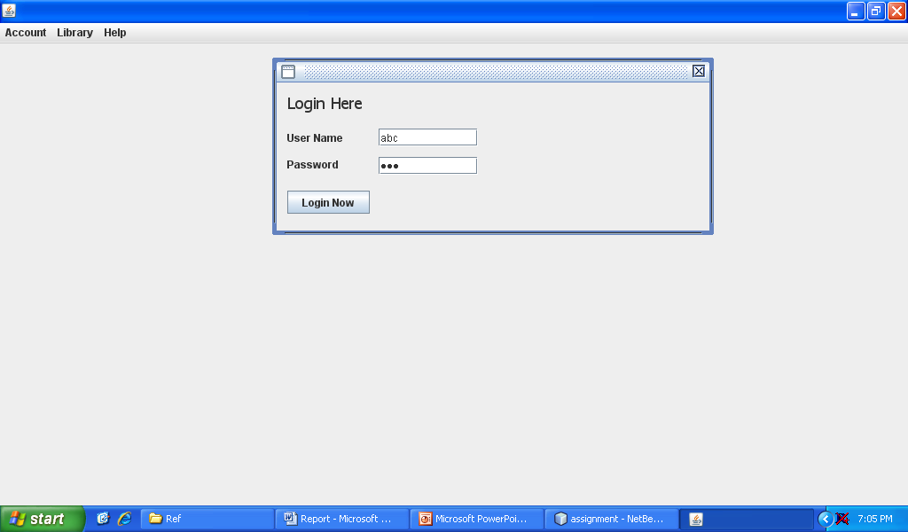
Figure 5: Login Screen with Correct Input Value
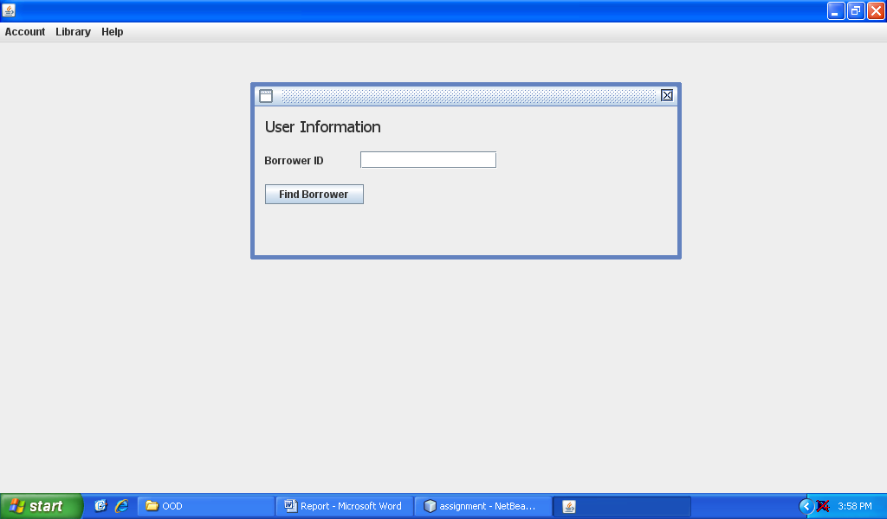
Figure 6: User is Authenticated and Next Screen is Appeared
In Figure 7 the incorrect user name “123”and password “d4uf”is entered and system failed the user authentication. Figure 8 verifies that an error message dialog box is popup, stating the error message.
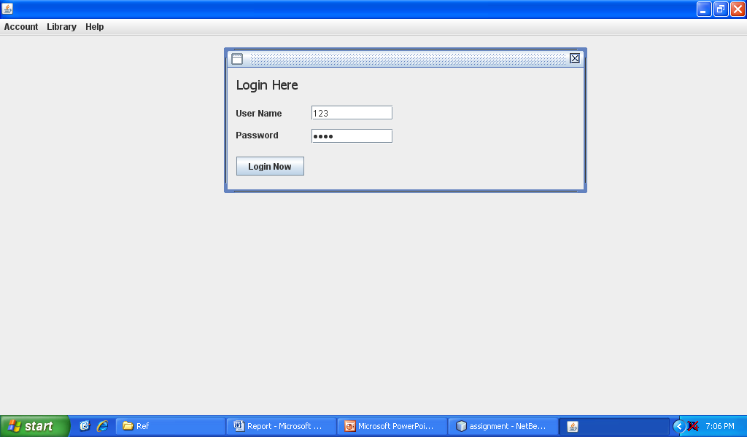
Figure 7: Login Screen with Incorrect Input Value

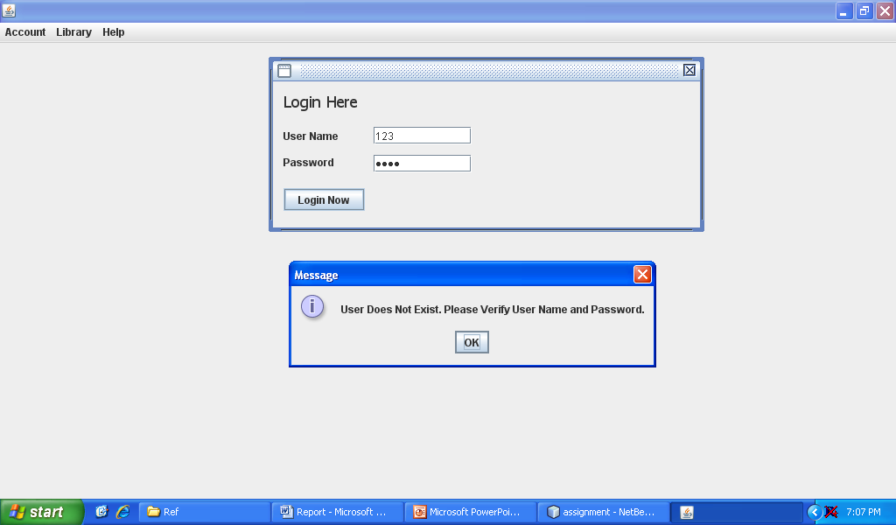
Figure 8: Login Screen Incorrect Input Verification
In Figure 9 the uppercase (incorrect) user name “ABC” and correct password (123) is entered and system authenticates the user. This fails the test as system should be careful of the case-sensitivity of the values entered. Figure 10 verifies that user has been authenticated and allows the user to identify a borrower for the sake of listing the books owed to him/her.
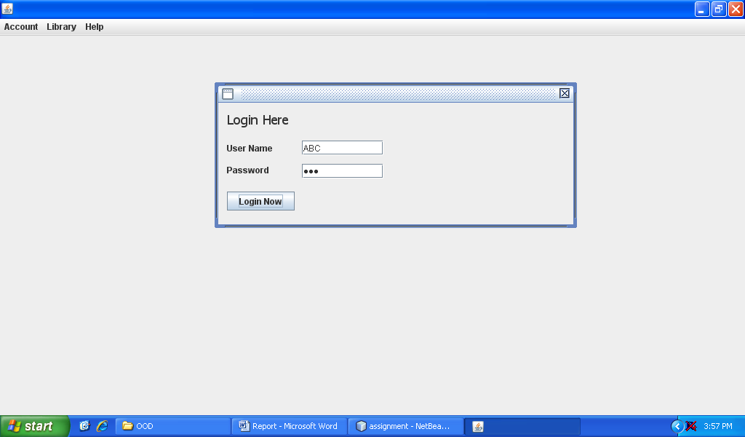
Figure 9: Login Screen Incorrect Input
Figure 10: User is Authenticated with Wrong Input and Next Screen is Appeared
    - Testing the Borrower Identification Function
Borrower authentication screen accepts only the specific value as an input, to allow the librarian enter id (number) of borrower to be identified. Following is the successful case of the user identification function.
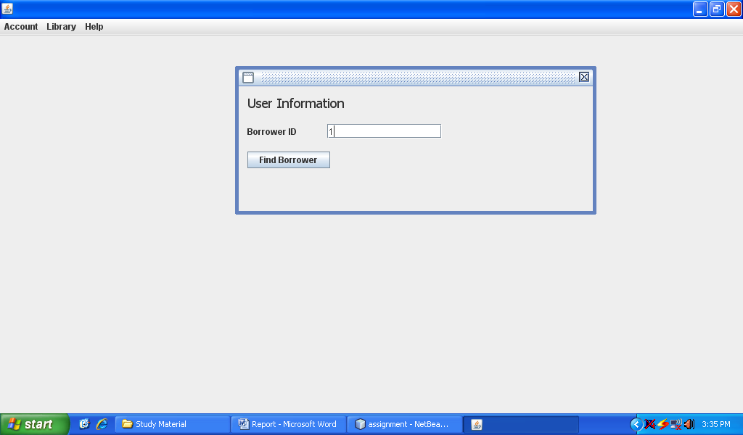
Figure 11: Correct Borrower Id Input

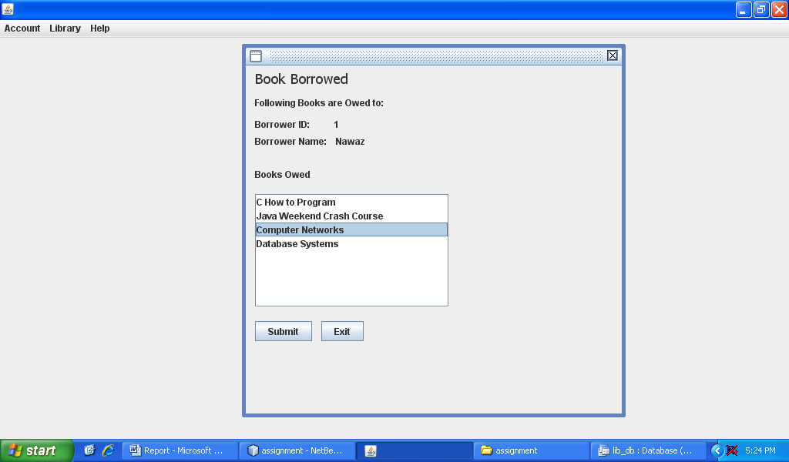
Figure 12: Booked Owed to Borrower are Shown along with the Name and Id
The next function that is provided in the book borrowed screen is submitting the book that borrower wants to return. In Figure 12 librarian selected a book and clicked on Submit button, what happens is book still appears on the book borrowed list (Figure 13), though it has been updated in database. This is a limitation in the system, in order to remove the book from the list again select the same book and click on Submit button. This will remove the book from the list too.

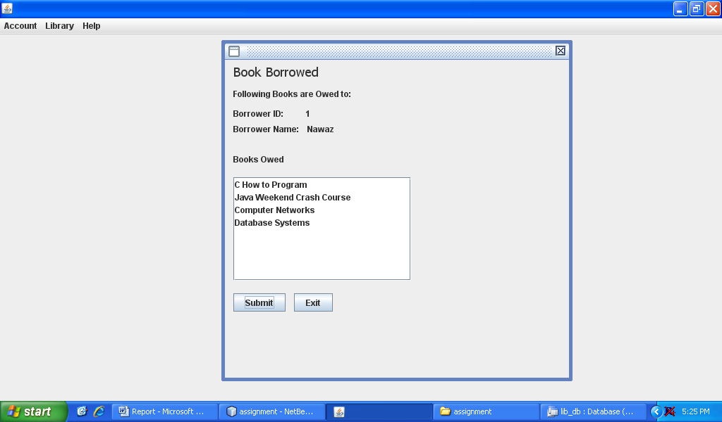
Figure 13: After Submitting the Book It is Not Removed from the List
The book is removed when the book is submitted twice. Figure 14 verfies that book is submitted and removed from the list.
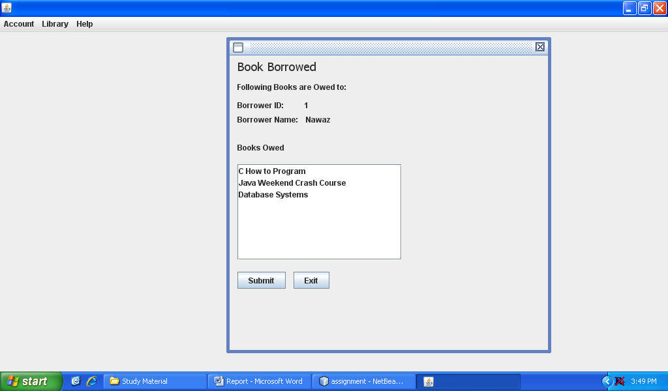
Figure 14: After Submitting the Book It is Not Removed from the List
In Figure 15 the required value is a number, but when a string value is entered the system generated a runtime error, though the program was in running condition waiting for another input.
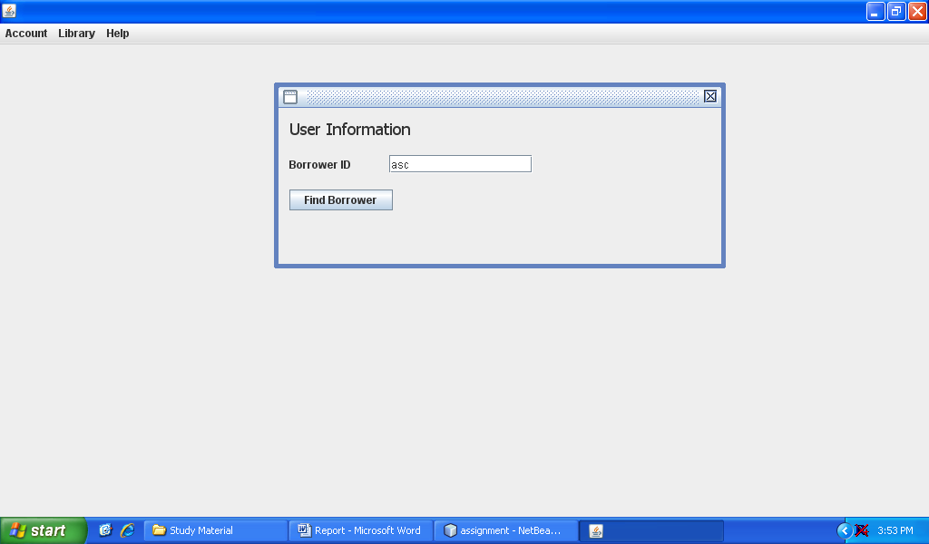
Figure 15: String Value Input as Borrower Id
    - Fine Calculation Test
In figure 15 the books submitted by librarian are submitted according to the current system date, the book was submitted on time and there is no previous find owed to borrower 1. Hence the screen shows the amount £ 0.0. The Figure 16 verifies this.
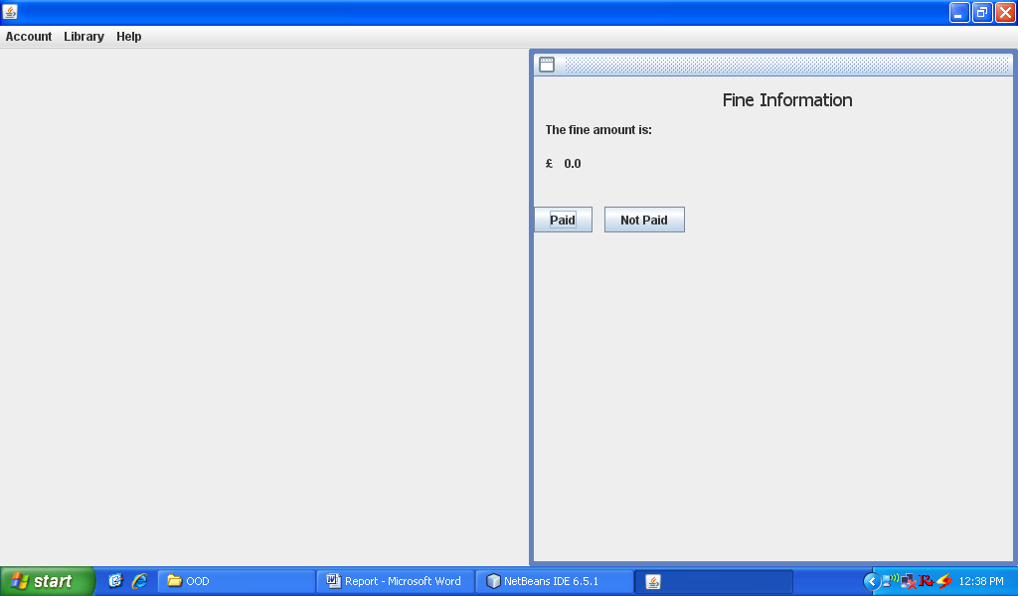
Figure 16: Fine Calculation Verification
  - Test Data
The objective of deriving the test data is to find possible limited combinations of input values that cause the system to produce error or behave in abnormal way. The system developed in the module has three functionality through which user interacts, as in section 4.1 the approach preferred for testing was black box testing, thus in the following section the report will test all the system components that provide interface to the user.
Test Case | Test Data
Librarian Login | [BXB,abd], [56,68], [s,], [,2], [], [^,$], [&3, 0.8], [x8,083]
Identify Borrower | [q], [dd], [&], [AA], [A3], [2BC], [aDx],[3],[-2], [1*1]
Find Book Owed | The system provides the user a list of books that are owed; the input from the system is achieved through mouse click. There is one fault in the system; it does not remove the book as soon as it is submitted. The book is removed by clicking the submit button twice. Data come from database, therefore no input data is devised here.
Fine Calculation | The fine is calculated based upon the date due and date return. The outcome is dependant on values from database. Hence no set of data can be devised here.
Table 1: Sample Test Data
The librarian case accepts two inputs (user name and password), therefore two combinations of input values are shown in the table.

References:
- Maciaszek, L.A. and Liong, B.L. (2005) Practical Software Engineering. A Case Study Approach, (Ch5). Addison Wesley, Harlow England, ISBN: 0 321 20465 4
- Roger S. Pressman (2001) Software Engineering: A Practitioner Approach (2005) Practical Software Engineering. A Case Study Approach, (Ch17,18). McGraw Hill Publication, ISBN: 0 07 365578 3
- Jalote, Pankaj (2005) [1991]. An Integrated Approach to Software Engineering (3rd ed.). Springer. ISBN 0-387-20881-X.
- Carlo (2003) [1991]. Fundamentals of Software Engineering (2nd ed.). Pearson Education Prentice-Hall.

