Weekly Work Log for CPSC 49200
Project Title | Your AI Doppelganger
Team members | Carlos Manzo
Start date | 11/08/2025
End date | 11/14/2025
Github repository URL | https://github.com/cmanzo20/YourAIDoppelganger
List your major accomplishments this week | Implemented dynamically changing loading message  Connected frontend to backend with successful API Calls  Page Rerender debugging
Check here to verify that you have updated the Work Log tab on the Project Tracker spreadsheet and have updated it in your GitHub repository. | I have updated the Project Tracker with this week’s work, and the updated version is on GitHub

The rest of this activity log describes and demonstrates the accomplishments listed above. (Feel free to copy the Accomplishment sections for as many accomplishments as you listed above. Make sure you delete this explanatory text as well as the explanatory text that appears in each section below. In other words, make sure this report contains content relevant just to your project.)

Accomplishment #1: Inserted dynamically changing loading message

Description
For this task, I simply wanted to have a loading message appear while files were being uploaded by the user and the AI model was being trained. To complete this, I had to learn a little bit about asynchronous JavaScript functions so that the loading message was dynamically updated at the correct times. This did not take too much time as I was already somewhat familiar with them. The message now works correctly and tells the user that the model is being trained and files are being uploaded at the correct times.

Implementation

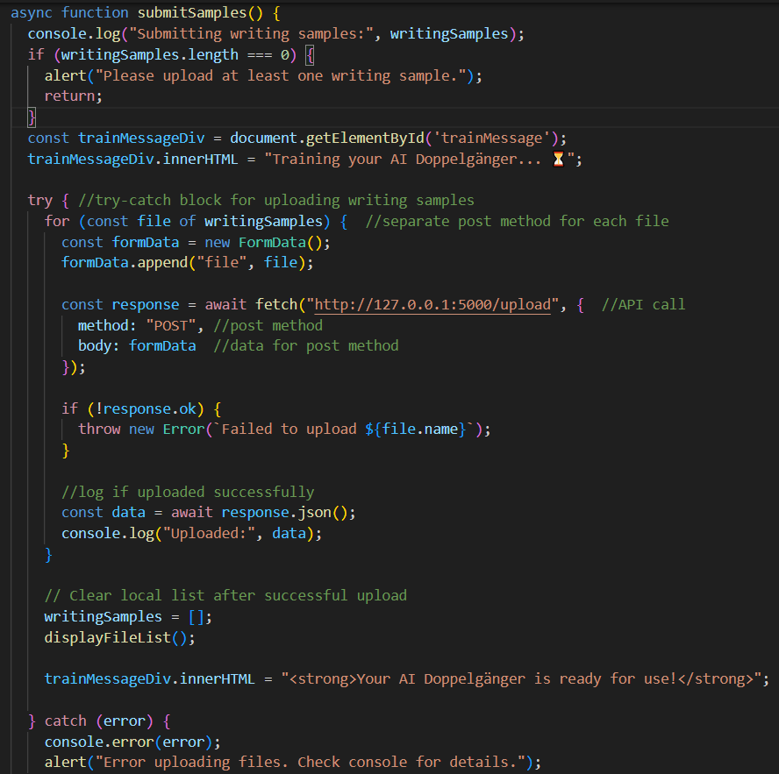
The above code shows the entire JavaScript function where the files are submitted. While the file is being submitted, the div is updated to tell the user that the AI doppelganger is being trained while the files are being uploaded. At the end of the function, the message is updated to say that the AI is ready for use. As of now, the AI model is not yet trained in this function, but adding the AI training should work just fine with the loading message.

List of relevant code / content files
Index.js- this is the file on github that contains the above code.

Outcome
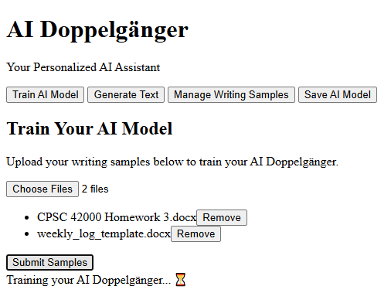
This is what the user sees while the AI is being trained.
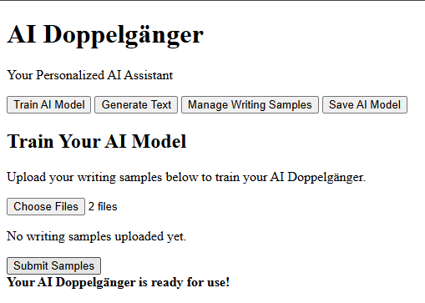
This is what the user sees after a successful file upload (and later AI training).

Accomplishment #2: Successfully Connected Frontend to Backend- Successful API Calls

Description
For this task, I wanted to connect the frontend of my application to the backend. This meant performing successful API calls to the backend of the application from the frontend. To do this, I had to call the location of my local server and call its post request from the frontend js file. Completing this step is important, because it is how my user will access the resources stored on the backend and will be used later on throughout the application.

Implementation
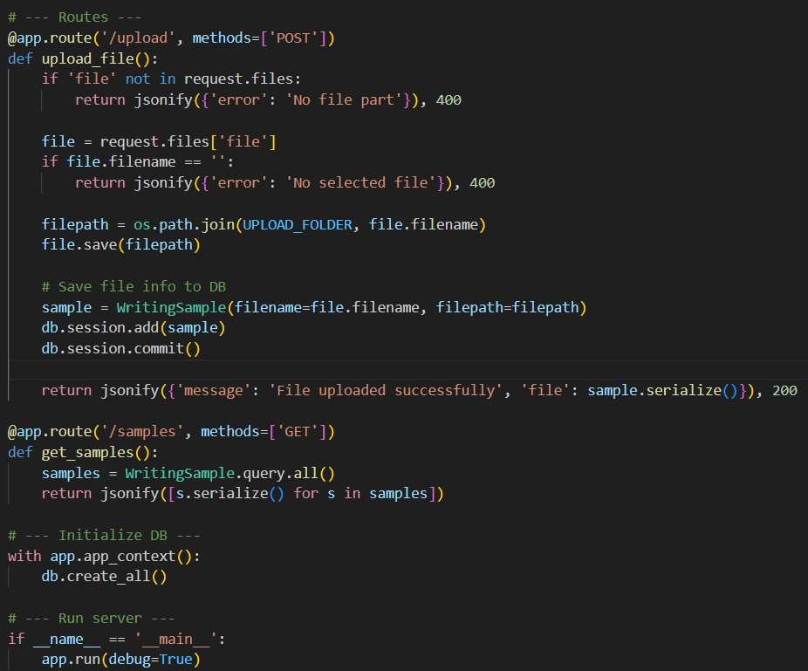
Above are the API routes on our python backends. In a nutshell, these are the API endpoints that our backend calls.
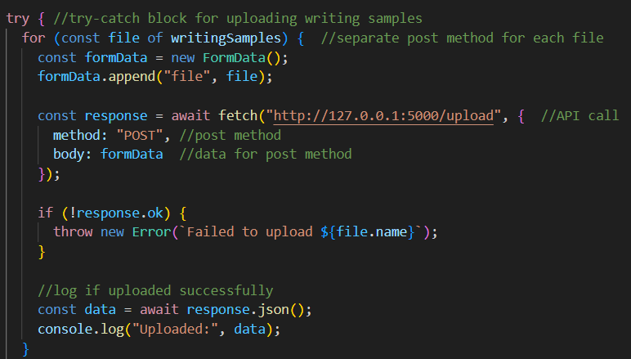
This is the JavaScript code used to call our backend from the frontend. Here, we attempt a post request with the files uploaded by the user. A successful API call should be logged to our frontend console.

List of relevant code / content files
App.py- contains our API endpoints that we call
index.js- contains the code that calls our API endpoints and uploads data

Outcome

Accomplishment #3: Insert title here (delete if not relevant)

Description
Write a paragraph describing what you set out to do for this particular accomplishment.

Implementation
Show the code or other content you wrote to accomplish the goal. Include descriptions of how each code or other content you are including here works.
Alternatively, if this is a test you performed, describe how you conducted the test, perhaps by including the step-by-step script.

List of relevant code / content files
Name and briefly describe the code files or other artifacts that are on GitHub so that others (such as the instructor) can review them. The code files you list here should relate to what you highlighted in the Implementation section.
Alternatively, if this is a test you performed, include the code for the unit test, or if it wasn’t an automated test, simply comment here that the test was performed manually and there is no code or content associated with this.

Outcome
Show screenshots of the result of your work along with a description of what each screenshot shows. What you show should relate to this particular accomplishment you are describing in this section. If this accomplishment regards a test you performed, show the outcome of the test as it appeared on the screen.

