NCI DAC Data Access Committee dbGaP Activity Report 2020-10-01-2020-10-15

hoyin

29 October, 2020

The NCI DAC Data Access Committee (DAC) currently manages 0 data access requests (DARs) for access to 0 projects in dbGaP.

# 1 Data Access Requests

Between 2020-10-01 and 2020-10-15 the DAC reviewed 675 DARs. Of these, 574 were accepted while 94 were rejected. The average amount of time from when the Principle Investigator (PI) submited a DAR to the final decision by the DAC was 0 days. The average time to an accepted decision was 4.40991216608595 days, while the average time to a rejected decision was 10.0265218676123 days. Figure 1.1 is a barplot comparing the NCI DAC DAC to time to final decision to the average across all NIH DACs during the same time interval.

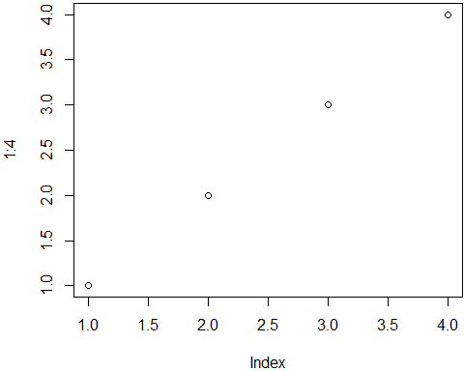

Figure 1.1: Comparison of Time to Final Decision

# 2 Study Registrations

This report was prepared using the DACReportingTool package for R, build 0.0.1 by Mr. Hoyin Chu and Dr. Christopher Steven Marcum.