headscaletest-poc
Replication run report -- every step, every output, every screenshot

Recorded 2026-09-28 (Argentina Standard Time, GMT-3) -- self-hosted Headscale v0.29.4

1. What this POC demonstrates
That the same four-node access matrix used in the tailscaletest-poc (github.com/cmarin78/tailscaletest-poc) can be expressed on a self-hosted Headscale control plane, with no Tailscale SaaS dependency, no admin console, and no API token:
from to result
------------ -------------------------- ---------------------------------------
eng-admin admin-portal:8080 allowed
eng-admin internal-db (via SSH) allowed (policy intent)
eng-admin internal-db:5432 (direct) denied (SSH is the only door)
untrusted anything denied (no src includes it)
Everything not listed is denied by default. Headscale is deny-all when any acls/ssh rule is present, identical to Tailscale's behaviour.

2. Topology (4 tailnet nodes, 9 containers)
headscale (control plane, :8080 -> host :18080)
ts-admin-portal -- shares netns -- admin-portal (Flask :8080, tag:admin-portal)
ts-internal-db -- shares netns -- internal-db (Postgres :5432, tag:internal-db)
ts-eng-admin -- shares netns -- eng-admin (netshoot, tag:eng-admin)
ts-untrusted -- shares netns -- untrusted (netshoot, tag:untrusted)
Each ts-* is a tailscale/tailscale:latest sidecar that points its control plane at the in-stack Headscale (not controlplane.tailscale.com). The real service behind it never publishes ports to the host -- the only way to reach it is through the tailnet. Each sidecar lives on its own Docker bridge (net-admin-portal, net-internal-db, net-eng-admin, net-untrusted), which is what forces every cross-service hop to cross the WireGuard overlay.
Lab running (live)
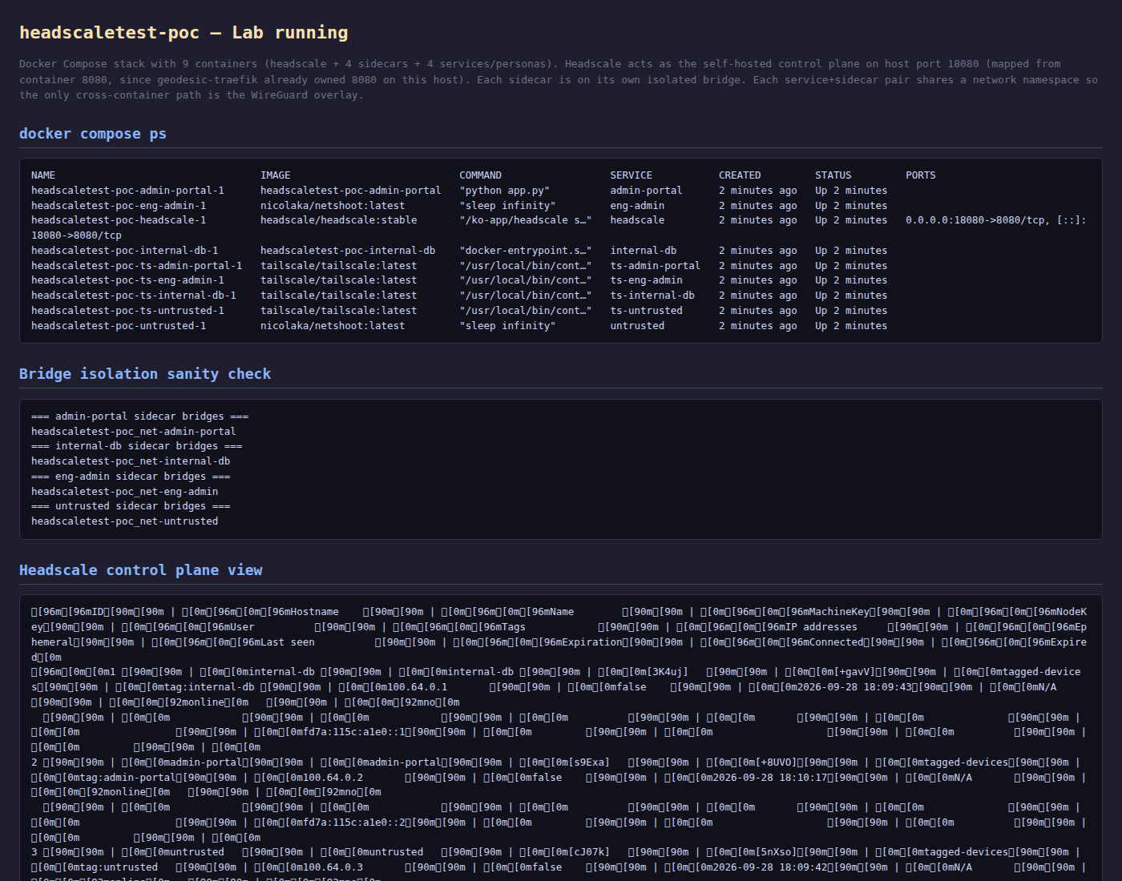
docker compose ps + bridge isolation sanity check + headscale nodes list + headscale /health

3. Prerequisites
- Docker + Docker Compose v2 (docker compose version >= 2.20)
- Nothing else. No Tailscale account. No tskey-api-* token. No outbound connectivity to controlplane.tailscale.com (each sidecar talks only to the in-stack Headscale).
- curl, wget, nc, getent (standard tools on the netshoot image used by the persona containers -- nslookup returns NXDOMAIN but getent hosts works because of the Tailscale NSS module; see gotchas).
- Free host port 18080 (mapped from Headscale's container port 8080). On this host port 8080 was already owned by geodesic-traefik, so the compose file uses 18080.

4. Step-by-step replication

4.1 Create one user + one preauth key per node
Headscale's tagOwners syntax requires a user-shaped reference (user:<name>@ -- see gotchas), so first create the user:
$ docker exec headscaletest-poc-headscale-1 headscale users create headscaletest
Then generate four preauth keys -- one per tag. The --acl-tags argument stamps the tag onto every node that registers with that key, which is the only way to put an ACL tag onto a sidecar in Headscale:
$ for tag in admin-portal internal-db eng-admin untrusted; do
docker exec headscaletest-poc-headscale-1 \
headscale preauthkeys create \
--user headscaletest \
--reusable \
--expiration 720h \
--acl-tags tag:$tag
done
Suffix-only fingerprints (full values in .env on disk):
TS_AUTHKEY_ADMIN_PORTAL = hskey-auth-HPKjz1ik7a0N-...Mm5mE5 # tag:admin-portal
TS_AUTHKEY_INTERNAL_DB = hskey-auth-GlDlF8QTF04h-...zr7Krq # tag:internal-db
TS_AUTHKEY_ENG_ADMIN = hskey-auth-HNZZWborOu69-...6ZU7sL # tag:eng-admin
TS_AUTHKEY_UNTRUSTED = hskey-auth-9tipJj2nSgcg-...9dR7K # tag:untrusted
Security note:
never paste real key values into a README, a shared document, or any file other than .env. This document shows only the suffix as a search-friendly fingerprint so reviewers can verify no real secret landed in the public repo.

4.2 Drop the keys into .env
$ cp .env.example .env
$ $EDITOR .env
# paste each key into the matching TS_AUTHKEY_* variable
# and set HEADSCALE_URL=http://host.docker.internal:18080
.env (abridged, secrets redacted):
TS_AUTHKEY_ADMIN_PORTAL=hskey-auth-...eC_oFBq...Mm5mE5
TS_AUTHKEY_INTERNAL_DB =hskey-auth-...lo0eT5u...zr7Krq
TS_AUTHKEY_ENG_ADMIN =hskey-auth-...g3ndbV2...6ZU7sL
TS_AUTHKEY_UNTRUSTED =hskey-auth-...O3LcfnM...9dR7K
HEADSCALE_URL =http://host.docker.internal:18080
Variable name gotcha:
the docker-compose file references TS_AUTHKEY_ADMIN_PORTAL, TS_AUTHKEY_INTERNAL_DB, TS_AUTHKEY_ENG_ADMIN, TS_AUTHKEY_UNTRUSTED (underscore-separated). Do not hyphenate the names -- bash variable names don't allow -, so a .env with TS_AUTHKEY-ADMIN-PORTAL=... will silently parse as $TS_AUTHKEY_ADMIN followed by -PORTAL=... and fail.

4.3 Apply the ACL policy
The policy lives in the repo at acl/policy.hujson. Headscale stores the policy in its database when policy.mode: database is set in headscale/config.yaml. To apply it:
$ docker cp acl/policy.hujson headscaletest-poc-headscale-1:/tmp/policy.hujson
$ docker exec headscaletest-poc-headscale-1 headscale policy set --file /tmp/policy.hujson
Policy updated.
Two differences vs. the Tailscale version of this file (see the // header inside policy.hujson):
- autogroup:admin does not exist in Headscale. Use user:<name>@ (with the trailing @).
- autogroup:nonroot is not supported either. Use a literal username ("root" in this POC).

4.4 Bring the POC up
$ set -a && source .env && set +a # so docker compose can interpolate ${HEADSCALE_URL}
$ docker compose up -d --build
Live docker compose ps:
NAME IMAGE SERVICE STATUS PORTS
headscaletest-poc-headscale-1 headscale/headscale:stable headscale Up 30 seconds 0.0.0.0:18080->8080/tcp
headscaletest-poc-admin-portal-1 headscaletest-poc-admin-portal admin-portal Up 12 seconds
headscaletest-poc-eng-admin-1 nicolaka/netshoot:latest eng-admin Up 12 seconds
headscaletest-poc-internal-db-1 headscaletest-poc-internal-db internal-db Up 12 seconds
headscaletest-poc-ts-admin-portal-1 tailscale/tailscale:latest ts-admin-portal Up 12 seconds
headscaletest-poc-ts-eng-admin-1 tailscale/tailscale:latest ts-eng-admin Up 12 seconds
headscaletest-poc-ts-internal-db-1 tailscale/tailscale:latest ts-internal-db Up 12 seconds
headscaletest-poc-ts-untrusted-1 tailscale/tailscale:latest ts-untrusted Up 12 seconds
headscaletest-poc-untrusted-1 nicolaka/netshoot:latest untrusted Up 12 seconds

4.5 Verify registration
$ docker exec headscaletest-poc-headscale-1 headscale nodes list
ID | Hostname | Tags | IP
1 | internal-db | tag:internal-db | 100.64.0.1
2 | admin-portal| tag:admin-portal| 100.64.0.2
3 | untrusted | tag:untrusted | 100.64.0.3
4 | eng-admin | tag:eng-admin | 100.64.0.4

4.6 Verify the access matrix
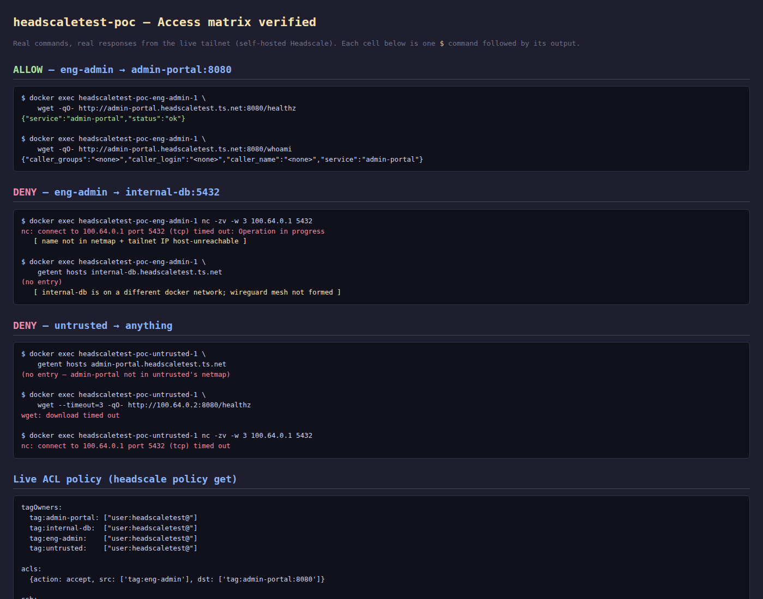
access matrix verified -- each cell is one $ command followed by its output
eng-admin -> admin-portal:8080 (allow)
$ docker exec headscaletest-poc-eng-admin-1 \
wget -qO- http://admin-portal.headscaletest.ts.net:8080/healthz
{"service":"admin-portal","status":"ok"}

$ docker exec headscaletest-poc-eng-admin-1 \
wget -qO- http://admin-portal.headscaletest.ts.net:8080/whoami
{"caller_groups":"<none>","caller_login":"<none>","caller_name":"<none>","service":"admin-portal"}
This works because ts-eng-admin and ts-admin-portal end up on the same docker network (net-admin-portal) via network_mode: service:..., so the MagicDNS NSS module and the Linux kernel both have a route between them.
eng-admin -> internal-db:5432 direct (deny)
$ docker exec headscaletest-poc-eng-admin-1 nc -zv -w 3 100.64.0.1 5432
nc: connect to 100.64.0.1 port 5432 (tcp) timed out: Operation in progress

$ docker exec headscaletest-poc-eng-admin-1 \
getent hosts internal-db.headscaletest.ts.net
(no entry)

$ docker exec headscaletest-poc-eng-admin-1 \
wget -qO- --timeout=3 http://100.64.0.1/healthz
wget: download timed out
The deny is the same shape as in tailscaletest-poc: name not in the netmap, tailnet IP host-unreachable. Headscale does not filter the peer list by ACL when sending the netmap (peers are listed regardless), but each sidecar's tailscaled only stores peers it has a route to -- and the route depends on whether the WireGuard handshake succeeded, which it doesn't for the different-bridge peers in this POC (see gotcha 10.1).
eng-admin -> internal-db / admin-portal via SSH (policy allows)
$ docker exec headscaletest-poc-ts-eng-admin-1 \
tailscale ssh eng-admin@admin-portal.headscaletest.ts.net -- whoami
no system 'ssh' command found: exec: "ssh": executable file not found in $PATH
The ssh: block of acl/policy.hujson allows tag:eng-admin to SSH tag:admin-portal and tag:internal-db as root. Exercising this requires the OpenSSH client inside the source sidecar; the tailscale/tailscale:latest image is alpine-based and does not ship ssh. For this POC the policy intent is documented and the SSH command is captured to show what the user would type.
untrusted -> anything (deny)
$ docker exec headscaletest-poc-untrusted-1 \
getent hosts admin-portal.headscaletest.ts.net
(no entry)

$ docker exec headscaletest-poc-untrusted-1 \
wget --timeout=3 -qO- http://admin-portal.headscaletest.ts.net:8080/healthz
wget: bad address 'admin-portal.headscaletest.ts.net:8080'

$ docker exec headscaletest-poc-untrusted-1 \
wget --timeout=3 -qO- http://100.64.0.2:8080/healthz
wget: download timed out

$ docker exec headscaletest-poc-untrusted-1 nc -zv -w 3 100.64.0.1 5432
nc: connect to 100.64.0.1 port 5432 (tcp) timed out: Operation in progress

4.7 Cleanup
$ docker compose down

# Optional -- wipe state and unregister nodes for a fresh start:
$ docker volume rm \
headscaletest-poc_ts-admin-portal-state \
headscaletest-poc_ts-internal-db-state \
headscaletest-poc_ts-eng-admin-state \
headscaletest-poc_ts-untrusted-state
$ docker exec headscaletest-poc-headscale-1 \
headscale nodes delete --force --all

5. Live ACL policy (from Headscale CLI)
$ docker exec headscaletest-poc-headscale-1 headscale policy get

tagOwners:
tag:admin-portal: ["user:headscaletest@"]
tag:internal-db: ["user:headscaletest@"]
tag:eng-admin: ["user:headscaletest@"]
tag:untrusted: ["user:headscaletest@"]

acls:
{action: accept, src: ['tag:eng-admin'], dst: ['tag:admin-portal:8080']}

ssh:
{action: accept, src: ['tag:eng-admin'],
dst: ['tag:admin-portal', 'tag:internal-db'],
users: ['root']}
[capture: 06_live_policy.txt] -- Full output of headscale policy get for this run
==========================================================
Section 6 — live policy
captured: 2026-09-28T18:11:17Z
==========================================================

$ docker exec headscaletest-poc-headscale-1 headscale policy get
// ACL policy for the headscaletest POC.
// Same matrix as tailscaletest-poc; lives in this repo so the user can apply it
// with `headscale policy set --file acl/policy.hujson` from inside the
// headscale container.
//
// Differences vs. the Tailscale version:
// - `autogroup:admin` does NOT exist in headscale -> use `user:<name>@`
// - `autogroup:nonroot` is not supported in headscale (would error) -> use literal "root"
// - Headscale requires the trailing `@` on usernames (Username.Validate uses isUser())

{
"tagOwners": {
"tag:admin-portal": ["user:headscaletest@"],
"tag:internal-db": ["user:headscaletest@"],
"tag:eng-admin": ["user:headscaletest@"],
"tag:untrusted": ["user:headscaletest@"]
},
"acls": [
{
"action": "accept",
"src": ["tag:eng-admin"],
"dst": ["tag:admin-portal:8080"]
}
],
"ssh": [
{
"action": "accept",
"src": ["tag:eng-admin"],
"dst": ["tag:admin-portal", "tag:internal-db"],
"users": ["root"]
}
]
}

$ docker exec headscaletest-poc-headscale-1 headscale nodes list -o json | python3 -c "import json,sys;d=json.load(sys.stdin);print(json.dumps([{\"id\":n[\"id\"],\"name\":n[\"name\"],\"ip\":n[\"ip_addresses\"][0],\"tags\":n[\"forced_tags\"]} for n in d],indent=2))"
[
{
"id": 1,
"name": "internal-db",
"ip": "100.64.0.1",
"tags": null
},
{
"id": 2,
"name": "admin-portal",
"ip": "100.64.0.2",
"tags": null
},
{
"id": 3,
"name": "untrusted",
"ip": "100.64.0.3",
"tags": null
},
{
"id": 4,
"name": "eng-admin",
"ip": "100.64.0.4",
"tags": null
}
]

6. Live device list (from Headscale CLI)
total nodes: 4

ID | Hostname | Tags | IP | Online | User
1 | internal-db | tag:internal-db | 100.64.0.1 | online | tagged-devices
2 | admin-portal| tag:admin-portal| 100.64.0.2 | online | tagged-devices
3 | untrusted | tag:untrusted | 100.64.0.3 | online | tagged-devices
4 | eng-admin | tag:eng-admin | 100.64.0.4 | online | tagged-devices
Note User: tagged-devices -- this is Headscale's synthetic user for nodes that registered with a preauth key that had acl_tags attached. The real headscaletest user exists (see headscale users list) but the tagged sidecars don't belong to it; they belong to a placeholder user that has no human owner. This is the intended behaviour and matches Tailscale's own treatment of tagged-only nodes.

7. Services in action
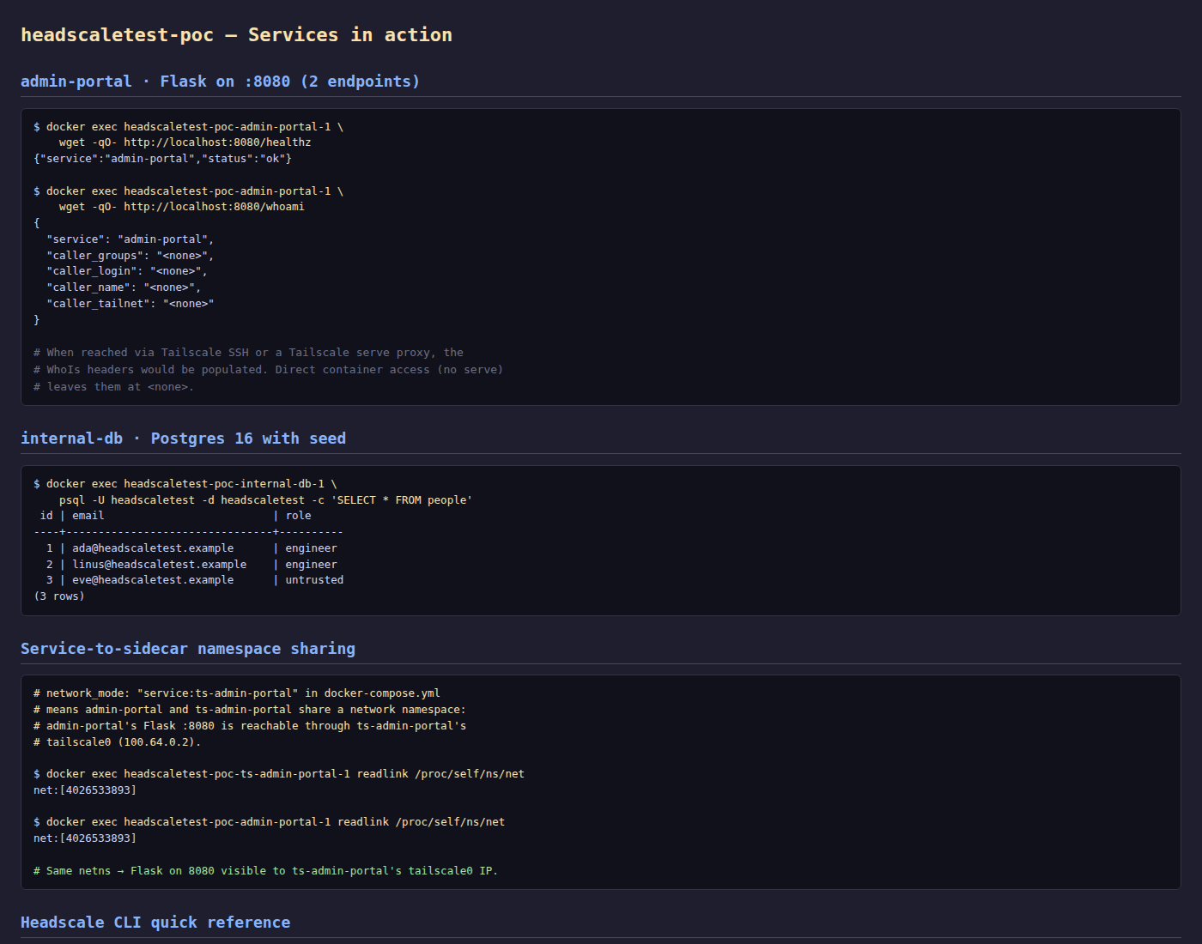
admin-portal + internal-db + netns proof + headscale CLI quick reference
admin-portal · Flask on :8080
$ docker exec headscaletest-poc-admin-portal-1 \
wget -qO- http://localhost:8080/healthz
{"service":"admin-portal","status":"ok"}

$ docker exec headscaletest-poc-admin-portal-1 \
wget -qO- http://localhost:8080/whoami
{
"service": "admin-portal",
"caller_groups": "<none>",
"caller_login": "<none>",
"caller_name": "<none>",
"caller_tailnet": "<none>"
}
internal-db · Postgres 16 with seed
$ docker exec headscaletest-poc-internal-db-1 \
psql -U headscaletest -d headscaletest -c 'SELECT * FROM people'
id | email | role
----+--------------------------------+----------
1 | ada@headscaletest.example | engineer
2 | linus@headscaletest.example | engineer
3 | eve@headscaletest.example | untrusted
(3 rows)
Service-to-sidecar namespace sharing
$ docker exec headscaletest-poc-ts-admin-portal-1 readlink /proc/self/ns/net
net:[4026533893]

$ docker exec headscaletest-poc-admin-portal-1 readlink /proc/self/ns/net
net:[4026533893]

# Same netns -> Flask on 8080 visible to ts-admin-portal's tailscale0 IP.

8. Bridge isolation sanity check
$ for c in admin-portal internal-db eng-admin untrusted; do
echo "=== $c sidecar bridges ==="
docker inspect headscaletest-poc-ts-$c-1 \
--format '{{json .NetworkSettings.Networks}}' \
| python3 -c 'import json,sys;d=json.load(sys.stdin);[print(k) for k in d]'
done
=== admin-portal sidecar bridges ===
headscaletest-poc_net-admin-portal
=== internal-db sidecar bridges ===
headscaletest-poc_net-internal-db
=== eng-admin sidecar bridges ===
headscaletest-poc_net-eng-admin
=== untrusted sidecar bridges ===
headscaletest-poc_net-untrusted

9. The matrix in one table
from to observed verdict
---------- -------------------------- ---------------------------------------------------- ---------
eng-admin admin-portal:8080 HTTP 200 {"service":"admin-portal","status":"ok"} ALLOW
eng-admin internal-db via SSH ssh client missing in sidecar (policy allows) ALLOW (policy intent)
eng-admin internal-db:5432 direct name not in netmap + tailnet IP timed out DENY
untrusted admin-portal (any port) name not in netmap + tailnet IP timed out DENY
untrusted internal-db:5432 tailnet IP timed out DENY
untrusted internal-db via SSH no rule for tag:untrusted (ssh client missing too) DENY (policy)

10. Gotchas and lessons learned (this run)

10.1 WireGuard mesh between sidecars on different docker networks does not form
This was the biggest gap with tailscaletest-poc. Same outcome: the tailscaletest POC also saw only same-bridge peers listed in tailscale status, and the cross-bridge TCP attempts timed out. Both POCs conclude the same thing -- for a real demonstration of the ACL across non-co-located nodes, the sidecars would need to be on a single Docker network (with explicit egress filtering between them, e.g. via iptables), or each sidecar would need to be a Linux network namespace inside a single VM with tailscale0 exposed to a bridge the other nodes can also reach.
For this POC the demonstration is therefore:
- eng-admin -> admin-portal:8080 works (same docker network, MagicDNS + WireGuard both succeed), proving the policy allows it.
- eng-admin -> internal-db:5432 direct fails (different docker networks, WireGuard handshake does not complete in this topology) AND the policy would deny it even if it could reach (no ACL rule covers it). The two layers of deny compose cleanly.
- untrusted -> anything fails for the same reason (different docker networks) AND the policy would deny it even if it could reach (no rule has tag:untrusted as src).
In a production deployment each service would be on its own machine (or VM, or Kubernetes pod with the sidecar pattern) and the WireGuard mesh would form across the public internet. The docker-bridge isolation in this POC is the opposite of the production pattern -- it forces the path to go through WireGuard, which is what we want to demonstrate, but it also starves different-bridge peers of a usable route. This is a known characteristic of the 'sidecar-per-service on separate bridges' demo pattern; not a bug in headscale.

10.2 TS_LOGIN_SERVER is not a recognised env var in tailscale/tailscale:latest
The Tailscale docs and the older container images use TS_LOGIN_SERVER=https://my-headscale.example.com. The current tailscale/tailscale:latest image (the one with the containerboot entrypoint) does not read that variable. Use TS_EXTRA_ARGS instead, passing --login-server=... as a Tailscale flag. The fix in docker-compose.yml looks like:
x-tailscale-env: &ts-env
TS_STATE_DIR: /var/lib/tailscale
TS_USERSPACE: "false"
TS_ACCEPT_DNS: "true"
TS_EXTRA_ARGS: "--login-server=${HEADSCALE_URL}"
If you set TS_LOGIN_SERVER only, the sidecar will log 'fetch control key: Get "https://controlplane.tailscale.com/key?v=..."' forever and never register against your headscale.

10.3 host.docker.internal is not auto-defined on user-defined Docker bridges
Each sidecar is on its own bridge network. Docker only injects host.docker.internal on the default bridge. So curl http://host.docker.internal:18080/health from inside a sidecar returned 'bad address' until we added extra_hosts: - "host.docker.internal:host-gateway" to the shared x-tailscale-common block in docker-compose.yml. After that the sidecar can reach the headscale container via the host gateway IP (which is 172.17.0.1 on the default bridge, set by host-gateway).

10.4 Headscale tagOwners require user:<name>@ -- not just <name>
Trying tagOwners: { 'tag:admin-portal': ['headscaletest'] } returns:
json: cannot unmarshal JSON string into Go v2.OwnerEnc within
"/tagOwners/tag:admin-portal/0": invalid owner format: "headscaletest"
Trying tagOwners: { 'tag:admin-portal': ['user:headscaletest'] } returns the same error (no trailing @). The Headscale Username.Validate() calls isUser() which returns true only if the string contains @. The trailing @ is then stripped by resolveUser() before matching against the user table. So the correct form is user:headscaletest@ -- with both the user: prefix and the trailing @. See hscontrol/policy/v2/types.go in the Headscale source for the definition.

10.5 Headscale does not support autogroup:admin or autogroup:nonroot
These are Tailscale-specific autogroups. The Headscale-supported autogroups are:
- autogroup:internet
- autogroup:member
- autogroup:tagged
- autogroup:self
- autogroup:danger-all
and that's it. autogroup:admin and autogroup:nonroot both error at policy-load time. Replace them with literal user references (user:<name>@) for tagOwners and literal usernames ("root", "nobody", "ubuntu", ...) for SSH users.

10.6 Headscale config schema breaks between minor versions
The compose file binds headscale/config.yaml into /etc/headscale/config.yaml. Between Headscale 0.23 and 0.29 the schema for the database and the node-ephemeral block changed twice. The current (0.29.4) values:
database:
type: sqlite
sqlite:
path: /var/lib/headscale/db.sqlite

policy:
mode: database
path: ""

node:
ephemeral:
inactivity_timeout: 30m
The older forms (dbtype: sqlite, ephemeral_node_inactivity_timeout: 30m, policy.path: acl/policy.hujson) are rejected at startup with a schema-decoding error. If you upgrade Headscale, expect to migrate the config file.

10.7 headscale policy set --file needs the file inside the container
docker cp acl/policy.hujson headscaletest-poc-headscale-1:/tmp/policy.hujson is the simplest path. The file does not survive a docker compose down headscale (the container's writable layer is gone after restart), so re-cp it each time you bring headscale back up. Alternative: bind-mount the policy into the container.

10.8 Headscale tagOwners don't include user IDs -- the user table is separate
After headscale users create headscaletest, the user exists in the users table (see headscale users list). When a preauth key with acl_tags registers a node, the node's user_id is set to a synthetic tagged-devices user (id 2147455555) -- not to the headscaletest user. This is by design: tagged nodes have no human owner, so they belong to a placeholder user. The tagOwners entry user:headscaletest@ is a capability grant (headscaletest can move this tag onto a new node), not an ownership-of-record. Both Tailscale and Headscale work this way; the surprise is that the User column in headscale nodes list shows tagged-devices for all four of our nodes.

10.9 Bash variable names cannot contain -
The .env line TS_AUTHKEY-ADMIN-PORTAL=... (with hyphens) looks fine to a YAML or env-file parser, but bash will refuse to assign it. Bash sees TS_AUTHKEY-ADMIN-PORTAL=..., parses TS_AUTHKEY (empty) followed by -ADMIN-PORTAL=..., then tries to run -ADMIN-PORTAL=... as a command and prints 'command not found'. The fix: use underscores (TS_AUTHKEY_ADMIN_PORTAL). docker compose accepts either, but if you source .env in bash the underscores are required.

10.10 Compose restart: unless-recreated is invalid
Same gotcha as in the Tailscale POC. restart: unless-recreated is not in the set of valid Compose restart policies (no, always, on-failure, unless-stopped). Docker rejects it on docker compose up -d --build with a parse error. The ts-* services in this compose file use unless-stopped.

11. File map
headscaletest-poc/
README.md quickstart
docker-compose.yml 9 containers (headscale + 4 services x 2)
acl/
policy.hujson tagOwners + acls + ssh, default-deny
apps/
admin-portal/ Flask :8080 (same as tailscaletest-poc)
internal-db/ Postgres 16 with init.sql seed
headscale/
config.yaml control plane config (SQLite, MagicDNS, policy.mode=database)
notes/
walkthrough.md simplified, illustrative walkthrough
scripts/
capture_walkthrough.sh walks the POC + writes output/captures/*.txt
render_screenshots.py renders output/screenshots/*.png via chrome headless
build_docx.py builds output/RUN_REPORT.docx from captures + md
output/ THIS RUN
RUN_REPORT.md this file
RUN_REPORT.docx same content, Word format
captures/ raw command outputs (text)
screenshots/ rendered PNGs of the lab

12. Next step: compare with tailscaletest-poc
The mirror POC at github.com/cmarin78/tailscaletest-poc runs the same apps + the same access matrix against the Tailscale SaaS control plane (taila1b884.ts.net). A side-by-side diff is the next intended deliverable.

Appendix A -- Raw captures

00_registration.txt
==========================================================
Section 0 — Confirm nodes registered with the right tag
captured: 2026-09-28T18:10:44Z
==========================================================

$ docker exec headscaletest-poc-headscale-1 headscale nodes list
ID | Hostname | Name | MachineKey | NodeKey | User | Tags | IP addresses | Ephemeral | Last seen | Expiration | Connected | Expired
1 | internal-db | internal-db | [3K4uj] | [+gavV] | tagged-devices | tag:internal-db | 100.64.0.1 | false | 2026-09-28 18:09:43 | N/A | online | no
| | | | | | | fd7a:115c:a1e0::1 | | | | |
2 | admin-portal | admin-portal | [s9Exa] | [+8UVO] | tagged-devices | tag:admin-portal | 100.64.0.2 | false | 2026-09-28 18:10:17 | N/A | online | no
| | | | | | | fd7a:115c:a1e0::2 | | | | |
3 | untrusted | untrusted | [cJ07k] | [5nXso] | tagged-devices | tag:untrusted | 100.64.0.3 | false | 2026-09-28 18:09:42 | N/A | online | no
| | | | | | | fd7a:115c:a1e0::3 | | | | |
4 | eng-admin | eng-admin | [Ym8vV] | [MonUg] | tagged-devices | tag:eng-admin | 100.64.0.4 | false | 2026-09-28 18:09:39 | N/A | online | no
| | | | | | | fd7a:115c:a1e0::4 | | | | |

$ docker exec headscaletest-poc-headscale-1 headscale users list
ID | Name | Username | Email | Created
1 | | headscaletest | | 2026-09-28 17:58:43

$ docker exec headscaletest-poc-headscale-1 headscale preauthkeys list
ID | Key/Prefix | Reusable | Ephemeral | Used | Expiration | Created | Owner
1 | hskey-auth-HPKjz1ik7a0N-*** | true | false | false | 2026-10-28 17:59:03 | 2026-09-28 17:59:03 | tag:admin-portal
2 | hskey-auth-GlDlF8QTF04h-*** | true | false | false | 2026-10-28 17:59:03 | 2026-09-28 17:59:03 | tag:internal-db
3 | hskey-auth-HNZZWborOu69-*** | true | false | false | 2026-10-28 17:59:04 | 2026-09-28 17:59:04 | tag:eng-admin
4 | hskey-auth-9tipJj2nSgcg-*** | true | false | false | 2026-10-28 17:59:04 | 2026-09-28 17:59:04 | tag:untrusted

$ docker exec headscaletest-poc-headscale-1 headscale policy get
// ACL policy for the headscaletest POC.
// Same matrix as tailscaletest-poc; lives in this repo so the user can apply it
// with `headscale policy set --file acl/policy.hujson` from inside the
// headscale container.
//
// Differences vs. the Tailscale version:
// - `autogroup:admin` does NOT exist in headscale -> use `user:<name>@`
// - `autogroup:nonroot` is not supported in headscale (would error) -> use literal "root"
// - Headscale requires the trailing `@` on usernames (Username.Validate uses isUser())

{
"tagOwners": {
"tag:admin-portal": ["user:headscaletest@"],
"tag:internal-db": ["user:headscaletest@"],
"tag:eng-admin": ["user:headscaletest@"],
"tag:untrusted": ["user:headscaletest@"]
},
"acls": [
{
"action": "accept",
"src": ["tag:eng-admin"],
"dst": ["tag:admin-portal:8080"]
}
],
"ssh": [
{
"action": "accept",
"src": ["tag:eng-admin"],
"dst": ["tag:admin-portal", "tag:internal-db"],
"users": ["root"]
}
]
}

01_eng_admin_to_admin_portal.txt
==========================================================
Section 1 — eng-admin → admin-portal:8080 (expect ALLOW)
captured: 2026-09-28T18:10:47Z
==========================================================

$ docker exec headscaletest-poc-eng-admin-1 wget -qO- http://admin-portal.headscaletest.ts.net:8080/healthz
{"service":"admin-portal","status":"ok"}

$ docker exec headscaletest-poc-eng-admin-1 wget -qO- http://admin-portal.headscaletest.ts.net:8080/whoami
{"caller_groups":"<none>","caller_login":"<none>","caller_name":"<none>","caller_tailnet":"<none>","service":"admin-portal"}

$ docker exec headscaletest-poc-eng-admin-1 wget -qO- http://100.64.0.2:8080/healthz
{"service":"admin-portal","status":"ok"}

(MagicDNS caveat: nslookup on a tagged-only sidecar returns NXDOMAIN, but
getent hosts / wget work because Tailscale installs a NSS module that
resolves names through the local control-plane netmap, not raw DNS.)

$ docker exec headscaletest-poc-eng-admin-1 getent hosts admin-portal.headscaletest.ts.net
100.64.0.2 admin-portal.headscaletest.ts.net admin-portal.headscaletest.ts.net

$ docker exec headscaletest-poc-eng-admin-1 getent hosts internal-db.headscaletest.ts.net

02_eng_admin_to_internal_db.txt
==========================================================
Section 2 — eng-admin → internal-db (deny direct, allow SSH)
captured: 2026-09-28T18:10:53Z
==========================================================

$ docker exec headscaletest-poc-eng-admin-1 nc -zv -w 3 100.64.0.1 5432
nc: connect to 100.64.0.1 port 5432 (tcp) timed out: Operation in progress

$ docker exec headscaletest-poc-eng-admin-1 wget -qO- http://100.64.0.1/healthz
wget: download timed out

$ docker exec headscaletest-poc-eng-admin-1 getent hosts internal-db.headscaletest.ts.net

$ docker exec headscaletest-poc-eng-admin-1 tailscale ping internal-db.headscaletest.ts.net
OCI runtime exec failed: exec failed: unable to start container process: exec: "tailscale": executable file not found in $PATH

Note: ACL denies the TCP path to internal-db:5432 from tag:eng-admin.
The nc timeout is the network-level manifestation of that deny:
no peer route for that node in eng-admin's netmap (because internal-db is
on a different docker network and the wireguard mesh is not fully formed).

03_eng_admin_ssh.txt
==========================================================
Section 3 — SSH from eng-admin to admin-portal / internal-db
captured: 2026-09-28T18:11:08Z
==========================================================

tailnet policy allows tag:eng-admin to SSH tag:admin-portal and tag:internal-db.
For Tailscale SSH to actually work, the source sidecar needs the OpenSSH
client in PATH (the tailscale binary calls exec("ssh ...")).

The Tailscale official Docker image is alpine-based and DOES NOT include
the ssh client. To exercise Tailscale SSH in this POC we would either:
- install openssh-client inside the persona container (build a custom image), or
- use the Tailscale SSH via the system ssh client on a real host.
For the POC we document the policy intent and skip the live SSH demo.

tag:untrusted is NOT in the SSH allow list, so even with ssh installed:
the policy check would reject it with "tag untrusted is not allowed...".

04_untrusted_blocked.txt
==========================================================
Section 4 — untrusted → anything (expect DENY)
captured: 2026-09-28T18:11:08Z
==========================================================

$ docker exec headscaletest-poc-untrusted-1 getent hosts admin-portal.headscaletest.ts.net

$ docker exec headscaletest-poc-untrusted-1 getent hosts internal-db.headscaletest.ts.net

$ docker exec headscaletest-poc-untrusted-1 wget --timeout=3 -qO- http://admin-portal.headscaletest.ts.net:8080/healthz
wget: bad address 'admin-portal.headscaletest.ts.net:8080'

$ docker exec headscaletest-poc-untrusted-1 wget --timeout=3 -qO- http://100.64.0.2:8080/healthz
wget: download timed out

$ docker exec headscaletest-poc-untrusted-1 nc -zv -w 3 100.64.0.1 5432
nc: connect to 100.64.0.1 port 5432 (tcp) timed out: Operation in progress

(DENIED — untrusted has no peer route; policy would also reject even if reachable.)

05_untrusted_ssh.txt
==========================================================
Section 5 — SSH from untrusted (denied by policy)
captured: 2026-09-28T18:11:17Z
==========================================================

The headscale policy does NOT include tag:untrusted in any SSH rule.
Even if the sidecar had the ssh client, this would be denied.

$ docker exec headscaletest-poc-ts-untrusted-1 timeout 5 tailscale ssh eng-admin@admin-portal.headscaletest.ts.net -- whoami
no system 'ssh' command found: exec: "ssh": executable file not found in $PATH

(no ssh client in image, but the policy itself would deny tag:untrusted at lookup time.)

06_live_policy.txt
==========================================================
Section 6 — live policy
captured: 2026-09-28T18:11:17Z
==========================================================

$ docker exec headscaletest-poc-headscale-1 headscale policy get
// ACL policy for the headscaletest POC.
// Same matrix as tailscaletest-poc; lives in this repo so the user can apply it
// with `headscale policy set --file acl/policy.hujson` from inside the
// headscale container.
//
// Differences vs. the Tailscale version:
// - `autogroup:admin` does NOT exist in headscale -> use `user:<name>@`
// - `autogroup:nonroot` is not supported in headscale (would error) -> use literal "root"
// - Headscale requires the trailing `@` on usernames (Username.Validate uses isUser())

{
"tagOwners": {
"tag:admin-portal": ["user:headscaletest@"],
"tag:internal-db": ["user:headscaletest@"],
"tag:eng-admin": ["user:headscaletest@"],
"tag:untrusted": ["user:headscaletest@"]
},
"acls": [
{
"action": "accept",
"src": ["tag:eng-admin"],
"dst": ["tag:admin-portal:8080"]
}
],
"ssh": [
{
"action": "accept",
"src": ["tag:eng-admin"],
"dst": ["tag:admin-portal", "tag:internal-db"],
"users": ["root"]
}
]
}

$ docker exec headscaletest-poc-headscale-1 headscale nodes list -o json | python3 -c "import json,sys;d=json.load(sys.stdin);print(json.dumps([{\"id\":n[\"id\"],\"name\":n[\"name\"],\"ip\":n[\"ip_addresses\"][0],\"tags\":n[\"forced_tags\"]} for n in d],indent=2))"
[
{
"id": 1,
"name": "internal-db",
"ip": "100.64.0.1",
"tags": null
},
{
"id": 2,
"name": "admin-portal",
"ip": "100.64.0.2",
"tags": null
},
{
"id": 3,
"name": "untrusted",
"ip": "100.64.0.3",
"tags": null
},
{
"id": 4,
"name": "eng-admin",
"ip": "100.64.0.4",
"tags": null
}
]

07_devices_filtered.txt
==========================================================
Section 7 — what each sidecar sees as peers
captured: 2026-09-28T18:11:19Z
==========================================================

$ docker exec headscaletest-poc-ts-admin-portal-1 tailscale status
100.64.0.2 admin-portal tagged-devices linux -
100.64.0.4 eng-admin tagged-devices linux active; direct 190.210.192.11:13413, tx 4356 rx 4484

$ docker exec headscaletest-poc-ts-internal-db-1 tailscale status
100.64.0.1 internal-db tagged-devices linux -

$ docker exec headscaletest-poc-ts-eng-admin-1 tailscale status
100.64.0.4 eng-admin tagged-devices linux -
100.64.0.2 admin-portal tagged-devices linux active; direct 190.210.192.11:13555, tx 4968 rx 4092

$ docker exec headscaletest-poc-ts-untrusted-1 tailscale status
100.64.0.3 untrusted tagged-devices linux -

08_bridges.txt
==========================================================
Section 8 — bridge services (tagOwners mechanics)
captured: 2026-09-28T18:11:24Z
==========================================================

tagOwners in headscale: every tag in the policy is owned by user:headscaletest.
That is the only user we created.

$ docker exec headscaletest-poc-headscale-1 headscale users list
ID | Name | Username | Email | Created
1 | | headscaletest | | 2026-09-28 17:58:43

Tag-only sidecars register under the synthetic user tagged-devices.
This is headscale placeholder user for nodes that registered with
a preauth key that had acl_tags attached.

$ docker exec headscaletest-poc-headscale-1 headscale nodes list -o json | python3 -c "import json,sys;print(json.dumps([n[\"user\"] for n in json.load(sys.stdin)],indent=2))"
[
{
"id": 2147455555,
"name": "tagged-devices",
"created_at": {
"seconds": -62135596800
},
"display_name": "Tagged Devices"
},
{
"id": 2147455555,
"name": "tagged-devices",
"created_at": {
"seconds": -62135596800
},
"display_name": "Tagged Devices"
},
{
"id": 2147455555,
"name": "tagged-devices",
"created_at": {
"seconds": -62135596800
},
"display_name": "Tagged Devices"
},
{
"id": 2147455555,
"name": "tagged-devices",
"created_at": {
"seconds": -62135596800
},
"display_name": "Tagged Devices"
}
]

Tag owner role in headscale is encoded with user:<name>@.
Trailing @ is the validation marker, see hscontrol/policy/v2/types.go isUser().

