Cesar Marin

CSE 471 Intro to AI

Project 5

Bayes Nets

Part I. [Bayesnet]

1. **Create the bayes network that you have above in the bayes net**

**tool. Enter the conditional probability tables as appropriate. To**

**show that you have done this task, you need to (1) include a bitmap**

**of the network (use Alt-Printscreen in windows) and (2) include the**

**.xml format representation of the network (you can output this**

**by going to the edit menu, and selecting the first command).**

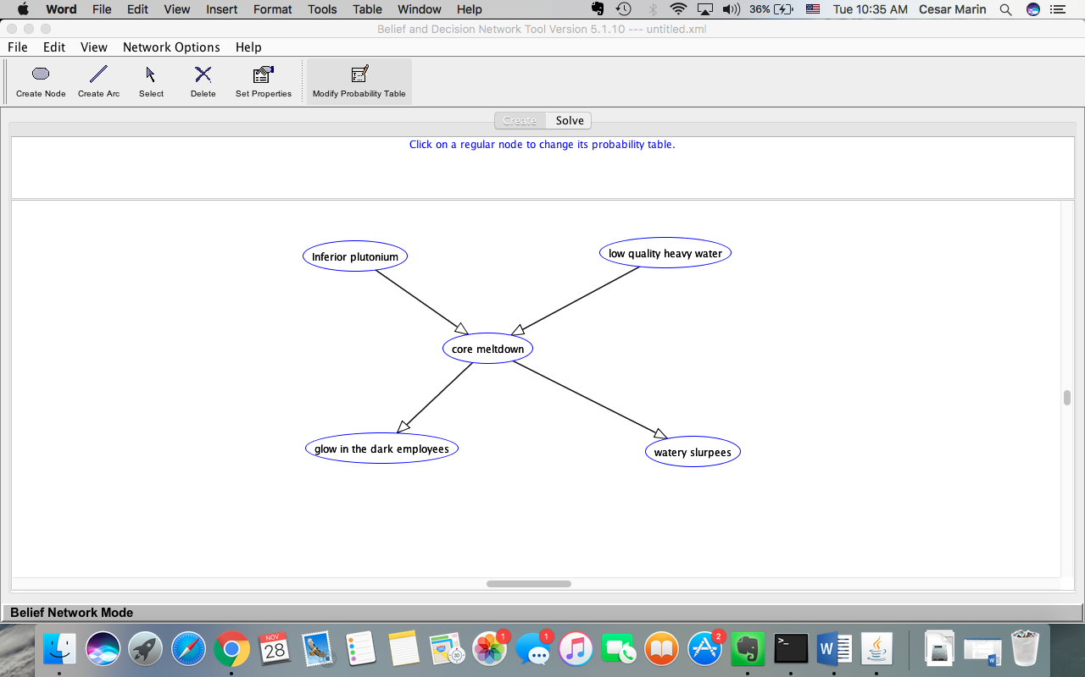

XML:

<?xml version="1.0" encoding="UTF-8"?>

<BIF VERSION="0.3" xmlns="http://www.cs.ubc.ca/labs/lci/fopi/ve/XMLBIFv0_3"

xmlns:xsi="http://www.w3.org/2001/XMLSchema-instance"

xsi:schemaLocation="http://www.cs.ubc.ca/labs/lci/fopi/ve/XMLBIFv0_3 http://www.cs.ubc.ca/labs/lci/fopi/ve/XMLBIFv0_3/XMLBIFv0_3.xsd">

<NETWORK>

<NAME>Untitled</NAME>

<PROPERTY>detailed = </PROPERTY>

<PROPERTY>short = </PROPERTY>

<VARIABLE TYPE="nature">

<NAME>Inferior plutonium</NAME>

<OUTCOME>T</OUTCOME>

<OUTCOME>F</OUTCOME>

<PROPERTY>position = (7174.0, 5064.0)</PROPERTY>

</VARIABLE>

<VARIABLE TYPE="nature">

<NAME>low quality heavy water</NAME>

<OUTCOME>T</OUTCOME>

<OUTCOME>F</OUTCOME>

<PROPERTY>position = (7540.0, 5060.0)</PROPERTY>

</VARIABLE>

<VARIABLE TYPE="nature">

<NAME>core meltdown</NAME>

<OUTCOME>T</OUTCOME>

<OUTCOME>F</OUTCOME>

<PROPERTY>position = (7330.0, 5173.0)</PROPERTY>

</VARIABLE>

<VARIABLE TYPE="nature">

<NAME>glow in the dark employees</NAME>

<OUTCOME>T</OUTCOME>

<OUTCOME>F</OUTCOME>

<PROPERTY>position = (7205.0, 5291.0)</PROPERTY>

</VARIABLE>

<VARIABLE TYPE="nature">

<NAME>watery slurpees</NAME>

<OUTCOME>T</OUTCOME>

<OUTCOME>F</OUTCOME>

<PROPERTY>position = (7572.0, 5295.0)</PROPERTY>

</VARIABLE>

<DEFINITION>

<FOR>Inferior plutonium</FOR>

<TABLE>0.3 0.7</TABLE>

</DEFINITION>

<DEFINITION>

<FOR>low quality heavy water</FOR>

<TABLE>0.4 0.6</TABLE>

</DEFINITION>

<DEFINITION>

<FOR>core meltdown</FOR>

<GIVEN>Inferior plutonium</GIVEN>

<GIVEN>low quality heavy water</GIVEN>

<TABLE>0.44 0.56 0.3 0.7 0.2 0.8 0.0 1.0</TABLE>

</DEFINITION>

<DEFINITION>

<FOR>glow in the dark employees</FOR>

<GIVEN>core meltdown</GIVEN>

<TABLE>0.5 0.5 0.05 0.95</TABLE>

</DEFINITION>

<DEFINITION>

<FOR>watery slurpees</FOR>

<GIVEN>core meltdown</GIVEN>

<TABLE>0.9 0.1 0.1 0.9</TABLE>

</DEFINITION>

</NETWORK>

</BIF>

2. **Now go to the solve pane and evaluate the following**

**queries--in that order. *Comment* on whether the relative values**

**are in accordance with our intuitions.**

P(IP)= 0.3, yes this is in accordance since it’s a given value.

P(IP|ASL)= 0.5, I would say it is in accordance, given that slurpees are watery, there is a 0.5 probability that we got inferior plutionium makes sense.

P(IP|CM)= 0.66, Again I would say it is in accordance. Given core meltdown, I would expect a similar probability that we have inferior plutonium.

P(IP|CM,ASL)= 0.66, it is in accordance, since IP is conditionally independent of ASL given CM.

P(IP|CM,LHW)= 0.49, it makes sense, since these are not conditionally independent (IP and LHW).

**If in the above, any of the probabilities don't change when extra**

**evidence is added, use the D-Separation criterion you learned in the**

**class to verify that it is as expected (for example, if P(IP|CM) is**

**the same as P(IP|CM,ASL) then it must be the case that IP is**

**conditionaly independent of ASL given CM).**

**(You can accomplish these easily by "monitoring" the IP node, and**

**observing/de-observing the appropriate variables).**

**(Glossary: IP--Inferior Plutonium. ASL-->Apu's Slurpees**

**liquify. CM-->Core Meltdown. GID-->Glow in the Dark, LHW-->Low**

**quality Heavy Water).**

Part II [Relations with logic]

1. **Modify the network such that the causations are "perfect" and**

**"exhaustive" (e.g. Inferior plutonium _always_ causes Core Melt down,**

**and core meltdown will not be true if none of its causing variables**

**are true). Confirm that you modified it by including a .xml format**

**representation of the new network.**

**[Note: You will only change the causations. You will keep the prior**

**probabilities of IP and LHW as before.]**

XML:

<?xml version="1.0" encoding="UTF-8"?>

<BIF VERSION="0.3" xmlns="http://www.cs.ubc.ca/labs/lci/fopi/ve/XMLBIFv0_3"

xmlns:xsi="http://www.w3.org/2001/XMLSchema-instance"

xsi:schemaLocation="http://www.cs.ubc.ca/labs/lci/fopi/ve/XMLBIFv0_3 http://www.cs.ubc.ca/labs/lci/fopi/ve/XMLBIFv0_3/XMLBIFv0_3.xsd">

<NETWORK>

<NAME>Untitled</NAME>

<PROPERTY>detailed = </PROPERTY>

<PROPERTY>short = </PROPERTY>

<VARIABLE TYPE="nature">

<NAME>Inferior plutonium</NAME>

<OUTCOME>T</OUTCOME>

<OUTCOME>F</OUTCOME>

<PROPERTY>position = (7174.0, 5064.0)</PROPERTY>

</VARIABLE>

<VARIABLE TYPE="nature">

<NAME>low quality heavy water</NAME>

<OUTCOME>T</OUTCOME>

<OUTCOME>F</OUTCOME>

<OBS>T</OBS>

<PROPERTY>position = (7540.0, 5060.0)</PROPERTY>

</VARIABLE>

<VARIABLE TYPE="nature">

<NAME>core meltdown</NAME>

<OUTCOME>T</OUTCOME>

<OUTCOME>F</OUTCOME>

<OBS>T</OBS>

<PROPERTY>position = (7330.0, 5173.0)</PROPERTY>

</VARIABLE>

<VARIABLE TYPE="nature">

<NAME>glow in the dark employees</NAME>

<OUTCOME>T</OUTCOME>

<OUTCOME>F</OUTCOME>

<PROPERTY>position = (7205.0, 5291.0)</PROPERTY>

</VARIABLE>

<VARIABLE TYPE="nature">

<NAME>watery slurpees</NAME>

<OUTCOME>T</OUTCOME>

<OUTCOME>F</OUTCOME>

<PROPERTY>position = (7572.0, 5295.0)</PROPERTY>

</VARIABLE>

<DEFINITION>

<FOR>Inferior plutonium</FOR>

<TABLE>0.3 0.7</TABLE>

</DEFINITION>

<DEFINITION>

<FOR>low quality heavy water</FOR>

<TABLE>0.4 0.6</TABLE>

</DEFINITION>

<DEFINITION>

<FOR>core meltdown</FOR>

<GIVEN>Inferior plutonium</GIVEN>

<GIVEN>low quality heavy water</GIVEN>

<TABLE>1.0 0.0 1.0 0.0 1.0 0.0 0.0 1.0</TABLE>

</DEFINITION>

<DEFINITION>

<FOR>glow in the dark employees</FOR>

<GIVEN>core meltdown</GIVEN>

<TABLE>1.0 0.0 0.0 1.0</TABLE>

</DEFINITION>

<DEFINITION>

<FOR>watery slurpees</FOR>

<GIVEN>core meltdown</GIVEN>

<TABLE>1.0 0.0 0.0 1.0</TABLE>

</DEFINITION>

</NETWORK>

</BIF>

2. **Write down a set of propositional logic statements that capture the**

**knowledge encoded in the bayes network.**

P(IP) = 0.3

P(LHW) = 0.4

P(CM|IP) = 1.0

P(CM|LHW) = 1.0

P(GID|CM) = 1.0

P(ASL|CM) = 1.0

P(CM|~LP~LWH) = 0.0

These show the ‘perfect causation and exhaustive’ model of the current bayes net.

3. **Evaluate the following probabilities in this bayes network**

P(IP|ASL) = 0.52, they are in line with the propositional logic, if we know that slurpees are liquefied, there is around half chance that we got inferior plutionium.

P(IP|ASL,~LHW) = 1. Again this makes sense, now that LHW is out of the question, then inferior plutionium is the only option to explain ASL.

P(IP|ASL,~GID) = ?. This one does not make sense, and the tool refuses to give an answer. In this perfect causation model, ASL and GID cannot be contradicting states. Either they are both true of both false.

**Interpret the answers. Comment on whether these answers are in line**

**with what propositional logic would have us derive given the**

**formulation in II.2.**

Part III [Reformulating Bayesnet]

**Consider the following alternative way of specifying this bayes**

**net. Here, we introduce the random variables in the following order**

**into the network:**

**1. Apus's slurpees are liquified**

**2. Core melt down occured**

**3. Employees glow in the dark**

**4. Low quality heavy water**

**5. Inferior quality plutonium**

**1. Show the network that will result if we specified the numbers this**

**way (need both the topology as a screen dump, and the .xml format**

**representation). Note that you also need to put in the CPTs**

**(conditional probability tables) for each variable. To do this, you**

**will have to use the network as it existed at the end of Part I.1. as**

**the expert--and get the required CPTs by querying the network.**

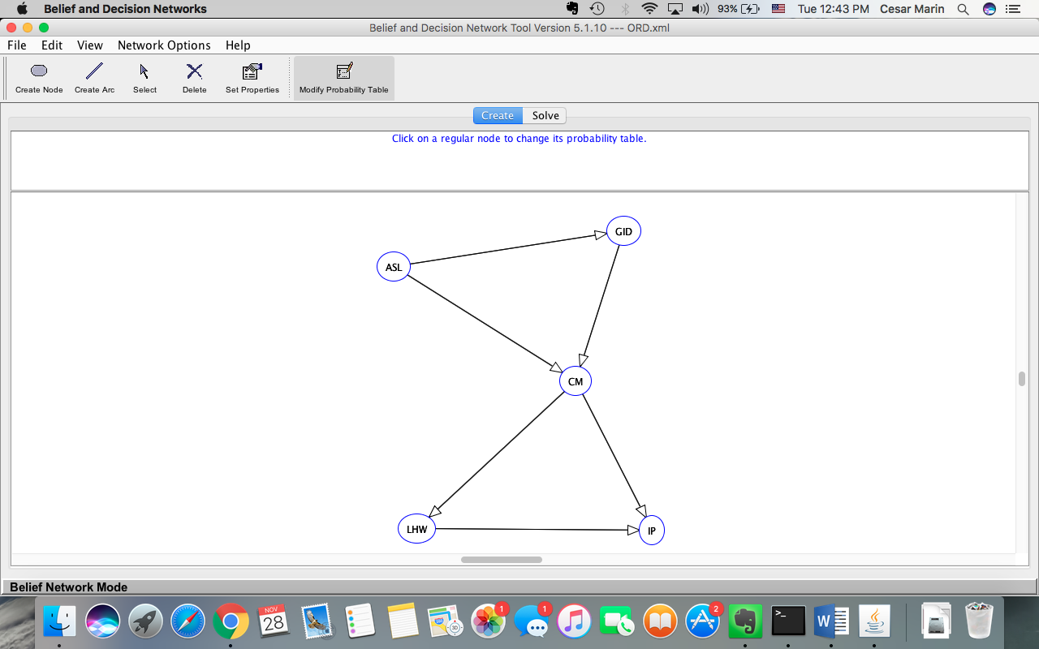

XML:

<?xml version="1.0" encoding="UTF-8"?>

<BIF VERSION="0.3" xmlns="http://www.cs.ubc.ca/labs/lci/fopi/ve/XMLBIFv0_3"

xmlns:xsi="http://www.w3.org/2001/XMLSchema-instance"

xsi:schemaLocation="http://www.cs.ubc.ca/labs/lci/fopi/ve/XMLBIFv0_3 http://www.cs.ubc.ca/labs/lci/fopi/ve/XMLBIFv0_3/XMLBIFv0_3.xsd">

<NETWORK>

<NAME>Untitled</NAME>

<PROPERTY>detailed = </PROPERTY>

<PROPERTY>short = </PROPERTY>

<VARIABLE TYPE="nature">

<NAME>ASL</NAME>

<OUTCOME>T</OUTCOME>

<OUTCOME>F</OUTCOME>

<PROPERTY>position = (7172.2724609375, 5034.4404296875)</PROPERTY>

</VARIABLE>

<VARIABLE TYPE="nature">

<NAME>CM</NAME>

<OUTCOME>T</OUTCOME>

<OUTCOME>F</OUTCOME>

<PROPERTY>position = (7396.28955078125, 5175.0)</PROPERTY>

</VARIABLE>

<VARIABLE TYPE="nature">

<NAME>GID</NAME>

<OUTCOME>T</OUTCOME>

<OUTCOME>F</OUTCOME>

<PROPERTY>position = (7455.58837890625, 4990.515625)</PROPERTY>

</VARIABLE>

<VARIABLE TYPE="nature">

<NAME>LHW</NAME>

<OUTCOME>T</OUTCOME>

<OUTCOME>F</OUTCOME>

<PROPERTY>position = (7200.82373046875, 5357.28955078125)</PROPERTY>

</VARIABLE>

<VARIABLE TYPE="nature">

<NAME>IP</NAME>

<OUTCOME>T</OUTCOME>

<OUTCOME>F</OUTCOME>

<PROPERTY>position = (7490.7275390625, 5359.48486328125)</PROPERTY>

</VARIABLE>

<DEFINITION>

<FOR>ASL</FOR>

<TABLE>0.23 0.77</TABLE>

</DEFINITION>

<DEFINITION>

<FOR>CM</FOR>

<GIVEN>ASL</GIVEN>

<GIVEN>GID</GIVEN>

<TABLE>0.95 0.05 0.48 0.52 0.18 0.82 0.01 0.99</TABLE>

</DEFINITION>

<DEFINITION>

<FOR>GID</FOR>

<GIVEN>ASL</GIVEN>

<TABLE>0.34 0.66 0.06 0.94</TABLE>

</DEFINITION>

<DEFINITION>

<FOR>LHW</FOR>

<GIVEN>CM</GIVEN>

<TABLE>0.67 0.33 0.0 1.0</TABLE>

</DEFINITION>

<DEFINITION>

<FOR>IP</FOR>

<GIVEN>CM</GIVEN>

<GIVEN>LHW</GIVEN>

<TABLE>0.49 0.51 1.0 0.0 0.23 0.77 0.23 0.77</TABLE>

</DEFINITION>

</NETWORK>

</BIF>

**Comment on whether this network is better or worse in terms of number**

**of probabilities that you needed to assess.**

There are the more number of probabilities needed to asses, since there are more connections.

**Once you specify the entire new network, to see that this and the**

**earlier network are equivalent, compute the the following thre**

**probabilities for the new network--and compare your values with the**

**answer for I.2.**

P(IP)= 0.3

P(IP|ASL)= 0.5, same as before.

P(IP|CM) = 0.66, same as before

P(IP|CM,ASL) = 0.66, same as before

P(IP|CM,LHW) = 0.49, same as before

**Part IV:**

**We found out more information about the causes behind Inferior**

**Plutonium (IP) and Low Quality Heavy Water (LHW). It turns out that**

**Mr. Burns' stinginess is partly to blame for these. We know that**

**Mr. Burns _is_ stingy with 0.99 probability. We also found that when he is stingy, he is**

**likely to buy inferior plutonium with probability 0.3 and low quality**

**heavy water with probability 0.4. When he is not stingy, he buys IP**

**with 0.0001 probability and low quality heavy water with 0.0002**

**probability.**

**1. Modify the bayes network to show this improved understanding of the**

**domain. Show the topology as well as the .xml representation**

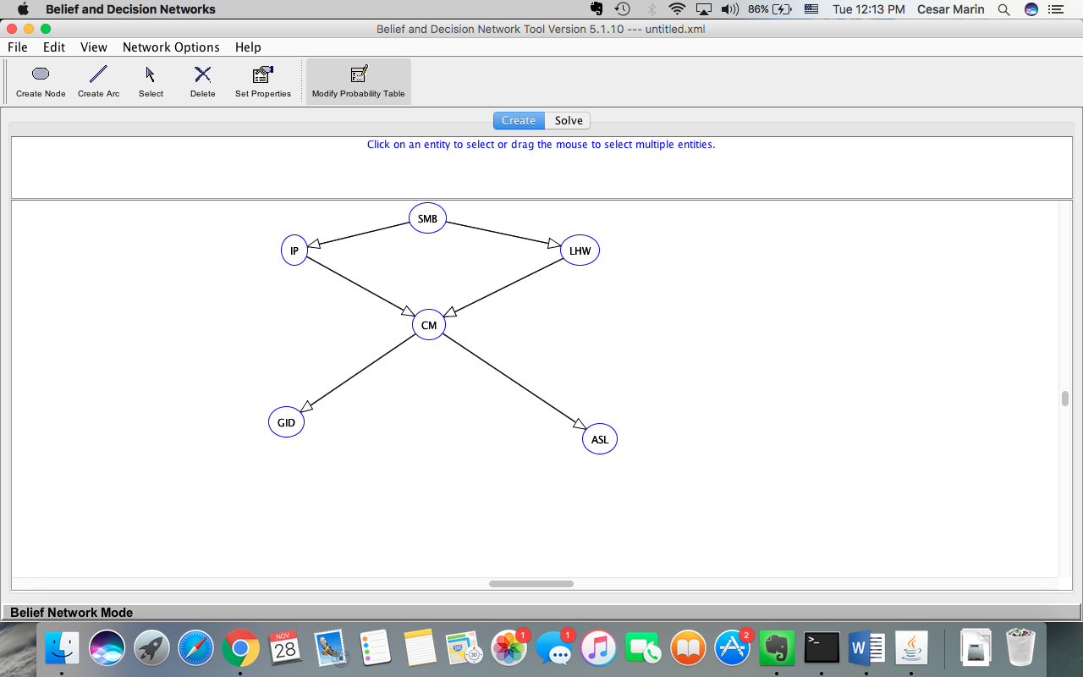

XML:

<?xml version="1.0" encoding="UTF-8"?>

<BIF VERSION="0.3" xmlns="http://www.cs.ubc.ca/labs/lci/fopi/ve/XMLBIFv0_3"

xmlns:xsi="http://www.w3.org/2001/XMLSchema-instance"

xsi:schemaLocation="http://www.cs.ubc.ca/labs/lci/fopi/ve/XMLBIFv0_3 http://www.cs.ubc.ca/labs/lci/fopi/ve/XMLBIFv0_3/XMLBIFv0_3.xsd">

<NETWORK>

<NAME>Untitled</NAME>

<PROPERTY>detailed = </PROPERTY>

<PROPERTY>short = </PROPERTY>

<VARIABLE TYPE="nature">

<NAME>IP</NAME>

<OUTCOME>T</OUTCOME>

<OUTCOME>F</OUTCOME>

<PROPERTY>position = (7159.0, 5074.0)</PROPERTY>

</VARIABLE>

<VARIABLE TYPE="nature">

<NAME>LHW</NAME>

<OUTCOME>T</OUTCOME>

<OUTCOME>F</OUTCOME>

<PROPERTY>position = (7496.0, 5074.0)</PROPERTY>

</VARIABLE>

<VARIABLE TYPE="nature">

<NAME>CM</NAME>

<OUTCOME>T</OUTCOME>

<OUTCOME>F</OUTCOME>

<PROPERTY>position = (7318.0, 5162.0)</PROPERTY>

</VARIABLE>

<VARIABLE TYPE="nature">

<NAME>GID</NAME>

<OUTCOME>T</OUTCOME>

<OUTCOME>F</OUTCOME>

<PROPERTY>position = (7149.0, 5277.0)</PROPERTY>

</VARIABLE>

<VARIABLE TYPE="nature">

<NAME>ASL</NAME>

<OUTCOME>T</OUTCOME>

<OUTCOME>F</OUTCOME>

<PROPERTY>position = (7520.0, 5297.0)</PROPERTY>

</VARIABLE>

<VARIABLE TYPE="nature">

<NAME>SMB</NAME>

<OUTCOME>T</OUTCOME>

<OUTCOME>F</OUTCOME>

<PROPERTY>position = (7316.0, 5036.0)</PROPERTY>

</VARIABLE>

<DEFINITION>

<FOR>IP</FOR>

<GIVEN>SMB</GIVEN>

<TABLE>0.3 0.7 1.0E-4 0.9999</TABLE>

</DEFINITION>

<DEFINITION>

<FOR>LHW</FOR>

<GIVEN>SMB</GIVEN>

<TABLE>0.4 0.6 2.0E-4 0.9998</TABLE>

</DEFINITION>

<DEFINITION>

<FOR>CM</FOR>

<GIVEN>IP</GIVEN>

<GIVEN>LHW</GIVEN>

<TABLE>0.44 0.56 0.3 0.7 0.2 0.8 0.0 1.0</TABLE>

</DEFINITION>

<DEFINITION>

<FOR>GID</FOR>

<GIVEN>CM</GIVEN>

<TABLE>0.5 0.5 0.05 0.95</TABLE>

</DEFINITION>

<DEFINITION>

<FOR>ASL</FOR>

<GIVEN>CM</GIVEN>

<TABLE>0.9 0.1 0.1 0.9</TABLE>

</DEFINITION>

<DEFINITION>

<FOR>SMB</FOR>

<TABLE>0.99 0.01</TABLE>

</DEFINITION>

</NETWORK>

</BIF>

2. **Is the new network singly connected or multiply connected? If it is**

**multiply connected, please provide an equivalent singly connected**

**network (once again, you will need to show the topology and .bn**

**representation).**

The network is multiply connected.

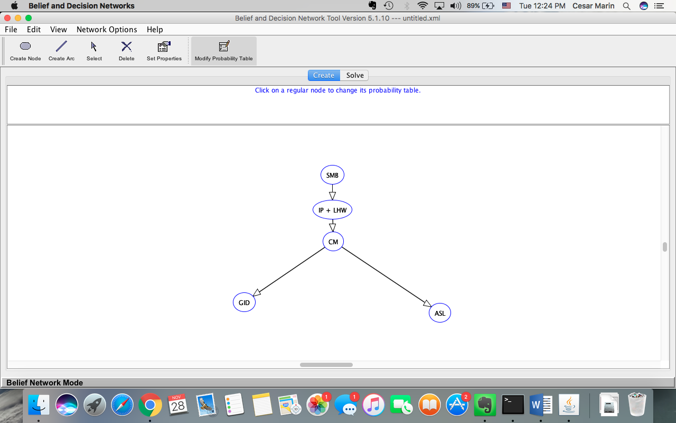

<?xml version="1.0" encoding="UTF-8"?>

<BIF VERSION="0.3" xmlns="http://www.cs.ubc.ca/labs/lci/fopi/ve/XMLBIFv0_3"

xmlns:xsi="http://www.w3.org/2001/XMLSchema-instance"

xsi:schemaLocation="http://www.cs.ubc.ca/labs/lci/fopi/ve/XMLBIFv0_3 http://www.cs.ubc.ca/labs/lci/fopi/ve/XMLBIFv0_3/XMLBIFv0_3.xsd">

<NETWORK>

<NAME>Untitled</NAME>

<PROPERTY>detailed = </PROPERTY>

<PROPERTY>short = </PROPERTY>

<VARIABLE TYPE="nature">

<NAME>IP + LHW</NAME>

<OUTCOME>IPT</OUTCOME>

<OUTCOME>IPF</OUTCOME>

<OUTCOME>LHT</OUTCOME>

<OUTCOME>LHF</OUTCOME>

<PROPERTY>position = (7316.0, 5102.0)</PROPERTY>

</VARIABLE>

<VARIABLE TYPE="nature">

<NAME>CM</NAME>

<OUTCOME>T</OUTCOME>

<OUTCOME>F</OUTCOME>

<PROPERTY>position = (7318.0, 5162.0)</PROPERTY>

</VARIABLE>

<VARIABLE TYPE="nature">

<NAME>GID</NAME>

<OUTCOME>T</OUTCOME>

<OUTCOME>F</OUTCOME>

<PROPERTY>position = (7149.0, 5277.0)</PROPERTY>

</VARIABLE>

<VARIABLE TYPE="nature">

<NAME>ASL</NAME>

<OUTCOME>T</OUTCOME>

<OUTCOME>F</OUTCOME>

<PROPERTY>position = (7520.0, 5297.0)</PROPERTY>

</VARIABLE>

<VARIABLE TYPE="nature">

<NAME>SMB</NAME>

<OUTCOME>T</OUTCOME>

<OUTCOME>F</OUTCOME>

<PROPERTY>position = (7316.0, 5036.0)</PROPERTY>

</VARIABLE>

<DEFINITION>

<FOR>IP + LHW</FOR>

<GIVEN>SMB</GIVEN>

<TABLE>0.3 0.0 0.4 0.3 1.0E-4 0.0 2.0E-4 0.9997</TABLE>

</DEFINITION>

<DEFINITION>

<FOR>CM</FOR>

<GIVEN>IP + LHW</GIVEN>

<TABLE>0.3 0.7 0.0 1.0 0.2 0.8 0.0 1.0</TABLE>

</DEFINITION>

<DEFINITION>

<FOR>GID</FOR>

<GIVEN>CM</GIVEN>

<TABLE>0.5 0.5 0.05 0.95</TABLE>

</DEFINITION>

<DEFINITION>

<FOR>ASL</FOR>

<GIVEN>CM</GIVEN>

<TABLE>0.9 0.1 0.1 0.9</TABLE>

</DEFINITION>

<DEFINITION>

<FOR>SMB</FOR>

<TABLE>0.99 0.01</TABLE>

</DEFINITION>

</NETWORK>

</BIF>