Making a [simple] tetris type game

This document and the accompanying HTML files show how to construct a game similar to the popular falling down blocks game called tetris invented by Alexey Pajitnov. The game has 4-block pieces, 7 distinct shapes that fall from the top. The challenge is to manipulate them by horizontal and rotation moves so that lines get completely filled up. You receive points for completing lines. Filled lines are removed. Completing more than one line (up to 4) at a time results in more points. My so-called 'tinytetris' begins like this:
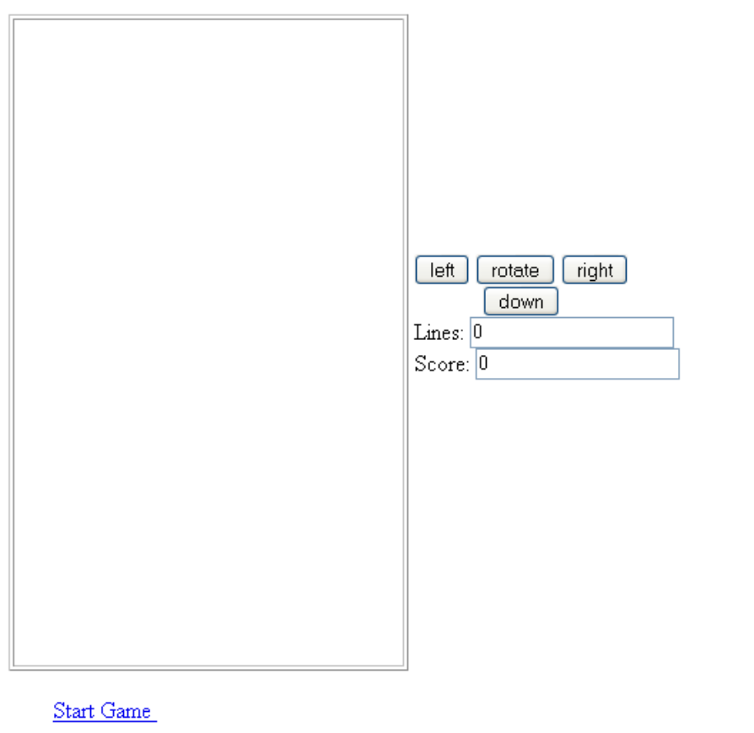
A complete game may look like this:
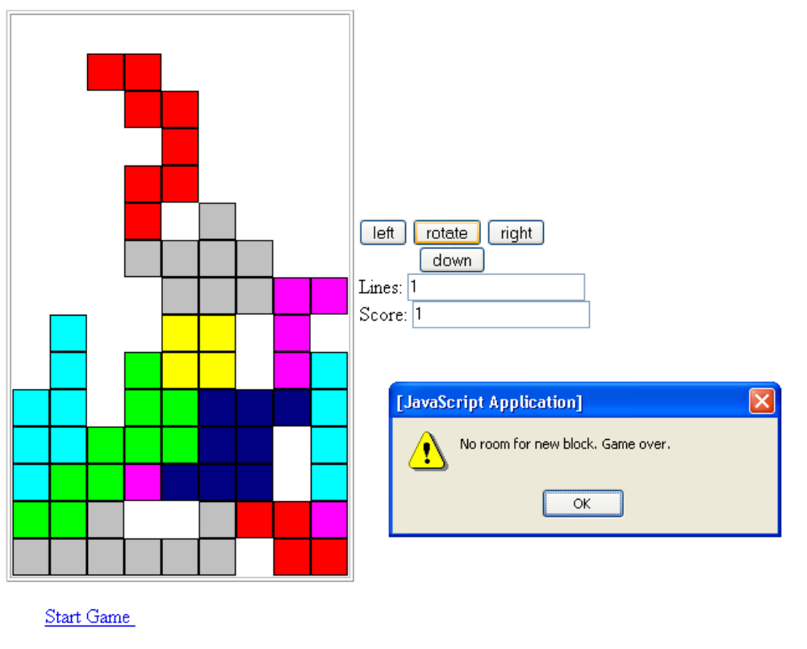
There are several improvements to make to this game to make it more resemble the 'real' game: modify the start game action so a new game can be started; change the scoring to involve speeding up and other features; and implement the actual down button (in the real game, you gain points by moving a piece all the way down in one move). The grace period implementation also may need improvement. A pause button would be nice.
I came across an on-line tetris-like game done in JavaScript by Hiro Nakamura and was inspired to create my own game, with accompanying notes. Though I did not take many features from Nakamura's game, it served as inspiration to make the attempt to get something working in JavaScript. Most 'industrial-strength' games are written in compiled languages such as c++ or Java or application development tools such as Flash. This JavaScript implementation probably is not very robust. A fast player could click the buttons too fast for the underlying program to perform—finish the service cycle before it must start again.
The main lessons to be learned from this work come from studying the process of building an application revealed in these notes and the documents. Two critical features of the process are
- I proceeded incrementally, as shown by examination of the files: tinytetris, tinytetris1 through tinytetris10. I put off inserting timed action until the very last stage.
- I implemented essentially a development environment to test the program without having to play the game. For example, I made hyperlink style buttons, easily changeable, to create specific pieces and to move the current piece one unit down the board. These links were removed for the final version of the game.
It is possible to skip to the exposition of the final program, tinytetris10, which does contain line by line explanations. However, the 'build-up' has value, especially for new programmers.
I used the Mozilla browser for its JavaScript console. This facilitated finding errors such as mis-matched brackets. I used Paint Shop Pro to create image files of 8 blocks. One, bblock.gif, is used for the blank or open space. The seven others are different colors and have borders.

Design decisions
For my 'tiny' tetris program, three design decisions deserve special mention.
I chose an essentially static approach. No element moves. Instead, the board contains a sequence of img tags laid out in a grid. The contents of these img tags (the src values) change. This makes it easy to determine when a row (line) of the board is filled. Looking back at my other examples, think of coin toss and image swap and not bouncing ball or cannonball. Doing it this way means I do not have to worry about browser differences.
The falling shapes are sets of blocks, four blocks each, put together using what I term formulas. I did this because the shapes must be considered as separate blocks once they hit down.
The left, right, rotate and down buttons are implemented as form submit buttons. This presents an obvious set of options for the player and I do not need to be concerned with key codes, which can vary with different keyboards.

Development stages
These development stages are not / were not perfect. There were cases in which I needed to go back and change tactics. However, the whole project was done quickly: 2 days (and I still went to aerobics, attended a party, had company at the house, and did some grass-roots political action).
tinytetris create board
tinytetris1 create pieces (2 different ones) using formula in a table
tinytetris2 create pieces of all 7 types. A button can be easily changed to make a different shape.
tinytetris3 start implementation of left and right moves and rotate
tinytetris4 checks for room for new piece—this is, check if game over
tinytetris5 move current piece down a row (invoked by button). Check if hit bottom
tinytetris6 Add places to put lines and scores (not yet used). Counts lines but only if player attempts to move down after hitting down.
tinytetris7 Add check that piece has hit down and can't go further using checkifhitdown function. Made change to completefalling function to ease next step. Added new testing option to get different block types.
tinytetris8 Remove filled lines (cascade down)
tinytetris9 Automatic new, random block when player clicks start game and when block touches down. Also, added call to checkifhitdown in rotate and moveover.
tinytetris10 Use setInterval to fall automatically. Set up grace period after touchdown to move current piece, thus allowing horizontal move after piece touches down. This involved changing how completefalling is called.

tinytetris

The general outline for the program (loosely following Nakamura) is to create the board by creating a two-dimensional grid of img tags (I am avoiding using the term table). These image tags are all in one <td> element. The screen is:

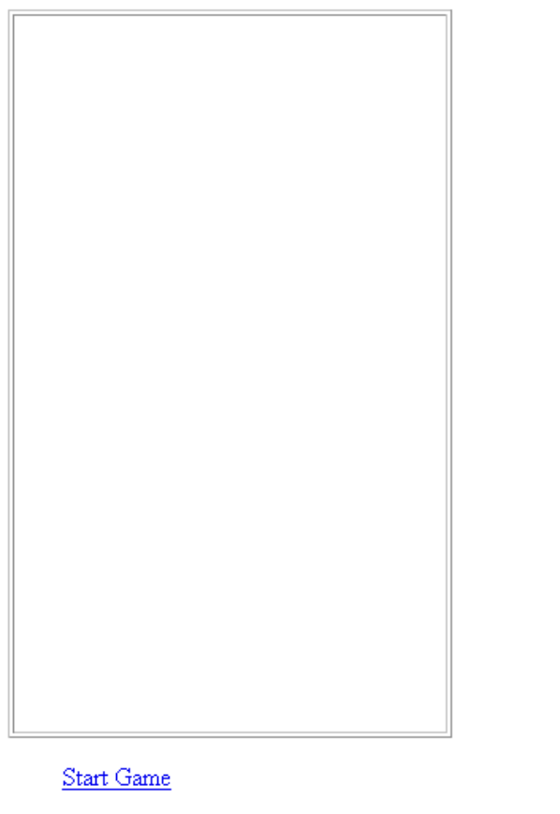
It certainly is not obvious, but this board contains 9 times 15 img tags. The following made up screen shot shows, somewhat crudely, how the img tags are laid out. The img tags initially hold a borderless white block held in the file bblock.gif. The images are all the same size. The game pieces consist of arrangements of blocks of 7 different colors. These blocks have borders.
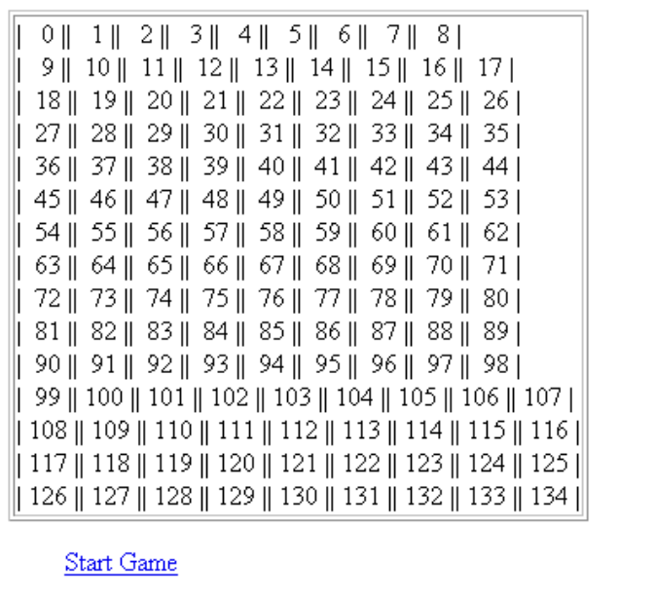

The code is

<html>
<head>
<title>Simple Tetris </title>
<script language="JavaScript">

/* createboard of images */

var hwidth = 9; //number of columns
var vheight = 15; //number of rows

function createboard() {
var i;
var j;
for (i=0; i<vheight; i++) {
for (j=0; j<hwidth; j++) {
document.write("<img src='bblock.gif'/>");
}
document.write("<br/>");
}
}
</script>
</head>
<body>
<table border="1"> // border of the board
<td>
<script language="JavaScript">
createboard();
</script>
</td>
</table>
<img src="bblock.gif"/>
<a href="javascript:startgame();">Start Game </a>
</body>
</html>

The createboard function is called from within a script element in the <body> element. It uses what will become a very familiar construction of nested for loops. The variables vheight and hwidth hold the number of columns and rows, respectively. After each complete iteration of the inner for loop, a <br/> tag is output to go to the next row. At this point, you may ask how the img tags can be accessed. The answer is by using the so-called images collection of the document object. The expression
document.images[imgno].src
can be used to access or set the img tag indicated by the number imgno. A function called imagenumber, to be described below, will convert from column and row to image number.
The <a> hyperlink that calls startgame is not yet functional.
**********************************************

tinytetris1

A critical feature of this game is the 4-block sets. Each shape is prescribed by a formula. (When we get to rotation, we will use an array of arrays of arrays to designate the formula for each orientation of each of the 7 types.) A formula specifies the x and y offset from an origin for each of the 4 blocks. In the code below, formulas are given for the T shape and the straight line shape. The new function is makeblock. It is invoked at this stage by code in an <a> link. Note also the imagenumber function for generating a number to use to indicate which image in the images collection corresponds to a given column and row pair. [See the file for the complete code. This just shows the new material.]
<html>
<head>
…
var blockformulas = [
[[0,0],[1,0],[2,0],[1,1]], // T shape
[[0,0],[1,0],[2,0],[3,0]] // straight line
];
var blockimages = [
"darkblue.gif",
"lightblue.gif"
];
// generates the image tag number from col and row
function imagenumber(atcol, atrow) {
var imagenum = atrow*hwidth + atcol;
return imagenum;
}
//make a block of type type at column atcol and at row atrow
//used to start off blocks
function makeblock(type, atcol, atrow) {
var i;
var block = blockimages[type];
var formula = blockformulas[type];
var imagenum;
for (i=0;i<=3;i++) {
imagenum=imagenumber(atcol+formula[i][0], atrow+formula[i][1]);
document.images[imagenum].src = block;
}
alert("end of makeblock");
}

</script>
</head>
<body>

…

<a href="javascript:makeblock(1,2,0)">Make block 1 2 0 </a>
</body>
</html>
**************************************************************

tinytetris2
Once the last program worked, I had the confidence to create the rest of the formulas. The javascript in the <a> tag was changed to check each of the 7 formulas.

var blockformulas = [
[[0,0],[1,0],[2,0],[1,1]],
[[0,0],[1,0],[2,0],[3,0]],
[[0,1],[1,1],[1,0],[2,0]],
[[0,0],[1,0],[0,1],[1,1]],
[[0,0],[1,0],[1,1],[2,1]],
[[0,0],[1,0],[2,0],[2,1]],
[[0,1],[1,1],[2,1],[2,0]]
];
var blockimages = [
"darkblue.gif",
"lightblue.gif",
"green.gif",
"yellow.gif",
"red.gif",
"purple.gif",
"gray.gif"
];

*********************************

tinytetris3

The challenge in this stage is to add the horizontal moves and the rotate move. The first step is to provide buttons for the player. This is done by using a table for layout and putting a <form> containing <input type="button"> tags all in the <body>. These buttons invoke moveover with an argument indicating the direction and rotate(). The rotate does not take any argument. Instead, its invocation goes through a fixed sequence of what I term orientations. The rotation operation required a very large array, orientations of the same type of formulas as described before. The first element (0th element) of orientations is the same as blockformulas. I decided not to combine these two. It took some testing to get these correct.
Doing the horizontal move or even the rotation turned out to be easy. The problem is that it is necessary to check if a move is possible, that is, not blocked by the edges of the board or other pieces. The check for the edges makes use of the modulus operator (%). The code makes use of the break; statement to get out of a for loop. This code uses what I call 'oksofar coding'. A variable is initialized to true and then set to false if and when something is detected.
The problem in checking for conflicts with other shapes is that it is necessary to distinguish between spaces occupied by the current piece and spaces occupied by other shapes. Spaces occupied by blocks in the current piece may be vacated to make room for others. This required a multi-step procedure (with several nested for loops) in which it is necessary to restore blocks if a conflict is detected.
The code to detect if some shape occupies a given position is done by doing a string search (search method of string object) on the document.images[ ].src (AFTER using String to convert this to a String from some other internal form). This is necessary because this string is very long, containing the whole file locator, not just 'bblock.gif' or 'darkblue.gif', etc. My method is to search for 'bblock.gif' and if it is not found, this indicates that this <img> contains an actual shape.
…
//block formulas for 4 orientations
//orientations[orient][type][block 0 to 3][x and y]
var orientations = [
[
[[0,0],[1,0],[2,0],[1,1]], //
[[0,0],[1,0],[2,0],[3,0]], //
[[0,1],[1,1],[1,0],[2,0]], //
[[0,0],[1,0],[0,1],[1,1]], //
[[0,0],[1,0],[1,1],[2,1]], //
[[0,0],[1,0],[2,0],[2,1]], //
[[0,1],[1,1],[2,1],[2,0]] //
],
[
[[1,0],[1,1],[1,2],[2,1]], //
[[1,0],[1,1],[1,2],[1,3]], //
[[1,2],[1,1],[0,1],[0,0]], //
[[0,0],[1,0],[0,1],[1,1]], //
[[1,0],[1,1],[0,1],[0,2]], //
[[1,2],[1,1],[1,0],[2,0]], //
[[2,2],[2,1],[2,0],[1,0]] //
],
[
[[0,1],[1,1],[2,1],[1,0]], //
[[0,0],[1,0],[2,0],[3,0]], //
[[2,0],[1,0],[1,1],[0,1]], //
[[0,0],[1,0],[0,1],[1,1]], //
[[0,0],[1,0],[1,1],[2,1]], //
[[2,1],[1,1],[0,1],[0,0]], //
[[2,0],[1,0],[0,0],[0,1]] //
],
[
[[1,0],[1,1],[1,2],[0,1]], //
[[1,0],[1,1],[1,2],[1,3]], //
[[1,2],[1,1],[0,1],[0,0]], //
[[0,0],[1,0],[0,1],[1,1]], //
[[1,0],[1,1],[0,1],[0,2]], //
[[1,0],[1,1],[1,2],[0,2]], //
[[1,0],[1,1],[1,2],[2,2]] //
]
];

…

var current = [ //image number, column and row of each of 4 blocks
[0,0,0],
[0,0,0],
[0,0,0],
[0,0,0]
];
var currenttype; //image file name
var currenttypenum; //0 to 6
var currentorientation; //0 to 3
var currentorigin; // nominal origin of whole 4-block piece

…

//make a block of type type at column atcol and at row atrow
//used to start off blocks
function makeblock(type, atcol, atrow) {
//need to check if room to add block
currentorigin = [atcol, atrow];
currenttypenum = type;
currenttype = blockimages[type];
currentorientation = 0;
var i;
var block = blockimages[type];
var formula = blockformulas[type];
var imagenum;
var atc;
var atr;
for (i=0;i<=3;i++) {
atc = atcol + formula[i][0];
atr = atrow + formula[i][1];
imagenum=imagenumber(atc, atr);
// will add check for room to add block. If none, end game.
document.images[imagenum].src = block;
current[i][0]=imagenum;
current[i][1] = atc;
current[i][2] = atr;
}

}
// move left (-1) or right (1)
function moveover(dir) {

var i;
var tests;
var oksofar = true;
var imgno;
var newcurrent = new Array();
var saved = new Array();
for (i=0; i<=3; i++) {
imgno = current[i][0];

if (dir==-1) { // moving left
if (0 == imgno % hwidth) // at left edge
{ oksofar = false;

break; } }
if (dir == 1) { // moving right
if ((hwidth-1)== imgno % hwidth) { //at right edge
oksofar = false;

break; }
}

newcurrent[i] = imgno+dir;
}
// if oksofar (no blocks at critical edge, newcurrent is set

if (oksofar) {
for (i=0; i<=3; i++) {
saved[i] = current[i][0];
document.images[current[i][0]].src = "bblock.gif";
}

for (i=0; i<=3; i++) {

tests = String(document.images[newcurrent[i]].src);
found = tests.search("bblock.gif");
if (found == -1) { // meaning it was not found
oksofar = false;
break;
}
}

if (oksofar) {
for (i=0;i<=3;i++) {
document.images[newcurrent[i]].src= currenttype;
current[i][0] = newcurrent[i];
current[i][1] = current[i][1]+dir;
}

currentorigin[0]=currentorigin[0]+dir;
}
else {
for (i=0;i<=3;i++) {
document.images[saved[i]].src = currenttype; //restore
}
}
}
}

// rotate current blocks
function rotate() {
var block = currenttype;
var savedorientation = currentorientation;
currentorientation = (currentorientation+1) % 4; //rotates to next orientation
var i;
var formula = orientations[currentorientation][currenttypenum];
var atcol = currentorigin[0];
var atrow = currentorigin[1];
var atc;
var atr;
var tests;
var newcurrent = Array();
var saved = Array();
var oksofar = true;
// calculate new imagenumbers & chk if over right side
for (i=0;i<=3;i++) {
atc = atcol + formula[i][0];
if (atc>=(hwidth-1)) {
oksofar = false;
break; }
if (atc<0) {
oksofar = false;
break; }
atr = atrow + formula[i][1];
if (atr>=(vheight-1)) {
oksofar = false;
break; }
newcurrent[i]=imagenumber(atc, atr);
}
if (oksofar) {
for (i=0;i<=3;i++) { //save then clear slots
saved[i] = current[i][0];
document.images[current[i][0]].src = "bblock.gif" }
// now go through and check each target slot for block
for (i=0;i<=3;i++) {
tests = String(document.images[newcurrent[i]].src);
found = tests.search("bblock.gif");
if (found == -1) { // meaning it was not found
oksofar = false;
break; }
}
if (oksofar) {
for (i=0;i<=3;i++) {
imagenum=newcurrent[i];
document.images[imagenum].src = block;
current[i][0]=imagenum;
current[i][1] = atcol+formula[i][0];
current[i][2] = atrow+formula[i][1];
}
}
else { //need to restore from saved
for (i=0;i<=3;i++) {
document.images[saved[i]].src = block;
}
currentorientation = savedorientation;
}
} //close first if oksofar
else {
currentorientation = savedorientation;
}
} // close function

</script>
</head>
<body>
<table>
<td>
<table border="1">
<td>
<script language="JavaScript">
createboard();
</script>
</td>
</table>
</td>
<td>
<form>
<input type="button" onClick="moveover(-1);" value="left">
<input type="button" onClick="rotate();" value="rotate">
<input type="button" onClick="moveover(1);" value="right">
<br/>
&nbsp; &nbsp; &nbsp; &nbsp; &nbsp; &nbsp;
<input type="button" onClick="movedown();" value="down">
</form>
</td>
</table>
<img src="bblock.gif"/>
<a href="javascript:startgame();">Start Game </a> <br/>
<a href="javascript:makeblock(5,5,1);">Make block 5 5 0 </a> <br/>
<a href="javascript:rotate();">Rotate </a>
</body>
</html>

***********************************

tinytetris4

function makeblock(type, atcol, atrow) {
var tests;
var found;
currentorigin = [atcol, atrow];
currenttypenum = type;
currenttype = blockimages[type];
currentorientation = 0;
var i;
var block = blockimages[type];
var formula = blockformulas[type];
var imagenum;
var atc;
var atr;
for (i=0;i<=3;i++) {
atc = atcol + formula[i][0];
atr = atrow + formula[i][1];
imagenum=imagenumber(atc, atr);
//check for room to add block. If none, end game.
tests = String(document.images[imagenum].src);
found = tests.search("bblock.gif");
if (found>=0) {
document.images[imagenum].src = block;
current[i][0]=imagenum;
current[i][1] = atc;
current[i][2] = atr;
}
else {
alert("No room for new block. Game over.");
break;
}
}

}

**********************

tinytetris5
To test the game, but without playing the game, I make the down button actually move the piece down one row. In what I term the real game, the down button is used to send the piece as far down as it can go all in one step. This stage will check the internal action to move the shape down until it hits something. This code works like the horizontal and rotation operations. It is necessary to use a multi-step procedure with provision to restore pieces if the move was blocked.

//move down one unit
function movedown() {
var i;
var tests;
var oksofar = true;
var imgno;
var atc;
var atr;
var newcurrent = new Array();
var saved = new Array();
var found;
for (i=0; i<=3; i++) {
imgno = current[i][0];
atc = current[i][1];
atr = current[i][2];

if (atr>=(vheight-1)) { //at very bottom already
//need to signal start of new block
alert("block i "+i+" is at bottom");
oksofar = false;
break;
}
newcurrent[i] = imagenumber(atc,atr+1);
}
if (oksofar) {
for (i=0;i<=3; i++) { //saved image nums & blank out current piece
saved[i] = current[i][0];
document.images[current[i][0]].src = "bblock.gif";
} // ends for loop
for (i=0; i<=3; i++) { //check if any blocking
tests = String(document.images[newcurrent[i]].src);
found = tests.search("bblock.gif");
if (found == -1) { // meaning it was not found
oksofar = false;
break;
} //ends if test
} //ends for loop
if (oksofar) {
for (i=0;i<=3; i++) {
document.images[newcurrent[i]].src = currenttype;
current[i][0] = newcurrent[i];
current[i][2]++; // y increases; x stays the same

} //ends for loop
currentorigin[1]++;
} //ends true clause for inner oksofar
else {
for (i=0;i<=3; i++) {
document.images[saved[i]].src = currenttype;

// signal need to start new falling piece
} //ends for loop
} //ends else of second oksofar
} //ends first if oksofar
}

************************

tinytetris6
In this stage, I added places to put lines and scores, but they are not yet used. This code does do an examination of the lines, but it counts the blanks and not the filled ones. This error is corrected in a later stage. The alert command is used to say what is found. Using alert is a good way to make progress without having to do everything at once. However, this function, completefalling, is invoked only if player attempts to move down after actually hitting down. This is changed in the next stages.

//move down one unit
function movedown() {
…
if (atr>=(vheight-1)) { //at very bottom already
//need to signal start of new block
hitdown = true;
oksofar = false;
break;
}

…
if (oksofar) {
for (i=0;i<=3; i++) { //saved image nums & blank out current piece
saved[i] = current[i][0];
document.images[current[i][0]].src = "bblock.gif";
} // ends for loop
for (i=0; i<=3; i++) { //check if any blocking
tests = String(document.images[newcurrent[i]].src);
found = tests.search("bblock.gif");
if (found == -1) { // meaning it was not found
oksofar = false;
break;
} //ends if test
} //ends for loop
if (oksofar) {
for (i=0;i<=3; i++) {
document.images[newcurrent[i]].src = currenttype;
current[i][0] = newcurrent[i];
current[i][2]++; // y increases; x stays the same

} //ends for loop
currentorigin[1]++;
} //ends true clause for inner oksofar
else {
for (i=0;i<=3; i++) {
document.images[saved[i]].src = currenttype;
hitdown = true;
} //ends for loop
} //ends else of second oksofar
} //ends first if oksofar
if (hitdown) {
completefalling();
}
}
function completefalling() {
//check for completed lines
var i;
var j;
var imgno;
var blankcount;
var tests;
var found;
for (i=vheight-1;i>=0;i--) {
blankcount = 0;
for (j=hwidth-1;j>=0;j--) {
imgno = imagenumber(j,i);
tests = String(document.images[imgno].src);
found = tests.search("bblock.gif");
if (found>-1) { // a blank
blankcount++ ;
} //
}
alert("line i "+i+" has "+blankcount+" blanks");
}

//will signal next falling piece
}

**********************

tinytetris7

This stage corrects the last by adding the check to see if a piece has hit down and can't go further using checkifhitdown function. The blanks are still being counted, and not the non-blank spaces. I also made change to completefalling function to ease next step. I added new hyperlinks buttons to allow starting different block types.

function checkifhitdown() { // but don't move it
var i;
var tests;
var oksofar = true;
var imgno;
var atc;
var atr;
var newcurrent = new Array();
var saved = new Array();
var found;
var hitdown = false;
for (i=0; i<=3; i++) {
imgno = current[i][0];
atc = current[i][1];
atr = current[i][2];

if (atr>=(vheight-1)) { //at very bottom already
//need to signal start of new block
hitdown = true;
oksofar = false;
break;
}
newcurrent[i] = imagenumber(atc,atr+1); //virtual move down
}
if (oksofar) {
for (i=0;i<=3; i++) { //save image nums & blank out current piece
saved[i] = current[i][0];
document.images[current[i][0]].src = "bblock.gif";
} // ends for loop
for (i=0; i<=3; i++) { //check if any blocking
tests = String(document.images[newcurrent[i]].src);
found = tests.search("bblock.gif");
if (found == -1) { // meaning it was not found
oksofar = false;
hitdown = true;
break;
} //ends if test
} //ends for loop
//restore blocks in all cases
for (i=0;i<=3; i++) {
document.images[saved[i]].src = currenttype;
} //ends for loop

} //ends first if oksofar
return hitdown;
}

//move down one unit
function movedown() {
…

} //ends first if oksofar
if (hitdown) {
completefalling();
}
else {
if (checkifhitdown()) { //tests if can go one more
completefalling(); }
}
}

function completefalling() {
//check for completed lines. Later add call for next piece to fall
var i;
var j;
var imgno;
var blankcount;
var tests;
var found;
i = vheight-1;
while (i>=0) {
blankcount = 0;
for (j=hwidth-1;j>=0;j--) {
imgno = imagenumber(j,i);
tests = String(document.images[imgno].src);
found = tests.search("bblock.gif");
if (found>-1) { // a blank
blankcount++ ;
} // end if test
}
alert("line i "+i+" has "+blankcount+" blanks");
i--;
} // end while loop of rows
} //end completefalling function

<a href="javascript:makeblock(1,5,1);">Make block 1 5 1 </a> <br/>
<a href="javascript:makeblock(3,2,1);">Make block 3 2 1 </a> <br/>

**************************

tinytetris8

This stage implements the task of removing filled lines and cascading the upper lines down. The code counts spaces that are not blank and uses a variable, filledcount. There is a variable named scoring used to give more points for removing multiple lines. My first approach was to figure out how high up (high up on the board, low down in terms of index values for the rows) the function needed to go. I made a variable called lowestoccupiedrow. However, I abandoned this as requiring too much computation. Instead, the for loop in the cascade function always goes all the way back to the 1st row. The 0th row is blank because pieces start at row 1.

var scoring= [
1, 4, 8, 16]; // 1 for 1 line, 4 for 2 at a time, etc.

function completefalling() {
//check for completed lines. Later add call for next piece to fall
var i;
var j;
var imgno;
var filledcount;
var tests;
var found;
var linesremoved = 0;
i = vheight-1;

while (i>=0) {
filledcount = 0;
for (j=hwidth-1;j>=0;j--) {
imgno = imagenumber(j,i);
tests = String(document.images[imgno].src);
found = tests.search("bblock.gif");
if (found==-1) { // didn't find blank
filledcount++ ;
} // end if test
}

if (filledcount == hwidth) {
linesremoved++;
cascade(i);
//call cascade to remove line i. Will return here to while loop at new line i
}
else {
i--;
}
} // end while loop of rows
if (linesremoved>0) {
document.f.lines.value = linesremoved + parseInt(document.f.lines.value);
document.f.score.value = scoring[linesremoved-1]+parseInt(document.f.score.value);
}
} //end completefalling function

function cascade(cut) {
// the line at row cut is to be removed, replaced by lines above
var upper;
var colindex;
var imgno;
var imgnox;
for (upper=cut;upper>0;upper--) {
for (colindex = 0; colindex<hwidth; colindex++) {
imgno = imagenumber(colindex,upper);
imgnox = imagenumber(colindex,upper-1);
document.images[imgno].src = document.images[imgnox].src;
}
}

}
</script>
…

<a href="javascript:makeblock(1,5,1);">Make block 1 5 1 </a> <br/>
<a href="javascript:makeblock(2,2,1);">Make block 2 2 1 </a> <br/>
<a href="javascript:makeblock(3,5,1);">Make block 3 5 1 </a> <br/>
<a href="javascript:makeblock(4,2,1);">Make block 4 2 1 </a> <br/>

**********************

tinytetris9

This next to the last stage was where I inserted the automatic start of a new block at the top. This was made more elaborate at the last stage, when I finally put in timing.

function completefalling() {

…
if (filledcount == hwidth) {
linesremoved++;
cascade(i);
}
else {
i--;
}
} // end while loop of rows
if (linesremoved>0) {
document.f.lines.value = linesremoved + parseInt(document.f.lines.value);
document.f.score.value = scoring[linesremoved-1]+parseInt(document.f.score.value);
}
startnewpiece();
} //end completefalling function

function startnewpiece() {
var type = Math.floor(Math.random()*7);
var scol = Math.floor(Math.random()*5);
makeblock(type,scol,1); // start at second (index = 1) row
}
function startgame() {
document.f.lines.value = "0";
document.f.score.value = "0";
startnewpiece();
}

*************************

tinytetris10

This last stage is when I added in the timing, that is, the automatic falling of the pieces. My initial value for the interval was 2000 milliseconds, to give me time to think while doing the debugging. At this point, I also decided to put in what I call a grace period. After a piece hits blocks or the bottom of the board, there is a chance to make horizontal moves before a new piece becomes the current piece. The 'real' game has this feature. This involved setting up variables called startnewone and grace as well as the startgame function. The approach appears to work, but I am not totally comfortable with it.
The startgame function invokes setInterval("clock();",timeperiod). The function clock uses startnewone and grace. In some situations, it invokes makeblock and in others, it invokes movedown. The completefalling function has changed. The display also has changed, with the extra <a> javascript buttons removed.
Here is a table listing the functions with calling structure. This is a useful exercise to do for applications. You can use the Find feature of NotePad or TextPad and then review to decide if it makes sense. One question I asked myself was why moveover does not require imagenumber. The answer is that the new image numbers can be calculated directly as the originals plus dir, the parameter holding the direction. It may be possible to extract common code from moveover, movedown and rotate since these do similar things in preparing for moves.

Function | Invoked by | Calls
makeblock | startnewpiece | (calls clearInterval to turn off calls to clock), imagenumber
startnewpiece | clock | makeblock
moveover | Buttons | checkifhitdown
clock | action set by call to setInterval | startnewpiece, movedown, completefalling
rotate | Button | checkifhitdown, imagenumber
checkifhitdown | movedown, rotate, moveover | imagenumber
movedown | clock | checkifhitdown, imagenumber
completefalling | clock | cascade, imagenumber
startgame | Hyperlink | (calls setInterval which sets up calls to clock)
cascade | completefalling | imagenumber
imagenumber | multiple places
createboard | called when HTML file loaded

<html>
<head>
<title>Simple Tetris </title>
<script language="JavaScript">
var hwidth = 9; | number of columns
var vheight = 15; | number of rows
var tid; | timer id
var timeperiod = 500; | Used in call to setInterval to set interval between drops. Make longer and shorter to ease debugging.
var grace = 0; | default grace period
var startnewone = false; | flag
var graceperiod = 3; | grace period
function createboard() { | called from script in body
var i;
var j;
for (i=0; i<vheight; i++) { | 2-dimensional
for (j=0; j<hwidth; j++) {
document.write("<img src='bblock.gif'/>"); | write out html
} | close inner
document.write("<br/>"); | make new row
} | close outer
} | close function
var blockformulas = [ | initial construction of shapes
[[0,0],[1,0],[2,0],[1,1]], | T shape
[[0,0],[1,0],[2,0],[3,0]], | line
[[0,1],[1,1],[1,0],[2,0]], | two two-block pieces shifted
[[0,0],[1,0],[0,1],[1,1]], | brick
[[0,0],[1,0],[1,1],[2,1]], | other shifted piece
[[0,0],[1,0],[2,0],[2,1]], | opposite of L shape
[[0,1],[1,1],[2,1],[2,0]] | L shape
];
var orientations = [ | orientations[orient][type][block 0 to 3][x and y]
[ | First element is blockformulas
[[0,0],[1,0],[2,0],[1,1]], // | Note: // check off marks made during testing
[[0,0],[1,0],[2,0],[3,0]], //
[[0,1],[1,1],[1,0],[2,0]], //
[[0,0],[1,0],[0,1],[1,1]], //
[[0,0],[1,0],[1,1],[2,1]], //
[[0,0],[1,0],[2,0],[2,1]], //
[[0,1],[1,1],[2,1],[2,0]] //
],
[ | next orientation index = 1
[[1,0],[1,1],[1,2],[2,1]], //
[[1,0],[1,1],[1,2],[1,3]], //
[[1,2],[1,1],[0,1],[0,0]], //
[[0,0],[1,0],[0,1],[1,1]], //
[[1,0],[1,1],[0,1],[0,2]], //
[[1,2],[1,1],[1,0],[2,0]], //
[[2,2],[2,1],[2,0],[1,0]] //
],
[ | next orientation index =2
[[0,1],[1,1],[2,1],[1,0]], //
[[0,0],[1,0],[2,0],[3,0]], //
[[2,0],[1,0],[1,1],[0,1]], //
[[0,0],[1,0],[0,1],[1,1]], //
[[0,0],[1,0],[1,1],[2,1]], //
[[2,1],[1,1],[0,1],[0,0]], //
[[2,0],[1,0],[0,0],[0,1]] //
],
[ | next orientation index = 3
[[1,0],[1,1],[1,2],[0,1]], //
[[1,0],[1,1],[1,2],[1,3]], //
[[1,2],[1,1],[0,1],[0,0]], //
[[0,0],[1,0],[0,1],[1,1]], //
[[1,0],[1,1],[0,1],[0,2]], //
[[1,0],[1,1],[1,2],[0,2]], //
[[1,0],[1,1],[1,2],[2,2]] //
]
];
var scoring= [1, 4, 8, 16];
var blockimages = [ | file names for single colored blocks with borders
"darkblue.gif",
"lightblue.gif",
"green.gif",
"yellow.gif",
"red.gif",
"purple.gif",
"gray.gif"
];
var current = [ | image number, column, row of current 4- block shape
[0,0,0],
[0,0,0],
[0,0,0],
[0,0,0]
];
var currenttype; | holds image file name
var currenttypenum; | 0 to 6
var currentorientation; | 0 to 3
var currentorigin; | nominal origin [x,y]
function imagenumber(atcol, atrow) { | generates the image tag number from col and row
var imagenum = atrow*hwidth + atcol;
return imagenum;
}
function makeblock(type, atcol, atrow) { | make a block of type type at column atcol and at row atrow
var tests; | used in testing if room
var found; | used in testing if room
currentorigin = [atcol, atrow]; | global var set here
currenttypenum = type; | global var set here. type is a number
currenttype = blockimages[type]; | global var. It is the file name
currentorientation = 0; | always start with 0 orientation. This could be made random.
var i;
var block = blockimages[type]; | Could be fixed to be currenttype
var formula = blockformulas[type]; | Extract formula for this type
var imagenum; | Used in loops
var atc; | Used in loops for column
var atr; | Used in loops for row
for (i=0;i<=3;i++) { | Loop to build the 4-shape
atc = atcol + formula[i][0];
atr = atrow + formula[i][1];
imagenum=imagenumber(atc, atr);
//check for room to add block. If none, end game.
tests = String(document.images[imagenum].src); | Make string from the src
found = tests.search("bblock.gif"); | Look for file name indicating blank
if (found>=0) { | Okay to add new block
document.images[imagenum].src = block; | Put it in appropriate value for src (image file name)
current[i][0]=imagenum; | Set initial data
current[i][1] = atc;
current[i][2] = atr;
}
else { | Not okay
alert("No room for new block. Game over."); | Signal end of game
clearInterval(tid); | Stop timing interval
break; | Leave loop
} | End of else (no room)
} | End of loop
} | End of function
function moveover(dir) { | move left (-1) or right (1)
var i;
var tests; | Used for test for possible block
var oksofar = true; | Flag set to false if problem
var imgno;
var newcurrent = new Array(); | Hold calculated new positions. Will be array of 4 image numbers.
var saved = new Array(); | Hold image numbers of current block. Used if restore necessary
for (i=0; i<=3; i++) { | Loop to check edges & calculate new positions.
imgno = current[i][0]; | Image number of this block
if (dir==-1) { | moving left
if (0 == imgno % hwidth) | at left edge
{ oksofar = false;
break; } } | End both if tests
if (dir == 1) { | moving right
if ((hwidth-1)== imgno % hwidth) { | at right edge
oksofar = false;
break; } } | End both if tests
newcurrent[i] = imgno+dir; | Simple adding of dir works because not at edges
} | End loop
// if oksofar (no blocks at critical edge, newcurrent is set
if (oksofar) {
for (i=0; i<=3; i++) { | Loop to setup saved
saved[i] = current[i][0];
document.images[current[i][0]].src = "bblock.gif"; | Erase (blank out) current 4-shape
} | End for loop
for (i=0; i<=3; i++) { | This for-loop will check for conflicts
tests = String(document.images[newcurrent[i]].src); | Extract and make string
found = tests.search("bblock.gif"); | Search for indicator of blank
if (found == -1) { | If bblock.gif not found, then something else was in this img
oksofar = false; | problem (can't do move
break; | break out of for loop
} | End if clause
} | End for loop
if (oksofar) { | If [still] ok, do move
for (i=0;i<=3;i++) { | for loop
document.images[newcurrent[i]].src= currenttype; | Move in this image file
current[i][0] = newcurrent[i]; | Set new values—for image number
current[i][1] = current[i][1]+dir; | Change the column value (row stays the same)
} | End loop
currentorigin[0]=currentorigin[0]+dir; | Set current origin value
checkifhitdown(); | Check if this means piece cannot go down (slipped under/into place)
} | End if oksofar
else { | Need to restore into saved images
for (i=0;i<=3;i++) { | for loop
document.images[saved[i]].src = currenttype;
} | End for loop
} | End else
} | End outer if okaysofar
} | End function
function rotate() { | rotate current piece
var block = currenttype;
var savedorientation = currentorientation; | May need to back up if this orientation clashes with other pieces.
currentorientation = (currentorientation+1) % 4; | rotates to next orientation. Uses modulus to go from 3 to 0.
var i;
var formula = orientations[currentorientation][currenttypenum]; | Pick up formula
var atcol = currentorigin[0];
var atrow = currentorigin[1];
var atc;
var atr;
var tests;
var newcurrent = Array(); | Calculated new img
var saved = Array(); | Used in case need to restore
var oksofar = true; | flag
 | Calculate new imagenumbers & chk if over right side. Also need to check if over left side
for (i=0;i<=3;i++) { | For loop for initial step
atc = atcol + formula[i][0]; | Determine new column
if (atc>=(hwidth-1)) { | Over the right edge?
oksofar = false;
break; } | Leave for loop. End clause.
if (atc<0) { | Over the left edge?
oksofar = false;
break; } | Leave for loop. End clause.
atr = atrow + formula[i][1]; | Determine new row
if (atr>=(vheight-1)) { | Past the bottom of board?
oksofar = false;
break; } | Leave loop. End clause.
newcurrent[i]=imagenumber(atc, atr); | Calculate new img number.
} | End for loop
if (oksofar) { | If no problem so far…
for (i=0;i<=3;i++) { | Save img numbers & clear slots
saved[i] = current[i][0];
document.images[current[i][0]].src = "bblock.gif" }
for (i=0;i<=3;i++) { | now go through and check each target slot for block: for loop
tests = String(document.images[newcurrent[i]].src); | Prepare to check for clashes
found = tests.search("bblock.gif");
if (found == -1) { | Something else in src
oksofar = false;
break; } | End clause
} | End for loop
if (oksofar) { | If ok…no clashes
for (i=0;i<=3;i++) { | For loop: do the move
imagenum=newcurrent[i];
document.images[imagenum].src = block;
current[i][0]=imagenum; | Set new current data
current[i][1] = atcol+formula[i][0];
current[i][2] = atrow+formula[i][1];
}
checkifhitdown(); | may have hit bottom as result of rotate
} | End if okay
else { | need to restore from saved
for (i=0;i<=3;i++) { | for loop
document.images[saved[i]].src = block;
} | End for loop
currentorientation = savedorientation; | Restore old orientation
} | End else clause
} | close first if oksofar
else { | Else clause for first if okaysofar
currentorientation = savedorientation; | Restore old orientation
} | End clause
} | close function
function checkifhitdown() { | Check if piece can't move further down (no move). Similar to code in move functions
var i;
var tests;
var oksofar = true;
var imgno;
var atc;
var atr;
var newcurrent = new Array();
var saved = new Array();
var found;
var hitdown = false;
for (i=0; i<=3; i++) {
imgno = current[i][0];
atc = current[i][1];
atr = current[i][2];
if (atr>=(vheight-1)) { | at very bottom already
hitdown = true;
oksofar = false;
break;
}
newcurrent[i] = imagenumber(atc,atr+1); | virtual move down
}
if (oksofar) {
for (i=0;i<=3; i++) { | save image nums & blank out current piece
saved[i] = current[i][0];
document.images[current[i][0]].src = "bblock.gif";
} // ends for loop
for (i=0; i<=3; i++) { | check if any blocking
tests = String(document.images[newcurrent[i]].src);
found = tests.search("bblock.gif");
if (found == -1) { | meaning it was not found
oksofar = false;
atc = currentorigin[1];
hitdown = true;
break;
} | ends if test
} | ends for loop
for (i=0;i<=3; i++) { | restore blocks in all cases
document.images[saved[i]].src = currenttype;
} | ends for loop
} | ends first if oksofar
startnewone = true; | Flag to start new piece, but…
grace = graceperiod; | … will allow grace period (3 intervals)
return hitdown; | This function returns value
} | End function
function movedown() { | move down one unit
var i; | index variable
var tests; | Used in search test of src
var oksofar = true; | Flag
var imgno; | Will hold imgno (for images collection)
var atc; | Column
var atr; | Row
var newcurrent = new Array(); | Img numbers following move
var saved = new Array(); | To save img numbers if move causes conflict
var found; | Flag
var hitdown = false; | Initialize to false
for (i=0; i<=3; i++) { | For loop
imgno = current[i][0]; | Img number for this block
atc = current[i][1]; | Column of this block
atr = current[i][2]; | Row of this block
if (atr>=(vheight-1)) { | at very bottom already
hitdown = true; | Flag
oksofar = false; | Flag
break; | Leave for loop
} | End if clause
newcurrent[i] = imagenumber(atc,atr+1); | Set newcurrent (used later to make the move)
} | End for loop
if (oksofar) { | No problems so far
for (i=0;i<=3; i++) { | save image nums & blank out current piece
saved[i] = current[i][0]; | just in case
document.images[current[i][0]].src = "bblock.gif"; | put in blank gif
} | ends for loop
for (i=0; i<=3; i++) { | Now can check for absence of other pieces
tests = String(document.images[newcurrent[i]].src); | Extract src
found = tests.search("bblock.gif"); | Do search
if (found == -1) { | meaning it was not found
oksofar = false; | Problem—other piece
break; | Leave for loop
} | ends if test
} | ends for loop
if (oksofar) { | No problems
for (i=0;i<=3; i++) { | For loop
document.images[newcurrent[i]].src = currenttype; | Do the move
current[i][0] = newcurrent[i]; | Set current data
current[i][2]++; | y increases; x stays the same
} //ends for loop
currentorigin[1]++;
} | ends clause for inner oksofar
else { | Else for problem
for (i=0;i<=3; i++) { | for loop
document.images[saved[i]].src = currenttype; | Restore current image
hitdown = true; | Set flag indicating hitdown
} | ends for loop
} | ends else of second oksofar
} | ends first if oksofar
if (hitdown) { | tried to move down beyond
startnewone=true; | Set flag to start new piece
grace = 0; | No grace period
} | End if clause
else { | Not down now, but
if (checkifhitdown()) { | tests if can go one more
startnewone = true; | Set flag to start new piece
grace = graceperiod; | Allow grace period
} | End if
} | End else
} | End function
function clock () { | Called by setInterval
if (startnewone) { | Start new piece after any grace period
if (grace==0) { | Check grace
startnewone = false; | reset flag
completefalling(); | call function to check for filled lines
startnewpiece(); | Call function to start new piece
} | End if grace down to zero
else { | Still grace period
grace--; } | Decrement grace
} | End if startnewone
movedown(); //move current piece down | In all cases, move piece down
} | End function
function completefalling() { | check for completed lines.
var i; | Index variables
var j;
var imgno;
var filledcount; | Used in counting up blocks
var tests; | Used in testing
var found;
var linesremoved = 0; | For scoring
i = vheight-1; | Start from bottom
while (i>=0) { | Go to top
filledcount = 0; | Initialize for each row
for (j=hwidth-1;j>=0;j--) { | Inner loop—along columns
imgno = imagenumber(j,i); | compute img number
tests = String(document.images[imgno].src); | Extract src
found = tests.search("bblock.gif"); | Search for blank
if (found==-1) { | didn't find blank
filledcount++ ; | increment filledcount
} | end if test
} | End inner for loop
if (filledcount == hwidth) { | Is row all filled?
linesremoved++; | one more line to remove
cascade(i); | Call cascade function to do it. Will return to do this line again.
} | End if test
else { | Row not filled so…
i--; | back up to previous line
} | End else clause
} | end while loop of rows
if (linesremoved>0) { | Any lines removed?
document.f.lines.value = linesremoved + parseInt(document.f.lines.value); | Increment displayed count
document.f.score.value = scoring[linesremoved-1]+parseInt(document.f.score.value); | Increase displayed score using scoring values
} | End if test for lines removed
} | end completefalling function
function cascade(cut) { | the line at row cut is to be removed, replaced by lines above
var upper; | Index value for (upper) rows
var colindex; | Index for columns
var imgno; | Img number for target img
var imgnox; | img number for source
for (upper=cut;upper>0;upper--) { | For loop starting from cut
for (colindex = 0; colindex<hwidth; colindex++) { | Inner for loop to do columns
imgno = imagenumber(colindex,upper); | Calculate target
imgnox = imagenumber(colindex,upper-1); | Calculate source (right above)
document.images[imgno].src = document.images[imgnox].src; | Move image down
} | End inner loop
} | End outer loop
} | End cascade function
function startnewpiece() { | Starts new falling piece
var type = Math.floor(Math.random()*7); | Generate random choice of type
var scol = Math.floor(Math.random()*5); | Generate random column
makeblock(type,scol,1); | Invoke makeblock. Always at 1st row (leaving 0th row to cascade).
} | End function
function startgame() { | Start game.
document.f.lines.value = "0"; | Set visible scores to zero
document.f.score.value = "0";
startnewone=true; | Set flag.
grace = 0; | Set grace period to zero.
tid = setInterval("clock();",timeperiod); | Start intervals.
} | End of startgame. Called by hyperlink.
</script>
</head>
<body>
<table> | Table to layout board and buttons
<td>
<table border="1">
<td>
<script language="JavaScript"> | Internal javascript to call …
createboard(); | function to create board
</script>
</td>
</table>
</td>
<td>
<form name="f"> | Form for
<input type="button" onClick="moveover(-1);" value="left"> | buttons…
<input type="button" onClick="rotate();" value="rotate">
<input type="button" onClick="moveover(1);" value="right">
<br/>
&nbsp; &nbsp; &nbsp; &nbsp; &nbsp; &nbsp;
<input type="button" onClick="movedown();" value="down"> | Does work, but should be changed to do move all the way down
<br/>
Lines: <input type="text" name="lines" value="0"> <br/> | displayed lines removed
Score: <input type="text" name="score" value="0"> <br/> | displayed score
</form>
</br>
</td>
</table>
<img src="bblock.gif"/>
<a href="javascript:startgame();">Start Game </a> <br/> | Hyperlink to call startgame function
</body>
</html>

