**Description of the features included in the TephraDatabase**

The TephraDataBase (working name) includes information of deposits of volcanic activity of the Southern and Austral Volcanic Zone of the Andes.

**Tephra**: this particular feature is not literally included, but belongs to the ontology of the database. A tephra is the sedimentary deposit that an explosive volcanic eruption leaves, from ashes transported by the wind which get deposited in vast areas; to large blocks deposited around the volcano. A tephra can also include ashes transported in other ways, for example when the volcanic plume collapses, avalanches of ashes flow in the edge of the volcano: <https://www.youtube.com/watch?v=Cvjwt9nnwXY>

An example of the deposits leaved by one of the eruptions of the data base, Vcha2008, an eruption of Volcán Chaitén which happened in 2008 can be found here (in spanish): <https://www.youtube.com/watch?v=No7RnYitOTQ>

Another example from the deposits of Volcán Llaima (in spanish): <https://www.youtube.com/watch?v=RSQYUSDmVdM>

**Attributes**

Disclaimer: Because this constitutes a database of great use for people in Chile and Argentina, the attributes names are in Spanish, our colonized heritage.

Because this database constitutes an effort to standardize previously published data, not all attributes where described for all samples.

The attributes are organized in the Ontology:

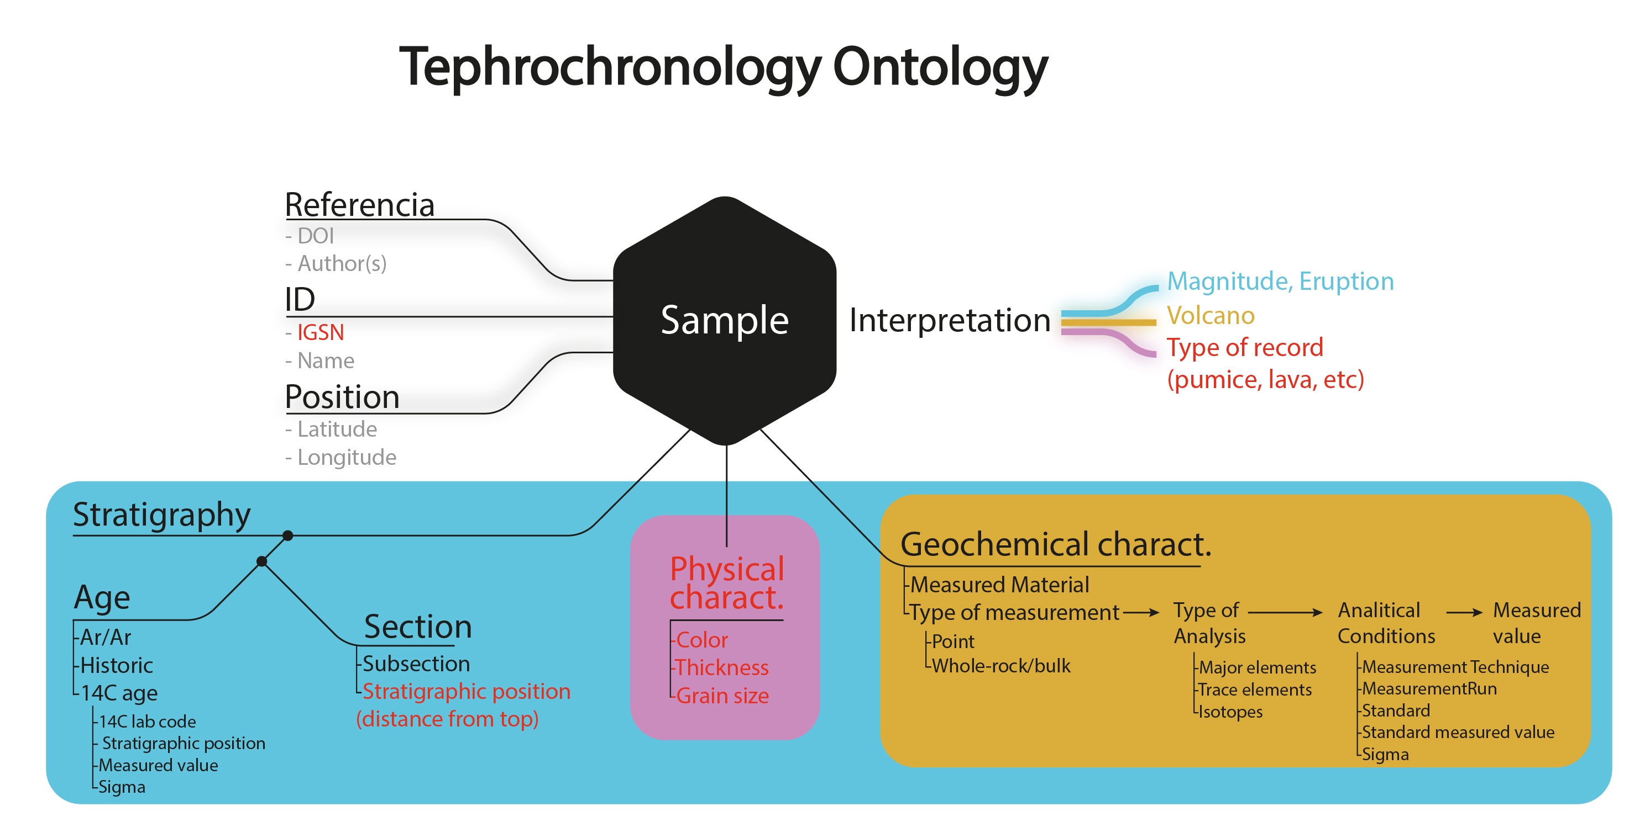

Figure 1. Ontology of the database, i.e. the relationship between its attributes. In red are shown the features to be included in the future.

**Identification attributes**

**SampleID**: Name given in the original publication to the sample. In cases where this information was not provided by the authors or a SampleID was repeated, a Sample name was given in the database and indicated by a Flag 0 along a FlagDescription indicating the particular case.

**SamplePoint:** Name given to a specific measurement of a sample. This is the case when various individual glass shards were measured in a same sample.

**Referencia**: Name of the publication from which the data was obtained.

**DOI**: Digital Object Identifier of the publication from which the data was obtained.

**Latitud and Longitud**: Latitude and Longitude where the sample was obtained. In cases where this information could not be obtained, even when contacting the co-authors, a position equal to the volcano was given and indicated with a Flag 1 along with the particular FlagDescription.

**Satratigraphic characteristics**

**Sección**: Name given in the original publication to a sequence of vertically deposited sediments (unconsolidated matter, for example sand, mud) from which the samples were obtained. Some sections are associated with one sample, other sections with many samples.

**SubSeccion**: The specific portion of the sequence from which the sample was obtained. As indicated in the original publication, it may be indicated with a different letter or number, for example Section1-1, Section1-2; it can also be indicated as distance from the top in cm.

**TipoDeSeccion:** It corresponds to the type of section and material studied. This may be: Terrestrial, when it corresponds to a terrestrial outcrop; Lacustrine core or Lacustrine Sediment; Bog peat, Bog core or Peat core; and Marine core.

**EdadArAr:** Estimated calendar age by 40Ar/38Ar dating presented in years. This kind of dating technique has the advantage that it can be performed in the same simple as the geochemistry, however the age uncertainty is regularly higher than in the case of radiocarbon.

**ErrorEdadArAr:** Analytical uncertainty of the 40Ar/38Ar age estimate, presented in years.

**Edad14C**: Radiocarbon age estimate of the sample, presented in years Before Present (BP)

**ErrorEdad**: Analytical uncertainty of the radiocarbon age estimate, presented in years.

**CódigoLaboratorioRadiocarbono**: Specific code assigned by each radiocarbon laboratory to each sample.

**Edad Histórica:** Corresponds to the AD age (our calendar) of the eruption.

**Stratigraphic position**: Position of the organic material in which the radiocarbon age was obtained in relation to the associated volcanic deposit. It might be Above, Below or Within the deposit.

**Physical characteristics**

*To be included.*

**Geochemical characteristics**

**SiO2, TiO2, Al2O3, MnO, MgO, CaO, Na2O, K2O, P2O5, Cl**: Major element composition of the analyzed volcanic products in wt %. In the database these are presented as normalized LOI-free (also called anhydrous-free) to the Total. The Total corresponds to the sum from SiO2 to Cl or from SiO2 to P2O5 depending on the analyzed elements. Both Cl and P2O5 are less routinely analyzed because their low concentrations translates in higher analysis time. Because of this low concentrations relatively to the total, the normalized values of the major elements vary very little if we take Cl and P2O5 into account or not, thus the results across studies are still comparable. This normalization is routinely done in geochemistry in order to compare different products and many of the publications present the data already normalized.

**FeO, Fe2O3, FeO*:** Iron is present in volcanic rocks in two oxidations states, forming FeO and Fe2O. In general analytical methods measure the total iron (FeO*) as either of these states. For example the Elecetron Microprobe method measures the total FeO* as FeO, whereas X-ray Fluorescence (XRF) measures the total FeO* as Fe2O. In some cases both FeO and Fe2O3 are measured and the FeO* must be estimated, here we use calculate FeO* as FeO+Fe2O3*0.899 according to ___.

**LOI:** Loss on Ignition. It indicates the amount of volatiles in the sample. When the sample is heated during the laboratory procedures to measure its chemistry, these volatiles escape the sample. In this kind of volcanic environment LOI is expected to be lower than 3-5%. LOI cannot be measured by Electron Microprobe, however sometimes it is estimated as the difference between the sum of major element concentrations and 100.

**Total**: It is the sum of the measured major elements and LOI, when available. It gives an idea of the quality of analyzes, if the Total is lower than 95%, it is considered low quality data.

*In some cases the Total in the database and in the original publication differ (ie. Naranjo &Stern 1998 and Naranjo and Stern 1998). This was done because the conversion to total FeO* was slightly different and thus the reported total corresponds to the total with the total FeO here calculated as FeO +Fe2O3*0.899. In this way the normalize values can be transformed in raw values easily.

**Rb-U**: Trace elements of the analyzed volcanic products of the sample in parts per million (ppm). Because of its low concentration many of them are noted bdl (below detection limit), some other are marked Over range, Not Analyzed or its concentration is lower than some number (e.g. <0.01), usually the detection limit.

**87Sr/86Sr, 2se**: Ignore, not yet included, might never be.

**MeasurementRun:** Name given to a group of samples analyzed for geochemistry at the same time and for which the same standard material measurement is used as a reference for the quality of the analysis. In some publications the measurement run corresponds to a date or to a code, in some other it is not communicated and here was given a particular name, usually the name of the publication, e.g. Rawson2015.

**TecnicaDeMedicion**: Laboratory technique employed to estimate the concentration of a determined element in a rock or its age. In some cases, a different technique was performed to measure major and trace elements, in which case both are indicated.

**MaterialMedido**: Material analyzed to assess the age, mayor elements or trace elements concentrations.

**Comentarios**: Comments on the sample. For the moment, the Stratigraphic position of the MaterialMedido for radiocarbon is indicated in the comments.

**Mapa?**: If the publication where the data were published includes a geological map.

**Flag**: Flag for data which might have some problem regarding different attributes. Flags correspond to a number between 0 and 5:

0: Issue with the sample name.

1: Issue establishing the geographic position were the sample was obtained.

2: Issue with the age assessment.

3: Issue with the interpretation of the volcanic source of the sample.

4: An issue with the geochemistry of the sample.

5: An issue with the name of the volcanic event.

**DescripciónFlag**: Description of the particular case why the data is flagged.

**Interpretation attributes**

**Volcan**: Volcanic center interpreted as the source of the deposit from which the sample was obtained.

**Evento**: Name given to a specific eruption, of a specific volcano, that is interpreted to have produced the deposit from where the sample was obtained.

**Magnitud**: A measurement of the size of the volcanic eruption. It is calculated from the estimated mass of material erupted from the volcano in a particular eruption. It goes from 0 tu ~7-8.

**VEI:** Volcanic Explosivity Index. An alternative measurement of the size of volcanic eruptions. It is estimated either from the erupted volume or the maximum height if the eruptive column. It is generally similar to the Magnitud, though VEI is a discrete value (0, 1, 2, …, 8) whereas magnitude is a continuous value (it can be 5.3, for example).

EXAMPLE

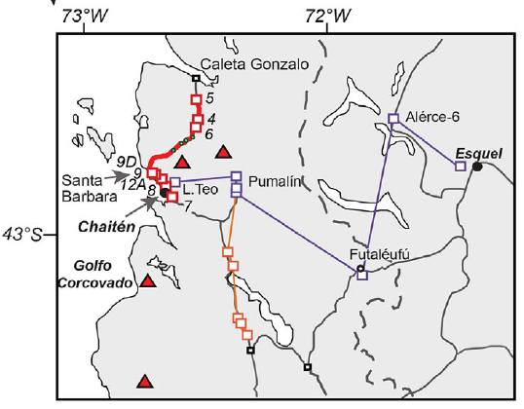

This map indicates the position (**Latitud, Longitud**) of different **Seccion** studied, each section is represented by a squares. At each section at least one tephra (eruption) is identified. 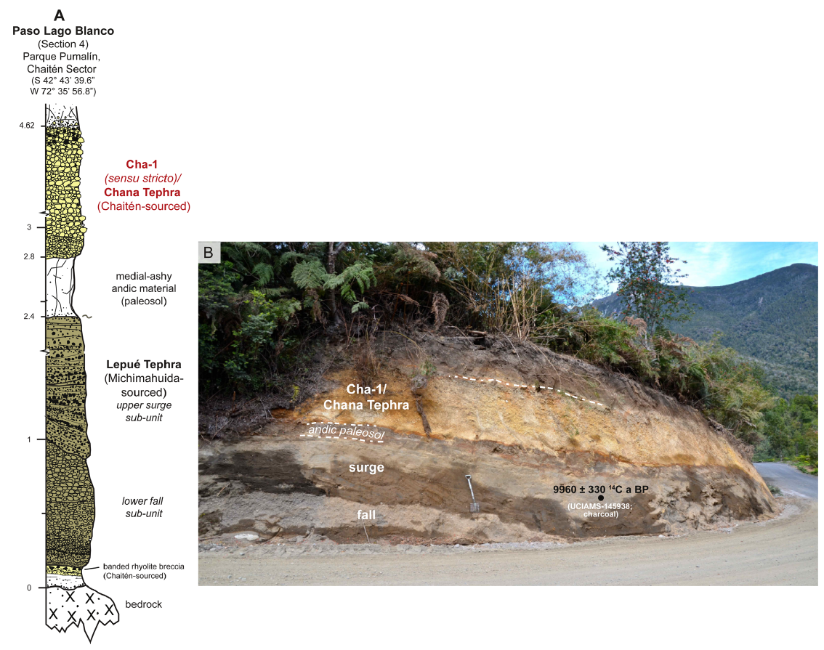

In the above picture, section 4 is photographed, there we can see two eruptions, Cha-1 above and Lepué below, each of these are **Subseccion** of section 4. In the left there is a schematic representation of the section. Each subsection is sampled to, at least, measure the chemical elements. In some cases, if any organic matter is observed, additional samples are obtained, each sample is identified by a **SampleID**. In this case “charcoal” is indicated with a black dot in the photograph (B) that indicates the specific place where a charcoal was extracted from the deposit. Afterwards the amount of radiocarbon of the charcoal is measured in a laboratory by an **Accelerator Mass Spectrometer** the and with that information we can estimate the calendar age of the deposit.

The obtained sample of sediment is observed in the microscope in order to identify volcanic glass shard which will be analyzed for its geochemical composition:

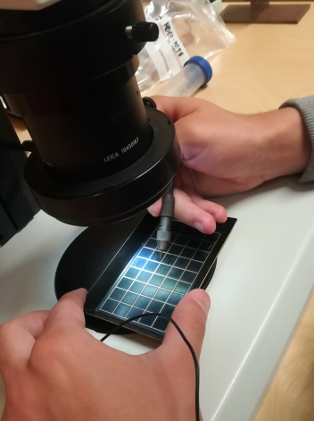

Ash is actually volcanic glass and it looks like this: 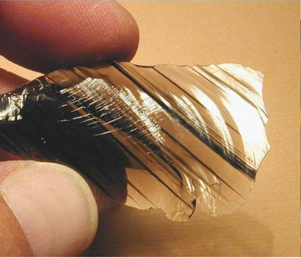

In each sample we can obtain individual volcanic glass shards and measure the geochemistry of each, like this, in each sample we can measure between 1 and ~30 different glass shards. In the database each one of these measurements is identified as a **SamplePoint.**

With the information of the chemistry of the glass shards but also from the physical characteristics, color, grain size, etc., the deposit is identified as coming from a specific **Volcan** and **Evento**, in this case the Cha-1 subsection coms from Volcán Chaitén and that specific eruptions is called Cha-1.

In the data base this specific example looks like this:

