Individual Project 5: Streaming Data Pipeline with Machine Learning
CS367
Cassandra Mason
11/15/24

Table of Contents
Summary of Project 3
The Dataset 3
The Ingest Job 4
Data Cleaning and Preparation 5
Data Storage 6
Exploratory Analysis 8
Predicting Market Orders 9
Results 10
Discussion 12
References 13

Summary of Project
This project trains and uses a machine learning model to predict stock prices from streaming stock market orders. There are 3 main aspects: ingest the streaming stock market orders with PubNub and Streamz, explore the data with summary statistics in pandas, and use linear regression to predict future stock prices with scikit-learn.
The entire process begins with data ingestion. PubNub is the stream source, and Streamz directs the data through several channels in this project. One channel is exploratory analysis, one channel is saving batch data to train and evaluate a linear regression model, and the last channel is making stock price predictions on the live stream using the model.
Results show that the current model has a mean squared error of 5285 and a coefficient of determination of 0.33. These indicate the model can only somewhat predict actual stock prices. Using time features, such as hour, day, and week, could improve the accuracy of the model.
To improve on this project, I would expand the exploratory analysis and training process to include visuals, more explanation, and different ways of viewing the data.

The Dataset
The data comes from a PubNub demo stream called ‘Market Orders’ (Demo, n.d.). It is a stream of simulated real time stock market orders. The attributes in each message are:
- Source: stream name
- Stock: Name of stock being sold or bought
- Bid Price: highest price a buyer will pay for stock
- Order Quantity: Number of stocks traded
- Trade Type: The way in which the stocks were traded
- Timestamp: date and time at which trade occurred
Trade Type can be one of 5 options (Charles Schwab, 2024; Chen, 2022):
- Day: Order is only active for the current trading session/day
- Market: an order to buy or sell at the best available price.
- Stop: an order that only becomes available once the market price for that stock has reached or exceeded a specified price, the stop price.
- Limit: sets a buy limit, the most the customer is willing to pay for it, and a sell limit, the minimum the seller would sell it for.
- Fill or Kill: complete order completely and immediately, or cancel order
We know we want to build a model that predicts future market orders. The most obvious thing to predict is the bid price, because this would let the user make decisions about buying or selling stocks. The target variable, the one we want to predict, is bid price. Influencing variables would certainly include the stock, which is called the ‘symbol’ in this dataset (Google, Elerium, etc.) because it represents specific products that gain and lose popularity/value. The order quantity may also indicate the direction a stock price will trend: selling more stocks could mean the price is high, or that it is declining so people are trying to sell it before it bottoms out. Trade type could also predict a change in a stock price. Stop orders could indicate that the market is trending up, while a sell limit could indicate the market is trending down.

The Ingest Job
Data was ingested with PubNub and Streamz into a pandas dataframe. The program subscribes to the ‘pubnub-market-orders’ channel, after configuring the connection with the stream’s subscribe key. The messages from the channel are fed into a Streamz stream as a continuous data stream. The stream is also given an execution thread with the ‘threading’ library so that other processes can execute while the stream is running.
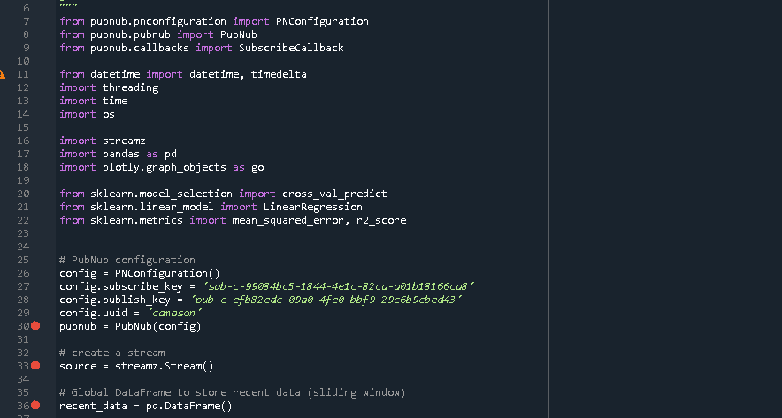
Figure 1. Imported libraries, configuration and initialization of data stream and dataframe
The above screenshot shows the imported libraries for PubNub, threading, time operations, Streamz, pandas, plotly, and scikit learn. It also shows the configuration for PubNub, Streamz and the pandas dataframe.
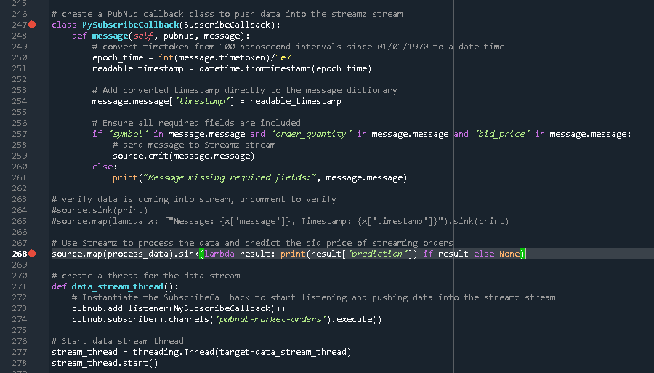
Figure 2. Threading, callback, and call to run the stream that processes the data and outputs the predicted order price
The above screenshot shows the callback class that formats the messages coming into the Streamz stream. It puts the timestamp into a datetime format and ensures all fields are present. It also shows the stream thread to isolate the stream from other processing. Line 268 begins processing the stream data and printing the predictions (discussed in the next sections).

Data Cleaning and Preparation
To prepare the data for exploratory analysis, model training, and predicting, the process_data function is applied to all messages in the stream. In the function, every message is added as a row to a pandas dataframe. Originally, this was the extent of the function. The dataframe was passed to a different function, aggregate_and_save, which runs summary statistics on the streaming data and stores data in several CSV files. It will be discussed at length in the exploratory analysis and data storage sections of this paper.
After the model was trained, the process_data function took on some new tasks to prep the data for the prediction algorithm. It adds some feature columns, hot encodes categorical columns, and makes a prediction on the latest incoming message. These are described in detail below:
During data processing, two new columns are added to the temporary data dataframe, bid_price_lag_1 and bid_price_lag_5. These reference the rows one before and five before the current row using shift(). The purpose of lag rows is to look for time-based trends in the market, such as the previous order price indicating what the current order price will be.
Next in the function, the target variable is isolated, as well as the timestamp for future use. I did not have time in this project, but in the future, I would break the timestamp column into multiple columns, perhaps minute, hour, day and week. Using these columns as features to predict the target variable could prove insightful.
Next in the process_data function, the ‘symbol’ and ‘trade_type’ columns are hot encoded. Hot encoding is when categorical data is represented numerically (One Hot Encoding in Machine Learning, 2019). The variable is split into a column for each category, and for each row, the relevant category receives a value of 1 while the other category columns receive a value of 0. In this way, a machine learning model can use categorical variables to make predictions. For example, in the ‘symbol’ column, hot-encoding creates a column for each company: ‘symbol-Apple’, ‘symbol-Elerium’, ‘symbol-Bespin Gas’, ‘symbol-Google’, and ‘symbol-Linen Cloth’ in this example dataset. For the real stock market orders, there would be thousands more symbols.
Once the dataframe is prepared, the function isolates the latest row and uses the trained linear regression model to predict the stock price of that order. The output of the prediction is printed to the console using source.sink() as shown in Figure 2.
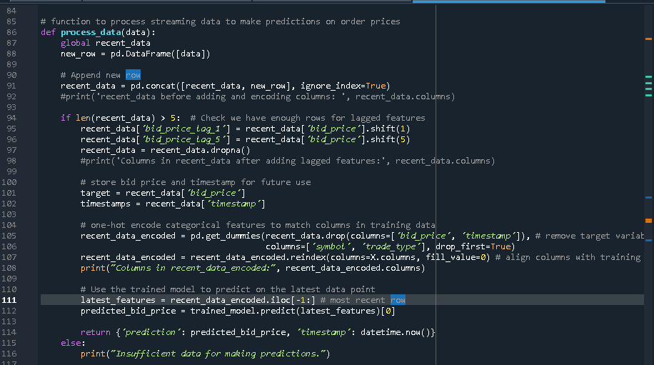
Figure 3. Process data function. Prepares data for the predictive model and applies the model on the most recent data.

Data Storage
There are several places in which data is stored in this program. One is a dataset to train the linear regression model. The other is a summary statistics CSV file that is added to whenever the program is running.
Both tasks are done in the aggregate_and_save function. After calculating summary statistics of the target variable, bid_price, the function appends that data to a CSV for future analysis and interpretation. Before the machine learning model was trained, the temporary dataframe containing all the stock orders was appended to a different CSV file to use as the training data.
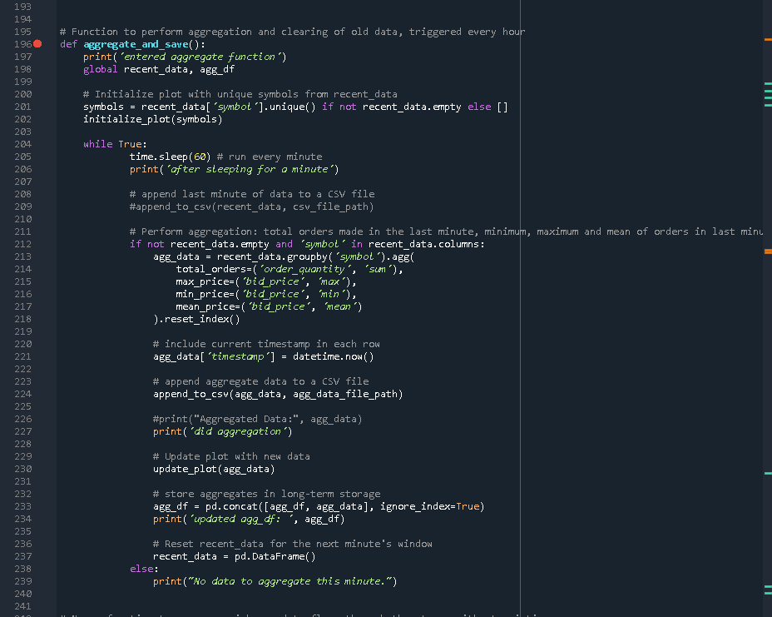
Figure 4. Aggregate and save function. It calculates summary statistics of the stock price, saves that data to a CSV file, and saves streaming data to a CSV to train a machine learning model.
Within this function, the function append_to_csv is called to facilitate writing data to the CSV file:
Figure 5. Initialize file paths for long term storage of training data and aggregated data
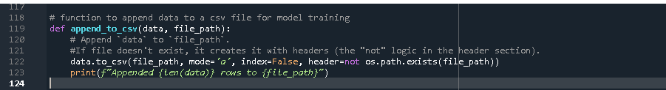
Figure 6. Function to append data to a CSV file.
To automate this process and allow for updated training to the model, future work would create a separate function periodically called within aggregate_and_save that adds more data to the training dataset and retrains the model. Furthermore, storing the data in a database, such as SQLite, could be a more permanent and useful storage than CSV files.

Exploratory Analysis
To begin to understand the incoming data, this program looks at summary statistics of stock prices as they stream in. The code is within the aggregate_and_save function (Figure 4). A temporary dataframe stores streaming data from the past minute. Every minute, the data is grouped by the stock (symbol). Within each stock, the total number of orders that minute, the mean price of the orders, and the most and least expensive order is calculated using pandas groupby() and aggregation functions. Within pandas agg(), the program uses ‘sum’ to count total orders, ‘max’ and ‘min’ to find the highest and lowest price respectively, and ‘mean’ to calculate the average price of that stock during the past minute. After aggregating the data and appending it to a CSV file, the temporary dataframe is cleared out by resetting it to an empty dataframe. This logic is encompassed within a while loop that continuously runs. It sleeps for a minute and then repeats the aggregation and data clearing.
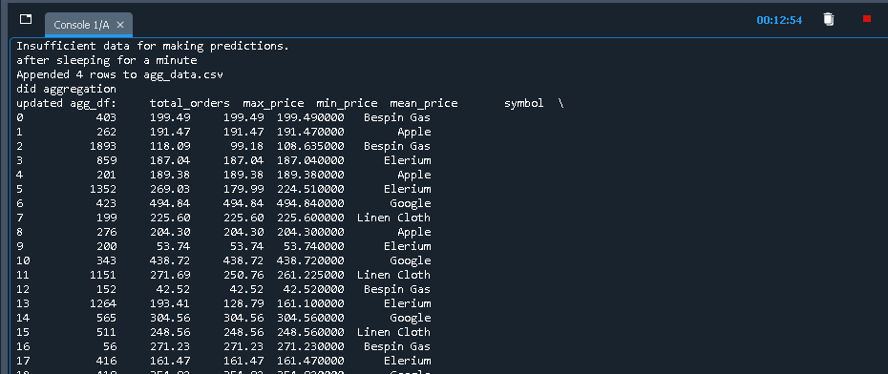
Figure 7. Console output of the aggregated dataframe showing the total orders, highest price, lowest price, average price, company and timestamp
The above screenshot shows the output of agg_df, accumulating a new row each minute.
This program attempted to visualize the aggregated data as a scatterplot. The graph would have a different line for each company that shows the mean price of its stock as it changes in real time. The plot would update every minute, when the loop within aggregate_and_save runs. I was not able to make the plot show up in the Spyder IDE. Future work is to get the visual up and running.
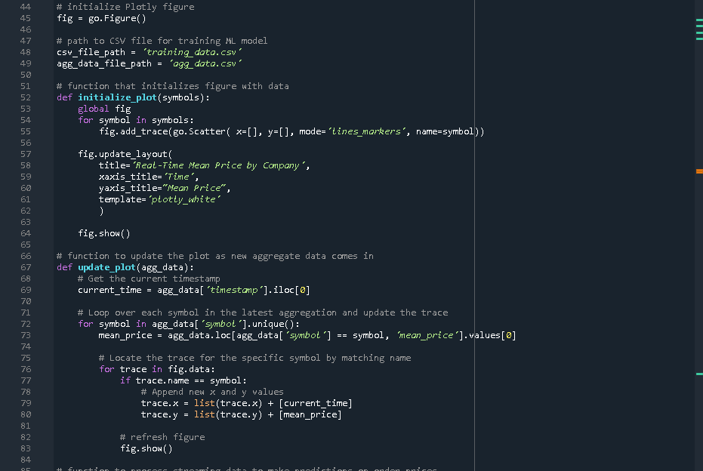
Figure 8. Initialize and update a scatterplot of summary statistics.
The above screenshot shows two functions, one to initialize a scatterplot of rolling average order price per company, and the other to update the plot with new data. Initialize_plot is called at the start of the aggregate_and_save function, while update_plot is called within the loop in the aggregate_and_save function.
Additional functionality I would like to include in the exploratory analysis is true rolling windows that show the stock price by company over time, it’s rolling average, and standard deviation. This would allow users to see how the stock prices are changing continuously, rather than in one minute block increments. A correlation matrix that shows the relatedness of the different variables in our data would also be a helpful assessment. This could show which feature variables correlate the most with bid_price, helping us build the machine learning model. We could use pandas corr() to build such a matrix.

Predicting Market Orders
There are three steps to begin predicting stock market orders. First, we need to train a model to fit the data. Second, we need to evaluate the accuracy and ability to predict new data of the model. Third, we need to apply the trained model to the data stream. This program uses multiple linear regression as the machine learning model. It attempts to predict a target variable based on the values of several feature variables. The model is a linear equation, where each x_{i} represents one of the feature variables.
To train the model (determine what the linear equation should be), we used the training data saved to the CSV file. A function called train_model_from_csv pulled the csv data into a pandas dataframe, added the lagged feature columns and one-hot encoded columns as discussed in the Data Cleaning and Preparation section, and specified the feature variables (X) and target variable (y). For this program the feature variables are all the columns in our dataframe except for bid price, since it is the target variable, and timestamp, because I ran out of time to format it in a useful way. The feature variables are: each company, bid quantity, each trade type, and the two lagged bid prices.
The function then chooses the model (linear regression) and uses cross validation to train the model on various subsets of the training dataset and test it against the rest of the training dataset (cross_val_predict). This was used to calculate the mean squared error and coefficient of determination, which are measures of the fit of the model to the data. Once trained, the model is fit with the entire dataset to improve robustness. This is the model that is used in the process_data function to predict bid prices on incoming orders.
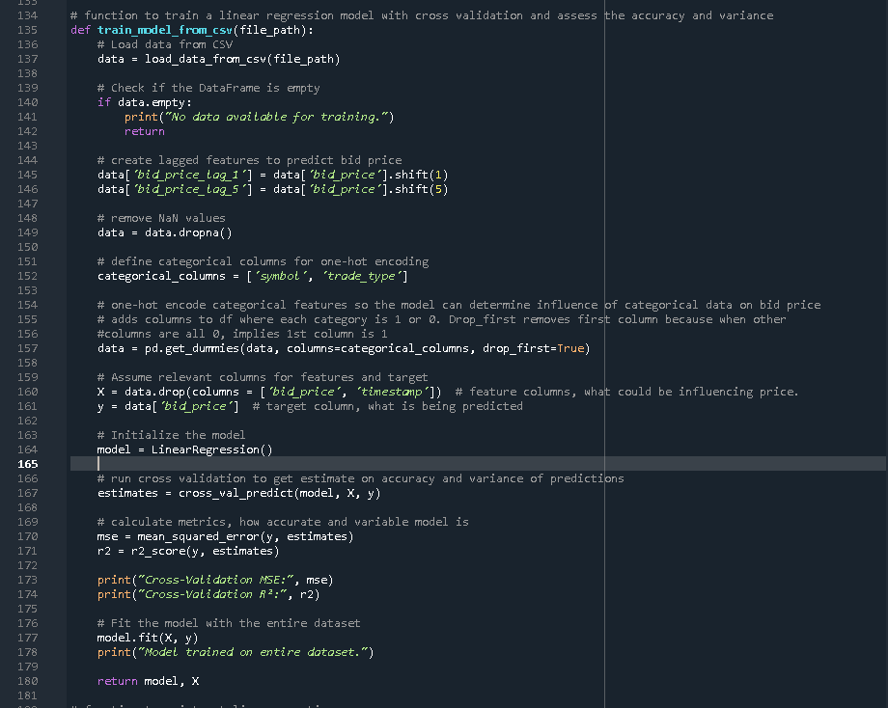
Figure 7. Function to train and finalize the linear regression model

Results
The results of training the linear regression model show a high mean squared error, and low coefficient of determination:
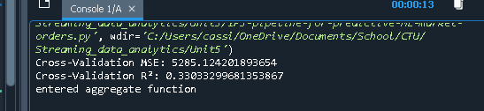
Figure 8. Console results of the MSE and r2 values
The Mean Squared Error (MSE) is the average distance the line of best fit is from the data points (Arcitura Education, 2021). We want as small a number as possible. This model doesn’t seem to predict the data very well because MSE is quite large. Also, the coefficient of determination (R² ) is a measure of how correlated the target variable is to the predictive variables (Arcitura Education, 2021). In this scenario, it is the percent of the variation in bid_price that can be explained by variation in the feature variables. About 33% of the variation is explained by the features, which is something but not great.
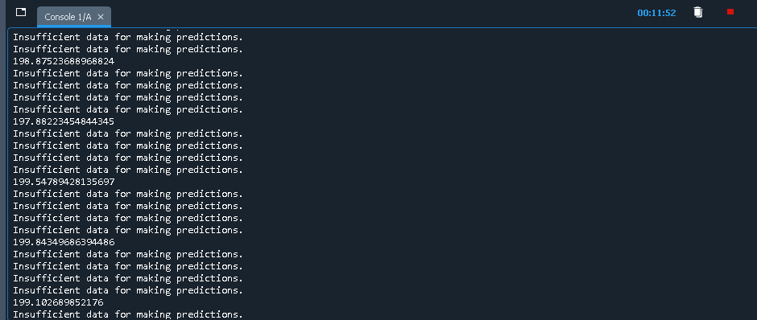
Figure 9. Console output of predictions on stock price
When the program runs, it does make predictions about the stock price of the incoming data. In the above screenshot, you can see the results. It only predicts when there are at least 5 messages to look at so that the lagged bid price variables function correctly, which is why you see “Insufficient data for making predictions” repeat 4 times and then be interspersed with a number. The number is the predicted price of the stock for the latest message. Future work would allow the model to see more of the previous market orders so it can make predictions on almost all of the incoming orders.
As it is, this doesn’t share valuable information. The predicted price needs more context. In future work, along with the prediction, the feature variables would also be printed so you could see which company, quantity, and type of trade the prediction is for. Furthermore, a visual representation of the predictions is needed. The actual model equation graph could be a good visual. As well as continuously measuring MSE and R² to see how the predictive ability of the model changes over time. A scatterplot of the predicted value and actual value, or the difference between them, would also be helpful.

Discussion
This project begins to predict stock market prices based on past data and streaming data. It determined that the target variables were only somewhat able to predict stock prices. Gathering more data and incorporating different metrics for predicting stock prices will be necessary. Splitting the timestamp of each market order into different time-based metrics may help us predict prices better.
It is also worth exploring other machine learning models. Linear regression is most likely too simple for such a complex prediction with multiple features influencing the outcome. Using a type of deep learning or neural network model may improve accuracy of predictions.
Various ways of expanding and improving on this project were discussed in each section. A recap of those and some additional ideas are listed below.
Using different lag times besides the order before and 5 before could better show time trends. Maybe using the difference in price between orders of the same stock for the past minute, hour and day. Comparing a bid price to the average bid price from the last minute/hour/day rather than a specific past order could show trends more accurately.
Using more visuals to represent the data, the model, and the prediction stream would allow for true insights into what the data is telling us.
More modes of exploratory analysis would give a fuller picture of the relationships between variables. A correlation matrix is one such tool.

References
Arcitura Education. (2021, June 16). 2 supervised learning techniques that aid value predictions. TechTarget Enterprise AI. https://www.techtarget.com/searchenterpriseai/post/2-supervised-learning-techniques-that-aid-value-predictions
Charles Schwab. (2024, June 11). 3 Order Types: Market, Limit, and Stop Orders. Schwab Brokerage. https://www.schwab.com/learn/story/3-order-types-market-limit-and-stop-orders
Chen, J. (2022, July 5). Fill or Kill (FOK) Order: Definition and Example. Investopedia. https://www.investopedia.com/terms/f/fok.asp
Demo: Easily Connect & Test Real-Time Streaming Data. (n.d.). PubNub. Retrieved October 28, 2024, from https://www.pubnub.com/demos/real-time-data-streaming/
One Hot Encoding in Machine Learning. (2019, June 12). GeeksforGeeks. https://www.geeksforgeeks.org/ml-one-hot-encoding/

