***Windows Phone platform-cmauer69***

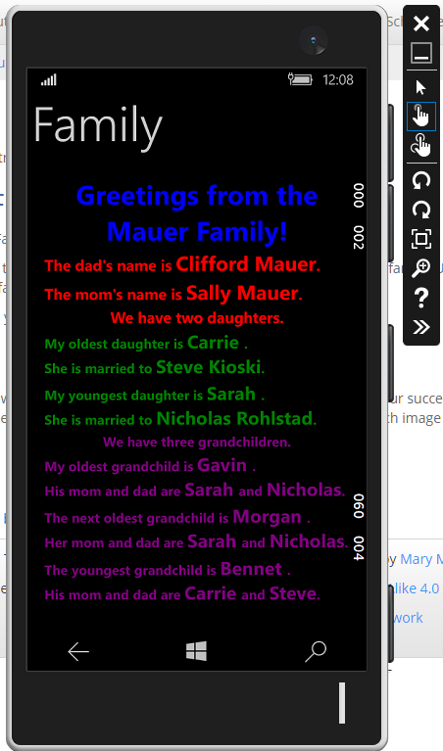

***Android platform-cmauer69***

