***FamilyAppXAML-Android Version***

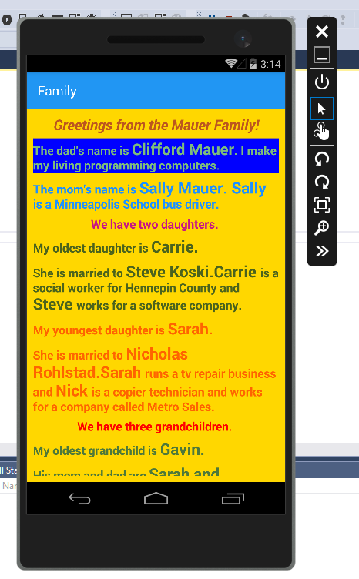

***FamilyAppXAML-Windows Version***

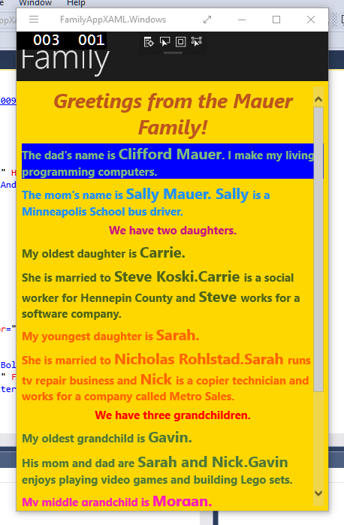

***FamilyAppXAML-Windows Phone Version***

