In this guide, we will set up Python 3 along with Jupyter graphical script editing environment on your local computer (assumed to be Windows OS)

Step 1: Install Anaconda with Python 3

* Go to <https://www.anaconda.com/> and download the installer for Windows (current version should come with Python 3.9)
* This will set up a **virtual environment** with its own Python so that you won’t accidentally change Python that came with the Windows OS or other software

Step 2: Launch Anaconda Prompt on your computer

* Search for Anaconda in your search bar or look in your program list (the bottom left button with Windows logo).

* Once you launched Anaconda Prompt, you should see a command line with **(base)** at the front. This signifies that you are in a new virtual environment.

* To check that you are using Anaconda’s Python, and not the OS’s, type **where python**. If your computer has multiple Python installed, all will be shown. But the top one should be located in your Anaconda3 folder.

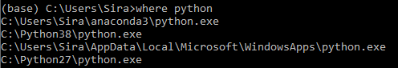

Step 3: Managing Python library

* To install/uninstall/upgrade Python library, we use the **pip** command.
* **pip list** will show the list of installed libraries

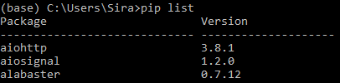

* **pip install** followed by library name will install that library, if it is not already installed
  + **pip install --upgrade** followed by library name will update the library, as well as other dependencies, to the latest version
  + To install the Jupyter library for editing Python code, run **pip install jupyter**
  + Let’s pre-install other libraries that we will be using in this course

**pip install numpy scipy pandas scikit-learn umap-learn matplotlib seaborn statsmodels**

* + Specific library version can be specified with == (if you ran into compatibility issue) as follows: **pip install jupyter**==**1.0**
* **pip uninstall** followed by library name will uninstall the library

Step 4: Setting up Jupyter environment

* From Anaconda prompt, you can launch Jupyter graphical editor with **jupyter notebook**.
* However, you may want to set up the folder where Jupyter will keep the script files (this process will allow you to set up a remote server with Jupyter in the future).
  + First, run **jupyter notebook generate-config**
  + This will create a file name **jupyter_notebook_config.py** in your user home directory (usually **C:\Users\*user name*\.jupyter\jupyter_notebook_config.py**)
  + Open this file in text editor, like Notepad

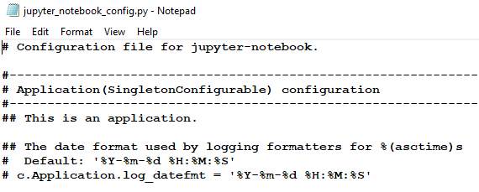

* + Search for the pattern **notebook_dir**. Edit the path to where you want to keep your Python scripts.

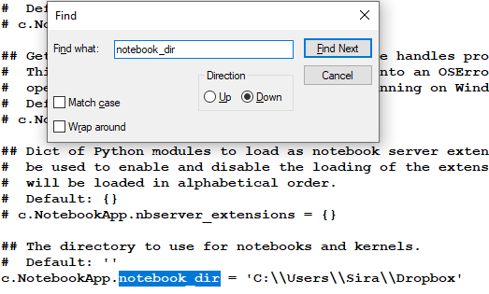

Step 5: Launching your first Python notebook

* Run **jupyter notebook**. You should see something like this on Anaconda Prompt

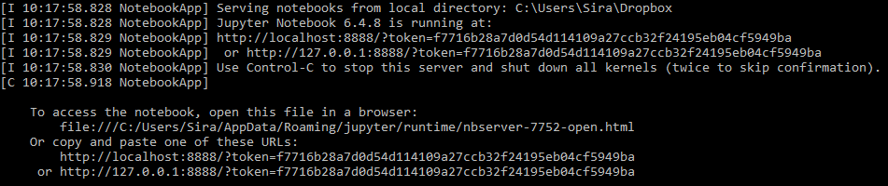

* A web browser should also be open with a page that looks like this

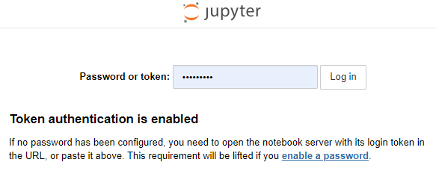

* If you follow the instruction to use token or password to log in correctly, you will be brought to a new page that looks like this. Note that the files and folders that show up will differ depending on the location you set in **notebook_dir**.

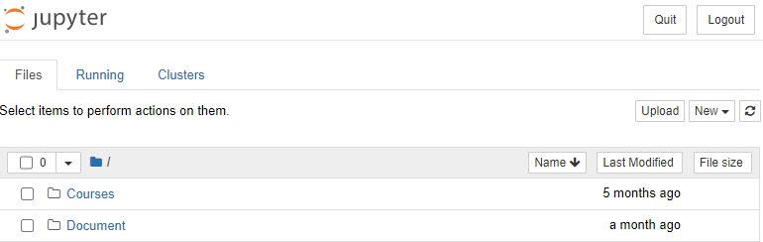

* You can use the **New** button to create new folder, text file, or Python notebook. You can rename or delete file and folder by checking the boxes as shown below.

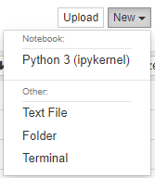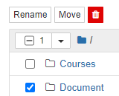

* Copy **3000788_Fall2022_L21_python_102722.ipynb** and **3000788_Fall2022_L21_python-more_102722.ipynb** to the folder you set in **notebook_dir**. Then open them in Jupyter. You should see something like this at the top of the page.

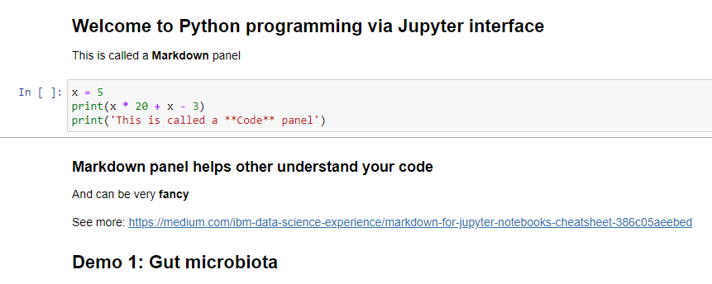

Step 6: Let’s learn the language

* Please watch the video in which I explain the codes and follow through!