Chris Bohnet

5/5/20

Assignment 2.2 - Web-335

ORD Diagram:

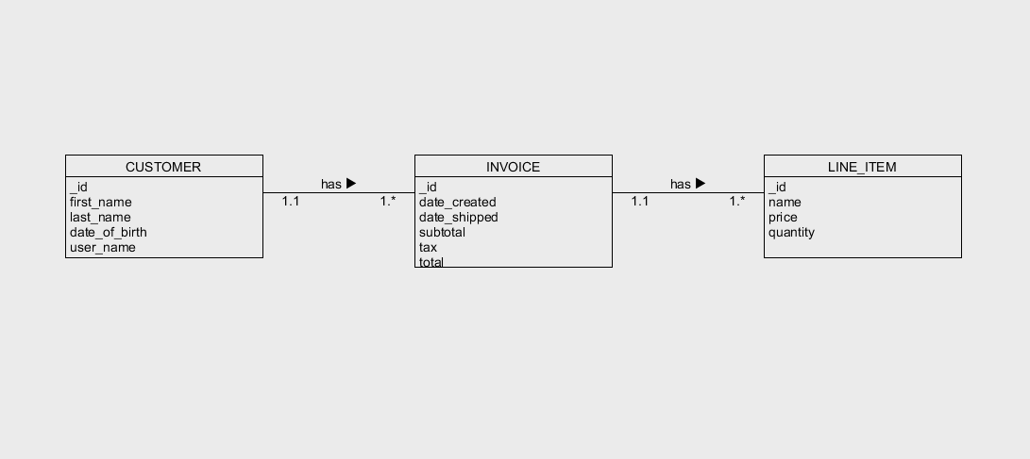

Data Structure:

