Chris Bohnet

5/5/20

Assignment 2.3 - Web-335

ORD Diagrams:

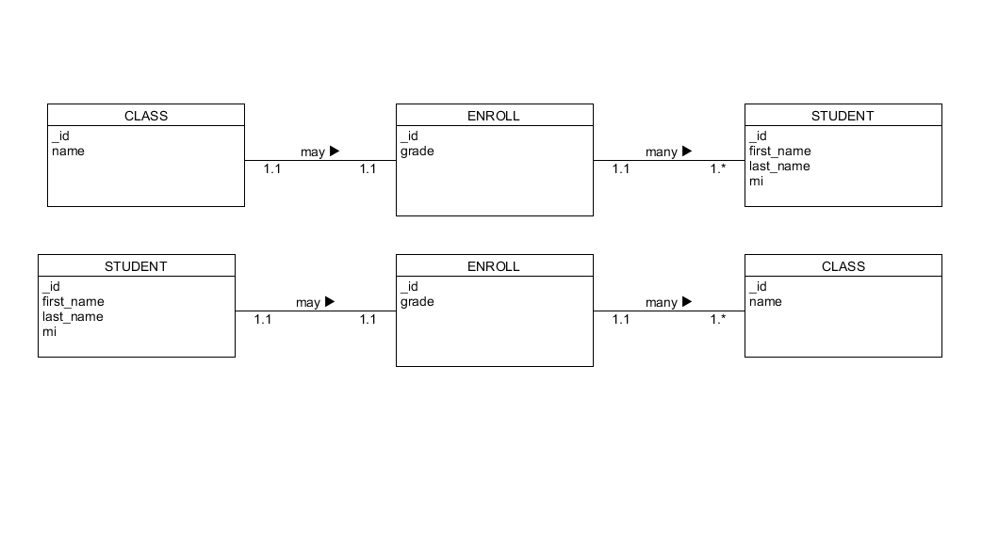

Data Structures:

