Chris Bohnet

5/13/2020

Web 335

Assignment 3.2

Convert the below ORD to business rules:

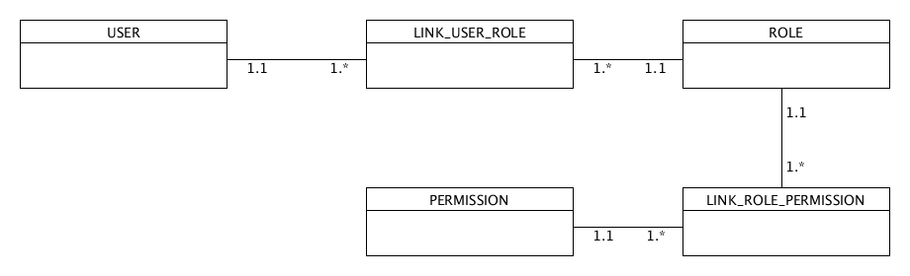

A user can have many link user roles.

A link user role can have one role.

A role can have many link role permissions.

A link role permission can have one permission.

