Chris Bohnet

5/13/2020

Web 335

Assignment 3.3

Normalized ORD:

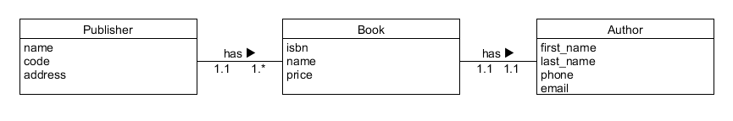

NoSQL Document Diagram:

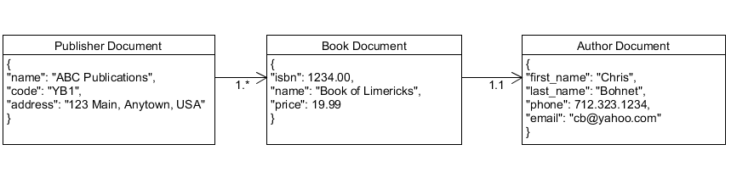

NoSQL Data Structure: