Chris Bohnet

6/17/2020

Web-335

Assignment 8.2

Anaconda Navigator:

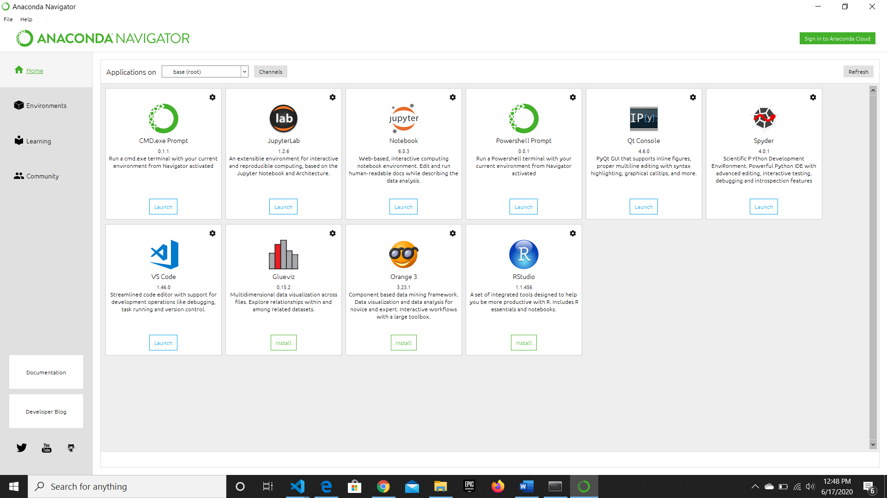

Program and Output:

