Chris Bohnet

5/21/20

Web-335

Assignment 4.2

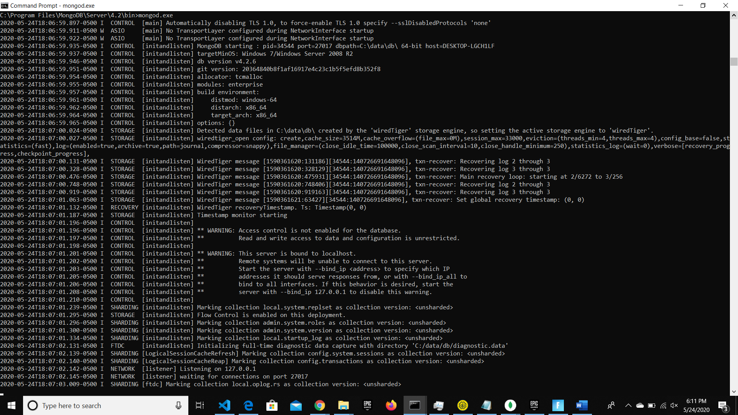MongoDB startup

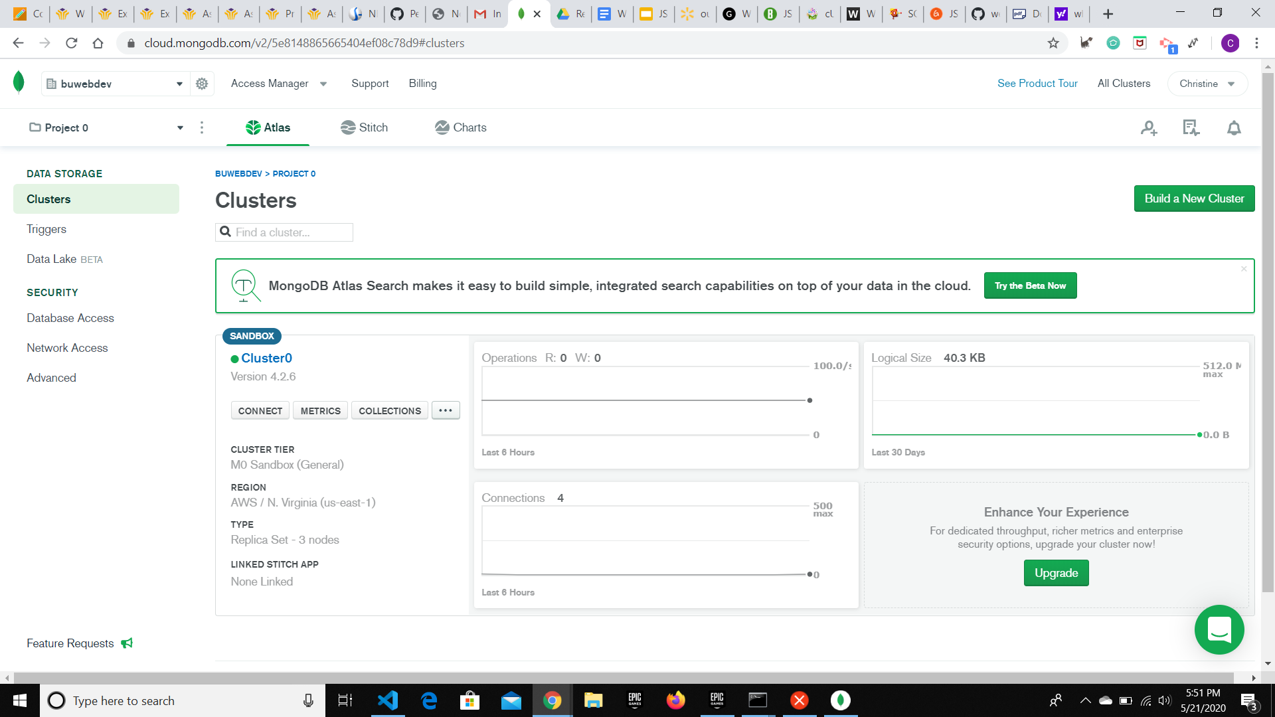MongoDB

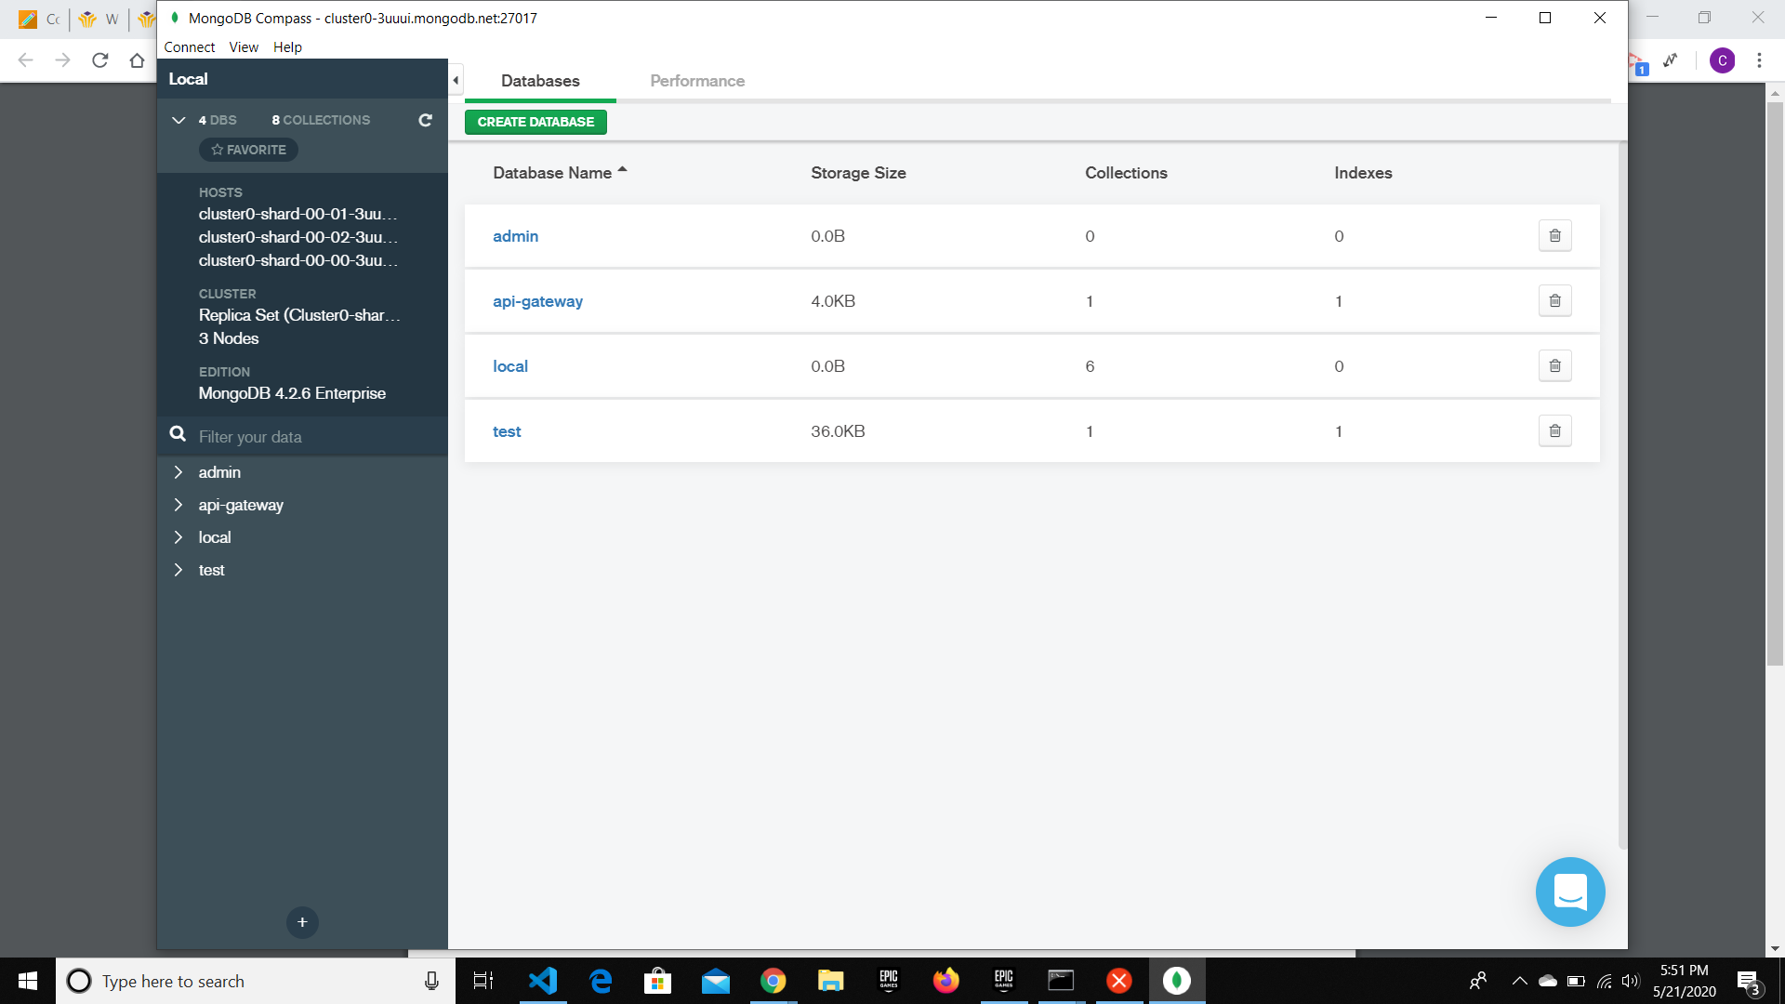Mongo Compass