Chris Bohnet

05/24/20

Web-335

Assignment 4.4

Mongo Shell Inserts

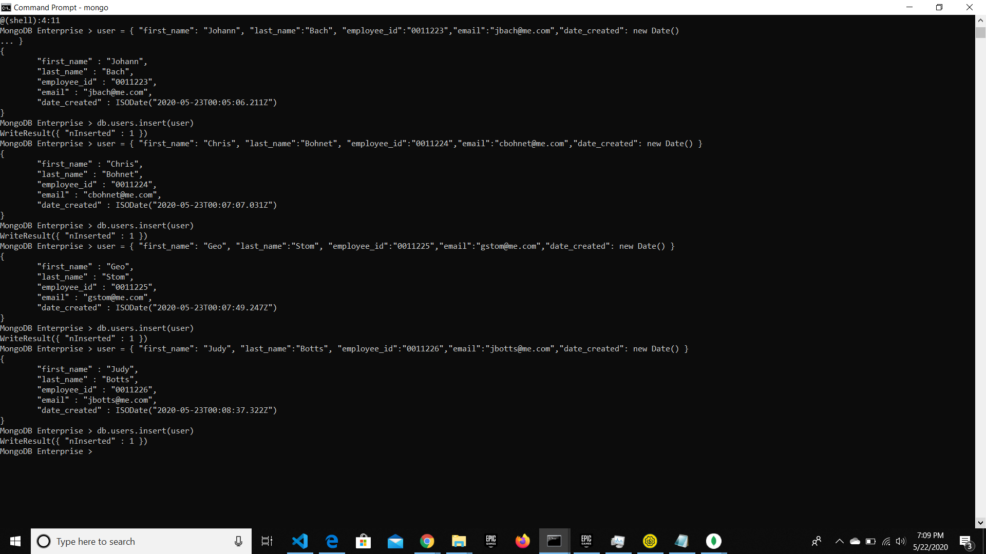

Mongo Compass Database

