Chris Bohnet

05/22/20

Web-335

Assignment 4.3

helloWorld Output

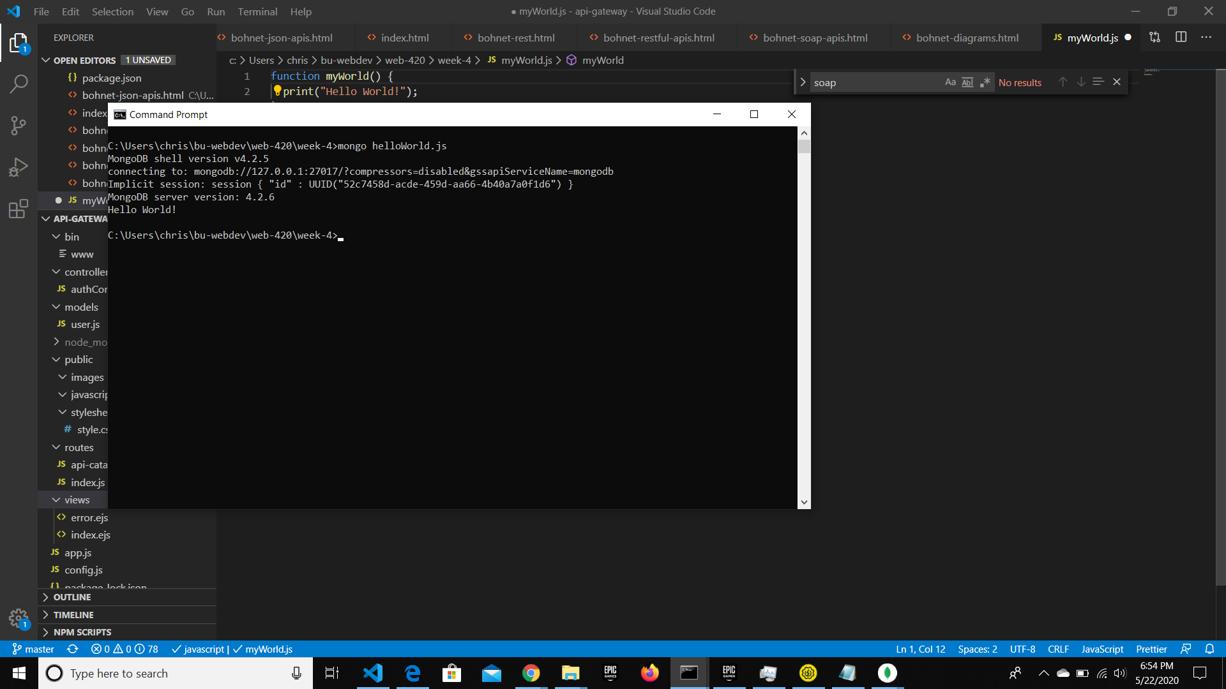

myWorld Output

