Chris Bohnet

05/31/2020

Web 420

Assignment 5.4

The record was inserted into the database “chris”. I copied the token but I’m getting an error when trying to retrieve it. Still working on it and will turn in once I figure it out.

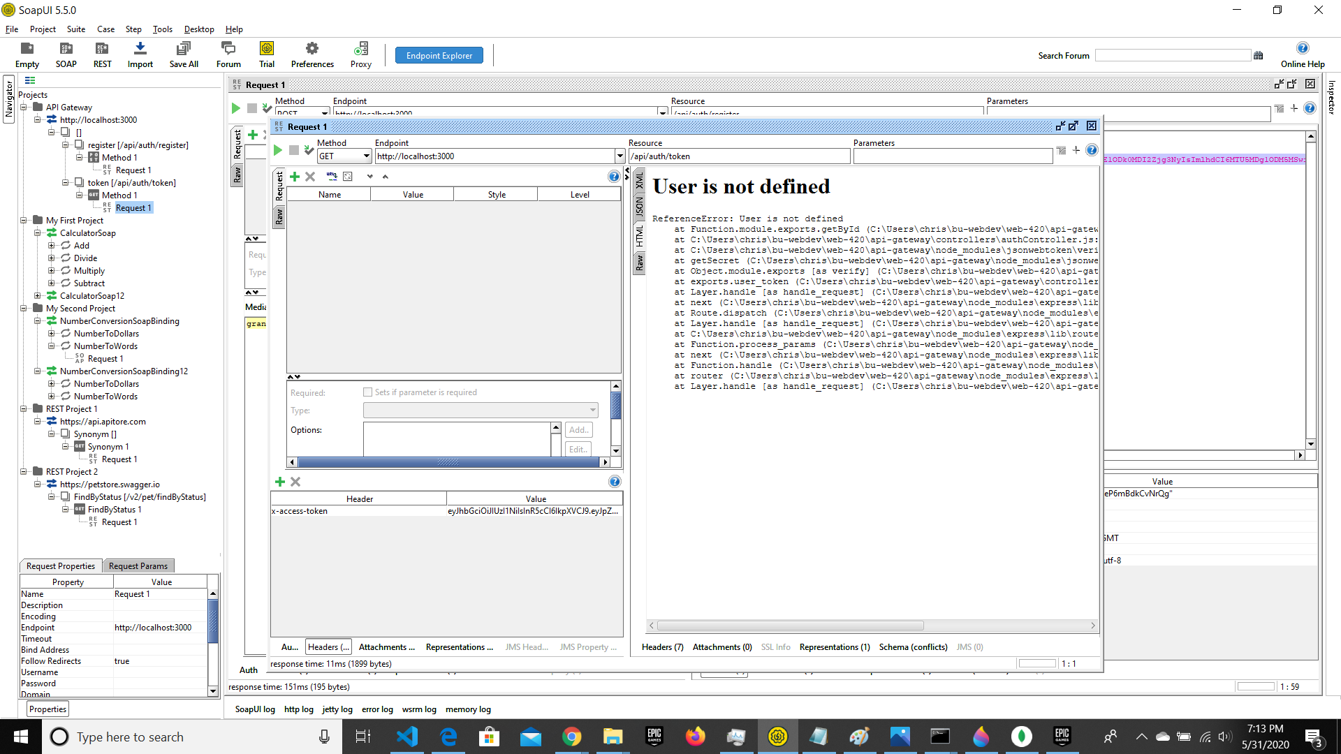

mongo db insert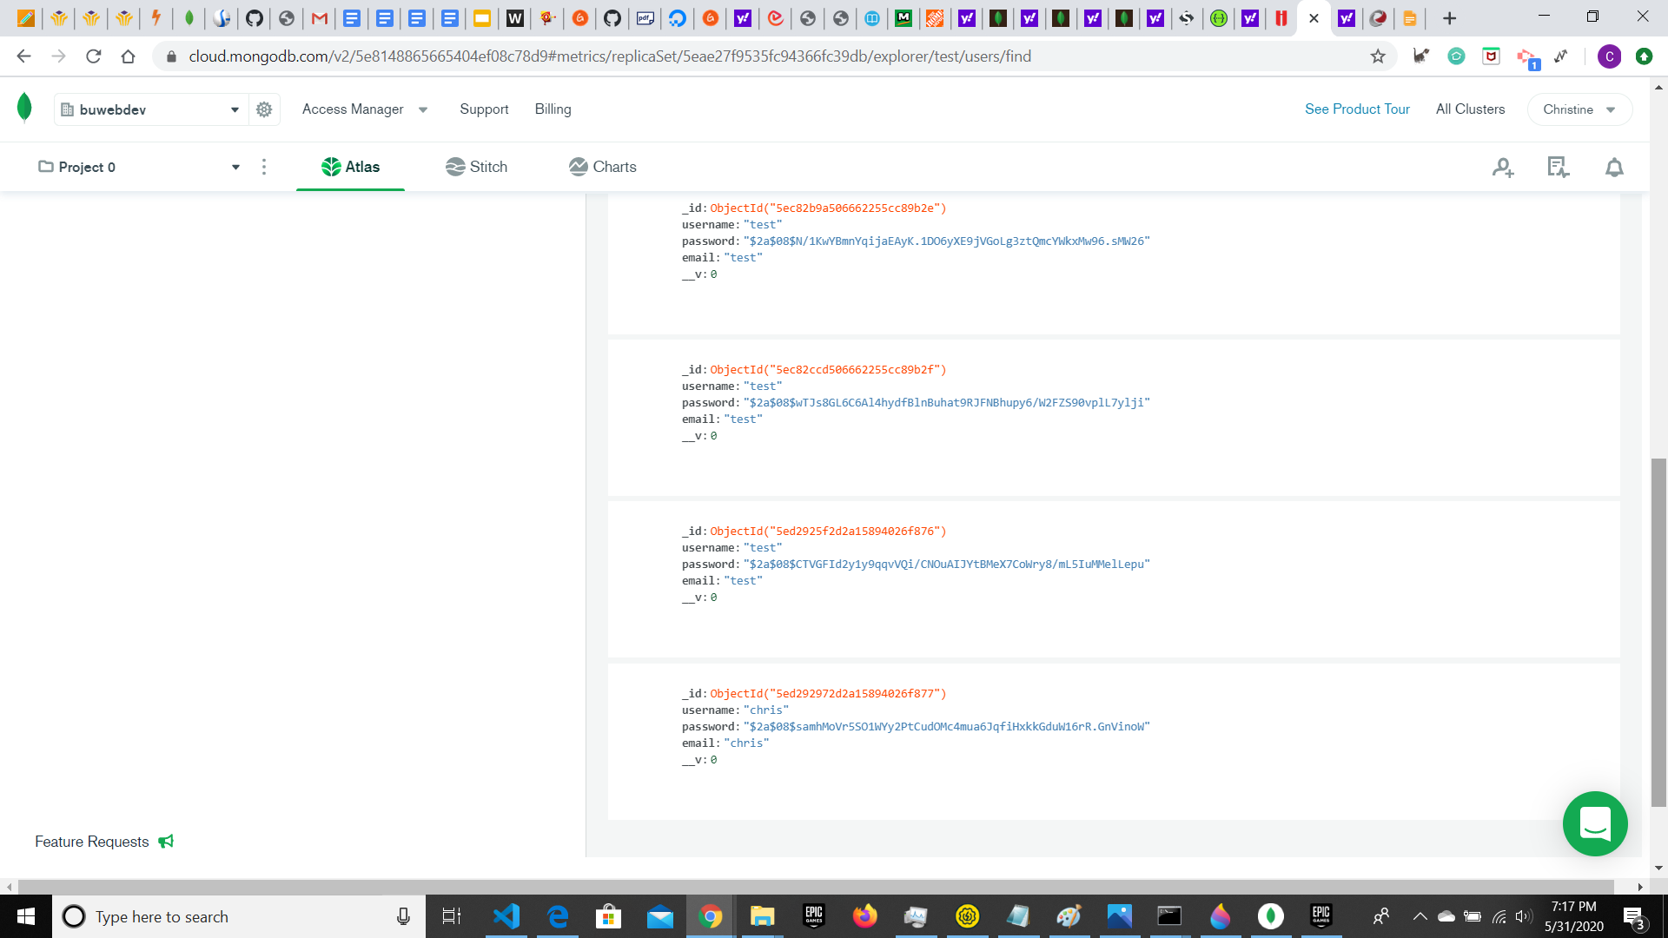

log messages

