To: Professor Krasso

From: Chris Bohnet

Date: 6/12/2020

Subject: From Legacy to SOA - Payroll

This is a proposal to migrate the legacy payroll system to a service oriented architecture.

The benefits to migrating the payroll system to a SOA follows:

1. **Service Reusability.** Small, self-contained decoupled pieces of functionality in a service can be reused in multiple applications independent of their interactions with other services.
2. **Easy Maintainability.** Services can be easily updated or maintained without having to worry about impacting other services.
3. **Greater Reliability.** Because of the small scale of modular functionality services offer, SOA-based applications are more reliable since working with pieces is easier to test and debug compared to traversing through many lines of code.
4. **Location Independence.** The services will be published to the corporate directory where consumers can look them up so the consumers are always able to locate their requested service through the directory look up in the event the service location changes.
5. **Improved Scalability and Availability.** There will be increased scalability and availability of services in relation to the legacy system since a single service can run on different servers at the same time.
6. **Improved Software Quality.** The services can be reused which helps reduce errors due to inconsistent data, which ultimately improves the code.
7. **Platform Independence.** SOA can integrate different products from different vendors independent of the platform and technology.
8. **Increased Productivity.** The existing legacy applications can be reused and have additional functionality built upon them without having to start over. Having this option is a consideration to reduce the cost of developing a new system.

Following is a diagram of the proposed payroll service oriented architecture:

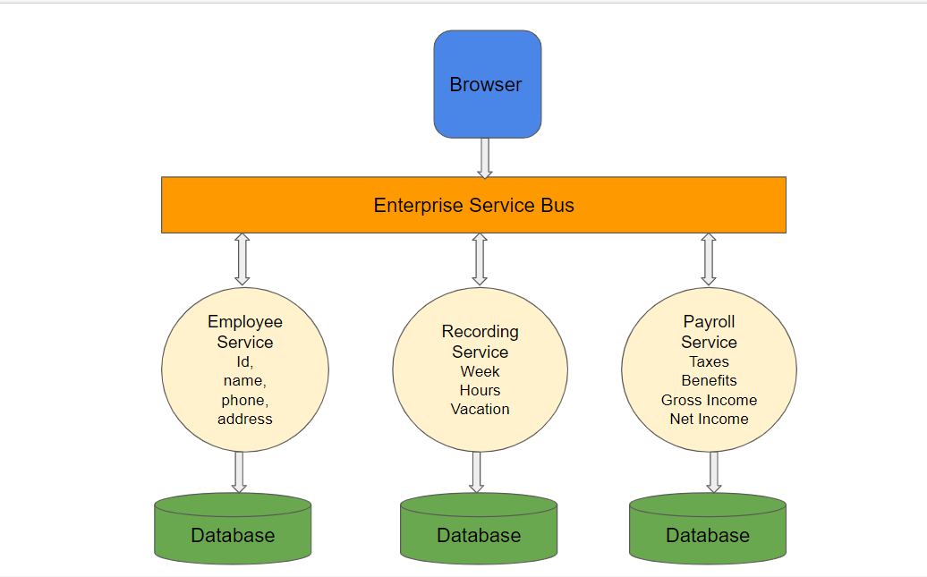

There are 3 primary services to the proposed structure:

1. **Employee Service.** The employee service will send and retrieve employee-specific data including id, name, phone and address. Notice that this service is simplistic enough to be used with other systems throughout the corporation other than payroll. Migrating to the employee service will be low risk. This service will be rolled out to employees to both initially insert and verify their personal data. Employees will be able to update their personal information.
2. **Recording Service.** The recording service will offer the ability to enter hours worked and record any vacation taken for any given week for any given employee. There is also the ability to retrieve work hours by employee. Migrating to the recording service will have low to medium risk. Thorough testing will need to be completed to ensure hours and vacation time are properly stored as recorded. The recording service will run in parallel to the legacy system until acceptance testing is complete.
3. **Payroll Service.** The payroll service will provide gross income, net income, taxes and benefits for an employee based on the hours recorded for the given week. This service is of medium to high risk. Rollout will be done in small groups or departments in order to verify accuracy before a full deployment is implemented.

**Migration Plan:**

1. Strategy development:
2. Review the business objectives and assess the services:

|  |  |  |  |  |
| --- | --- | --- | --- | --- |
| Service | Impact | Priority | Difficulty | Rank |
| Employee | low | High | low | 1 |
| Recording | low-medium | High | medium-high | 2 |
| Payroll | medium-high | High | medium-high | 3 |

1. Data assessment and analysis:
2. How much content do you need to migrate?
3. What format is your content in?
4. How much of it is duplicate content?
5. What attributes do the files have?
6. How much of it is redundant, obsolete, or trivial data?
7. How old are all of these files?

3. Validation and staging:

a. Review how the services are working.

b Validate against business rules.

4. Deployment:

* 1. Set up infrastructure.
  2. Rollout the employee service.
  3. Request employees to insert and verify their personal information.
  4. Rollout the recording service.
  5. Recording service will run in parallel to the legacy system until acceptance testing and verification complete.
  6. Rollout the payroll service by department.
  7. Verify payment amount and withholdings.
  8. Continue to migrate additional departments to the payroll service.

**Rollback Plan:**

1. Shut down payroll service.
2. Continue to use legacy service until issues are resolved.
3. Continue to run employee and recording services for verification and testing.
4. Test payroll services and rollout any fixes or updates.

**References**

PackT, “Service-oriented architecture (SOA)”, as referenced at <https://subscription.packtpub.com/book/application_development/9781789133608/1/ch01lvl1sec12/service-oriented-architecture-soa>

ADLIB, “Six steps to a successful migration: The Enterprise Data Migration Checklist”, as referenced at

<https://www.adlibsoftware.com/blog/2017/December/six-steps-to-a-successful-migration-the-enterprise-data-migration-checklist.aspx>

TechSprited, “Advantages and disadvantages of Service-oriented Architecture (SOA) “, as referenced at

<https://techspirited.com/advantages-disadvantages-of-service-oriented-architecture-soa>