Select two domain-specific formats and explain their purpose, protocol semantics, application semantics, medium, and where they are defined.

1. OpenSearch -

purpose - It is a standard representation for search forms that can be used independently or incorporated within another API that uses the search link relation. It does not define a representation of the results.

protocol semantics - searching using GET

application semantics - search queries

medium - XML

where they are defined - consortium standard (http//[www.opensearch.org/Specifications/OpenSearch/1.1](http://www.opensearch.org/Specifications/OpenSearch/1.1))

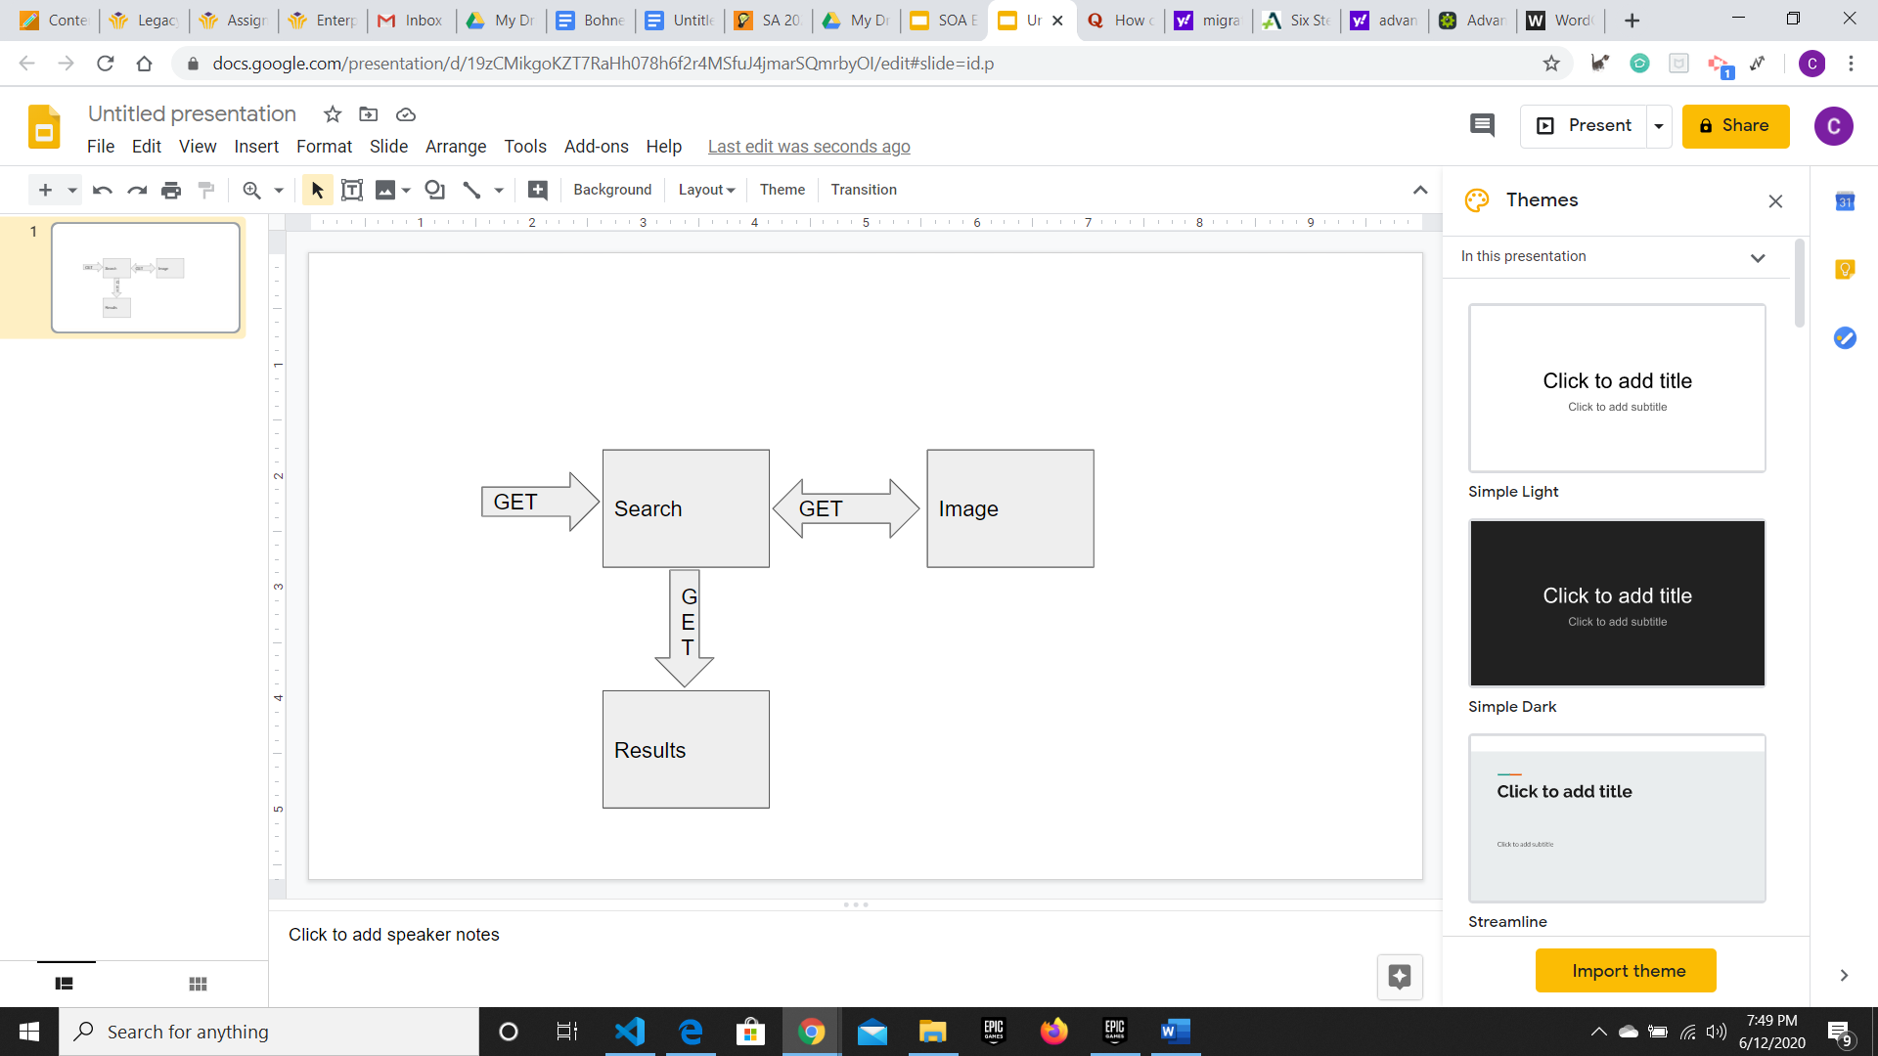

2. Maze + XML -

purpose - It is games of mazes defined by XML tags and link relations of maze cells and the connections between them.

protocol semantics - navigation using GET links

application semantics - maze games

medium - XML

where they are defined - personal standard (http//www.amundsen.com/media-types/maze/)

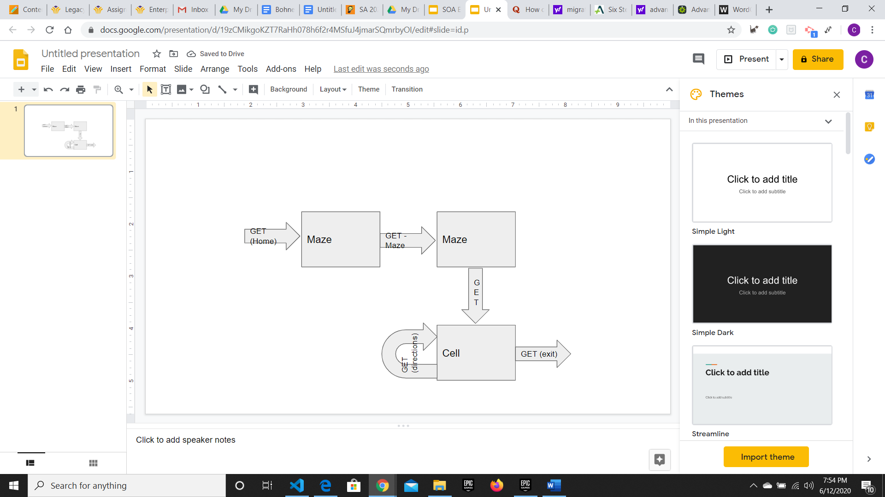

Sources:

RESTFul Web APIs, Leonard Richardson & Mike Amundsen, 2013.