Chris Bohnet

6/17/2020

Web-420

Assignment 8.4

Still working on my issue but here are screen shots of my attempts. First one was successful.

Register

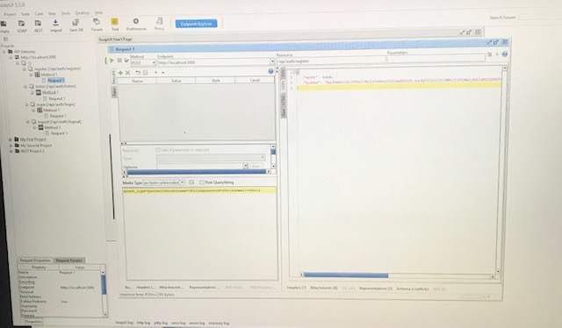

Token

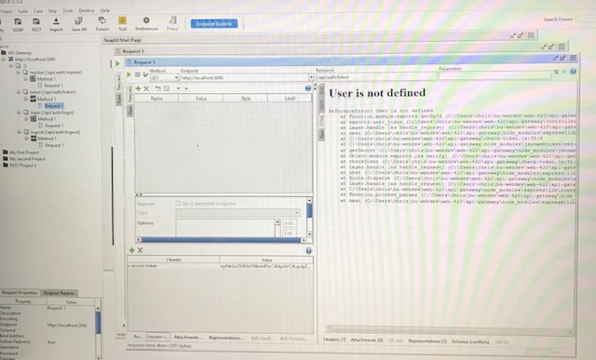

Login

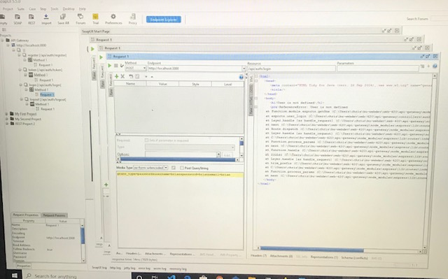

Logout

