Chris Bohnet

7/20/20

Web-425, Assignment 3.4

First test by selecting the submit button:

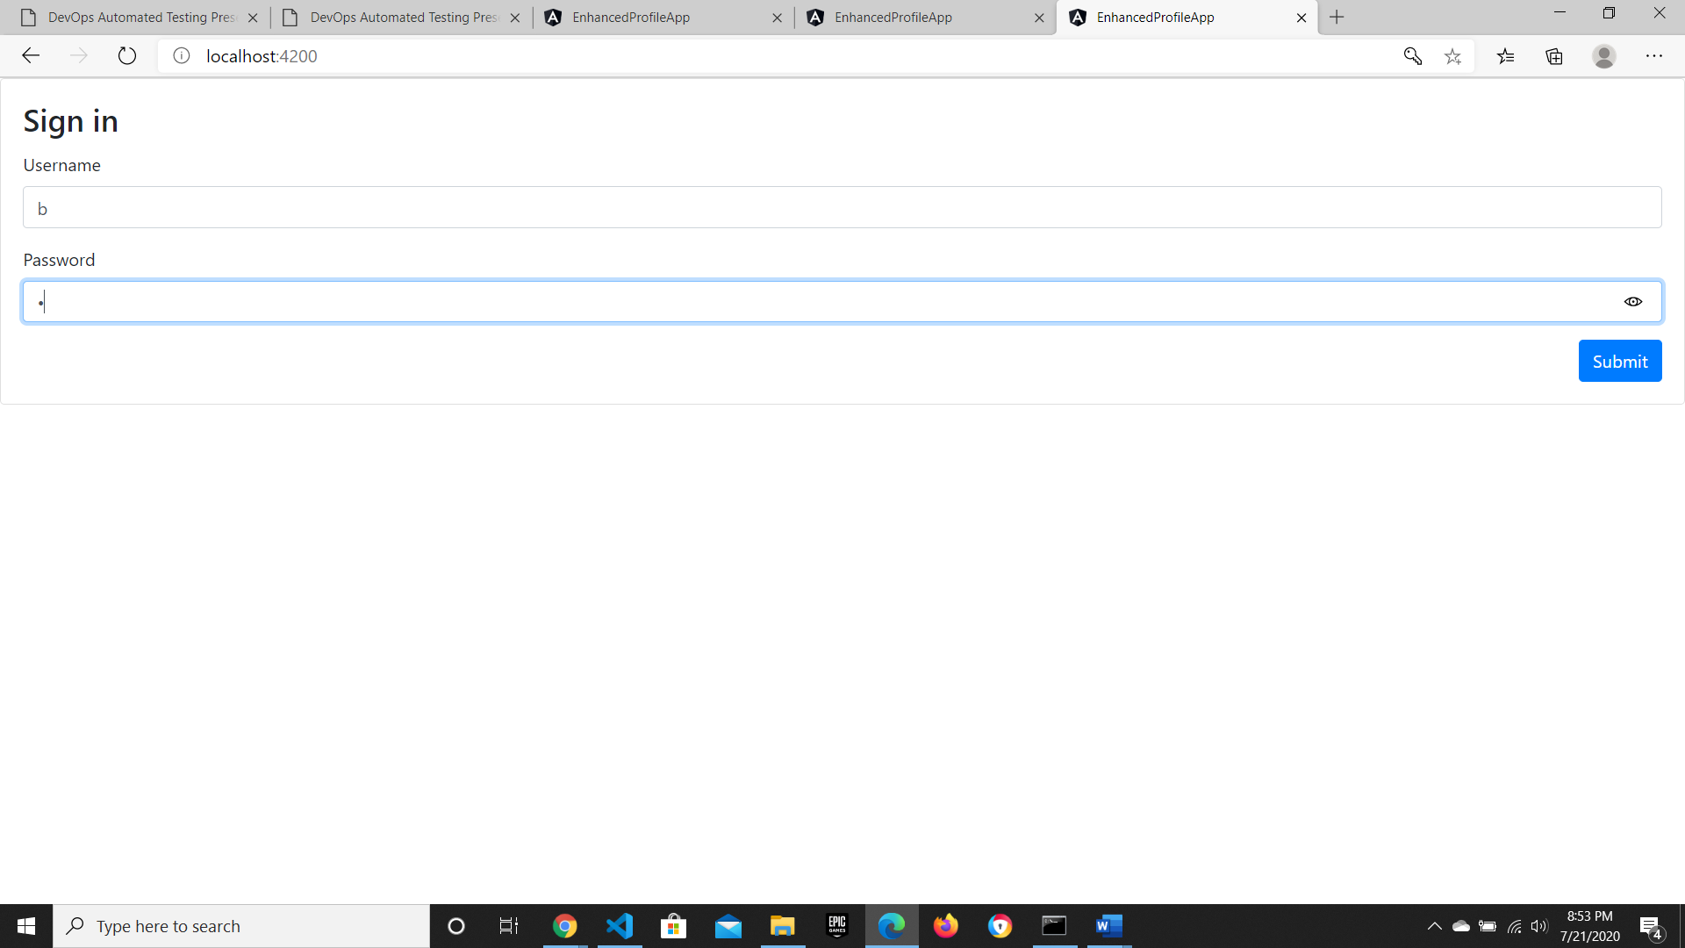

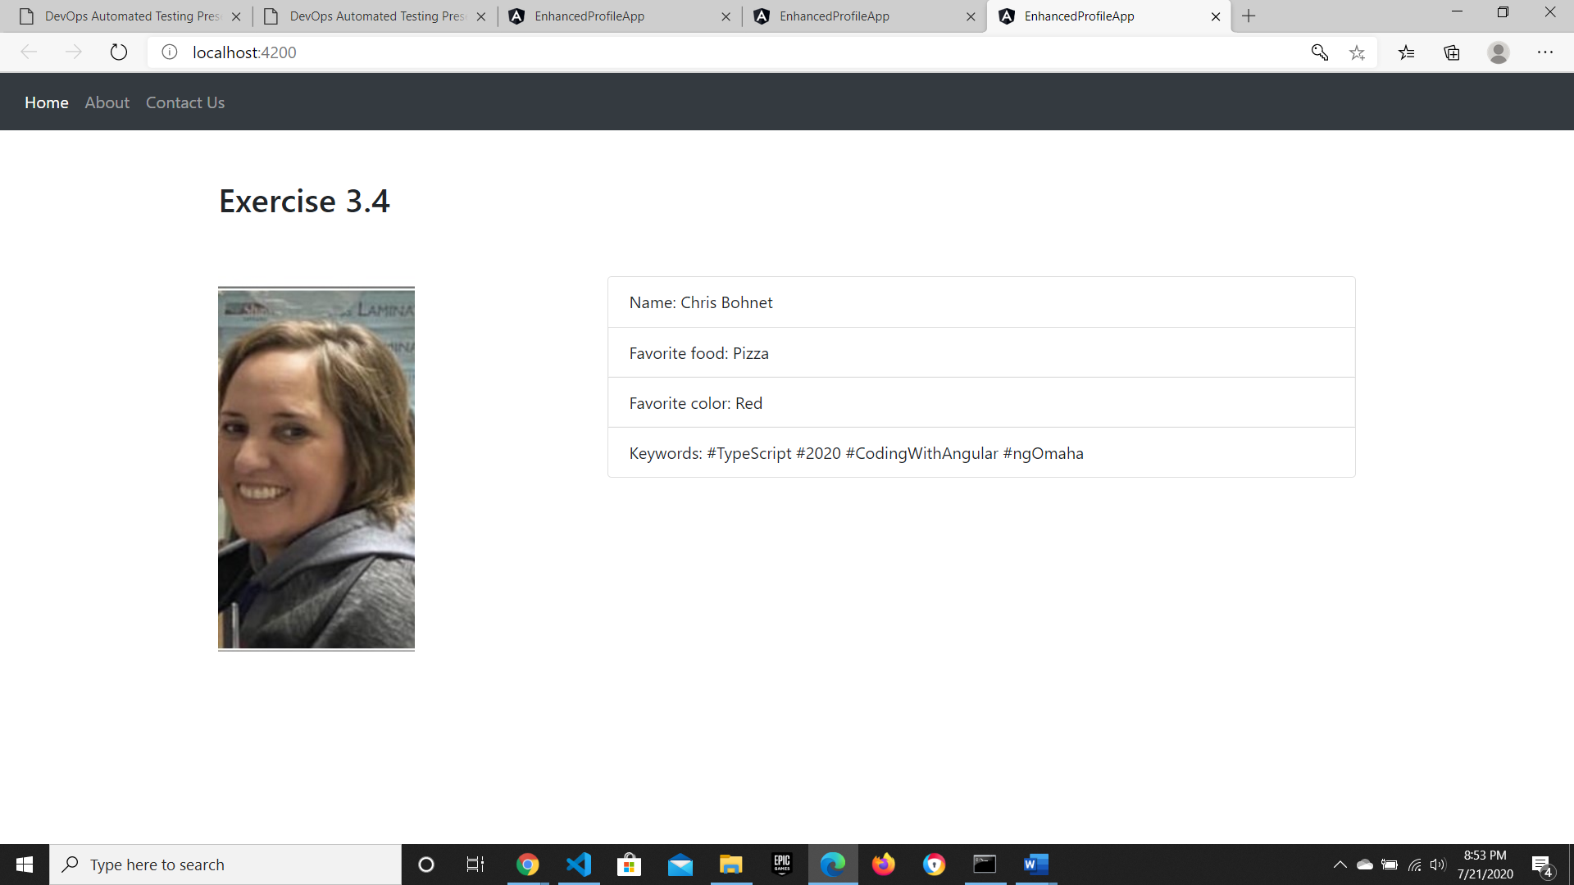

Second test by entering localhost:4200/home. It redirected to the sign in page:

