**A Graphical User Interface and Text-Based User Interface for the Humane Society**

**Computer Science Department, Lamar University**

Vipul Prajapati

Dennis Huynh

Chelsea Boling

Jason Higdon

Instructor: Dr. Andrei

CPSC 4360 Software Engineering

Date: May 05, 2014

**Table of Contents**

**Project Description………………...............................................................................................................3**

* **Purpose………………………………………………………………………………………………………………………….………3**
* **Motivation……………………………………………………………………………………………………………………………..3**
* **Difficulties………………………………………………………………………………………………………………………………3**
* **Structure…………………………………………………………………………………………………………………………………3**
* **Humane Society Computer Support……………………………………………………………………………………..…4**
* **Humane Society Software Project Requirements…………………………………………………………………….4**

**Use Case Analysis……………………………………………………………………………………………………………………………….5**

* **Actors…………………………………………………………………………………………………………………………………….5**
* **Use Cases……………………………………………………………………………………………………………………………….5**

**Use Case Diagram………………………………………………………………….……………………………………………………………6**

**Sequence Diagram………………………………………………………………………………………………………………………………7**

**Domain Model…………………………………………………………………………………………………………………………………….8**

**State Model………………………………………………………………………………………………………………………………………..9**

**Project Implementation………………………………………………………………………………………………….…………………10**

**Testing………………………………………………………………………………………………………………………………………………10**

**GUI Black-box Testing……………………………………………………………………………………………………………………….10**

**TUI Black-box Testing…………………………………………………………………………………………………………………..……13**

**Data Persistency…………………………………………………………………………………………………………………….…………15**

**Conclusion…………………………………………………………………………………………………………………………………………15**

**Description of the Humane Society Project**

**Purpose**

The purpose of this software engineering project is to adopt a use-case driven object-oriented approach to develop a system to support the services offered by a Humane Society by providing or receiving pets for the benefit of the customers.

**Motivation**

Humane Societies are nonprofit charitable organizations supported in part or entirely by voluntary donations and dedicated to the promotion of animal welfare throughout a region. The purpose of a Humane Society is preventing cruelty to animals, providing care for homeless and distressed animals, promoting spaying and neutering, educating the public in proper animal care, and related humane issues.

**Difficulties**

A Humane Society is a nonprofit organization that is not supported by people’s tax money. Animal Control, on the other hand, is a part of local government and is supported by people’s taxes. The Humane Society accepts and places out for adoption unwanted animals brought in by the public. Animal Control deals with stray and nuisance animals and is responsible for enforcement of laws relating to these animals. A Humane Society is not connected with Animal Control in any way and operates only as a result of generous contributions from caring people.

**Structure**

Among the services provided, a Humane Society provides in general:

1. Adoptions and Receiving Service: Over 1,000 animals come to the society each year and good homes with carefully screened, concerned, qualified owners are found for a large percentage.
2. Lost And Found Service: One of the most rewarding services provided by a Humane Society is the successful reunion of lost pets with their owners. In addition to lost animals actually brought to the shelter, a Humane Society may act like an intermediary between the one who lost the pet and the one who find it.
3. Hurricane / Disaster Preparedness for Pets Service: Hurricanes, tornadoes, fires, floods and hazardous or toxic material spills are just a few of the disasters we face living along the Texas Gulf Coast. Preparing your pet for a disaster today might save his / her life tomorrow. Having a plan will help the customer and his / her pet feel calmer in the event of an emergency.
4. Animal Population Control Services (Spay / Neuter). A Humane Society is greatly concerned about the problem of animal over-population in our area. In an effort to combat the pet population explosion, sterilization is required for every animal adopted from a shelter in the State of Texas and other states.
5. Legislative Activities Services: A Humane Society works actively with other local, regional and national humane organizations in promoting legislation aimed at alleviating animal suffering.

**Humane Society Computer Support**

All services enumerated in the Structure should be accompanied by the computer. For example, the adoption service should display all pets and allow a customer to select one pet and book the selection for 24 hours (until the adoption paper work is signed). The receiving service has also to allow a customer informing the staff that he / she brings a pet or more. The software should also include a way to inform the Humane Society that a pet was lost and should facilitate the connection with the one who found it. All of the three services (hurricane / disaster preparedness, animal population control, and legislative activities may also be supported by a computer.

**Humane Society Software Project Requirements**

1. Develop a system that will hold information about pets and services of the Humane Society.
   1. Registration for online or in person as a customer looking to adopt a pet or to return a pet.
   2. Record the details of losing and finding a pet and to perform the connection between these two people.
   3. Information for customers about hurricane / disaster preparedness related to pets.
   4. Information for customers about the animal population control
   5. Information for customers about the legislative activities related to pets.
2. Analyze the history of pets’ services and estimate what people will most likely choose in the future.
   1. If a customer has a preferred choice of a pet, the Humane Society should offer periodically information related to the pets to retain the customer and help him / her decide adopting the pet.
   2. Promote the national spirit of adopting a pet and take the responsibility to take care of a pet, and so on.
3. The system must be able of future expansion to incorporate information about existing Humane Societies and how to expand them in the future.

**Use Case Analysis:**

**Actors:**

* Customer

**Use Cases:**

Use case (1): Customer selects the Service needed

* Customer chooses Direct Animal Services
* Customer chooses Information
* Customer chooses other humane societies

Use case (2): Adopt a pet

Use case (3): Return a pet

Use case (4): Report lost/found pets

Use case (5): Legislative Information related to the pets

Use case (6): Information about hurricane/disaster preparedness related to pet

Use case (7): Information about the animal population control

Use case (8): Information about other humane societies

**Use Case Diagram:**

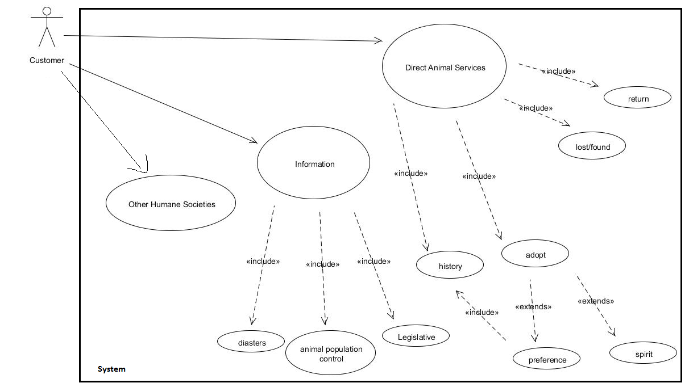

**Figure 1**: This is the use case diagram of the program, which showcases three main groups, namely other humane societies, animal services, and information services.

**Sequence Diagram**

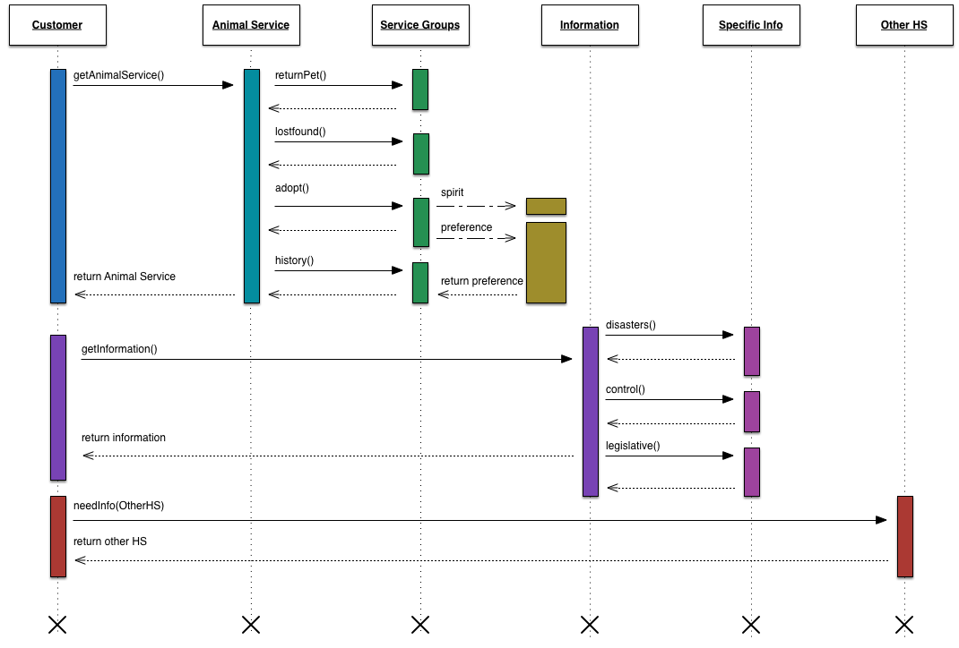

**Figure 2:** This is the sequence diagram, which shows the customer going to three groups, mainly animal services, information services, and other humane societies.

**Domain Model**

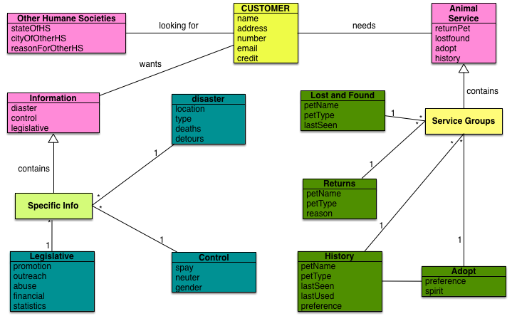

**Figure 3:** This is the domain model, which shows all possible classes needed to model the services of the Humane Society.

**State Diagram**

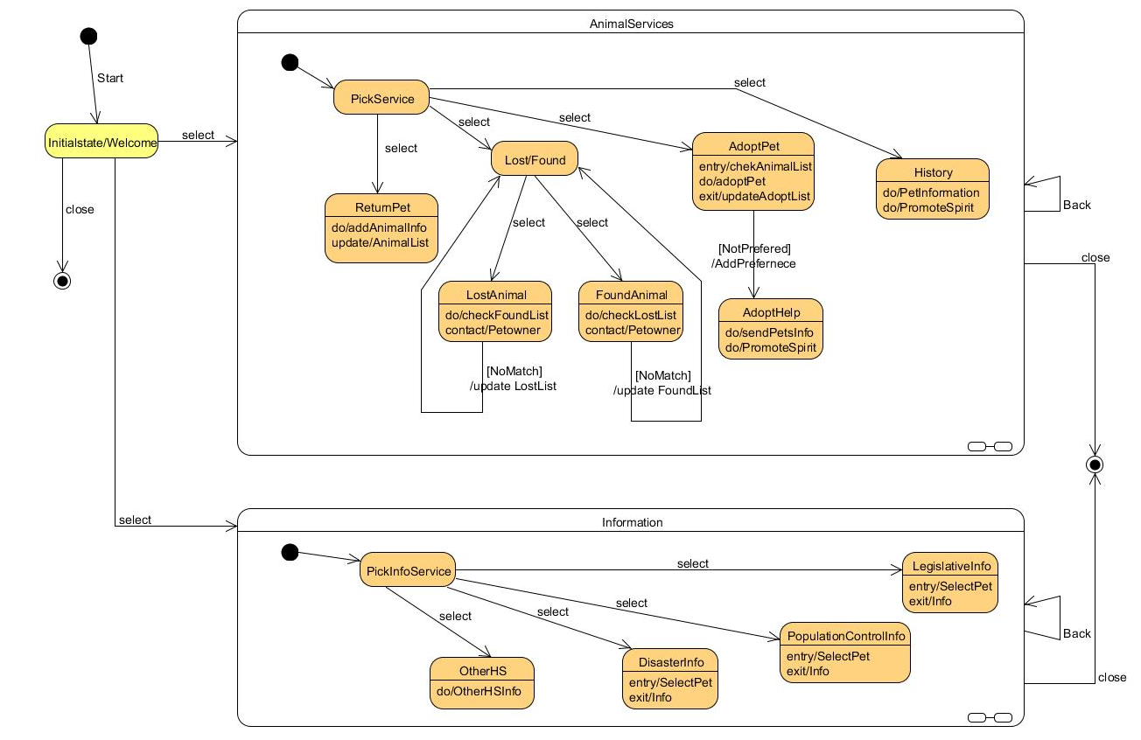

**Figure 4:** This is the state diagram, which shows the states in which the customer can be in. The animal service state and the information state are linked to the welcome page.

**Project Implementation**

For our project, we did two approaches. First approach is a Graphical User Interface (GUI) and the second approach is a Text-based User Interface (TUI).

**Testing**

The software will betested by using the black-box method. In black-box testing, all knowledge of the code is ignored and the tester will play the role of a consumer using the software for its intended use.

**GUI Black-box Testing:**

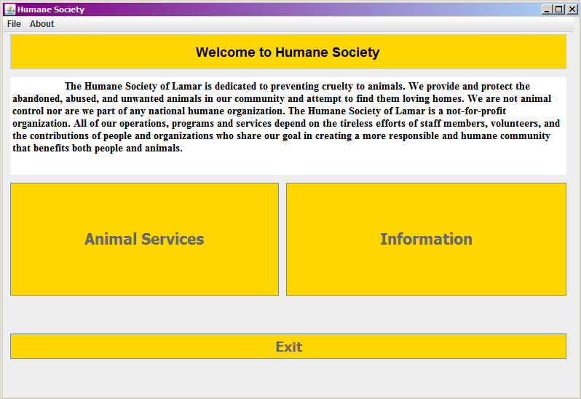

**Figure 5:** GUI Main Menu Screen: Recall that black-box testing refers to a user who tests a program but does not have any prior knowledge to how the program is coded. When a user tests our Humane Society GUI, this is the welcoming page.

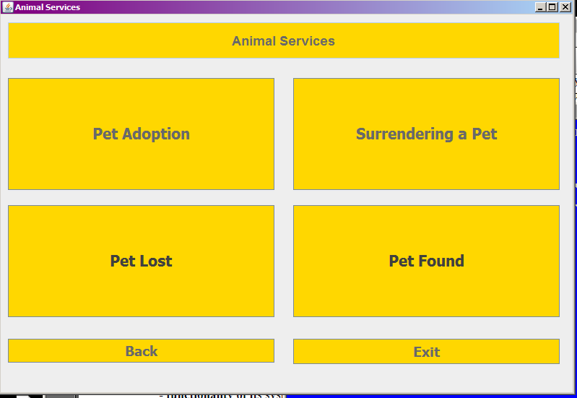

**Figure 6:** GUI Animal Services: The user may click on Animal Services, and this is the page that leads to four options.

Example Test Case 1:

* User wants to adopt a pet.
* User opens up Humane Society welcome page.
* User chooses Animal services.
* User chooses the adoption pet form.
* User fills out form.
* User clicks “Submit Application”.
* Data is entered in a text file.
* User is notified of submission.
* Next, the “committee” (people behind the program) review the application and make decisions.

Example Test Case 2:

* User wants to know more information about population control.
* User opens up Humane Society welcome page.
* User chooses information services.
* User chooses “population control” information.
* User reads information.
* User clicks “back” for more information.

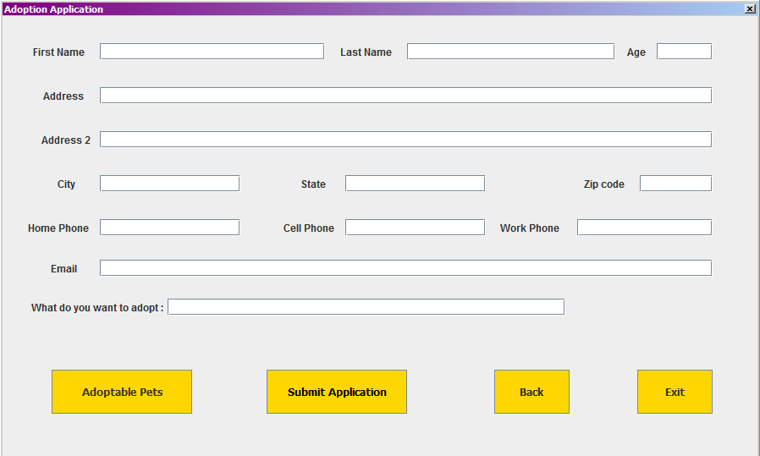

**Figure 7:** GUI Adoption Application: When the user wants to adopt a pet, this is the form that the user can fill out. When the user clicks “Submit Application.” The user is notified that their application is sent in to review by the Humane Society committee.

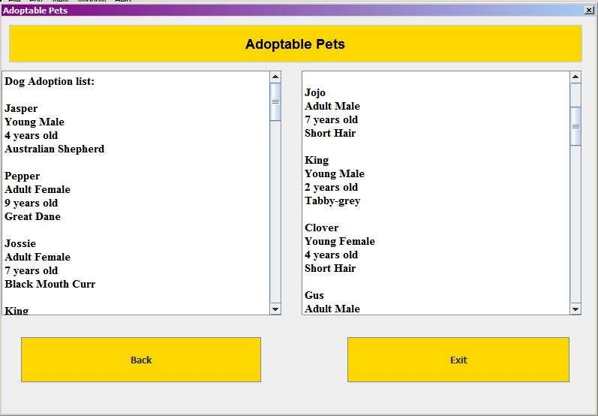

GUI Adoptable Pets List: The user may view the list of pets to adopt. This is also how we persist data into our program.

**TUI Black-box Testing:**

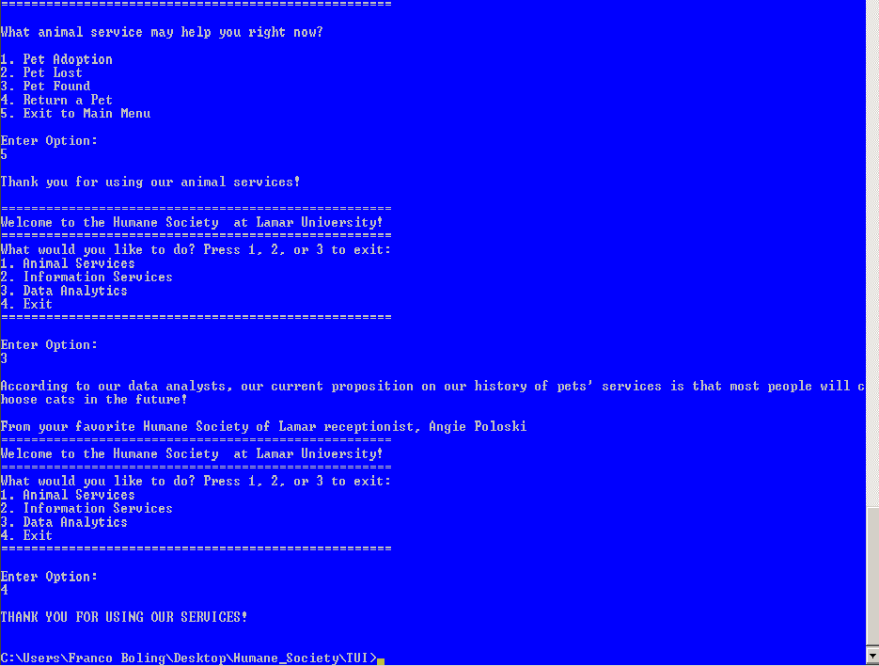

**Figure 8:** TUI Main Menu:As an alternative, we created a text based user interface of our Humane Society Application. It works the same way, but everything is based on looping. We wanted to see the control flow of our data.

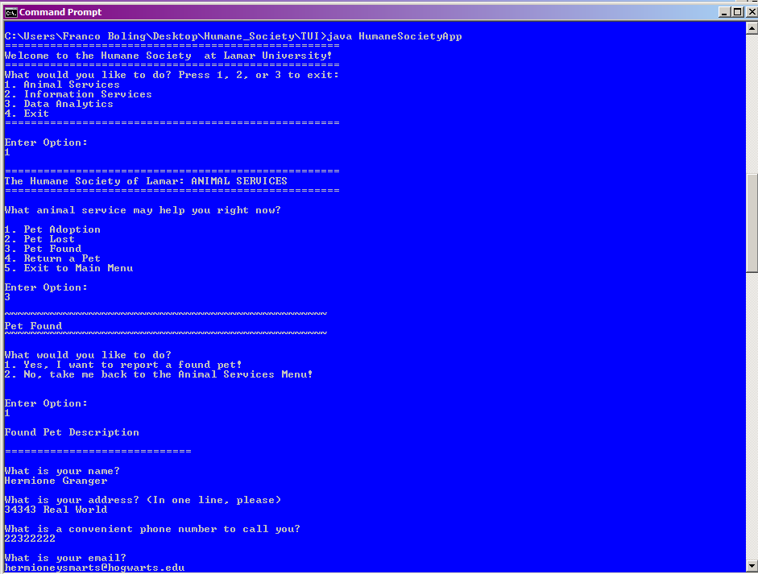

**Figure 9:** TUI Adoption Form: The loop goes through the adoption form. The form consists of basic questions, such as name, contact, and email.

**Data Persistency**

Data is persisted in our program through our application forms. The humane society committee (which is us) can look at this data, and make certain inferences on what needs to be done. Based on the data, or the test cases that we implemented, we can then determine or estimate what may be likely chosen as a pet in the future. Furthermore, data is persisted in our adoption form, lost form, and found form.

**Conclusion**

Overall, this is a nice general application to get a Humane Society to start their non-profit business. The interface is nice to used, but if someone is looking for an alternative, the text-based user interface does the same job. The program is friendly and is used as a tool. Some limitations may be that the program does not “know” when to link people who have found or lost a pet. Therefore, a search function may have been implemented. However, human inference is just as good since humans make vivid descriptions of what they found or lost such that it is better to just read the data itself than making a program guess or check the people who can be linked to each other. We hope to make this program useful to anyone who is looking forward to using a program for their Humane Society. We strongly wish to add more features as requested by our future clients.